CyberIA
Automated Cyberattack Timeline Reconstruction & Forensic Analysis
Project Report
Date: October 20, 2026
Status: Working prototype, demonstrated on synthetic data

1. Executive summary
CyberIA is a defensive digital-forensics (DFIR) tool. It takes exported log files from a Windows host, a Sysmon sensor and a network capture, and reconstructs what an attacker did. It orders events on a single timeline, groups related activity into incidents, maps each finding to MITRE ATT&CK techniques, extracts indicators of compromise (IOCs), scores risk with an explanation, and exports the results as forensic reports.
The tool runs entirely offline. It needs no database, no paid APIs and no network access. Analysts work through a dark-themed Streamlit web console.

Headline results on the sample dataset
Measure | Result
Events analysed | 587 (from 3 log sources)
Incidents identified | 2 (on WS-FIN-07 and WS-HR-02)
Detections raised | 31 (3 Critical, 19 High, 9 Medium)
Overall risk score | 100 / 100 (Critical)
Malicious IOCs | 30 attack-linked IOCs
Automated tests | 48 passed, 0 failed

2. Scope and inputs
CyberIA accepts CSV exports from three sources. It detects the source from the column headers, so the file name does not need to follow a convention.
Source | Typical export | Used for
Windows Event Log | Security log CSV (logon, process, account and task events) | Authentication, account changes, process creation
Sysmon | Sysmon event CSV (EIDs 1, 3, 10, 11, 12, 13, 22 and others) | Process tree, network connections, file and registry activity
Wireshark | Packet-list CSV (time, source, destination, protocol, info) | Network reconnaissance, traffic volume, DNS names

3. How it works
Processing runs as one pipeline. Each stage hands its output to the next:
- Parse: read each CSV, normalise column names and timestamps to UTC, and isolate row-level errors.
- Correlate: sort events chronologically, map IPs to hosts, and build process trees from PID and PPID.
- Detect: run event-level rules and cross-event rules (brute force, port scanning, beaconing, exfiltration).
- Extract IOCs: pull IPs, domains, URLs, hashes and suspicious file paths, then scope each as internal, external or allowlisted.
- Group and reconstruct: link related detections into incidents and order them into an attack chain.
- Score: compute an explainable 0–100 risk score at the detection, event and incident levels.
- Report: write JSON, CSV and ZIP outputs, with an executive summary and recommended actions.

Project structure
app.py Streamlit SOC console (7 views)
core/ normalisation, correlation, risk scoring, pipeline
parsers/ Windows, Sysmon and Wireshark parsers, plus format router
detection/ rules, detection engine, MITRE ATT&CK mapping
ioc/ IOC extractor
reports/ JSON, CSV and ZIP report generation; recommendations
visualization/ Plotly charts (dark theme)
config/ paths and detection thresholds (overridable)
scripts/ synthetic sample data generator
tests/ pytest suite (48 tests)

4. Detection coverage
Each detection carries a rule, an ATT&CK technique, a severity, a confidence value and the evidence rows that support it. Thresholds and allowlists are configurable, which is how false positives are reduced. Benign Microsoft update traffic, for example, is allowlisted and does not produce C2 alerts.
Area | Techniques detected | Method
Brute force and password spraying | T1110.001, T1110.003 | Failure bursts per account and per source IP
Valid account use after attack | T1078 | Successful logon following a failure burst
PowerShell abuse | T1059.001 | Encoded commands (decoded from UTF-16), download cradles, hidden windows
Living-off-the-land binaries | T1105, T1218.x, T1197, T1047 | certutil, mshta, rundll32, regsvr32, bitsadmin, wmic and others
Persistence | T1547.001, T1053.005, T1543.003, T1136.001 | Run keys, scheduled tasks, services, new local accounts
Privilege escalation | T1098, T1548.002 | Admin group changes, UAC bypass via registry hijack
Credential access | T1003.001 | LSASS dumping via comsvcs or procdump, suspicious LSASS access
Defense evasion | T1070.001, T1562.001, T1490 | Event log clearing, Defender tampering, shadow copy deletion
Reconnaissance | T1046, T1595 | Vertical and horizontal port scans
Command and control | T1071.001, T1571 | Periodic beaconing (interval regularity and jitter analysis)
Exfiltration | T1041, T1048, T1567.002 | Large outbound transfers to external hosts, rclone uploads

5. Sample dataset
The sample dataset is synthetic. It is generated by scripts/generate_sample_data.py, so it can be reproduced with a fixed seed. It contains two multi-stage attacks mixed with routine activity:
- Scenario A (WS-FIN-07): an external port scan, an RDP brute force that succeeds, an encoded PowerShell cradle, a certutil download, a Run-key and scheduled-task persistence, a new administrator account, C2 beaconing, an LSASS dump, data staged in an archive and exfiltrated, and finally the Security log cleared.
- Scenario B (WS-HR-02): a malicious Office document that launches mshta, a PowerShell download, a rundll32 DLL load, a fodhelper UAC bypass, and HTTPS beaconing.
- Benign activity: normal logons, browsing, Microsoft updates, a legitimate admin script, a scheduled backup and a few password typos below the brute-force threshold. These test the false-positive controls.

6. The working application
The following screenshots were captured from the running application after loading the sample dataset. Each one corresponds to a sidebar view.

6.1 Start screen

Figure 1. Start screen before any evidence is loaded

6.2 Overview
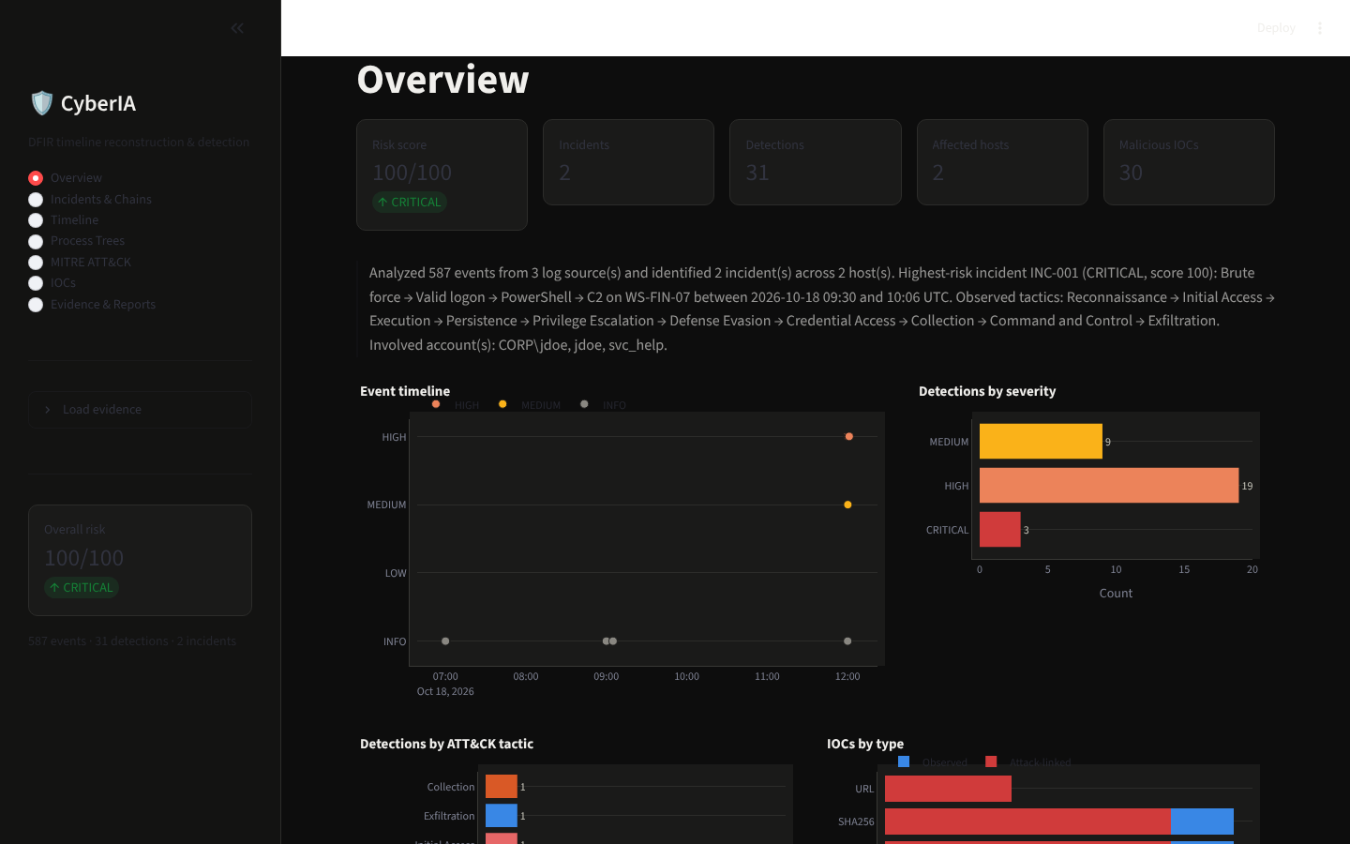
Figure 2. Overview: risk score, key counts, plain-language summary, event timeline and detection charts

6.3 Incidents & Chains
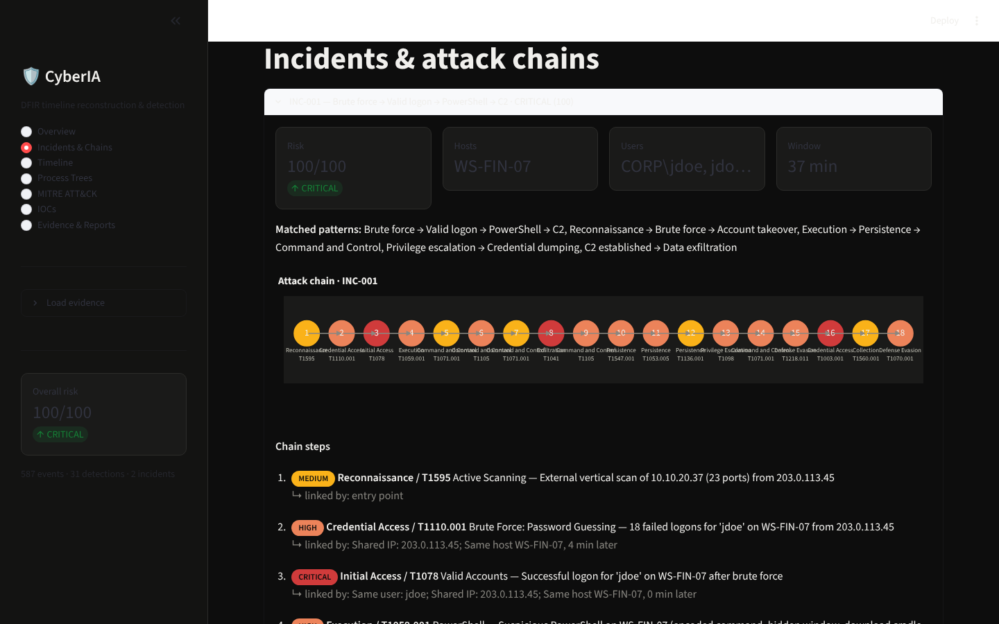
Figure 3. Incidents and attack chains: INC-001 with a chain of 18 steps, linkage reasons and the score breakdown

6.4 Timeline
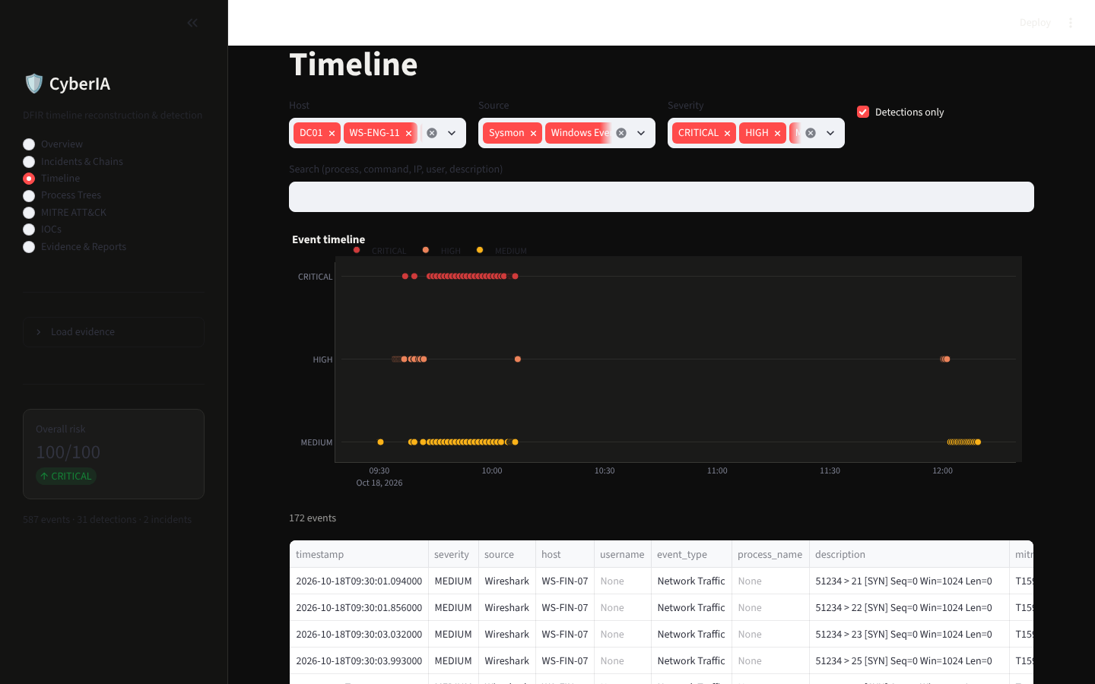
Figure 4. Timeline: events plotted by severity with host, source and text filters

6.5 Process Trees
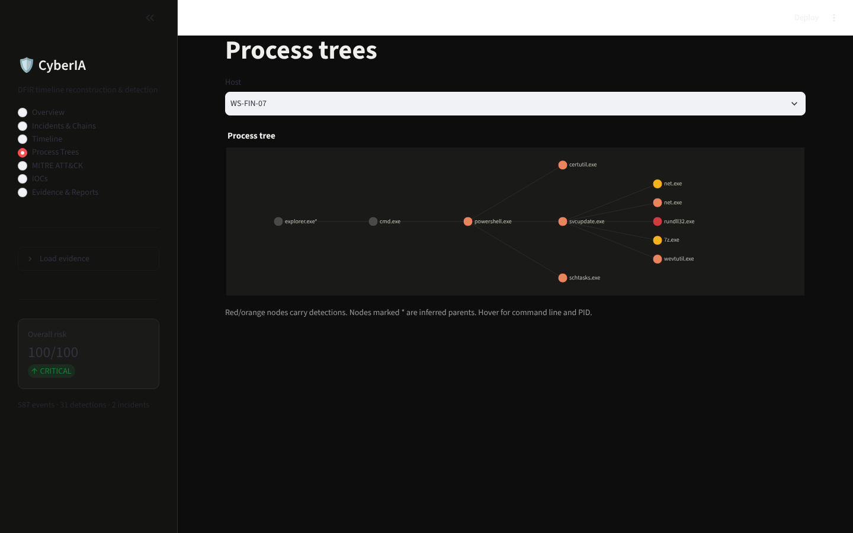
Figure 5. Process tree for WS-FIN-07: flagged processes are coloured by severity, and inferred parents are marked

6.6 MITRE ATT&CK
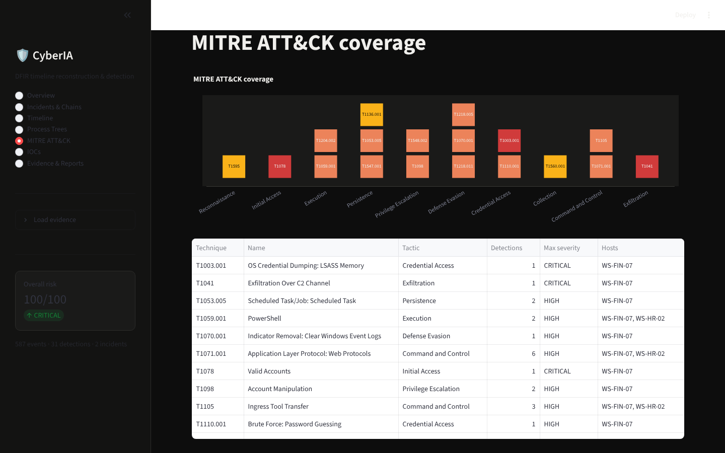
Figure 6. MITRE ATT&CK coverage matrix: observed techniques by tactic, coloured by highest severity

6.7 IOCs
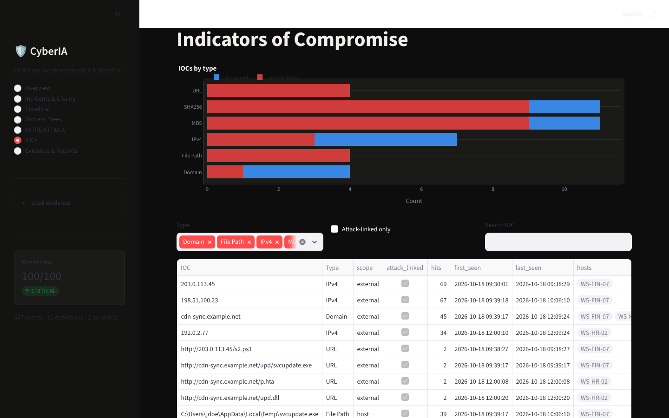
Figure 7. Indicators of Compromise: scoped table with first and last seen times, hit counts and attack links

6.8 Evidence & Reports
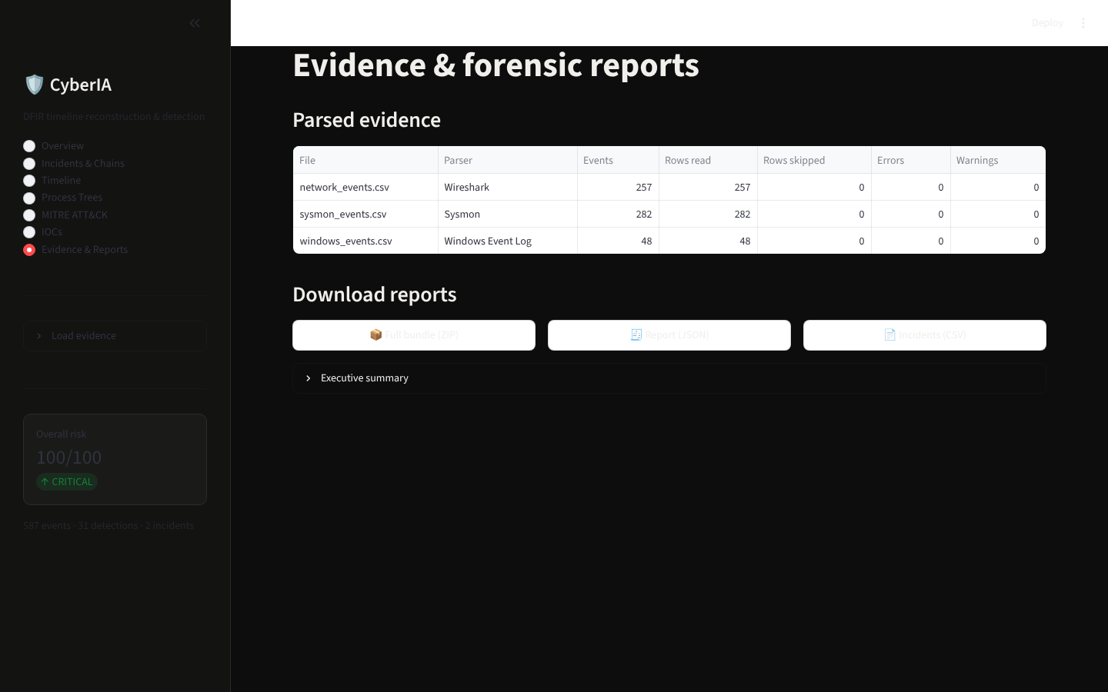
Figure 8. Evidence and reports: parser results per file, with downloads for the ZIP bundle, JSON and CSV

7. Outputs
Every analysis can be exported in several formats. Each one is designed for a different audience:
Output | Contents | Audience
Report (JSON) | Executive summary, incidents, attack chains, detections, MITRE mappings, IOCs, process trees, recommendations, timeline | Tooling and integration
Incidents (CSV) | One row per incident: severity, score, hosts, users, tactics, techniques, explanation, recommendations | Management and tracking
Attack chains (CSV) | One row per chain step with the linkage reason and evidence references | Investigators
Detections (CSV) | One row per detection with confidence, score, entities and event IDs | Analysts
IOCs (CSV) | Deduplicated IOCs with scope, first and last seen times, hits and related techniques | Blocking and hunting teams
Events (CSV) | The full normalised, enriched event timeline | Forensic review
Full bundle (ZIP) | All of the above in one archive | Case files

8. Testing and verification
The automated suite contains 48 tests in four modules and passes in full:
Module | Covers
test_parsers.py | Format detection, required columns, empty and malformed files, column aliases, bad-timestamp rows
test_normalization.py | Timestamp formats and time zones, epoch values, IP and hash parsing, PowerShell decoding, internal and external classification
test_detection.py | Each detection family, benign-activity suppression, allowlists, rule disabling, rule-failure isolation
test_pipeline.py | End-to-end run on the sample data: incidents, expected techniques, IOC scoping, score bounds, report generation, process trees

The end-to-end test confirms that scenario A is reconstructed as a single high-scoring incident, that the expected techniques appear, that the Microsoft range is not flagged as malicious, and that the risk scores stay within bounds.

9. How to run
- Install the dependencies:
pip install -r requirements.txt
- Generate the sample dataset (optional, a copy is already included):
python scripts/generate_sample_data.py
- Start the console:
streamlit run app.py
- In the browser, open the sidebar, click "Load sample dataset", and navigate between the views. To analyse your own evidence, upload CSV exports under "Upload log CSVs" and click "Analyze uploads".
- Run the tests:
pytest -q

Detection thresholds and allowlists can be changed without editing code. To do so, create config/detection_rules.json and override only the keys you need.

10. Known limitations and next steps
The following items are open. They are listed so the project can be assessed honestly.
Area | Limitation | Suggested next step
Validation data | Results come from synthetic data designed to exercise the rules. False-positive and detection rates on real telemetry are unmeasured. | Test on public datasets (e.g. EVTX-ATTACK-SAMPLES, Mordor) and record precision and recall.
Attack-chain view | Step labels overlap when a chain has many steps. | Use a horizontal scroll or a two-row layout for long chains.
Dark theme | Expander headers have low contrast. | Raise the header text colour in the theme CSS.
User names | The same account can appear in more than one format (e.g. CORP\jdoe and jdoe). | Normalise domain prefixes in the correlation step.
Input formats | Supports CSV exports only. Native EVTX and PCAP are not parsed. | Add an EVTX reader and a PCAP-to-CSV step.
Scale | Analysis runs in memory and is sized for a single case. | Add chunked processing for very large logs.

