PYTHON LAB PROJECT REPORT

E-Commerce Customer Segmentation & Business Analytics
RFM feature engineering, unsupervised clustering and an interactive executive dashboard on the Online Retail II dataset
Submitted by
Name | Akash Gupta
Roll number | 26IM61R02
Program | M.Tech, ORDA (1st Year)
Course | Python Lab

Item | Detail
Dataset | Online Retail II (UK online retailer, Dec 2009 – Dec 2011)
Scale | 1,067,371 transactions; 5,939 customers analysed
Methods | RFM, log transform, K-Means, Hierarchical (Ward), PCA
Stack | Python, Pandas, Scikit-Learn, Matplotlib/Seaborn, Streamlit, Plotly
Repository | github.com/AkashGupta004/ecommerce-customer-segmentation-analytics
License | MIT

Contents
1. Executive Summary 3
2. Project Goals and Business Problem 3
2.1 The business challenge 3
2.2 Objectives 3
2.3 Success criteria 4
3. Dataset 4
4. System Architecture 5
4.1 Overview 5
4.2 Data flow 5
4.3 Repository structure 5
4.4 Module responsibilities 6
4.5 Technology stack 6
5. Methodology 7
5.1 Data ingestion and unification 7
5.2 Cleaning and return auditing 7
5.3 Customer RFM feature engineering 7
5.4 Skewness mitigation and scaling 8
5.5 Cluster-count selection and model comparison 8
5.6 Dimensionality reduction (PCA) 9
6. Results 9
6.1 Customer segments 9
6.2 Pareto concentration 10
6.3 Segment interpretation 10
6.4 Generated figures 11
7. Retention and Marketing Playbook 11
8. How to Use the Project 12
8.1 Prerequisites 12
8.2 Installation 12
8.3 Running the master pipeline 12
8.4 Launching the Streamlit dashboard 13
8.5 Running the Jupyter notebook 13
8.6 Output files 13
9. How to Replicate the Results 14
10. Limitations and Future Work 15
10.1 Limitations 15
10.2 Future roadmap 15
11. Conclusion 15

1. Executive Summary
This project is an end-to-end customer segmentation and business analytics system built on the public Online Retail II dataset. It transforms more than one million raw transaction lines into a small set of actionable customer segments, and delivers the result through a reproducible command-line pipeline, a guided Jupyter notebook and an interactive Streamlit dashboard.
The core idea is simple: customers who buy at different times, with different regularity and at different values should not be treated identically. Each customer is described by Recency (how recently they bought), Frequency (how many orders they placed) and Monetary value (net spend after refunds). After correcting the heavy right-skew in these variables, K-Means clustering groups customers into four behavioural segments.

Headline findings
20.13% of customers (the Champions segment) generate 73.68% of net revenue. The silhouette-optimal operational choice is k = 4 (silhouette 0.3657), and K-Means (0.3657) outperforms Ward hierarchical clustering (0.3285). Two principal components explain 95.14% of the variance in the standardised RFM space.

Key numbers at a glance
Metric | Value
Raw transaction rows | 1,067,371 (525,461 in 2009-10 + 541,910 in 2010-11)
Rows after cleaning | 797,815
Credit-note / return rows retained | 18,390
Customers analysed | 5,939 (5,837 clustered + 102 refund-only)
Net customer sales | approx. £16.38M across the four clustered segments
Chosen number of clusters | k = 4 (Silhouette = 0.3657)
Variance explained by 2 PCs | 95.14% (PC1 76.63%, PC2 18.52%)

2. Project Goals and Business Problem

2.1 The business challenge
In online retail, treating every customer the same leads to wasted marketing spend, blanket discounting that erodes margin, and unnoticed churn among valuable accounts. Management needs to know who the best customers are, who is drifting away, and where retention effort will pay off most.

2.2 Objectives
- Audit and clean the raw transaction data transparently, including a reconciled treatment of returns and cancellations so that profitability is not overstated.
- Engineer customer-level features (RFM plus supporting ratios such as average order value, tenure and return rate).
- Correct statistical skew in transactional variables so that distance-based clustering behaves sensibly.
- Discover natural segments with unsupervised learning, choosing the number of clusters using evidence (Elbow/WCSS and Silhouette) rather than assumption.
- Benchmark K-Means against Hierarchical Agglomerative Clustering.
- Translate segments into strategy through personas and a retention and marketing playbook.
- Deliver the work usably as a pipeline, a notebook and an executive dashboard that non-technical users can explore.

2.3 Success criteria
Criterion | How it is assessed
Data quality is auditable | Every cleaning step reports rows before, after and removed (cleaning_audit_report.json)
Clusters are well-justified | Elbow (WCSS) and Silhouette analysis across k = 2 to 8; hierarchical benchmark
Segments are interpretable | Each cluster has a named persona with distinct R, F, M and AOV profiles
Results are reproducible | Single command (python main.py) regenerates all outputs
Insights are accessible | Streamlit dashboard with filters, 3D RFM view and Customer 360 lookup

3. Dataset
The data is online_retail_II.xlsx, a workbook of transactions from a UK-based online gift and homeware retailer between 01/12/2009 and 09/12/2011. It has two sheets: Year 2009-2010 (525,461 records) and Year 2010-2011 (541,910 records), giving 1,067,371 rows and 8 columns in total.
Column | Type | Description
Invoice | String | 6-digit order number. A leading 'C' marks a cancellation / credit note.
StockCode | String | Unique product SKU.
Description | String | Product name.
Quantity | Integer | Units per line item; negative for returns.
InvoiceDate | Datetime | Timestamp of the transaction.
Price | Float | Unit price in GBP.
Customer ID | Float / String | Unique 5-digit customer account identifier.
Country | String | Customer's country of residence.

The dataset is sourced from the UCI Machine Learning Repository (Online Retail II).

4. System Architecture

4.1 Overview
The system is a modular Python project. Each stage of the analysis lives in its own module under src/, and three entry points (main.py, app.py and the notebook) orchestrate those modules for different audiences. Intermediate results are cached as Parquet files so the dashboard and repeat runs load quickly.

4.2 Data flow
Stage | Module | Input | Output
1. Ingest | data_loading.py | online_retail_II.xlsx | Combined DataFrame; raw_combined_cache.parquet
2. Clean & audit | preprocessing.py | Combined DataFrame | cleaned_transactions.parquet; cleaning_audit_report.json
3. Feature engineering | rfm_analysis.py | Cleaned transactions | Customer-level RFM table plus ratios and quintiles
4. Model | clustering.py | RFM table | Log + scaled features, K-Means / Ward labels, PCA, profiles
5. Visualise | visualization.py | Transactions and segments | 8 figures (300 DPI) in outputs/figures
6. Deliver | main.py, app.py | All of the above | customer_segments.csv, reports, Streamlit dashboard

4.3 Repository structure
Ecommerce/
├── data/
│ └── online_retail_II.xlsx
├── notebooks/
│ └── customer_segmentation.ipynb # guided end-to-end notebook
├── src/
│ ├── __init__.py
│ ├── data_loading.py # Excel loader, path resolution, parquet cache
│ ├── preprocessing.py # nulls, duplicates, returns, price checks
│ ├── rfm_analysis.py # RFM metrics, ratios, quintiles
│ ├── clustering.py # skew fix, K-Means, Hierarchical, PCA, profiling
│ └── visualization.py # publication-quality charts
├── outputs/
│ ├── figures/ # 8 exported 300-DPI charts
│ ├── reports/ # cleaning_audit_report.json, model_comparison.json,
│ │ # segment_summary.csv
│ ├── cleaned_transactions.parquet
│ ├── raw_combined_cache.parquet
│ └── customer_segments.csv
├── app.py # Streamlit dashboard
├── main.py # master CLI pipeline
├── build_notebook.py # notebook generator
├── requirements.txt
├── .gitignore
└── README.md

4.4 Module responsibilities
Component | Responsibility
data_loading.py | Reads both Excel sheets with pd.read_excel(..., sheet_name=None), concatenates them, resolves file paths and writes a Parquet cache for fast reloads.
preprocessing.py | Runs the audit pipeline: removes missing Customer IDs, exact duplicates and non-positive prices, while retaining returns. Records an audit trail.
rfm_analysis.py | Computes Recency, Frequency, Monetary, AOV, tenure, average days between purchases, product diversity and return rate.
clustering.py | Handles skewness, scaling, K-Means evaluation (k = 2 to 8), Hierarchical benchmark, PCA projection and segment profiling.
visualization.py | Generates all static figures with Matplotlib and Seaborn.
main.py | Runs the full pipeline from the command line and writes every output.
app.py | Streamlit and Plotly executive dashboard reading the cached outputs.
build_notebook.py | Programmatically generates the guided Jupyter notebook.

4.5 Technology stack
Category | Technology | Purpose
Language | Python 3.12+ (3.10+ supported) | Primary runtime
Data manipulation | Pandas 2.x, NumPy 1.24+ | Vectorised wrangling, grouping, metrics
Spreadsheet engine | OpenPyXL | Reading the multi-sheet Excel file
Machine learning | Scikit-Learn 1.3+, SciPy | K-Means, Agglomerative Clustering, PCA, Silhouette, skewness
Static visualisation | Matplotlib, Seaborn | 300-DPI publication figures
Interactive UI | Streamlit 1.30+, Plotly 5.15+ | Executive dashboard and 3D scatter

5. Methodology

5.1 Data ingestion and unification
Both Excel sheets are read in one call with pd.read_excel(..., sheet_name=None) and stacked vertically with pd.concat(), producing 1,067,371 rows. The combined frame is cached as Parquet so later runs avoid the slow Excel parse (about 75 seconds cold versus 10 to 15 seconds from cache).

5.2 Cleaning and return auditing
Three cleaning steps are applied in sequence, each with a documented business rationale and a row-count audit:
Step | Rows before | Rows after | Removed | Rationale
1. Missing Customer IDs | 1,067,371 | 824,364 | 243,007 (22.77%) | Segmentation needs persistent identities to track repeat behaviour.
2. Exact duplicates | 824,364 | 797,885 | 26,479 (3.21%) | Retransmissions or duplicate POS logging that inflate volume.
3. Non-positive prices | 797,885 | 797,815 | 70 (0.01%) | Non-commercial rows such as damaged stock, samples and manual adjustments.

Treatment of returns and cancellations
- Invoices prefixed with 'C' and rows with negative quantity (18,390 credit-note rows) are kept in cleaned_transactions.parquet.
- Line revenue is Quantity × Price. Because returns carry negative quantity, a customer's net spend automatically deducts refunds.
- Positive transactions are isolated when computing basket size and order frequency, so returns do not distort those measures.

5.3 Customer RFM feature engineering
All features are computed per customer, relative to a fixed reference date of 2011-12-10 12:50:00 (one day after the last recorded transaction on 2011-12-09).
Feature | Definition
Recency (R) | Days between the reference date and the customer's most recent transaction.
Frequency (F) | Count of unique completed purchase invoices.
Monetary (M) | Net lifetime spend across all transactions (returns deducted).
Average Order Value | M / F.
Customer tenure | Days since the customer's first purchase.
Avg. days between purchases | Typical gap between consecutive orders.
Product diversity | Number of distinct SKUs purchased.
Return rate | Percentage of items refunded.

5.4 Skewness mitigation and scaling
Customer behaviour data is strongly right-skewed: a few very large buyers dominate the tails. Distance-based algorithms such as K-Means would otherwise be driven almost entirely by those outliers. A log(1 + x) transform is applied to R, F and M, followed by StandardScaler (mean 0, standard deviation 1).
Feature | Skewness before | Skewness after log(1+x)
Recency | 0.91 | -0.47
Frequency | 12.60 | 1.00
Monetary | 26.64 | 0.26

5.5 Cluster-count selection and model comparison
K-Means was evaluated for k = 2 to 8 using the within-cluster sum of squares (Elbow Method) and the Silhouette score.
k | WCSS | Silhouette | Comment
2 | 8,499.6 | 0.4395 | Broad active vs inactive split; too coarse to act on.
3 | 6,260.7 | 0.3479
4 | 4,845.9 | 0.3657 | Selected: operational elbow and local silhouette peak.
5 | 4,029.7 | 0.3431
6 | 3,490.5 | 0.3330

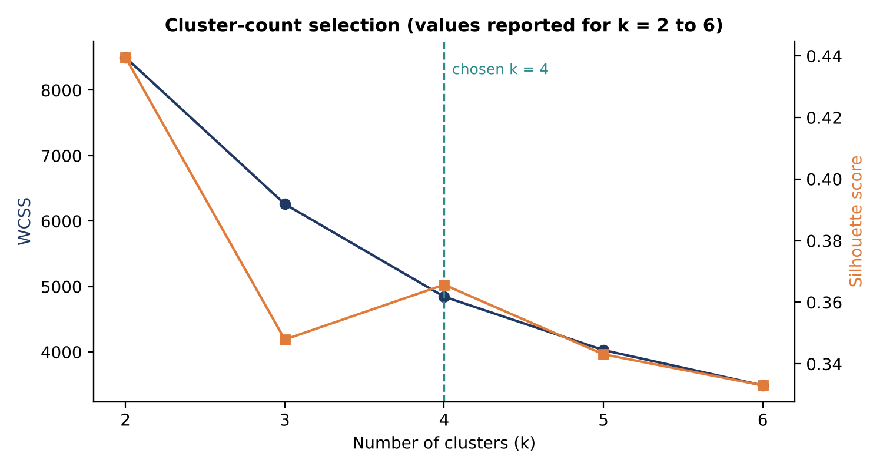
Figure 1. WCSS and silhouette by k (values as reported by the pipeline for k = 2 to 6).
Although k = 2 has the highest silhouette, it only separates active from inactive customers and offers little strategic nuance. k = 4 is a local silhouette maximum and sits at the elbow of the WCSS curve, so it balances statistical separation with business usability.
Benchmark: Hierarchical clustering
Hierarchical Agglomerative Clustering with Ward linkage at k = 4 achieved a silhouette of 0.3285, below K-Means at 0.3657. K-Means therefore provides the better-separated partition and is used for the final model.

5.6 Dimensionality reduction (PCA)
The three standardised features are projected onto two principal components to visualise cluster structure.
Component | Variance explained | Interpretation
PC1 | 76.63% | Volume axis: Frequency and Monetary spend
PC2 | 18.52% | Dormancy axis: Recency
Total | 95.14% | Two dimensions retain almost all information

6. Results

6.1 Customer segments
The final K-Means model partitions the 5,837 active, eligible customers into four behavioural segments. A fifth operational cohort of 102 defected / refund-only accounts (net negative spend) is tagged separately as cluster -1, bringing the total to 5,939 customers.
Cluster | Persona | Customers | % Cust. | Net revenue (£) | % Rev.
3 | Champions / High-Value Loyal | 1,175 | 20.13% | 12,070,863.72 | 73.68%
1 | At-Risk Customers | 1,447 | 24.79% | 2,632,123.42 | 16.07%
2 | Loyal Customers | 1,257 | 21.54% | 1,069,355.86 | 6.53%
0 | Hibernating / Churned | 1,958 | 33.54% | 610,285.02 | 3.73%
-1 | Defected / Inactive Refund | 102 | 1.72% | -23,491.50 | -0.14%

Cluster | Persona | Avg Recency | Avg Freq. | Avg Monetary (£) | Avg AOV (£) | Avg Tenure
3 | Champions | 25.6 days | 19.5 | 10,273.08 | 474.21 | 619.2 days
1 | At-Risk | 221.9 days | 5.1 | 1,819.02 | 435.95 | 575.2 days
2 | Loyal | 27.0 days | 3.1 | 850.72 | 308.76 | 283.6 days
0 | Hibernating | 391.7 days | 1.4 | 311.69 | 244.99 | 444.7 days
-1 | Refund-only | 280.4 days | 0.0 | -230.31 | 0.00 | 382.1 days

Note on revenue percentages
Revenue shares in the source report are computed against the £16.38M total of the four clustered segments. Including the -£23,491.50 from refund-only accounts, total net revenue is approximately £16.36M.

6.2 Pareto concentration
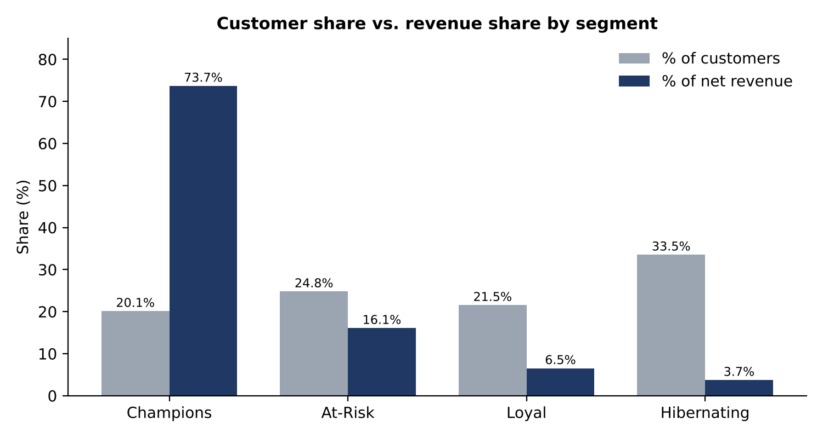
Figure 2. Share of customers versus share of net revenue by segment.
Revenue is highly concentrated: Champions are one in five customers but deliver nearly three-quarters of revenue. At-Risk customers are the second most valuable group (16.07% of revenue) and are the clearest near-term win-back opportunity because their average order value (£435.95) is close to the Champions' (£474.21) even though they have gone quiet. Hibernating customers, a third of the base, contribute under 4% of revenue.

6.3 Segment interpretation
Segment | Behavioural signature
Champions | Bought very recently (about 26 days), order often (about 19.5 orders), spend about £10.3k each and have the longest tenure.
At-Risk | Previously solid buyers (about 5 orders, £1.8k) who have not purchased for about 222 days. High AOV signals real value at stake.
Loyal | Recent (about 27 days) but newer (about 284 days tenure) with few orders so far. Growth candidates rather than established high spenders.
Hibernating | Roughly one order, lowest spend and about 392 days since last purchase. Largely lapsed.
Refund-only | Net-negative accounts where refunds exceed purchases within the dataset window.

6.4 Generated figures
The pipeline writes eight 300-DPI figures to outputs/figures/:
File | Content
monthly_revenue_trend.png | 24-month revenue trajectory with order-volume overlay
revenue_by_country.png | Top 10 countries and UK vs. international donut chart
top_products_and_customers.png | Bestselling SKUs and top-10 customer Pareto concentration
distributions_eda.png | Quantity log-distribution, customer AOV distribution, order frequency
seasonal_patterns.png | Revenue by day of week and hour of day
clustering_evaluation.png | Dual-axis Elbow (WCSS) and Silhouette for k = 2 to 8
pca_customer_clusters.png | 2D PCA projection of clusters with explained variance
segment_profiles_comparison.png | Customer vs. revenue share and Spend vs. Recency bubble map

7. Retention and Marketing Playbook
Segments are only useful if they change what the business does. The matrix below combines customer activity with value, and the table that follows gives the recommended strategy for each segment.
 | High value | Low value
Active (< 60 days) | Champions: white-glove VIP service, avoid heavy discounts | Loyal: cross-sell, tier-upgrade perks
Lapsed (> 180 days) | At-Risk: high-urgency win-back offers (up to 20%), direct sales call | Hibernating: automated clearance emails, sunset unengaged contacts

Segment | Goal | Tactics | Caution
Champions (20.1% cust. / 73.7% rev.) | Zero churn; protect VIPs | Dedicated account management, early access to seasonal lines, concierge support | Do not discount heavily; they buy on range, reliability and service
At-Risk (24.8% / 16.1%) | Reactivate before permanent loss | 3-stage win-back email series (10%, 15%, 20%), feedback survey on why ordering stopped | Escalate high-AOV accounts to a personal call
Loyal (21.5% / 6.5%) | Raise order value and frequency | Recommendations from past categories, bundle offers, free-shipping thresholds | Avoid over-discounting accounts already engaged
Hibernating (33.5% / 3.7%) | Low-cost opportunistic re-engagement | Annual clearance and outlet emails | Sunset contacts inactive over 24 months to protect sender reputation

8. How to Use the Project

8.1 Prerequisites
- Python 3.10 or newer (the project targets 3.12+; Anaconda or standard Python both work).
- Git.
- The online_retail_II.xlsx file placed at data/online_retail_II.xlsx.

8.2 Installation
- Clone the repository:
git clone https://github.com/AkashGupta004/ecommerce-customer-segmentation-analytics.git
cd ecommerce-customer-segmentation-analytics

- Create and activate a virtual environment (recommended):
Windows (PowerShell / Command Prompt):
python -m venv venv
venv\Scripts\activate

macOS / Linux:
python3 -m venv venv
source venv/bin/activate

- Install dependencies:
pip install -r requirements.txt

8.3 Running the master pipeline
python main.py

- Runs ingestion, cleaning, feature engineering, clustering, PCA and figure generation end to end.
- Runtime: about 10 to 15 seconds from cache, or about 75 seconds on the first cold run from raw Excel.
- Outputs: updates outputs/customer_segments.csv, all figures in outputs/figures/ and the audit reports in outputs/reports/.

8.4 Launching the Streamlit dashboard
streamlit run app.py

Then open http://localhost:8501 in a browser.
Feature | What it provides
Executive overview | Net revenue (£), total customers, total invoices, average order value and repeat rate.
Interactive filters | Slice by country, customer segment and a net-spend range slider.
3D RFM explorer | Plotly 3D scatter of Recency, Frequency and Monetary space.
Customer 360 drilldown | Search any Customer ID (e.g. 14911, 18102, 14646, 12346) to see RFM scores, segment badge, tenure, return rate and full line-item history.
Strategic playbook | Quantified recommendations and Pareto risk evaluation.

8.5 Running the Jupyter notebook
jupyter notebook notebooks/customer_segmentation.ipynb

The notebook walks through the analysis in sequential sections, each with executable code and accompanying markdown commentary. It is generated by build_notebook.py and can be regenerated if the analysis changes.

8.6 Output files
File | Contents
outputs/customer_segments.csv | Customer-level features, cluster labels and persona names
outputs/reports/cleaning_audit_report.json | Row counts removed at each cleaning step
outputs/reports/model_comparison.json | WCSS, silhouette and benchmark metrics
outputs/reports/segment_summary.csv | Per-segment aggregates (customers, revenue, averages)
outputs/cleaned_transactions.parquet | Cleaned transactions (returns retained) for fast dashboard load
outputs/raw_combined_cache.parquet | Cache of the full combined raw dataset

9. How to Replicate the Results
Follow these steps to reproduce the reported numbers, then use the checklist to confirm your run matches.
- Install the environment as described in Section 8.2.
- Place the original Online Retail II workbook at data/online_retail_II.xlsx without modification (both sheets intact).
- Run python main.py. The first run reads from Excel and builds the Parquet caches.
- Open outputs/reports/cleaning_audit_report.json and compare against the cleaning checkpoints below.
- Open outputs/reports/model_comparison.json and outputs/reports/segment_summary.csv and compare against the model and segment checkpoints.
- Optionally launch the dashboard and confirm the headline metrics and Customer 360 lookups.

Verification checklist
Checkpoint | Expected value
Raw rows (both sheets combined) | 1,067,371
After removing missing Customer IDs | 824,364
After removing exact duplicates | 797,885
After removing non-positive prices | 797,815
Credit-note rows retained | 18,390
Reference date | 2011-12-10 12:50:00
Skewness after log(1+x): R / F / M | -0.47 / 1.00 / 0.26
K-Means k = 4: WCSS / Silhouette | 4,845.9 / 0.3657
Hierarchical (Ward) k = 4 silhouette | 0.3285
PCA variance: PC1 / PC2 / total | 76.63% / 18.52% / 95.14%
Champions: customers / revenue share | 1,175 (20.13%) / 73.68%
Clustered customers + refund-only | 5,837 + 102 = 5,939

Replication notes
Cluster ID numbers (0 to 3) are arbitrary labels from K-Means, so the persona names, sizes and averages matter rather than the integer IDs. If you change the dataset version, the reference date, the cleaning rules or library versions, small numeric differences are possible. Keep the reference date and cleaning order unchanged to match the published figures.

Replicating on your own data
- Provide a transaction table with the same eight columns, especially Invoice, Quantity, InvoiceDate, Price and Customer ID.
- Update the reference date in the RFM step to one day after your latest transaction.
- Re-run the k = 2 to 8 evaluation rather than assuming k = 4; the best k depends on the data.

10. Limitations and Future Work

10.1 Limitations
- Unidentified checkouts: 22.8% of transactions lacked a Customer ID and cannot be linked to longitudinal customer personas.
- Revenue, not margin: the analysis uses net revenue. Without Cost of Goods Sold, segments cannot be ranked by profitability.
- Moderate cluster separation: a silhouette of 0.3657 indicates meaningful but overlapping segments, which is typical for behavioural data with no hard boundaries.
- Single retailer, two-year window: results reflect one business and period; seasonality and external events are not modelled.

10.2 Future roadmap
- Predictive CLV: BG/NBD and Gamma-Gamma models to forecast 90-day purchase probability and future value.
- Market basket mining: FP-Growth to find co-purchased item pairs for recommendation engines.
- CRM integration: sync segment tags automatically with Klaviyo, Mailchimp or Salesforce Marketing Cloud.

11. Conclusion
The project shows that a carefully audited, skew-corrected RFM representation combined with K-Means can turn a large transaction log into four clear customer segments with very different commercial importance. The finding that one in five customers drives roughly three-quarters of revenue gives marketing and account teams a concrete basis for prioritising retention spend, while the modular code, cached pipeline, notebook and dashboard make the analysis straightforward to rerun, inspect and extend.

License: MIT. Dataset: UCI Machine Learning Repository, Online Retail II.

