ERROR DETECTION IN A MULTI USER REQUEST SYSTEM USING ENHANCED CRC ALGORITHM:

ABSTRACT:

Communication is an important part of our lives and errors in communications have to be corrected at the earliest to avoid damage, especially if the communication involves machines as even the slightest of mistakes can be costly for an overall project. This paper aims to perform error detection and correction for messages sent by different users across a multi user request system by using Cyclic Redundancy Check(CRC). The CRC algorithm has been enhanced to detect all burst errors up to a length of 5 as well as finding the CRC for a particular message in a faster manner.

INTRODUCTION:

Errors in data gives rise to a lot of problems when the data is used for some calculations. It makes the data unreliable. For a series of computations, error in one stage can accumulate to other stages. Therefore it is necessary that the error be detected at the earliest stage to cut down the loss of damage and cost.Many communication channels are subject to channel noise, and thus errors may be introduced during transmission from the source to a receiver. Error detection techniques allow detecting such errors, while error correction enables reconstruction of the original data .
A multi – user request system is a system that allows multiple users on different computers or terminals to access a single system with one OS on it. These systems need to be properly managed to coordinate the users connected to it. The connected users can access shared data and processes present on the system. This system must be able to handle the various needs and requests of all of the users effectively and efficiently.In a multi-user request system, for example, the system may need to handle numerous users attempting to use a single resource simultaneously. The system processes the requests and places the task in a queue that keeps them organized and allows each job to be carried out one at a time. Without a multi-user request system, the jobs or data management could become intermingled and the resulting information pages would be virtually incomprehensible and error prone.
A) Error : An error is the difference between a computed or measured value and a true or theoretical value. It is the mismatching which takes place between the data unit sent by the transmitter and the data unit received by the receiver. For example, if 101101 is the data sent and 111101 is received, then the 2nd bit from the left has an error.
Types of errors :
1) single bit error : If data received differs from the data sent by just 1 bit , it is a single bit error.
2) Burst Error : If the data received differs from the data sent by 2 or more bits, there is a burst error. With respect to burst error we define burst length – The maximum number of consecutive bits received that can have an error.
Example , if sent message is 1011001 and received is 1000101, then bits 2,3 and 4 contain error. It has a burst length of 3. But even the received message 1001101 also has a burst length of 3 even though only bits 2 and 4 are corrupted.

B) Common Error Detection Methods :
The most common method of detecting errors is by using some form redundancy.
Redundancy : is some extra bits or data that is sent along with the actual message for the purpose of error control at the receiver end.
1) Vertical Redundancy Check : This error detection technique involves generation of a parity bit in the transmitter side. This bit is then appended with the message and transmitted. There are 2 types of parity: even parity and odd parity. Both involve counting the number of 1s present in the message.
even Parity : if The number of 1s is odd, an extra 1 is appended as the parity bit, else a 0 is appended.
odd parity : if the number of 1s is even. An extra 1 is appended as parity bit, else a 0 is appended.
At receiver side, the same operation of finding the parity bit is done ,for the case of even parity, if the resultant parity found here is 0 , then is no error in the message or even number of bits have an error. If it is 1, then there is a single bit error or an odd number of bit errors.
Example, consider message : 1011010. The number has 4 1s. Considering even parity, parity bit = 0. Therefore sent message is : 10110100. At receiver side, no of 1s now =4, hence parity to be added = 0, which means no error exists. Suppose data received was 11110100, number of 1s now is 5 and parity to be added at receiver side is = 1 which shows a single bit error.

2) Longitudinal Redundancy Check : if the message to be sent is in the form of segments ,say of each 8 bits. Then they can be considered row after row and a parity bit can be found for each digit position considering all the bits of the segment at that position, based on either even or odd parity.This obtained 8 bit Parity bits is appended as the last segment and sent. At the receiver side, same operation is performed on the received segments and if the 8 bit parity is obatined is all 0s, there is no error.
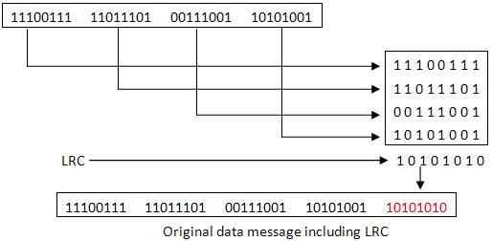
Example, consider, the message sent is form 8 bit segments and an even parity scheme is followed.
At the receiver end the same operation of finding parity is done for all 5 segments. This error detection technique can detect single bit errors along with their bit positions. It can also detect burst errors with their positions as long as the error bits doesnt occur in the same digit position.

3)Cyclic Redundancy Check : In this error detection technique , a pre-decided n bit divisor is chosen,and n-1 0s are appended to the given message. This is then divided by the divisor (2 bit modulo division), to obtain a remainder. The message appended with the remainder is sent by the transmitter. At the receiver end, The received data is divided by the same divisor and the remainder is noted. If this remainder happens to be 0, there is no error in the message ,else an error occurs. Detection of single bit and burst errors in CRC involves choosing a divisor that satisfies many conditions. In this paper, an accepted divisor is chosen and an enhanced version of the algorithm is given which finds the CRC remainder in a faster manner and also can detect burst errors up to a length of 5. It is loosely based on the logic behind Hamming Code.

4) CheckSum Method : For large messages, the data is split up into n segments each of k bits. If the message length is not perfectly divisible by n, some 0s can be appended to the last segment. These segments are then added (normal binary addition.). Any carry obtained is added back to the least significant bit of the sum. Now, 1s complement of this sum is found and is the checksum. This checksum is appended to the n segments of data as the (n+1)th segment and then transmitted. At the receiver end, The same operation is performed on the received (n+1) segments. If the checksum so obtained consists of all bits as 0s, then no error is present in the message. This technique can be used to detect single bit errors and burst errors.
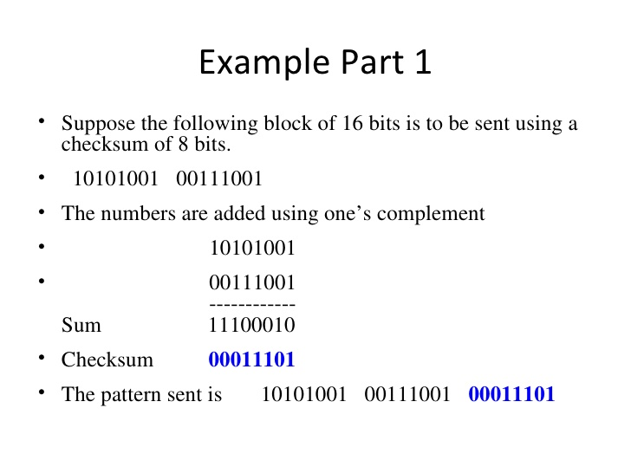

ANALYTICAL FINDINGS:

Data or database is said to be defective or error prone if there is any form of inconsistency in the content of data sent and the data stored in the database. Error or defect detection analysis reduces the time, resource, and cost required to rework, re-store and retransmit data within a multi-user database environment. Early data defect detection prevents data defect migration to archives or other repository of the data store. It also enhances reliability and maintenance of stored data in the database. Hence there is a continuous need to test data in the database and data that are backed up before they are archived [15]. In is not ideal to restore untested backup or to wait till there is need for database restore before data can be backed up.
As a result, in this paper, we have chosen a database to be our multi user-request system in the implementation of the error control. The error detected technique is applied on the data received from the database to prevent any errors that may have crept up during storing of data into the database.

ANALYSIS AND DESIGN OF THE CRC ERROR DETECTION TECHNIQUE:

In our implementation of the algorithm, to detect burst errors, we split the given message into 5 segments columnwise,i.e if the message given by user is 11010101. we split it as
11
10
01
1
0
This splitting up is done so that if we do have a burst error in the message of say length 5, the 5 bits that are corrupted will be part of different rows of data, as we filled the data columnwise into the matrix. Therefore now the rows can be detected for single bit error using CheckSegmentData function given later in the paper.

so now we have 5 rows of data. Each row is taken as an individual message it is supplied to a CRCGenerator function that takes the row as message and generates the CRC remainder for it using the following algorithm :
CRCGenerator :
Step 1: Start
Step 2: Initialize the CRC register to all 0-bits
Step 3. Hash message for operations.
Step 4: Get first/next message bit m.
Step 5: If the high-order bit of CRC is 1,
Step 6: Shift CRC and m together left 1 position, and XOR the result with the low-order r bits of G. Otherwise,
Step 7: Just shift CRC and m left 1 position.
Step 8: If there are more message bits, go back to get the next one else Go to Step 3.
Now each row has a crc remainder appended to it. These 5 rows of data are then transmitted to the receiver. At the receiver end, The the 5 segments of data are then passed to a CRCChecker to first check if there is any error in any of the segments.
Sent message :
1100011010
1010010111
0110001101
110001101
000000000

CRCChecker:
step1: start
step2: Take each of the 5 received segments ,divide each by the common divisor using the same logic as the CRCGenerator function to find the CRC remainder for each.
Step3: If any of the CRC remainders obtained for any segment > 0, call CheckSegmentData() on those segments to find the positions of error in the segment.else go to step 4.
Step 4: If all of the CRC remainders are equal to zero, print “NO error in received message”.

CheckSegmentData:
This function is called only if any of the segments have a positive CRC remainder obtained at receiver end. It takes the segment as parameter and finds the position of error using :
step 1 : Start
step 2: Note the length of the data.
Step 3:take new strings as 10000,01000,00100,00010,00001 if the message length is 5(for example) and find the CRC remainder for each.
Step 4: Which ever CRC reminder matches that of the Data passed to function will decide the bit position of error in the data,i.e if 10000 CRC remainder is same as that of Data, there is an error in the 1st bit of the data.

Using the overall number of errors and their bit positions knows, correcting that is easy and is done to display the actual corrected message.

IMPLEMENTATION:

In our implementation, we have taken a database as a multi user request system. This database is a mysql database hosted on an Apache server like WAMP.
We have a c++ program that takes a message from a user and generates the 5 segments of data ,each with appended CRC and outputs this to a file.
This file is then uploaded to the server via a PHP script that reads the contents of the file line by line and sends it to the database along with the sender’s ip address. There a web page for this uploading process.
Whoever wants to request for some messages sent by another user, can open another Web page and type the ip address of the person who sent the data and request for those messages. The PHP script then takes this ip , checks the database for messages by that user, writes the corresponding messages to a file and is served up to the user. Some of the lines of data are randomly corrupted to show the error control the receiver side.
Once the file has been downloaded by the receiver user he can run the same c++ program which contains the checker functions to check for errors in the sent messages. If there are any errors then the actual corrected messages are displayed to the user.
Screenshots:

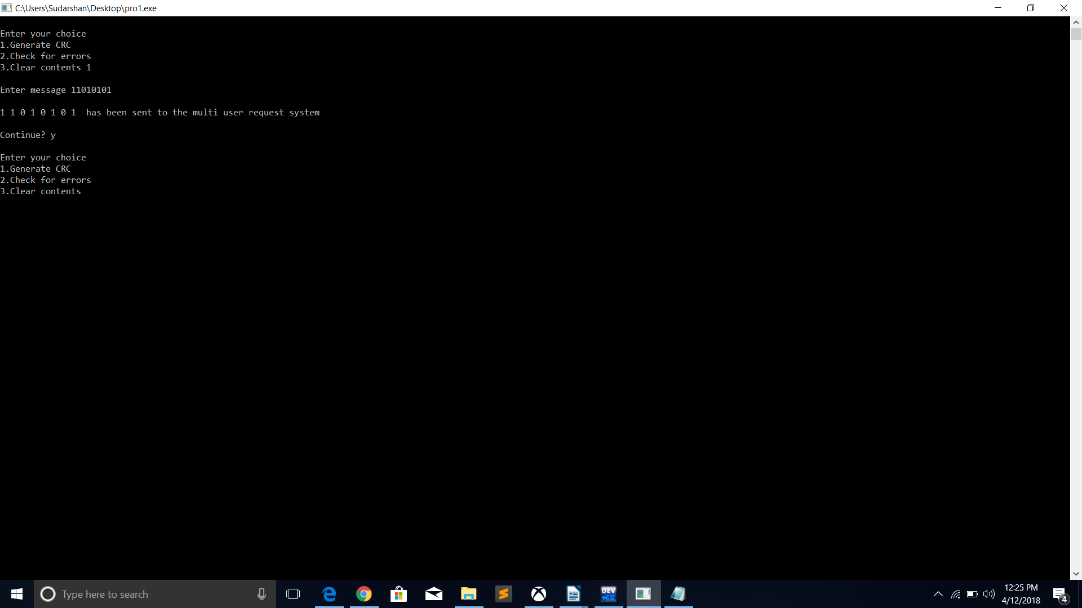





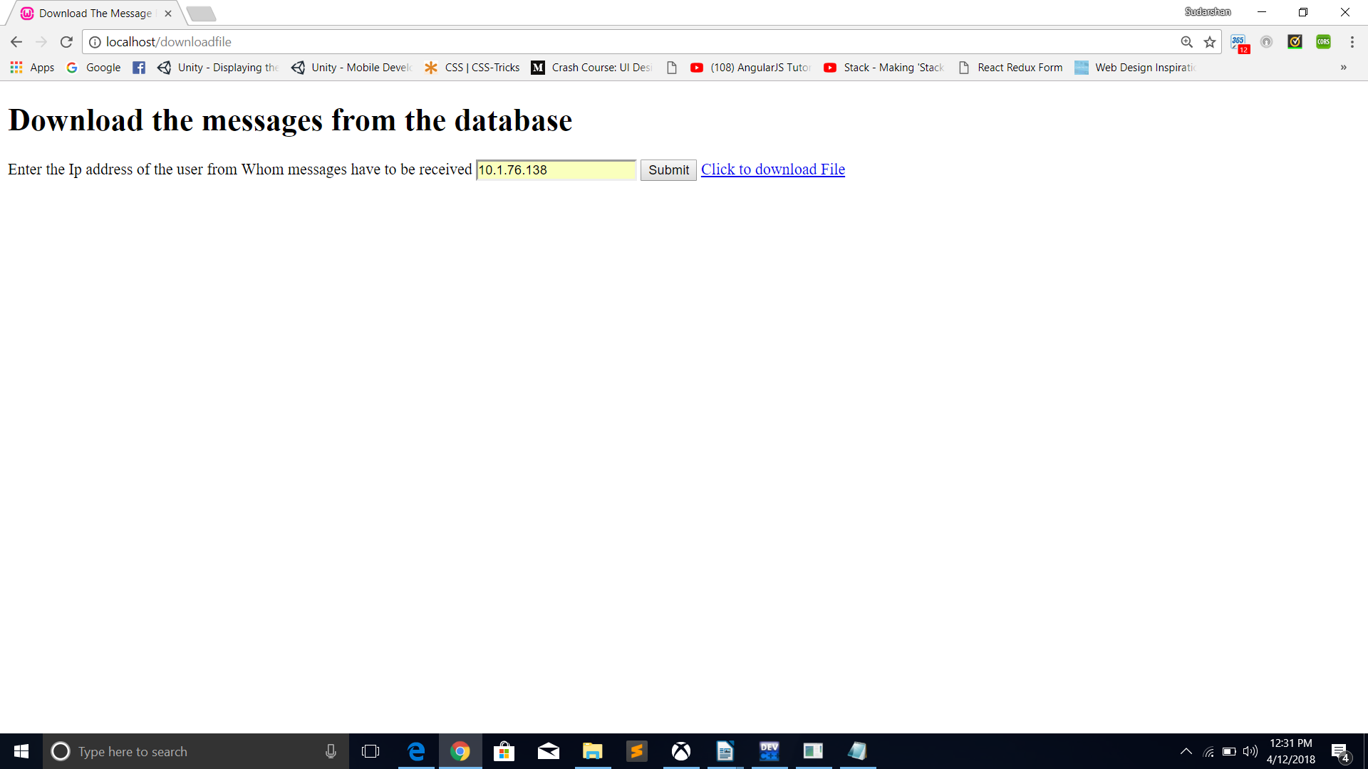

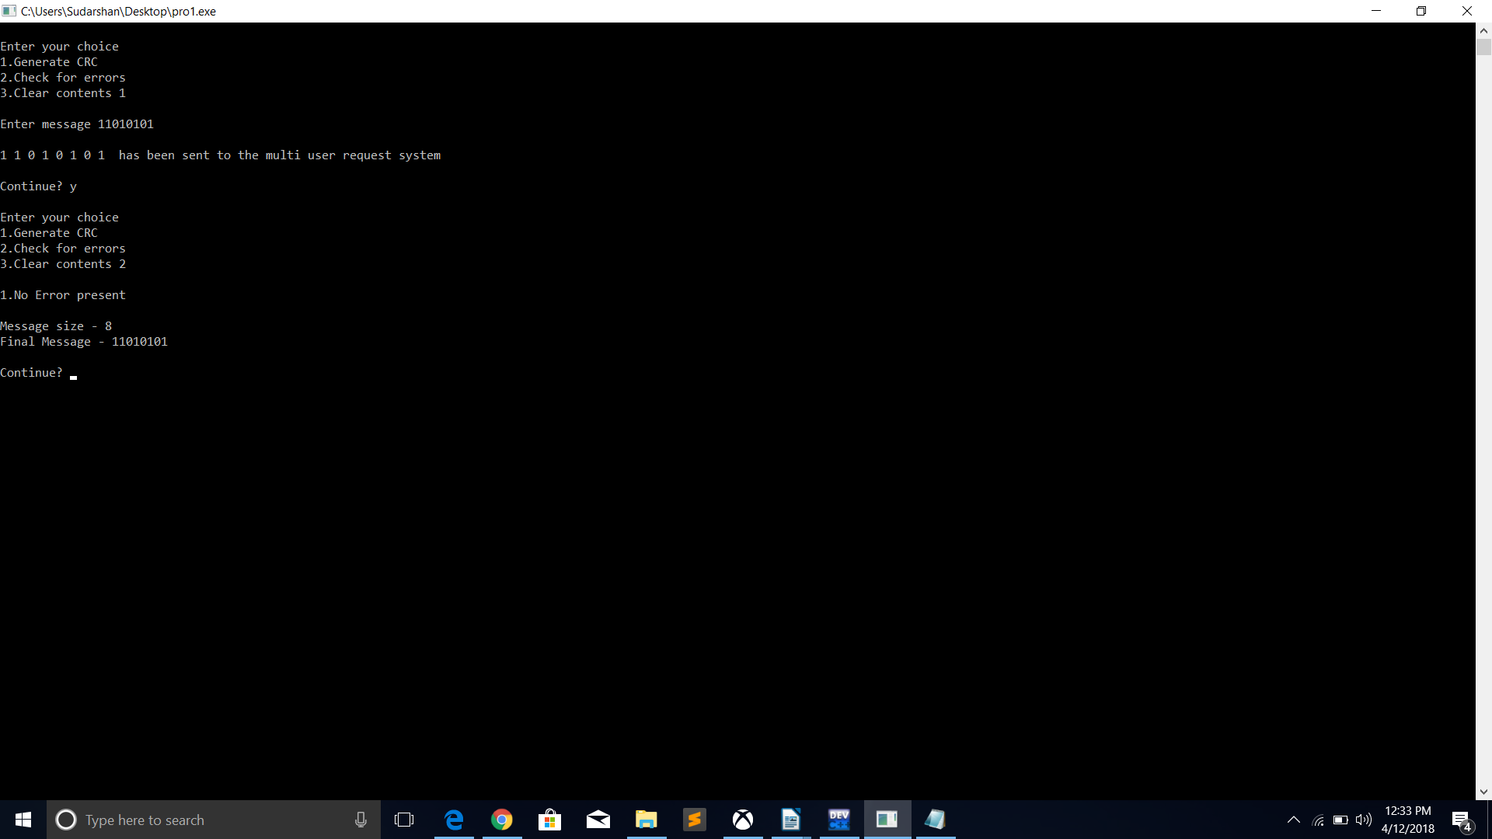

CONCLUSION:

In This paper, we have focused on the error detection and control in a multi user-request system as this system involves many users requesting the system for information, errors in the working of the system can lead to miscommunication among all the connected users.
We have designed a CRC algorithm loosely based on hamming code to detect burst errors in the messages received by the user when requested from the multi user request system.

