

**Survey Data Analysis Insights**



* People aged 20-30 mostly prefer watching matches occasionally rather than every day.
* While both males and females in this age group watch matches occasionally, there is a higher count of female occasionally watch compared to males.



* People aged 20-30, both men and women, prefer watching cricket matches at home instead of on mobile, in stadiums, or at cafés.



* The favourite team among both males and females in 20-30 age group is the Indian cricket team.



* Across the 20-30 age Group, Rohit Sharma is considered the best opener, suggesting he has much popularity

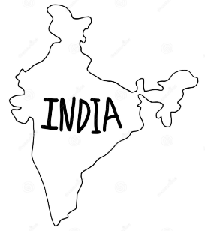

* All males in the 20-30 age group think that India's will win match, which means they support Indian team.