**MINI-PROJECT REPORT**

**On**

**WEB APPLICATION FOR**

**PREDICTING HOUSING PRICES**

## **B.E (IT) – IV Semester by**

**Akash Kanteti (160119737042)  
Pramod Ambati (160119737043)**

### Under the guidance of

**Smt. T. Satya Kiranmai**

**Assistant Professor**



## DEPARTMENT OF INFORMATION TECHNOLOGY

## CHAITANYA BHARATHI INSTITUTE OF TECHNOLOGY (A)

**(Affiliated to Osmania University; Accredited by NBA(AICTE) and NAAC(UGC), ISO Certified 9001:2015)**

### KOKAPET(V), GANDIPET(M), RR District HYDERABAD -75

**Website:** [**www.cbit.ac.in**](http://www.cbit.ac.in/)

## 2020-2021





**CERTIFICATE**

This is to certify that the project work entitled “**WEB APPLICATION FOR PREDICTING HOUSING PRICES**” submitted to CHAITANYA BHARATHI INSTITUTE OF TECHNOLOGY, in partial fulfillment of the requirements for the award of the completion of III semester of B.E in Information Technology, during the academic year 2020-2021, is a record of original work done by **Akash Kanteti(160119737042), Pramod Ambati(160119737043)** during the period of study in Department of IT, CBIT, HYDERABAD, under our guidance.

#### Project Guide Head of the Department Faculty Name:

#### Smt.T.Satya Kiranmai Dr.Radhika

Assistant Professor, Dept. of IT, Professor, Dept. of IT,

CBIT, Hyderabad. CBIT, Hyderabad.

**ACKNOWLEDGEMENT**

We would like to express our heartfelt gratitude to Smt. T.Satya Kiranmai, our project guide, for her invaluable guidance and constant support, along with her capable instruction and persistent encouragement.

We are grateful to our Head of the Department, Dr. Radhika, for her steady support and for the provision of every resource required for the completion of this project.

We would like to take this opportunity to thank our Principal, PROF G.P SARADHI VARMA, as well as the management of the institute, for having designed an excellent learning atmosphere.

**PREFACE:**

As the students of H1 of a very prestigious engineering college in Hyderabad, Chaitanya Bharathi Institute of Technology, and to expand our knowledge beyond the classroom and the books, we are glad to work on our second Minor Project, “WEB APPLICATION FOR PREDICTING HOUSING PRICES”. The following pages include a detailed solution, which is the fully executable code in HTML, CSS and Machine Learning, the possible test cases and  
detailed information about how to predict housing prices.

**Akash Kanteti**

**Pramod Ambati**

**LETTER OF TRANSMISSAL**

16th May, 2021

Smt. T.Satya Kiranmai

Assistant Professor

Department of Information Technology

CBIT, Hyderabad

Telangana.

Respected Madam,

We, the students of H1, are grateful to take this opportunity to submit this report on our minor project, “WEB APPLICATION FOR PREDICTING HOUSING PRICES”, that we have chosen.

This document shows the detailed information and code about predicting the housing prices. We have strictly followed the instructions given to us and we hope, this report document meets all the requirements.

Sincerely,

Akash Kanteti (160119737042)

Pramod Ambati (160119737043)

**ABSTRACT**

Real estate is the least transparent industry in our ecosystem. Housing prices keep changing day in and day out and sometimes are hyped rather than being based on valuation. Predicting housing prices with real factors is the main crux of our research project. Here we aim to make our evaluations based on parameters that are considered while determining the price. In this project, we present a Web application that can generate predictions for future housing prices. We use flask as our web framework and html, CSS for frontend and ML based Algorithm for this project.

Akash Kanteti (160119737042)

Pramod Ambati (160119737043)

**TABLE OF CONTENTS:**

|  |  |  |
| --- | --- | --- |
| **S.no** | **TOPICS** | **Page. No** |
|  | **Certificate** | ii |
|  | **Acknowledgement** | iii |
|  | **Preface** | iv |
|  | **Letter of Transmissal** | v |
|  | **Abstract** | vi |
|  | **Contents** | vii |
| **1** | **Introduction**   * 1. Motivation   2. Objective of the project   3. Process |  |
|  | 8 |
|  | 8  8 |
| **2** | **Existing system’s disadvantage**  **Solution using proposed system.**  **Requirements** | 9 |
|  | 9 |
|  | 9 |
|  |  |
| **3** | **Implementation (code) and Screenshots of output** |  |
|  |  |
|  | 10 – 19 |
|  |  |
| **4** | **Conclusion** | 20 |
| **5** | **Bibliography** | 20 |

**INTRODUCTION**

* 1. **MOTIVATION**

Real estate is the least transparent industry in our ecosystem. Housing prices keep changing day in and day out and sometimes are hyped rather than being based on valuation. Predicting housing prices with real factors is the main crux of our research project.

* 1. **OBJECTIVES OF THE PROJECT**

The phenomenon of the falling or rising of the house prices has attracted interest from the researcher as well as many other interested parties. So, we developed this application in a minimal way such that everyone interested in real estates can use this application.

**1.3 PROCESS**

When we click on the link <http://127.0.0.1:5000/> we were sending GET request to the server (flask application), then it returns a landing page. After providing the requirements through form input, we can click submit on landing page. Then the form input is given to server which then computes estimated price using ml model that we have trained, after the prices is calculated it is then displayed in a new html page.

**EXISTING SYSTEM’S DISADVANTAGE:**

Before buying any property, anyone would like to consult brokers, real-estate managers, house rental sites etc. These may not be free or not available some time or may be inaccurate.

**SOLUTION USING PROPOSED SYSTEM:**

Housing prices keep changing day in and day out and sometimes are hyped rather than being based on valuation. Predicting housing prices with real factors is the main crux of our project. We build it in a minimal way for predicting housing prices so that naïve user can also understand how to make use of the application.

**REQUIREMENTS:**

**Software Requirements:**

* Python version 3.6
* Flask
* ML based libraries
* Any text editor (e.g., atom)
* Web browser (e.g., chrome, safari etc.)
* Jupyter notebook (Anaconda optional)

**Hardware Requirements:**

* Modern system RAM is sufficient
* Disk space of 200 MB (approx.)

**CODE:**

*Frontend: HTML, CSS*

*Backend: Machine learning*

**Code snippets:**

**//cleaning and training**

import pandas as pd

import numpy as np

import pandas as pd

import seaborn as sns

import matplotlib.pyplot as plt

from sklearn.linear_model import LinearRegression

from sklearn.metrics import mean_squared_error

from sklearn.metrics import r2_score

import joblib

from sklearn.datasets import load_boston

boston_dataset=load_boston()

boston=pd.DataFrame(boston_dataset.data,columns=boston_dataset.feature_names)

boston.head()

boston['MEDV']=boston_dataset.target

X=pd.DataFrame(np.c_[boston['LSTAT'],boston['RM']],columns=['LSTAT','RM'])

Y=boston['MEDV']

from sklearn.model_selection import train_test_split

X_train, X_test, Y_train, Y_test = train_test_split(X, Y, test_size = 0.2, random_state=5)

print(X_train.shape)

print(X_test.shape)

print(Y_train.shape)

print(Y_test.shape)

lin_model = LinearRegression()

lin_model.fit(X_train, Y_train)

y_train_predict = lin_model.predict(X_train)

rmse = (np.sqrt(mean_squared_error(Y_train, y_train_predict)))

r2 = r2_score(Y_train, y_train_predict)

print("The model performance for training set")

print("--------------------------------------")

print('RMSE is {}'.format(rmse))

print('R2 score is {}'.format(r2))

print("\n")

# model evaluation for testing set

y_test_predict = lin_model.predict(X_test)

rmse = (np.sqrt(mean_squared_error(Y_test, y_test_predict)))

r2 = r2_score(Y_test, y_test_predict)

print("The model performance for testing set")

print("--------------------------------------")

print('RMSE is {}'.format(rmse))

print('R2 score is {}'.format(r2))

# Save the model as a pickle in a file

joblib.dump(lin_model, 'trained_model.pkl')

**//Landing page**

<!DOCTYPE html>

<html lang="en" dir="ltr">

<head>

<title>Bootstrap Example</title>

<meta name="viewport" content="width=device-width, initial-scale=1.0">

<link rel="stylesheet"

href="https://maxcdn.bootstrapcdn.com/bootstrap/3.4.1/css/bootstrap.min.css">

<script src="https://ajax.googleapis.com/ajax/libs/jquery/3.5.1/jquery.min.js"></script>

<script src="https://maxcdn.bootstrapcdn.com/bootstrap/3.4.1/js/bootstrap.min.js"></script>

<style>

.hi{

background-color: #1abc9c;

padding-left: 10px

}

.containerd

{

text-align:center;

font-size: 60px;

text-shadow: 4px 2px #4d3664;

color: white;

bottom:15px;

}

.conatiner-fluidd{

font-size: 40px;

padding-top: 10px;

padding-left: 100px;

padding-right: 100px;

text-align: left;

text-shadow: 1px 2px #c7004c;

color:#ffaaaa;

}

.form-groups{

font-size: 22px;

padding-top: 30px;

padding-left: 200px;

padding-right: 200px;

top: -340px;

width: auto;

position: relative;

}

.kin{

width: 400px;

}

.submit{

border: 2px solid red;

font-size: 24px;

padding: 5px 24px 5px 24px;

top: -400px;

}

.submit:hover{

border:4px solid green;

color:white;

background-color:#c7004c;

}

.divsubmit{

padding-top: 55px;

padding-left: 330px;

position: relative;

top: -300px;

}

.house{

vertical-align: top;

padding-bottom: 10px;

max-width: 100%;

}

div.polaroid{

box-shadow: 5px 5px 5px #aaaaaa;

width: 500px;

position: relative;

left:800px;

padding: 10px 10px 10px 10px;

border: 1px solid #BFBFBF;

background-color: white;

}

.p-middle{

text-align: center;

}

.footer {

position: fixed;

left: 0;

bottom: 0;

width: 100%;

background-color: #ffaaaa;

color: black;

text-align: center;

}

</style>

</head>

<body class=hi>

<div class="containerd">

<h1 class="containerd">Web application for Predicting housing prices</h1>

</div>

<div class="conatiner-fluidd">

<h4 class="conatiner-fluidd">Enter the following details</h4>

</div>

<div class="polaroid">

<img class="house" src="{{ url_for('static', filename='house.jpeg') }}" alt="" style="max-width:100%;height:auto;">

<p class="p-middle" style="font-size:20px">Home is a place only one can rest</p>

</div>

<form class="form-horizontals" method="post">

<div class="form-groups">

<label for="%low">% of lower status of the population</label>

<input type="number" min="0" step="any" class="form-control kin" name="low" placeholder="Enter % of lower class" id="Age">

<p style="padding-top:20px"></p>

<label for="No of rooms">Avg no of rooms per house</label>

<input type="number" min="0" step="any" class="form-control kin" name="nor" placeholder="Enter no of rooms"id="No of rooms">

</div>

<div class="divsubmit">

<button type="submit" class="submit">Estimate</button>

</div>

</form>

<div class="footer">

<p style="padding-top:10px">Developed by Akash Kanteti and Pramod Ambati</p>

<p>contact info: ak4523@gmail.com</p>

</div>

</body>

</html>

**//Output page**

<!DOCTYPE html>

<html lang="en" dir="ltr">

<head>

<meta charset="utf-8">

<title></title>

<style media="screen">

body{

background-color: #1abc9c;

margin-top: 100px;

}

.shadow1 {

max-width: 60%;

background-color: #3B2B5B;

box-shadow: 5px 5px rgba(0, 98, 90, 0.4),

10px 10px rgba(0, 98, 90, 0.3),

15px 15px rgba(0, 98, 90, 0.2),

20px 20px rgba(0, 98, 90, 0.1),

25px 25px rgba(0, 98, 90, 0.05);

}

h1{

text-align:center;

font-size:50px;

height: auto;

width: 600px;

margin-left: auto;

margin-right: auto;

padding: 20px;

text-shadow: 4px 2px #4d3664;

color: white;

}

p{

text-align:center;

font-size:60px;

text-shadow: 1px 2px #c7004c;

color:#FEE6C0;

width: 600px;

height: auto;

margin-left: auto;

margin-right: auto;

padding: 20px;

}

</style>

</head>

<body>

<h1 class="shadow1">Estimated Value is</h1>

<p>{{ans}} dollars</p>

</body>

</html>

**//finalapp**

from flask import Flask,render_template,request

from sklearn.linear_model import LinearRegression

import math

import joblib

import numpy as np

import pandas as pd

app = Flask(__name__)

@app.route("/",methods=["POST","GET"])

def hello():

if request.method=="POST":

data=[[request.form['low'],request.form['nor']]]

lin_model_from_joblib = joblib.load('trained_model.pkl')

# Use the loaded model to make predictions

dft=pd.DataFrame(data)

x=(lin_model_from_joblib.predict(dft)[0])*1000

return render_template("output.html",ans=round(x,2))

else:

return render_template("my.html")

if __name__ == "__main__":

app.run(debug=True)

**RESULTS:**

**Landing page**

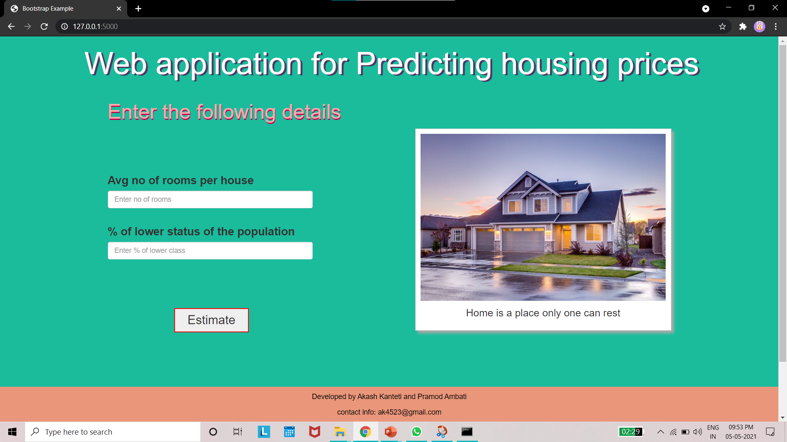

**Output page**

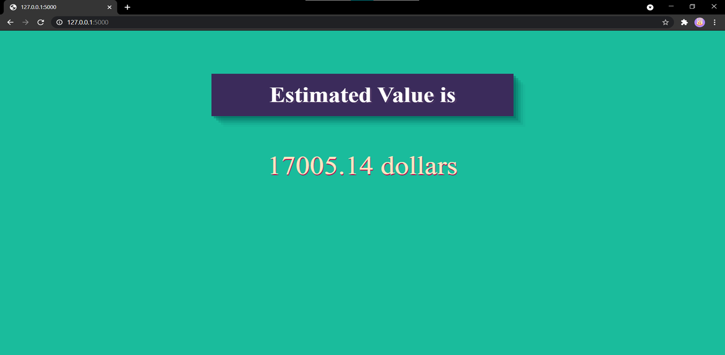

**CONCLUSION:**

The phenomenon of the falling or rising of the house prices has attracted interest from the researcher as well as many other interested parties. So, we developed this application in a minimal way such that everyone interested in real estates can use this application.

**BIBLIOGRAPHY:**

* **W3School**
* [**https://towardsdatascience.com/a-data-science-web-app-to-predict-real-estate-price-d2366df2a4fd**](https://towardsdatascience.com/a-data-science-web-app-to-predict-real-estate-price-d2366df2a4fd)
* [**https://ieeexplore.ieee.org/abstract/document/8473231**](https://ieeexplore.ieee.org/abstract/document/8473231)
* **Stack overflow**
* **FreeCodeCamp**