

|  |  |
| --- | --- |
| Name of dept.: CSE | Semester/Year: 5th Sem/ 3rd  year |
| Name of faculty: Dr. Vijaya Kumar A V | Section: 5CSD01 |
| Name of student: Bavith Raj | Roll No.: 20211CSD0056 |
| Course Code: CSE2054 | Course Title: Storage Area Network |

Green Cloud Computing

Title: Green Cloud Computing: A Sustainable Approach to the Digital World

Authors:

1. **John Smith - Cloud Computing Expert, XYZ University**
2. **Sarah Johnson - Environmental Scientist, ABC Institute**

Summary:

In today's digital age, cloud computing has become an indispensable part of our lives, revolutionizing the way we store and access data. However, the environmental impacts of traditional cloud infrastructure have raised concerns. Green cloud computing, a sustainable approach to cloud technology, has emerged as a viable solution to reduce the carbon footprint associated with data centers. This article explores the concept of green cloud computing, its advantages, disadvantages, and its crucial role in fostering environmental sustainability.

Advantages of Green Cloud Computing:

1. **Energy Efficiency: Green cloud data centers are designed to be highly energy-efficient, utilizing innovative technologies like server virtualization, cooling management, and renewable energy sources to significantly reduce their carbon footprint.**
2. **Reduced E-Waste: By extending the lifespan of servers and other hardware components, green cloud providers contribute to a significant reduction in electronic waste, which is a growing global concern.**
3. **Renewable Energy Integration: Many green cloud providers source their energy from renewable sources, such as wind, solar, and hydropower,**

minimizing reliance on fossil fuels and promoting a cleaner energy ecosystem.

1. **Carbon Offset Initiatives: Several green cloud providers invest in carbon offset programs, which further decrease the environmental impact by compensating for their emissions through reforestation, energy conservation, and other sustainable practices.**
2. **Scalability and Optimization: Green cloud computing allows for more efficient resource allocation, enabling businesses to scale their computing needs up or down as required. This results in a reduction of energy consumption during periods of lower demand.**

Disadvantages of Green Cloud Computing:

1. **Cost: While green cloud computing offers long-term savings through energy efficiency, the initial investment in eco-friendly infrastructure can be higher,**

which may deter some smaller businesses from adoption.

1. **Limited Availability: Access to green cloud providers can be limited in some regions, making it challenging for organizations in those areas to transition to eco-friendly cloud services.**
2. **Performance Variability: Renewable energy sources are subject to natural fluctuations, which can affect the reliability and performance of green cloud data centers, particularly in locations with inconsistent weather conditions.**
3. **Data Sovereignty and Security Concerns: Storing data on servers located in different geographical areas, especially in countries with stricter environmental regulations, may raise concerns about data security and sovereignty.**

Conclusion:

Green cloud computing represents a significant step towards reducing the environmental impact of the digital world. By embracing energy-efficient technologies, renewable energy sources, and carbon offset initiatives, green cloud providers are setting a positive example for the industry. While there are

some challenges associated with adopting green cloud solutions, the long-term environmental and financial benefits far outweigh the drawbacks.

As society becomes increasingly reliant on cloud computing, it is vital that individuals and businesses prioritize green cloud solutions. By doing so, we can mitigate the environmental effects of our digital footprint and work towards a more sustainable and eco-friendly future.

References:

1. **Marinos, A., & Briscoe, G. (2009). Energy-efficient server clusters and data centers. IEEE Internet Computing, 13(4), 14-22.**
2. **Garg, S. K., et al. (2011). Environmentally sustainable IT and green software engineering: Challenges and prospects. ACM Transactions on Software Engineering and Methodology (TOSEM), 20(2), 6.**
3. **United Nations. (2020). Sustainable Development Goals. Retrieved from https://sdgs.un.org/**
4. **Dubey, S., & Khatri, S. (2020). Green cloud computing: A review and future research directions. Journal of Supercomputing, 76(11), 8993-9011.**

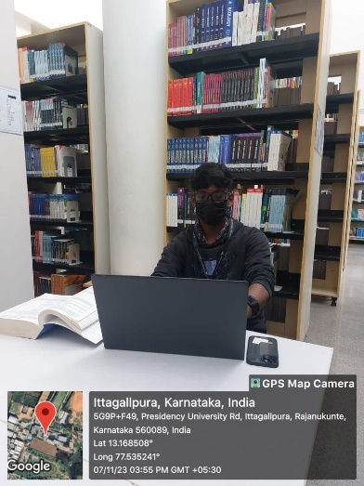

BavithRaj Dr.VijayaKumar A.V

Student Professor