**Solar Powered, Remote Controlled, Smart Garden using Raspberry Pi**

AKASH ,DARSHAN M.S ,KARTHIK K.J,JOYCE A,KAVYA JAI SHREE

Computer Science and Engineering

***Abstract*-** - In India most of people is doing work related agriculture directly or indirectly. An economy of India is mostly affected by agriculture related activities. To check water level of well, farmer have to go to farm and start water pump. Sometimes he has to go in night. If fire is spread in farm how farmer can know? If he know about it, he cannot do anything about it because many plants burned .In this paper, we made one smart irrigation system which will notify farmer on his registered mobile device and email address, if the soil is dry and it need watering, using soil moisture sensor and also notify by glowing bulb and start motor which is attached with main controller. System is also measuring the water level of well and notify the farmer two times a day. For fire detection we used flame detection sensor and if fire is there in farm system will notify the farmer and also bugger will blow.

1. **Introduction**

One of the key activity smart farming is skills and times. Farmers should know at which time which plant will grow better. Cultivation takes huge amount of time and also money from farmer. So reducing the effort of the farmers is heavy task. It need various resource in large scale. To use modern technologies for farming is reduce human efforts as well as the time require to watering a farm or garden. If we compare traditional system with modern system, wastage of various resources is very high for example water is the important resource for cultivation. In India, Agriculture is a major part of the GDP of the country. Most of people are doing farming in India. The agriculture field is involves in many industries in India. Let’s say to make raw material for clothes we need cotton. So to get a cotton, people need to contact farmer or company that collect cotton from farmers. This is only one example there is many example like this. So basically agriculture is a backbone of the country. To growth of industries depends on the various fields. To make a vast amount of production in agriculture field farmer should know many things like moisture of soil, humidity, temperature, rain fall, etc. To make a cultivation smart we will make a fusion of traditional farming and modern technologies. Using IoT, we can make communication between devices, machine and also services which based on internet. IoT is also help human to do work very easily. If we have look on policy of Internet of Things of Indian government, they have plan to invest 15 billion up to 2020 in Internet of Things. It is also state that it will help also other industries like agriculture, banking, retail International Journal of Scientific & Engineering Research Volume 9, Issue 6, June-2018 ISSN 2229-5518 197 IJSER © 2018 http://www.ijser.org IJSER business, auto mobile, and more by making system automated which are used in it. This will help to increase IoT devices to 2.7 billion. Currently there are 200 million devices which are connected to internet in India. It is assume that India will have share 5-7 % in Global market of internet of things. In agriculture there are more laborer work is there so using automation we can save laborer work and also reduce the size of human resources in cultivation. It is also improve quality and accuracy, saves lots of energy, material. To make this happen researcher and scientist collaborate with large industries and trying to make automatic system which is very efficient and effective. Using automation machine like fan, fridge, AC, lights can be run automatically i.e. depends on environment. It is makes a great use of available resources, like in home it saves electricity and in agriculture it saves water.

1. **General-description**

The Smart Garden 9 is an innovative self-growing garden for every home and every plant growing need. Experience the benefits of having your own garden, no matter where you live. Grow 100% organic herbs, fruits, salads and flowers, free from GMOs and pesticides, fresher than any plants you'll find in stores.PROPOSED SYSTEM

Now it is the time to articulate the research work with ideas gathered in above steps by adopting any of below suitable approaches:

In this approach combine all your researched information in form of a journal or research paper. In this researcher can take the reference of already accomplished work as a starting building block of its paper.

Jump Start

This approach works the best in guidance of fellow researchers. In this the authors continuously receives or asks inputs from their fellows. It enriches the information pool of your paper with expert comments or up gradations. And the researcher feels confident about their work and takes a jump to start the paper writing.

There are numbers of software available which can mimic the process involved in your research work and can produce the possible result. One of such type of software is Matlab. You can readily find Mfiles related to your research work on internet or in some cases these can require few modifications. Once these Mfiles are uploaded in software, you can get the simulated results of your paper and it easies the process of paper writing.

As by adopting the above practices all major constructs of a research paper can be written and together compiled to form a complete research ready for Peer review.

1. **EXPERIMENTAL SETUP**
2. As the soil's moisture might rot the wood over time, we cut down a sheet of tarpaulin to size and lined it on the inner surface of the planter.
3. Make sure to pull it over the sides and then finally hold it in place with some glue.
4. Once done we filled in soil that we got from a local farm. Spread the soil evenly till the top and then embed the three rows of the drip irrigation tubing.
5. On the corner near the water pipes fit the electronic box and embed the moisture sensor into the soil.
6. These makes the wiring job easier as the solenoid valve is near to the electronics and can be easily connected.
7. **RESULTS AND DISCUSSIONS**

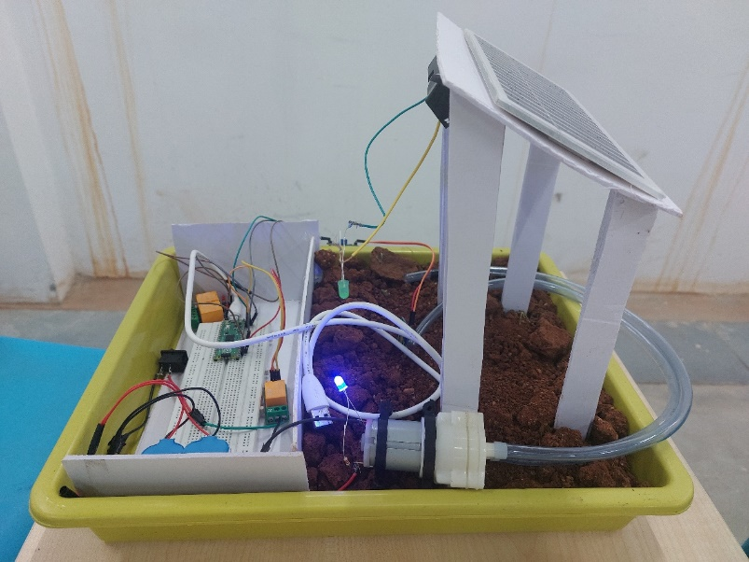

* As the soil's moisture might rot the wood over time, we cut down a sheet of tarpaulin to size and lined it on the inner surface of the planter.
* Make sure to pull it over the sides and then finally hold it in place with some glue.
* Once done we filled in soil that we got from a local farm. Spread the soil evenly till the top and then embed the three rows of the drip irrigation tubing.
* On the corner near the water pipes fit the electronic box and embed the moisture sensor into the soil.
* These makes the wiring job easier as the solenoid valve is near to the electronics and can be easily connected.

1. **CONCLUSION**

Overall, this paper provides a novel approach to save a water usage and make irrigation system better. Raspberry pi is an important part of system which is handle the processing and working. In this proposed system we used many sensors like soil moisture to measure moisture of soil, flame detection sensor to detect fire and also ultra-sonic sensor to find the water level in well. GSM module to notify the farmers about current state of the farms. If soil needs water we will send message as well as email to farmer about water and water level. To notify the farmer about dryness we set threshold value. If count goes up to that count system will notify the farmer. Now if fire is there in farm, system will also notify famer about it via message and email. System also send notify about water level of well.

This system is provides very huge future scope. It can be comprehend in many ways. One way is to add camera module to it. When flame sensor detect fire, camera module click picture and put it in website or send it in mail. And take input from user that there is fire or not if it is there send message to fire bridge. Another way is attach different type of sensor like humidity sensor, measuring fertilizer and also attach temperature sensor to generate more data about soil. Another way is to join water pump to the system and when moisture goes down system will atomically start the motor. This type of agriculture application of Internet of things in the real world environment is necessary to know the effect of the environment on such system. So is always better to know the risks beforehand.

**References**

1. Prabhu, Boselin and Pradeep, M. and Gajendran, E., “An Analysis of Smart Irrigation System Using Wireless Sensor Network” Star Vol.5 Issue 3(3), March (2017)
2. Ryu M, Yun J, Miao T, Ahn IY, Choi SC, Kim J (2015) “Design and implementation of a connected farm for smart farming system” 2015 IEEE, pp 1–4 (2015).
3. Pranita A. Bhosale, Prof. V. V. Dixit, “Water Saving-Irrigation Automatic Agricultural Controller, International Journal of Scientific & Technology Research volume 1, Issue 11, December 2012
4. Sneha Angal, “Raspberry pi and Arduino Based Automated Irrigation System” Department of Electronics & telecommunication, Dhole Patil College of Engineering, Pune, India