**Low Level Design (LLD)**

**Heart Disease Diagnostic - Analysis**

|  |  |
| --- | --- |
| **Written By** | **Akash Mandlik** |
| **Document Version** |  |
| **Last Revised Date** |  |

**DOCUMENT CONTROL**

**Change Record:**

|  |  |  |  |
| --- | --- | --- | --- |
| **VERSION** | **DATE** | **AUTHOR** | **COMMENTS** |
| 0.1 | **17th nov 2022** | **Akash Mandlik** |  |
| 0.2 |  |  |  |

**Reviews:**

|  |  |  |  |
| --- | --- | --- | --- |
| **VERSION** | **DATE** | **REVIEWER** | **COMMENTS** |
|  |  |  |  |

**Approval Status:**

|  |  |  |  |  |
| --- | --- | --- | --- | --- |
| **VERSION** | **REVIEW**  **DATE** | **REVIEWED BY** | **APPROVED**  **BY** | **COMMENTS** |
|  |  |  |  |  |

**1 Introduction**

* 1. **Why this Low-Level Design Document?**
* Low-Level Design (LLD)is a component-level design process that follows a step-by- step refinement process. It provides the details and definitions for the actual logic for every system component
* The goal of the LLD or Low-level design document (LLDD) is to give the internal logic design of the actual program code for the deloitte case dashboard.
* LLD describes the class diagrams with the methods and relations between classes and programs specs. It describes the modules so that the programmer can directly code the program from the document.

**1.2 Scope**

**Low-level design (LLD) is a component-level design process that follows a step-by-step refinement process. The process can be used for designing data structures, required software architecture, source code and ultimately, performance algorithms. Overall, the data organization may be defined during requirement analysis and then refined during data design work.**

**1.3 The main difference of HLD and LLD**

The Low-Level Design Document is quite similar to the High Level Design Document. They are both design documents after all. The difference lies in their focus. The HLD is focused on the functionality and data structure of a software. The LLD is focused on the data manipulation and internal interfaces (internal APIs) of a software. I’m going to make a note here about the differences between functions and modules. In the HLD I mention modules/libraries a lot, in this post, we’re more focused on functions

**2 Functional Architecture**

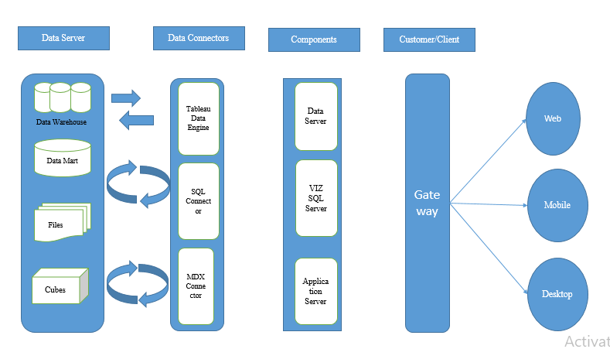

FIGURE 1

**3. Architecture Description**

3.1. Data Description

⦁ Raw Data Collection- The dataset is taken from iNeuron’s which is provided in the introduction document of project.

⦁ Data Pre-Processing

Before building any model, it is crucial to perform data pre-processing to feed the correct data to the model to learn and predict. Model performance depends on the quality of data feeded to the model to train.

This Process includes-

⦁ Handling Null/Missing Values

⦁ Handling Skewed Data

⦁ Outliers Detection and Removal

⦁ Data Cleaning

Data cleaning is the process of fixing or removing incorrect, corrupted, incorrectly formatted, duplicate, or incomplete data within a dataset.

⦁ Remove duplicate or irrelevant observations

⦁ Filter unwanted outliers

⦁ Renaming required attributes

⦁ Exploratory Data Analysis (EDA)

Exploratory Data Analysis refers to the critical process of performing initial investigations on data to discover patterns, spot anomalies, test hypothesis and to check assumptions with the help of summary statistics and graphical representations.

⦁ Reporting

Reporting is a most important and underrated skill of a data analytics field. Because being a Data Analyst you should be good in easy and self explatory report because your model will be used by many stakeholders who are not from technical background.

⦁ High Level Design Document (HLD)

⦁ Low Level Design Document (LLD)

⦁ Architecture

⦁ Wireframe

⦁ Detailed Project Report

⦁ Power Point Presentation

⦁ Modelling

Data Modelling is the process of analyzing the data objects and their relationship to the other objects. It is used to analyze the data requirements that are required for the business processes. The data models are created for the data to be stored in a database. The Data Model's main focus is on what data is needed and how we have to organize data rather than what operations we have to perform.

**Types of Heart Disease**

1. **Heart arrhythmia**

* A heart arrhythmia is an abnormal heartbeat. The heart can beat too slow, too fast, or with an irregular rhythm. A heart rate that is slower than normal is called bradycardia. If your heart rate is too slow, it may mean the brain is getting insufficient blood flow.
* For most adults, a resting heart rate fewer than 60 beats per minute (BPM) is considered bradycardia. However, physically active adults can often have a resting heart rate slower than 60 BPM. A heart rate that is faster than normal is called tachycardia.
* For most adults, a resting heart rate above 100 BPM is considered tachycardia. While it is common to have your heart rate rise in response to exercise, illness, or stress, it becomes concerning when it occurs at rest.

1. **Coronary artery** **disease**
   * The most common type of heart disease is coronary artery disease, a name used interchangeably with coronary heart disease and ischemic heart disease to describe the same heart condition. What causes this heart disease? Coronary artery disease is caused by atherosclerosis, a narrowing and hardening of the arteries due to a buildup of plaque. The heart’s blood flow becomes restricted through narrowed arteries, preventing the heart muscle from properly delivering oxygen nutrients throughout the body. High levels of LDL cholesterol (which you can check with a cholesterol test) can make the buildup of plaque more likely.
   * A very common symptom of coronary artery disease is chest pain that feels like a squeezing sensation, known as angina. However, this heart condition may not cause any symptoms for a long time before a heart attack occurs, so regular monitoring of your heart health is important for identifying possible warning signs of heart disease.
2. **Heart valve disease**

* There are four valves of the heart that work together to pump blood to all areas of the body. Each valve is covered by flaps of tissue that open and close to direct the blood flow through the different chambers of the heart. Changes in the shape or flexibility of the heart valves can prevent the valves from opening and closing properly.
* Heart valve diseases can be caused by other heart conditions that progress over time; for example, congenital structural defects affecting the aortic valves can cause this heart condition. But often the cause of a heart valve disease is not completely known.
* Possible symptoms include a heart murmur, fatigue, shortness of breath, and swelling in the legs, feet, and abdomen. Heart valve disease can eventually cause heart failure over time.

1. **Rheumatic heart disease**

* In rheumatic heart disease, the heart valves are irreversibly damaged by rheumatic fever, a condition that causes inflammation in the heart, brain, joints, and skin. Rheumatic fever is triggered by bacterial infections that cause strep throat and scarlet fever.
* The incidence of rheumatic fever is relatively rare in the United States due to the availability of antibiotics. Rheumatic fever mostly occurs in children between the ages of 5 and 15. Prompt treatment of strep throat and infections caused by streptococcal bacteria can prevent rheumatic fever from occurring.
* In rheumatic heart disease, the heart valves become narrow, which can cause leaking. It may take many years to progress to this stage, and a history of rheumatic fever is key in diagnosing this condition. Shortness of breath, chest pain, and swelling are common symptoms of rheumatic heart disease.

**Heart Disease By Gender**

* Gender Differences in Diagnosis and Management of Heart Disease. Overall, only 16 percent of the women screened were eligible for TPA, compared with 25 percent of men. Of those eligible women, 55 percent received the drug, compared with 78 percent of the men.
* We've come a long way since the days when a woman's worry over heart disease centered exclusively on its threat to the men in her life. We now know it's not just a man's problem. Every year, coronary heart disease, the single biggest cause of death in the United States, claims women and men in nearly equal numbers.
* **Risk still underappreciated** In a survey conducted by the American Heart Association, about half of the women interviewed knew that heart disease is the leading cause of death in women, yet only 13% said it was their greatest personal health risk. If not heart disease, then what? Other survey data suggest that on a day-to-day basis, women still worry more about getting breast cancer — even though heart disease kills six times as many women every year.
* **Heart Disease Men Vs Women**

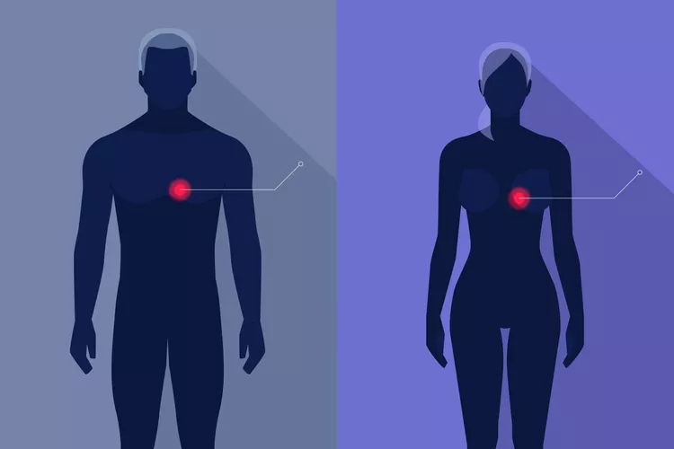

FIGURE 3

why do these differences matter? They matter because gender plays a role in the symptoms, treatments, and outcomes of some common heart diseases.

Coronary Artery Disease (CAD) CAD, the leading cause of heart attack, is the same process in men and women. Extra fats circulating in the blood are deposited in the walls of the heart’s arteries, forming deposits called plaques. When these plaques grow slowly, they become hard and gradually narrow the artery, interfering with blood flow.

women have risk factors for CAD that men don’t have. They also tend to have different symptoms of heart attack. When symptoms appear, CAD may be more difficult to diagnose using conventional testing methods.

**Heart Disease Rate**



FIGURE 4

**Heart Disease Rates By Country 2022**



* **Russia** Russia has the highest rate of heart disease compared to other countries worldwide. Russia has 1,752 cardiovascular deaths per every 100,000 people every year. Nearly 60% of all deaths in Russia can be attributed to heart disease. This country has the highest mortality rate due to heart disease compared to any other developed nation in the world. The majority of deaths related to CVD occur in the Northwestern territories of Russia.
* **Hungary** For every 100,00 people, roughly 1,330 people die every year from cardiovascular disease in Hungary. This country has the second-highest rate of heart disease in the world. Compared to other countries, Hungary has some of the worst dietary habits, which could contribute to ongoing heart disease. Rich and heavy foods are related to increased heart disease in the country. In 2012 a sugar tax was imposed to help lessen heart disease that develops due to obesity.

**China** Rounding our list of the highest rate of heart disease in countries is China. In China, about 931 people for every 100,000 people die from heart disease every year. That number correlates to nearly 230 million people every year dying from heart disease. One in every five adults in China has some sort of cardiovascular disease. Based on current statistical trends, a 50% increase in cardiovascular disease is expected to occur between 2010 and 2030.

* **Argentina** Nearly 993 people for every 100,000 people die in Argentina every year from heart disease. The leading factor contributing to heart disease-related deaths in Argentina is a sedentary lifestyle. Nearly 17% of all heart disease-related deaths can be traced to people who get fewer than 600 minutes per week of exercise, elevating the heart rate.
* **Poland** Each year, 1,171 people per every 100,000 people in the population die from heart disease in Poland. Sadly, in recent years, heart disease-related deaths have increased from 17% to 25%. This statistic makes heart disease the leading cause of death in the country. The main factors contributing to heart disease include lack of physical activity, smoking, and high cholesterol levels.

**4 Deployment**

We created a power bi dashboard.

