Wireframe Document

Heart Disease Diagnostic Analysis


Revision Number - 1.2

Last Date of Revision - 16/12/2022

Akash Mandlik
WIREFRAME DOCUMENT DESIGN

Document Control

Date | Version | Description | Author
17/12/2022 | 1.0 | low level design | Akash

WIREFRAME DOCUMENT DESIGN

We Performed Exploratory Data Analysis on Jupyter Notebook and then created a power bi Dashboard.

- What Kind of Population do we have?

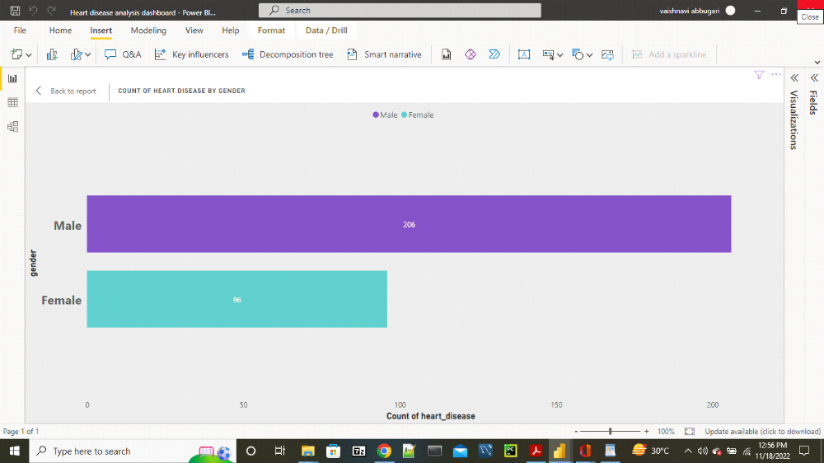

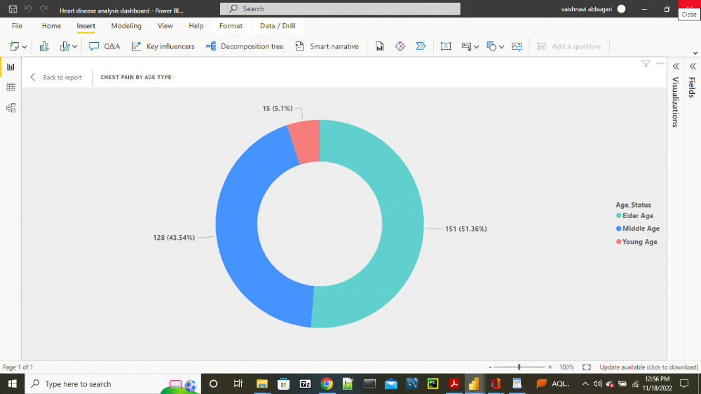

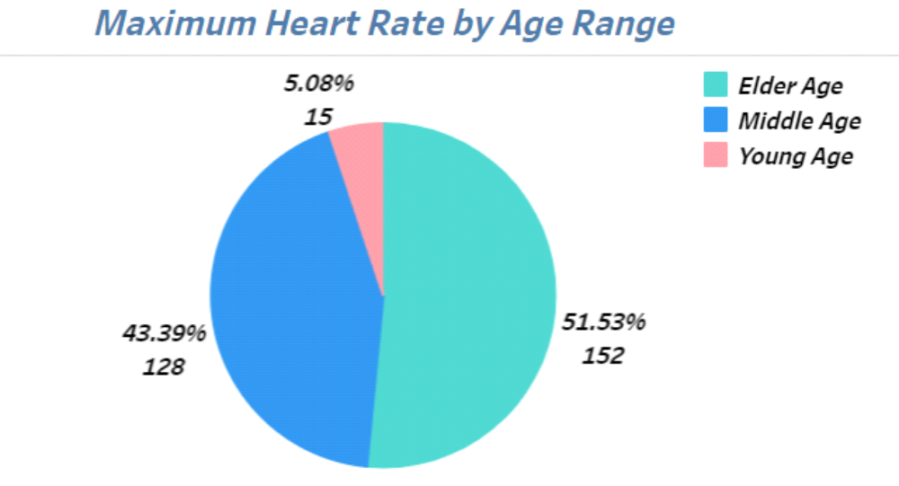
- Males are more prone to heart disease.

- Elderly Aged People are more prone to heart disease

