Electricity Billing System Project

Login and Signup:

|  |
| --- |
|  |

|  |
| --- |
|  |

Admin Page:

|  |
| --- |
|  |

|  |
| --- |
|  |

|  |
| --- |
|  |

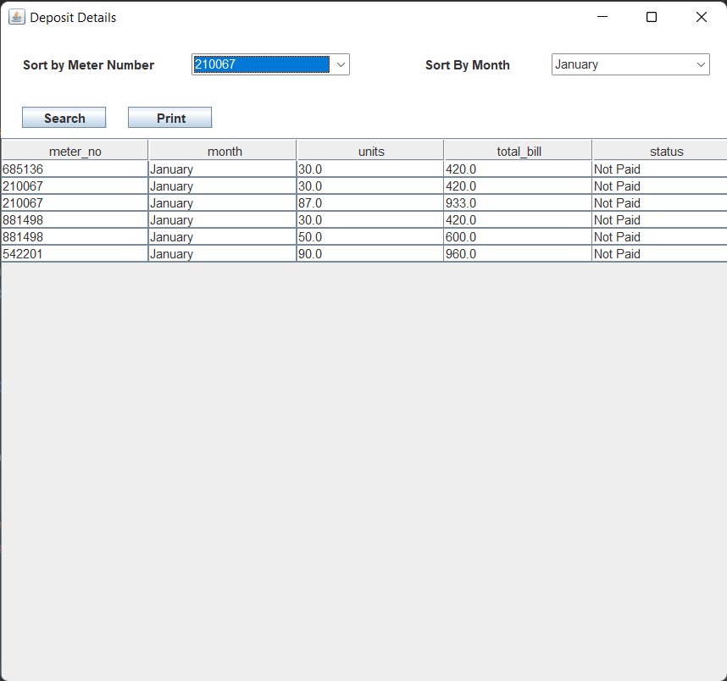

|  |
| --- |
|  |

Customer Page:

|  |
| --- |
|  |

|  |
| --- |
|  |

|  |
| --- |
|  |

|  |
| --- |
|  |

|  |
| --- |
|  |

|  |
| --- |
|  |

|  |
| --- |
|  |

|  |
| --- |
|  |

|  |
| --- |
|  |

|  |
| --- |
|  |

|  |
| --- |
|  |

Classes in Project:

Total classes – 16

|  |
| --- |
|  |