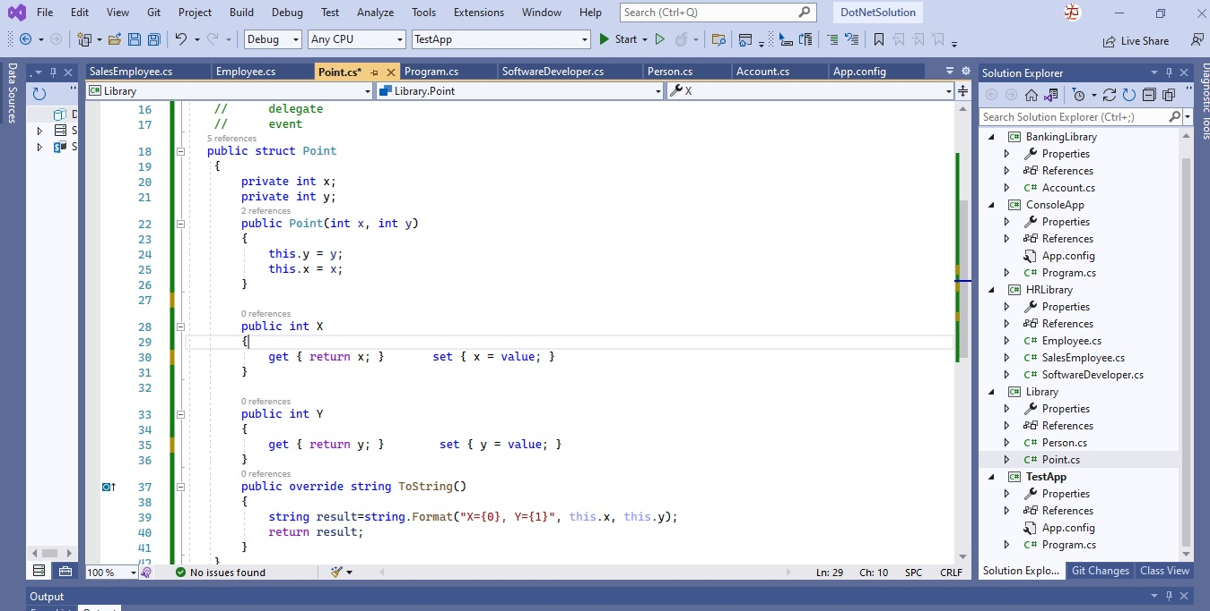

Edit

Git

Window

Help

04 1

File .

View

8

Project

.

Build Debug Test Analyze

Debug - Any CPU

Tools Extensions TestApp

Search (Ctrl+O) Start - E

2 DotNetSolution 11 DaDa

0

Live Share

Software Developer.cs

Person.cs

Account.cs

App.config

=

x

Solution Explorer

**Persons**

- 2 x 0 "

Data Sources

SalesEmployee.cs C# Library

Point

SoftwareDeveloper.cs

+

Employee.cs Point.cs* + X Program.cs

- Library.Point delegate

event 5 references public struct Point

Diagnostic lools

*1*

:

*//*

private int x; private int y; 2 references public Point(int x, int y)

this.y = yi this.x = x;

O references public int x

Search Solution Explorer (Ctrl+;) C# BankingLibrary

Properties 87 References ► C# Account.cs - C# ConsoleApp

Properties 8. References

App.config C# Program.cs C# HRLibrary

Properties 88 References

C# Employee.cs ► C# Sales Employee.cs

C# Software Developer.cs C# Library

Properties 87 References ► C# Person.cs

**C# Point.cs c# TestApp**

Properties 88 References

App.config C# Program.cs

get { return x; }

set { x = value; }

O references public int Y

get { return y; }

set { y = value; }

O references public override string ToString()

string result=string.Format("x={0}, Y={1}", this.x, this.y); return result;

41

A

100%

-

No issues found

Ln: 29

Ch: 10

SPC

CRLF

Solution Explo... Git Changes Class View

Output

IX