**DOCKER Task**

**Basic Command task**

**1.** Start 4 containers from an image that does not automatically exit, such as nginx, detached.

Stop 2 of the containers leaving 2 up.

Prove and validate that you have completed this part of exercise by delivering the output.

**ANS :**

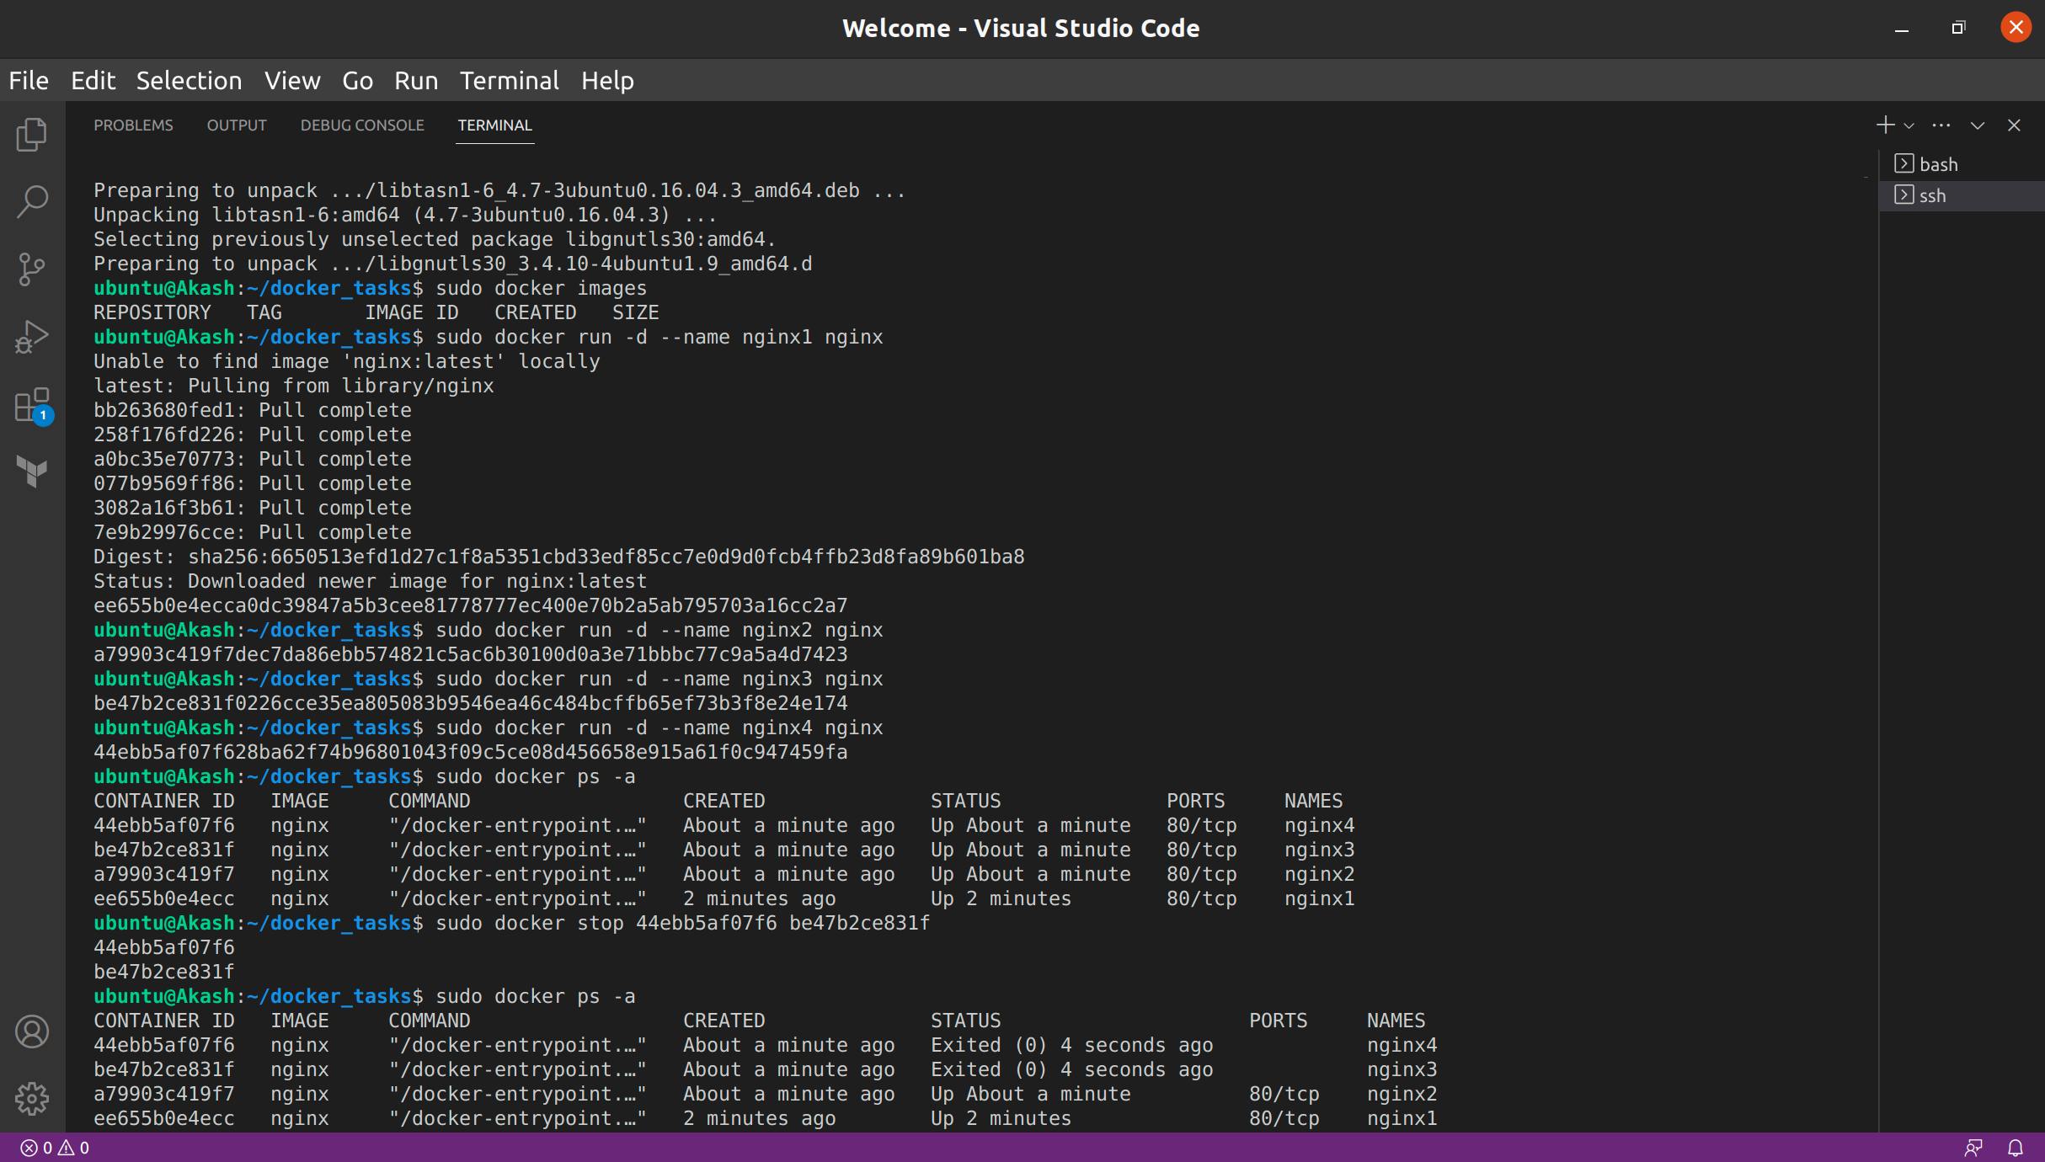

**2.** Check the usage of docker containers and clean the spaces taken by stopped containers/images.

Prove and validate that you have completed this part of exercise by delivering the output.

**ANS :**

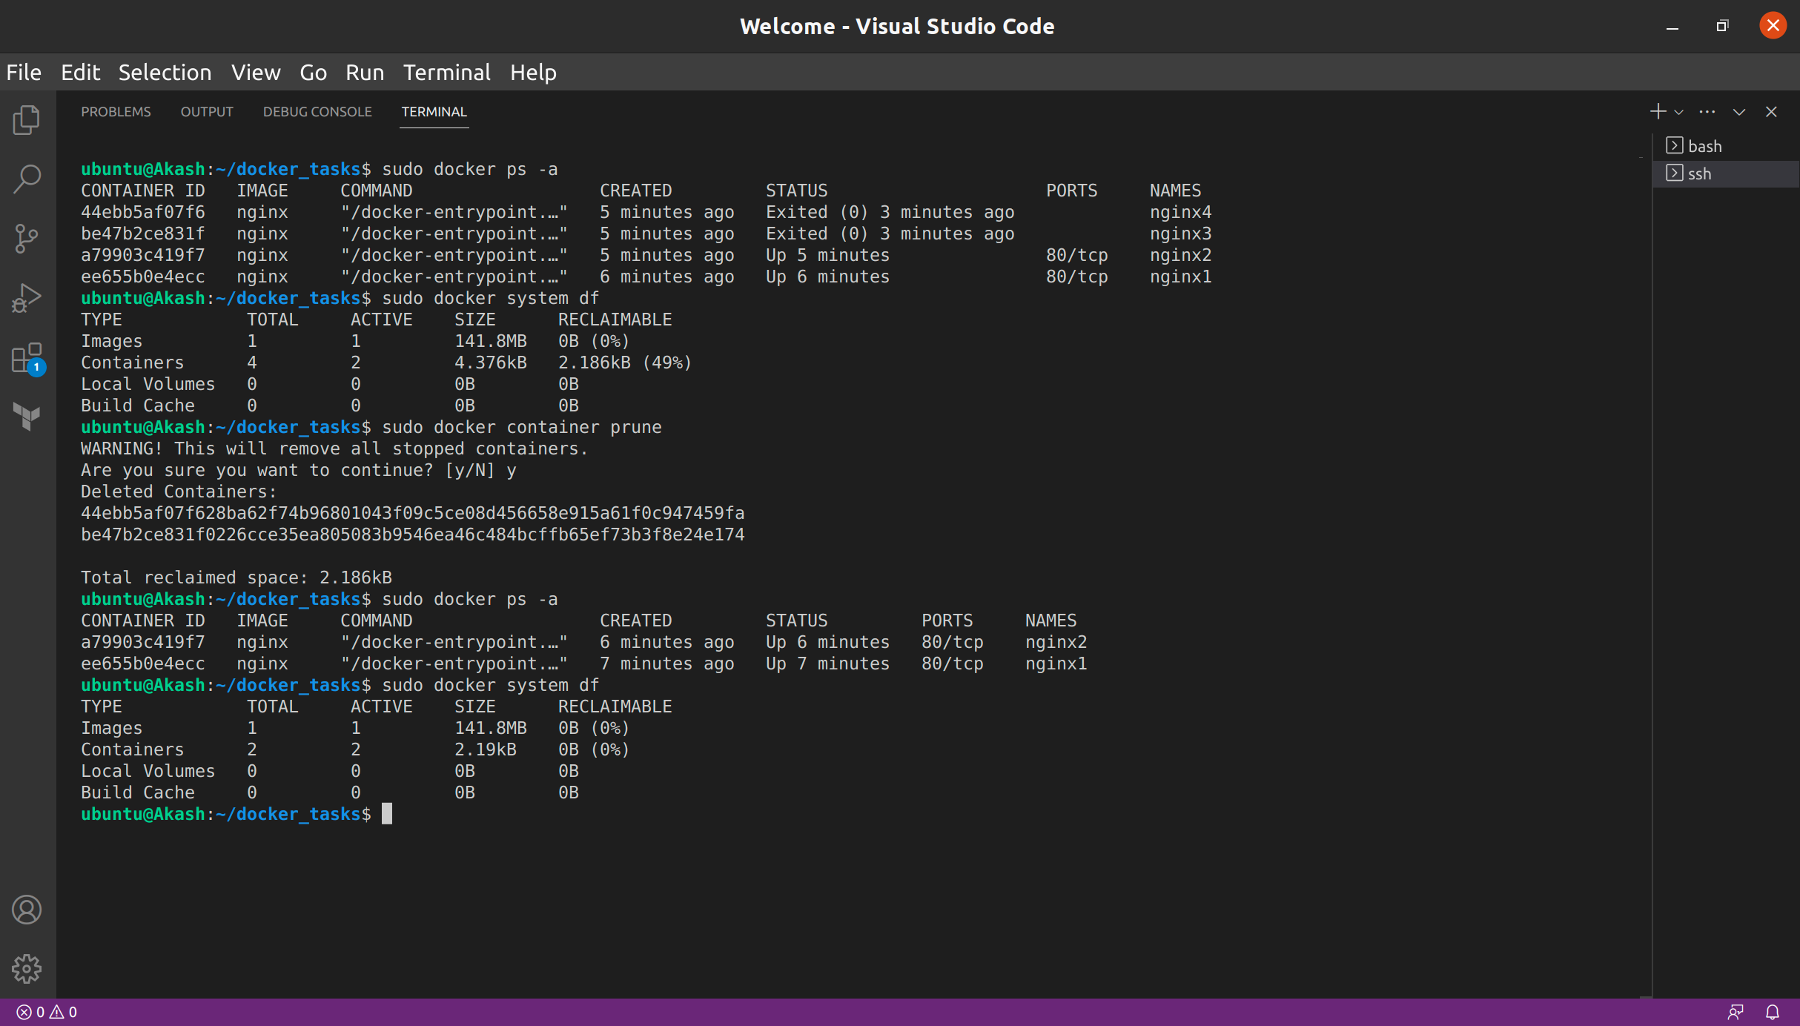

**3.** Start image devopsdockeruh/exec_bash_exercise, it will start a container with clock-like features and create a log. Go inside the container and use tail -f ./logs.txt to follow the logs. Every 15 seconds the clock will send you a “secret message”.

Submit the secret message and command(s) given as your answer.

**ANS :**

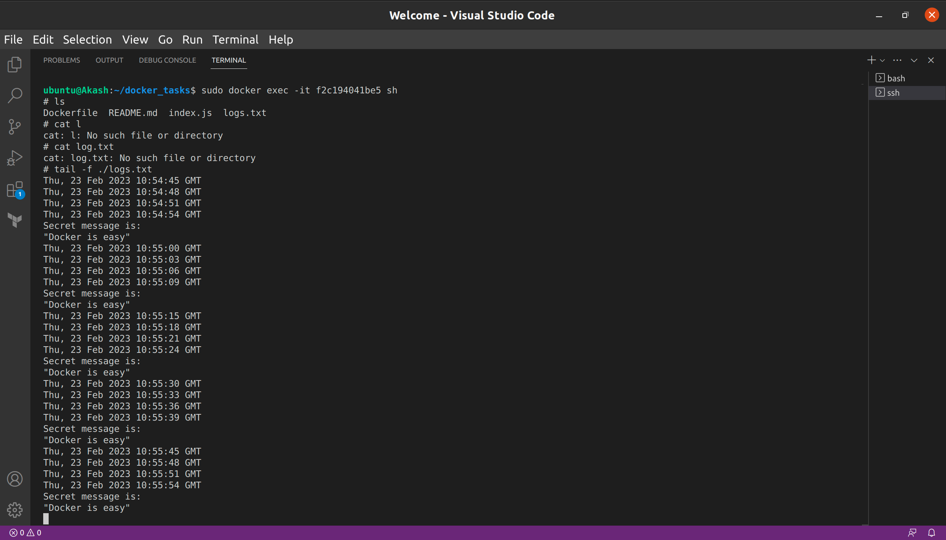

**Dockerfile task**

Create a dockerfile using Ubuntu 16.04 as base image and install ping utilities, also provide some target as default to showcase at time of running the container after building the image.

Paste the output to validate.

**ANS :**

DockerFile

FROM ubuntu:16.04

RUN apt-get update && apt-get install -y iputils-ping

CMD echo "OS Version is:" && cat /etc/os-release

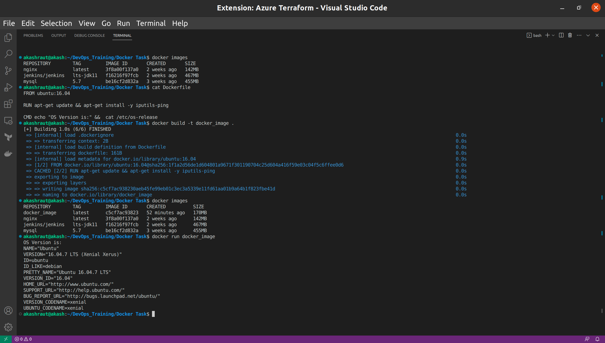

**Docker Compose task**- Create a docker compose file and deploy multiple services and showcase the use of docker network and volumes.

- Exec inside the container and ping other service private IP

**ANS :**

docker-compose.yaml

version: "3.3"

services:

db:

image: mysql:5.7

volumes:

- db:/var/lib/mysql

environment:

MYSQL_ROOT_PASSWORD: example

MYSQL_DATABASE: my_database

networks:

- my-network

web:

image: nginx:latest

ports:

- "80:80"

volumes:

- web:/usr/share/nginx/html

depends_on:

- db

networks:

- my-network

volumes:

db:

web:

networks:

my-network:

