School of Computer Science and Artificial Intelligence
Lab Assignment # 1.2
Program : B. Tech (CSE)
Specialization :
Course Title : AI Assisted coding
Course Code :
Semester II
Academic Session : 2025-2026
Name of Student : R.Akash Reddy
Enrollment No. : 2403A51L30
Batch No. 51
Date :14-01-2026

Submission Starts here
Task Description-1
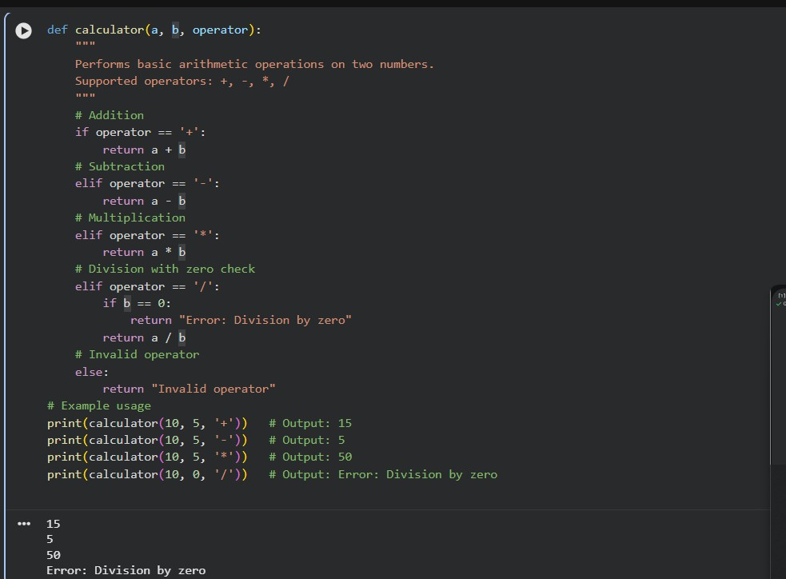
- Progressive Prompting for Calculator Design: Ask the AI to design a simple calculator program by initially providing only the function name. Gradually enhance the prompt by adding comments and usage examples.

Explanation:


Function Definition
1
def calculator(a, b, operator):

  - Defines a function named calculator

  - Takes three parameters:

    - a → first number

    - b → second number

    - operator → arithmetic operation (+, -, *, /)

Function Documentation
2
"""
Performs basic arithmetic operations on two numbers.
Supported operators: +, -, *, / """

  - This is a docstring
  - It explains what the function does
  - Helps other programmers understand the function easily

Addition Operation
3
if operator == '+': return a + b

  - Checks if the operator is +

  - Adds a and b

  - Returns the result

Subtraction Operation
4
elif operator == '-': return a - b

  - Executes when operator is -

  - Subtracts b from a

Multiplication Operation
5
elif operator == '*': return a * b

  - Executes when operator is *

  - Multiplies both numbers

Division Operation with Safety Check
6
elif operator == '/': if b == 0:
return "Error: Division by zero" return a / b

  - Executes when operator is /

  - First checks if b is 0

  - Division by zero is not allowed

  - Returns an error message if b is zero
  - Otherwise, performs division

Invalid Operator Handling
7
else:
return "Invalid operator"

  - Executes when operator is not valid
  - Prevents program crash
  - Makes code more robust

▶ Example Execution
print(calculator(10, 5, '+'))

Step-by-step:
  - a = 10

  - b = 5

  - operator = '+'

  - Condition operator == '+' is true
  - Output → 15

Task2:
  - Refining Prompts for Sorting Logic: Start with a vague prompt for sorting student marks,
  - then refine it to clearly specify sorting order and constraints.
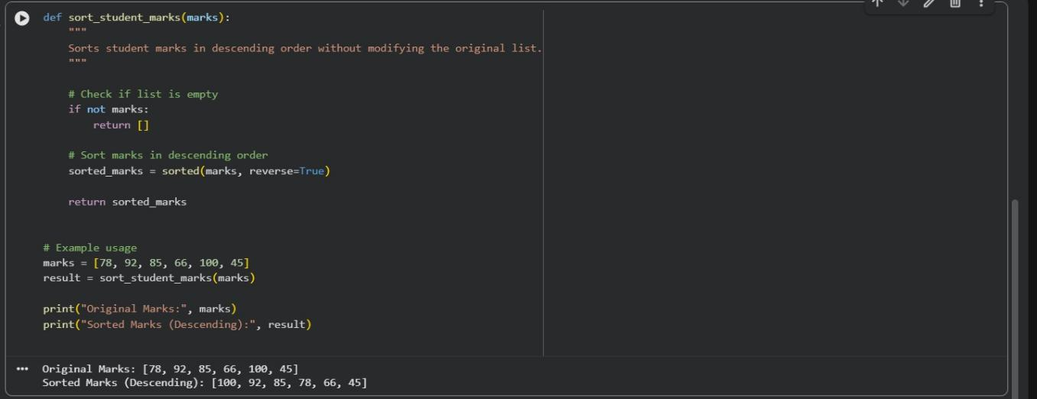

Explanation:

- Function Definition
def sort_student_marks(marks):

  - Defines a function named sort_student_marks

  - Accepts one parameter:

    - marks → list of student marks (integers)

- Function Documentation
"""
Sorts student marks in descending order without modifying the original list.
"""

- This docstring explains:
  - Purpose of the function
  - Sorting order (descending)
  - Original list remains unchanged

- Empty List Check
if not marks:
return []

- Checks whether the list is empty
- Prevents errors during sorting
- Returns an empty list if no marks are provided

- Sorting Logic
sorted_marks = sorted(marks, reverse=True)

  - Uses Python’s built-in sorted() function

  - reverse=True → sorts in descending order

  - sorted() creates a new list, so the original list is safe

- Return Statement
return sorted_marks

  - Returns the sorted list to the caller

- Example Usage
marks = [78, 92, 85, 66, 100, 45]

  - Sample list of student marks

result = sort_student_marks(marks)

  - Calls the function and stores the result

print("Original Marks:", marks) print("Sorted Marks (Descending):", result)

  - Shows:
    - Original list (unchanged)
    - Sorted list (descending order)

▶ Sample Output
Original Marks: [78, 92, 85, 66, 100, 45]
Sorted Marks (Descending): [100, 92, 85, 78, 66, 45]

Task3:
  - Few-Shot Prompting for Prime Number Validation: Provide multiple input-output
  - examples for a function that checks whether a number is prime. Observe how few-shot
  - prompting improves correctness.
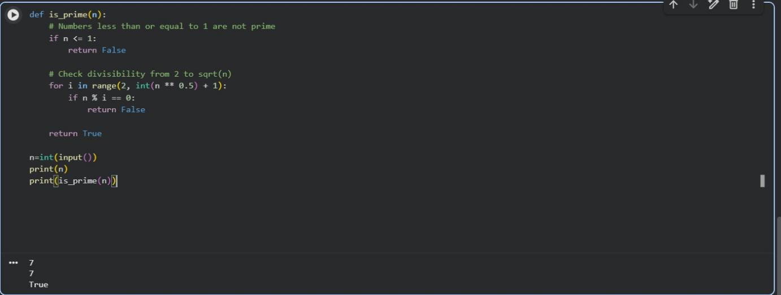

Explanation:
Handle Edge Cases
1
if n <= 1:
return False

  - Prime numbers must be greater than 1
  - Eliminates wrong results for 0 and 1

Efficient Loop
2
for i in range(2, int(n ** 0.5) + 1):

  - Checks factors only up to √n
  - Improves performance

Divisibility Check
3
if n % i == 0: return False

  - If divisible, number is not prime

Final Return
4
return True

- If no divisors found → number is prime

▶ Example Test Cases print(is_prime(7)) # True print(is_prime(4)) # False print(is_prime(1)) # False
print(is_prime(17)) # True print(is_prime(20)) # False

Task4:
- Prompt-Guided UI Design for Student Grading System: Create a user interface for a student grading system that calculates total marks, percentage, and grade based on user input.
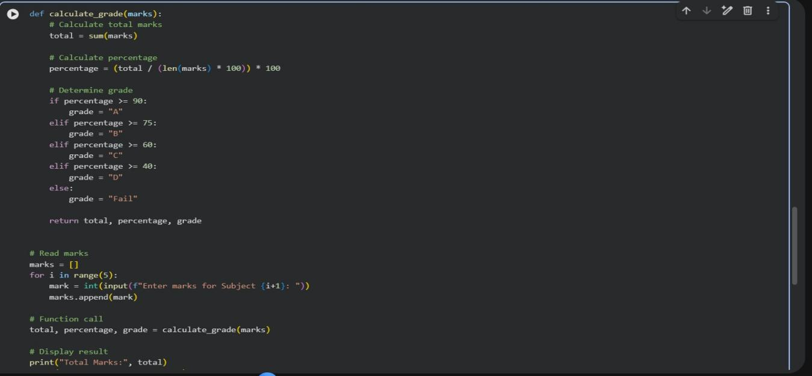

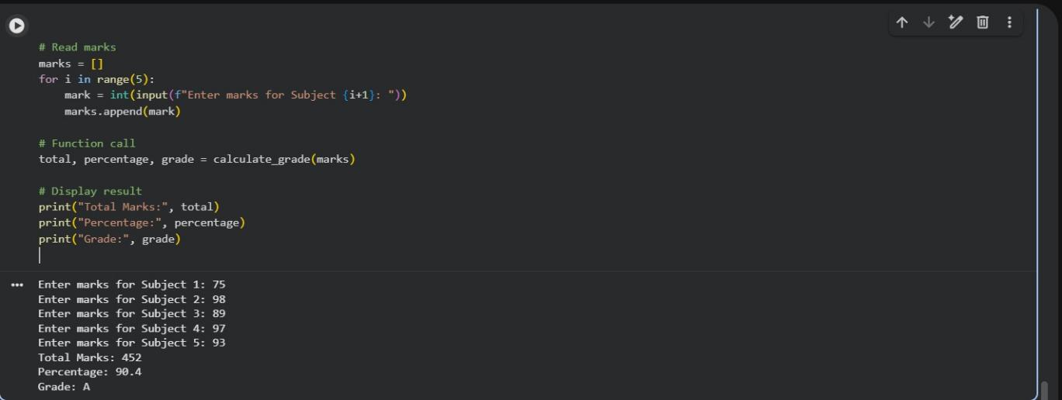

Explanation:
Function Definition
1
def calculate_grade(marks):

- Accepts a list of subject marks

Total Calculation
2
total = sum(marks)

- Adds all subject marks

Percentage Calculation
3
percentage = (total / (len(marks) * 100)) * 100

- Assumes each subject is out of 100

Grade Assignment
4
- Uses if-elif-else conditions
- Assigns grade based on percentage


Function Return
5
return total, percentage, grade

- Returns all results together

Function Call
6
total, percentage, grade = calculate_grade(marks)

- Calls the function and stores results

Task5:
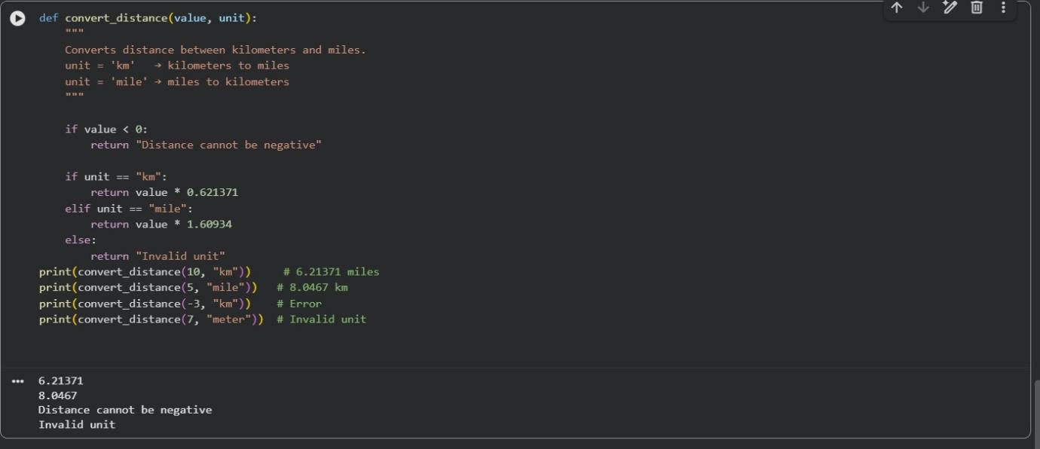
- Analyzing Prompt Specificity in Unit Conversion Functions: Improving a Unit Conversion Function (Kilometers to Miles and Miles to Kilometers) Using Clear Instructions.

Explanation:

Function Definition
1
def convert_distance(value, unit):

- Defines a function named convert_distance

- Takes two parameters:

  - value → numerical distance

  - unit → type of input unit ("km" or "mile")

Function Description (Docstring)
2
"""
Converts distance between kilometers and miles. """

- Explains the purpose of the function
- Helps users understand expected input and output

Negative Value Check
3
if value < 0:
return "Distance cannot be negative"

- Distance cannot be negative in real life
- This check avoids incorrect results
- Shows how constraints improve correctness

Kilometers to Miles Conversion
4
if unit == "km":
return value * 0.621371

- Uses the standard formula:
  - 1 km = 0.621371 miles

- Executes when input unit is "km"

Miles to Kilometers Conversion
5
elif unit == "mile": return value * 1.60934

- Uses the formula:

  - 1 mile = 1.60934 km

- Executes when input unit is "mile"

Invalid Unit Handling
6
else:
return "Invalid unit"

- Runs if unit is not "km" or "mile"

- Prevents incorrect conversions
- Makes the function more reliable

▶ Example Execution
print(convert_distance(10, "km"))

Execution Flow:
- value = 10

- unit = "km"

- Negative check → passed

- "km" condition is true
- Output → 6.21371 miles

