

School of Computer Science and Artificial Intelligence
Lab Assignment # 4.2
Program : B. Tech (CSE)
Specialization : --
Course Title : AI Assisted coding
Course Code :

Semester II

Academic Session : 2025-2026

Name of Student : Akash Reddy

Enrollment No. : 2403A51L30

Batch No. : 51
Date :20-01-2026

Task Description-1
Zero-shot: Prompt AI with only the instruction. Write a Python function to determine whether a given number is prime.

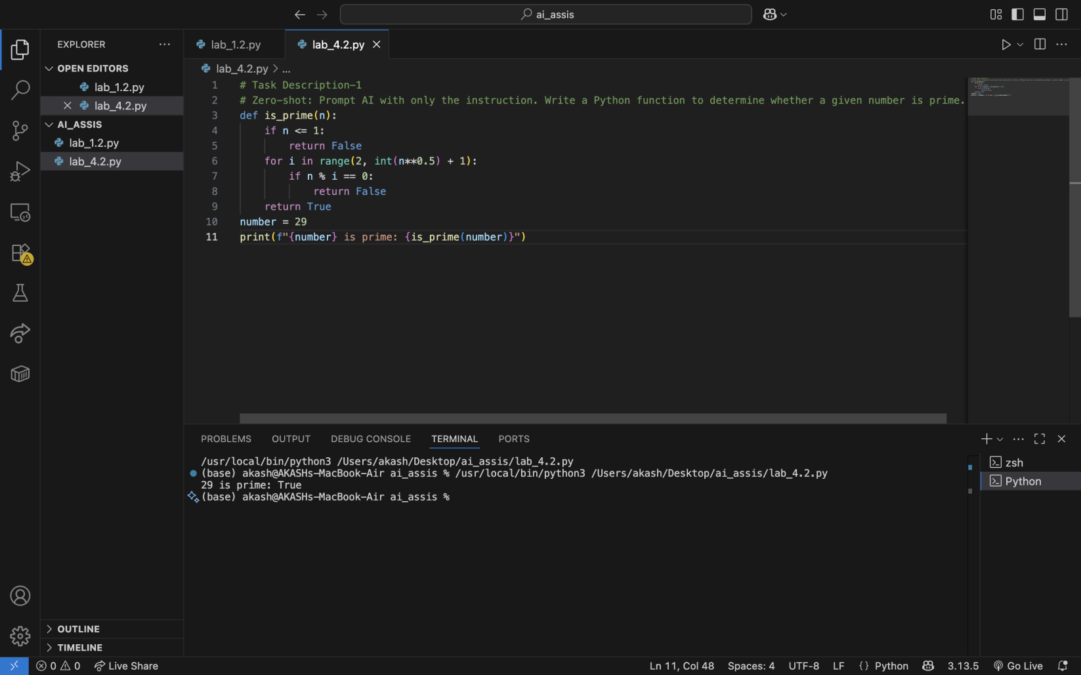
Explanation:
# The function is_prime checks if a number n is prime by testing divisibility from 2 to the square root of n.
# If any divisor is found, it returns False; otherwise, it returns True.
# Few-shot: Provide AI with examples before the instruction.
# Example 1: 5 is prime because it has no divisors other than 1
# and itself.

Task Description-2
- One-shot: Provide one example: Input: [1, 2, 3, 4], Output: 10 to help AI generate a function that calculates the sum of elements in a list.

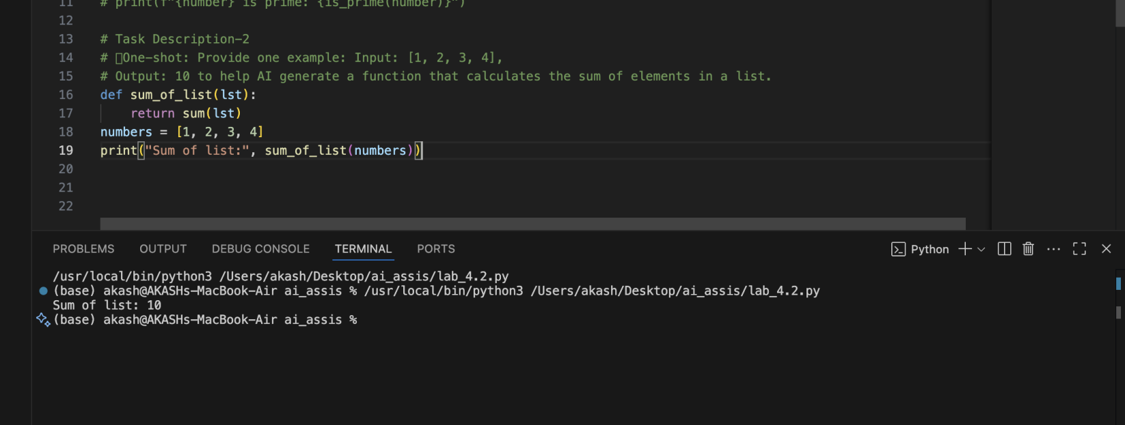

Explanation

# The function sum_of_list takes a list as input and returns the sum of its elements using Python's built-in sum() function.

Task Description-3
- Few-shot: Give 2–3 examples to create a function that extracts digits from an alphanumeric string.

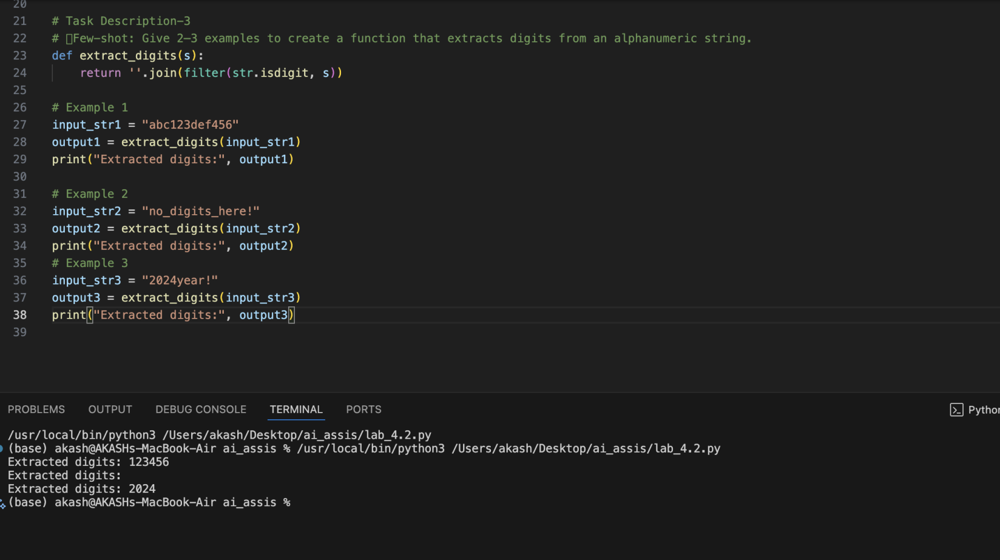

Explanation
# The function `extract_digits` takes an alphanumeric string as input and uses the `filter` function along with `
# str.isdigit` to extract only the digit characters from the string.
# It then joins these characters into a single string and returns it.
# The examples demonstrate the function's ability to extract digits from different types of input strings.

Task Description-4
- Compare zero-shot vs few-shot prompting for generating a function that counts the number of vowels in a string.
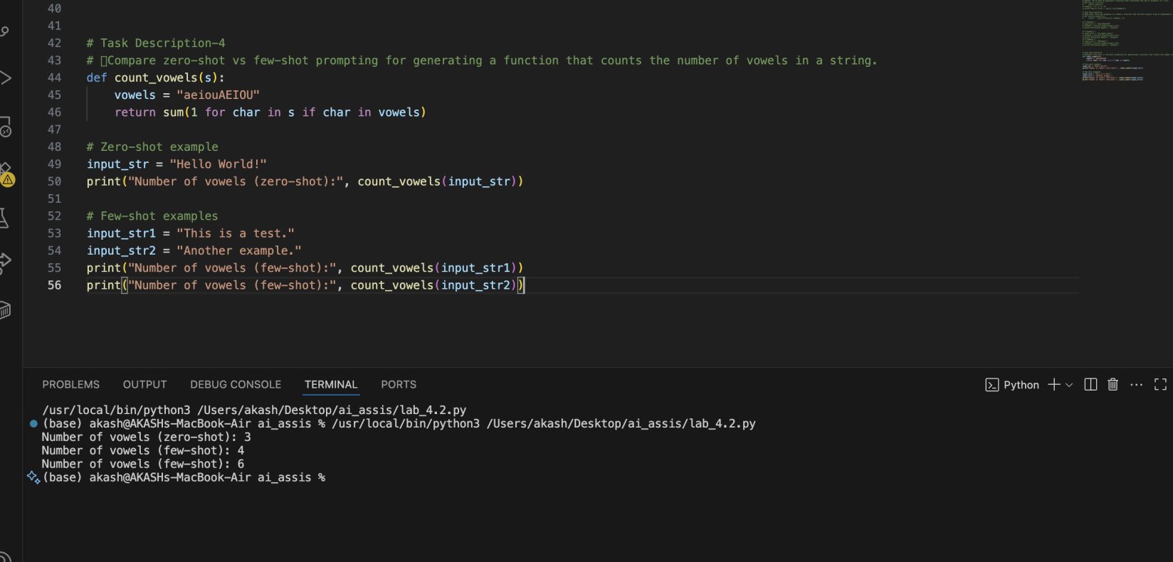

Comparison
# The zero-shot approach relies solely on the initial instruction, which may lead to less accurate or less optimized code.
# The few-shot approach, by providing examples, helps the AI understand the context better and often results in
# more accurate and efficient implementations. In this case, both approaches yield the same function,
# but few-shot prompting can enhance understanding for more complex tasks.

Task Description-5
Use few-shot prompting with 3 sample inputs to generate a function that determines the minimum of three numbers without using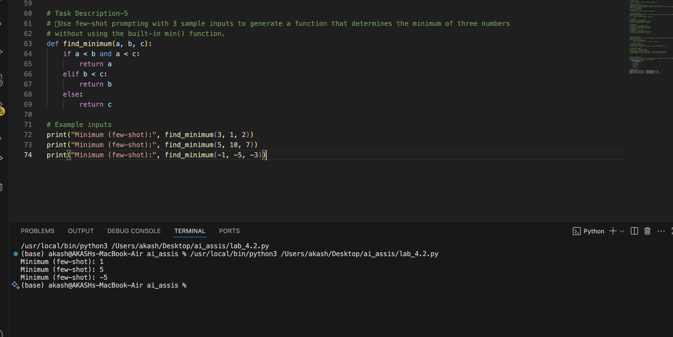

Explanation
# The function find_minimum takes three numbers as input and compares them using conditional statements to determine the smallest number.

