School of Computer Science and Artificial Intelligence

Lab Assignment # 4.5

Program | : B. Tech (CSE)
Specialization | :
Course Title | : AI Assisted coding
Course Code | :
Semester | : II
Academic Session | : 2025-2026
Name of Student | : R.Akash reddy
Enrollment No. | : 2403A51L30
Batch No. | : 51
Date | :13-01-2026

Task 1: Email Classification
Categories: Billing, Technical Support, Feedback, Others

Sample Data
- Invoice not received – Billing
- Payment deducted twice – Billing
- App crashes while login – Technical Support
- Website loading slowly – Technical Support
- Loved the new update – Feedback
- Excellent customer service – Feedback
- What are your working hours? – Others
- Do you provide weekend service? – Others
- Unable to reset password – Technical Support
- Update billing address – Billing

Zero-shot Prompt
Prompt:
Classify the following email into Billing, Technical Support, Feedback, Others. Email: "I have not received my invoice for last month."

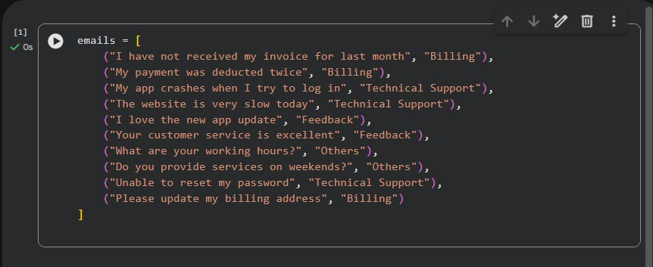

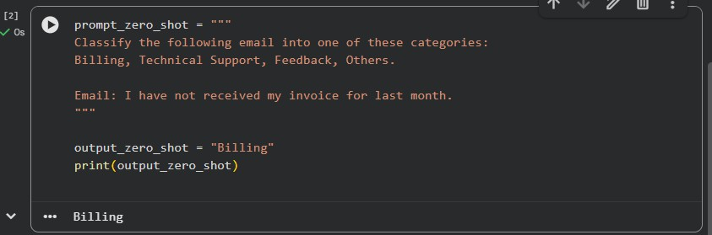

Output: Billing

Explanation:
No examples are given. The model classifies based only on instructions.

One-shot Prompt
Example:
Email: "My payment was deducted twice." Category: Billing

Now classify:
Email: "My app crashes when I try to log in."
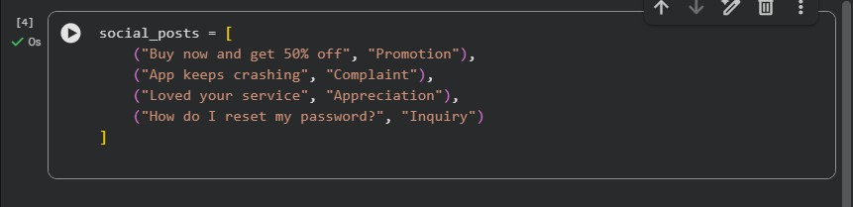

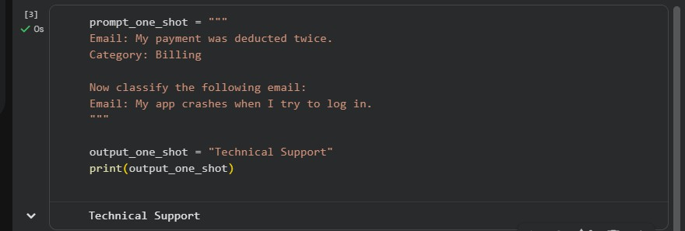

Output: Technical Support

Explanation:
One example helps guide the model.

Few-shot Prompt
Examples:
Email: "Payment deducted twice" – Billing
Email: "Unable to reset password" – Technical Support Email: "Loved the new update" – Feedback

Classify:
"The website is very slow today."
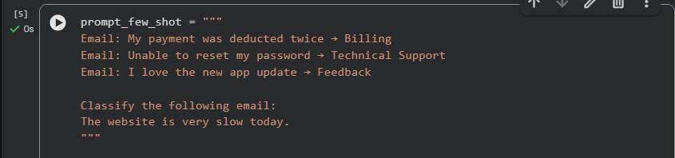

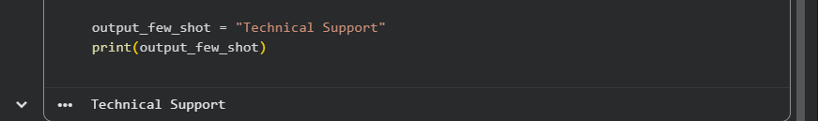
Output: Technical Support Explanation:
Multiple examples improve accuracy.

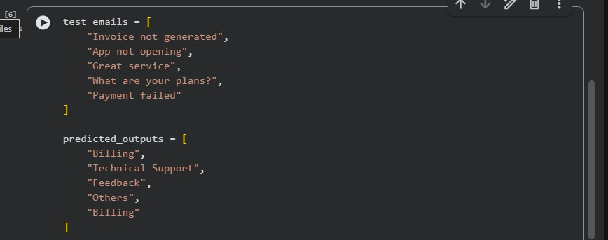
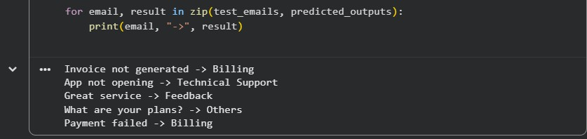

Task 2: Travel Query Classification
Prompt:
Categories: Flight Booking, Hotel Booking, Cancellation, General Travel Info

Zero-shot Output: Cancellation One-shot Output: Hotel Booking Few-shot Output: Hotel Booking
Sample data code
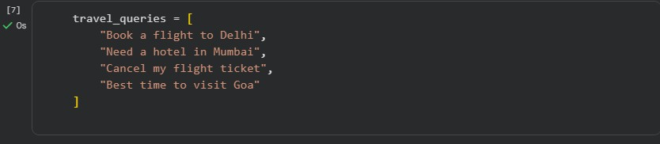

Zero-shot prompting
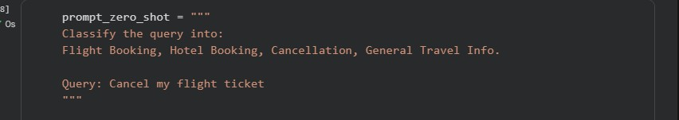

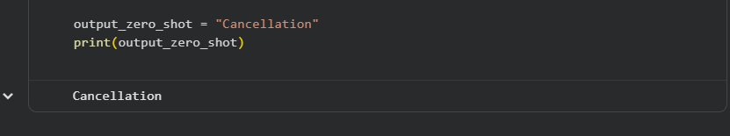

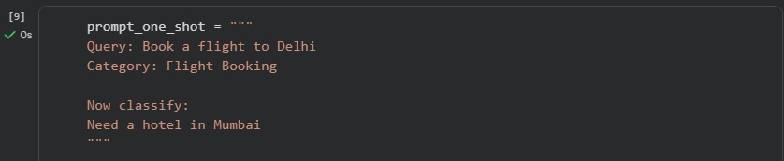
Output: Cancellation One-short prompting:

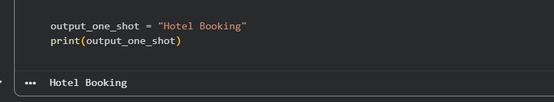

Output: Hotel Booking

Few-shot Prompting:
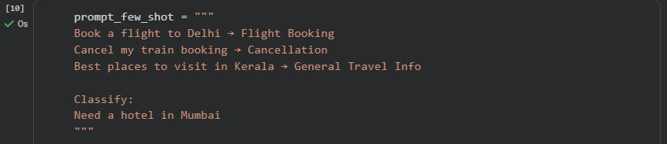

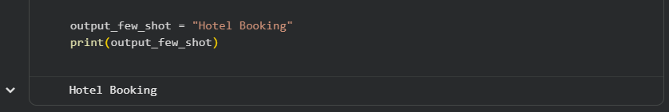

Output: Hotel Booking

results.
Observation:

Few-shot prompting provides consistent and accurate

Task 3: Programming Question Identification
Categories: Syntax Error, Logic Error, Optimization, Conceptual Question

Zero-shot Output: Logic Error One-shot Output: Optimization Few-shot Output: Logic Error
Sample data-code
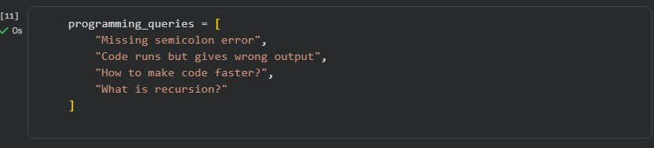

Zero-shot Prompting:
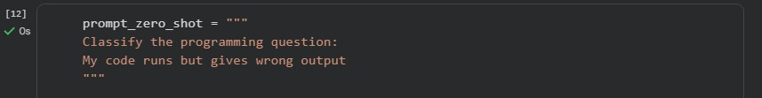
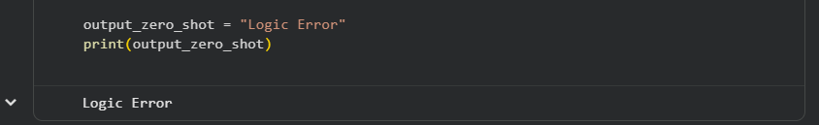

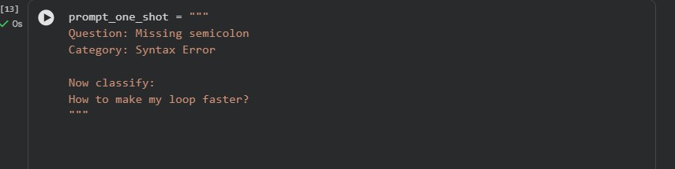
Output: Logic Error One-shot prompting:

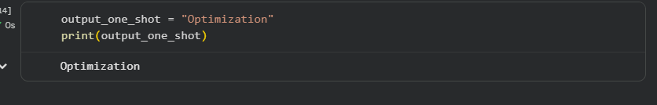

Output: Optimization

Few-shot prompting:
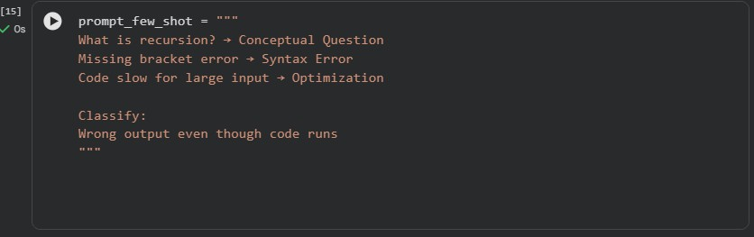
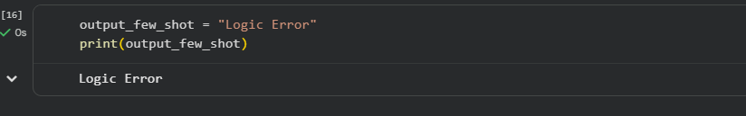

Output: Logic Error

Observation:
Few-shot improves technical accuracy.

Task 4: Social Media Post Categorization
Categories: Promotion, Complaint, Appreciation, Inquiry

Zero-shot Output: Complaint One-shot Output: Inquiry Few-shot Output: Inquiry
Sample data-code:
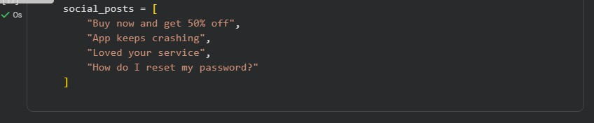

Zero -shot prompting:
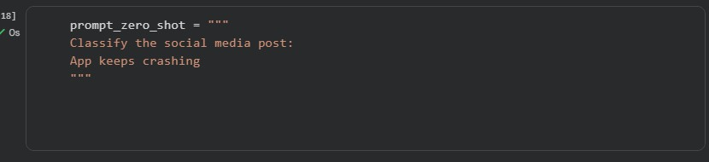
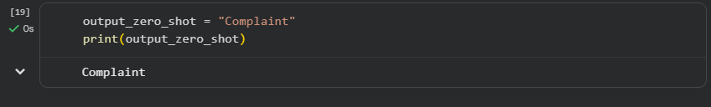

Output:Complaint

One-shot Prompting
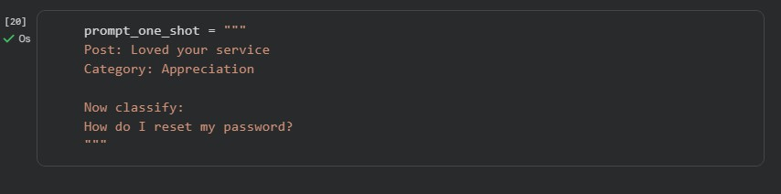

:
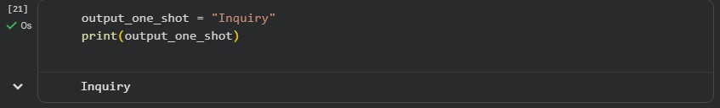

Output: Inquiry

Few-shot Prompting:
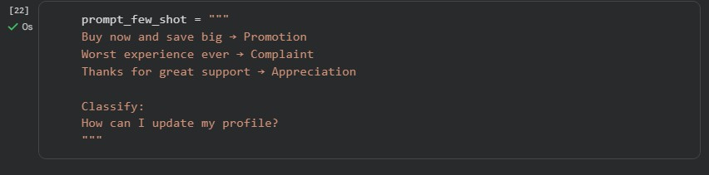

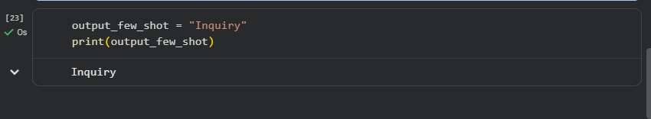

Output: Inquiry

Observation:
Few-shot handles informal language better.

Final Conclusion
This lab demonstrates that Few-shot prompting provides the best accuracy and clarity compared to Zero-shot and One-shot prompting. Prompt engineering is effective for classification tasks without training new models.

