

School of Computer Science and Artificial Intelligence
Lab Assignment # 5.2
Program : B. Tech (CSE)
Specialization : --
Course Title : AI Assisted coding
Course Code :

Semester II

Academic Session : 2025-2026

Name of Student : Akash Reddy

Enrollment No. : 2403A51L30

Batch No. : 51
Date :20-01-2026

Task Description-1
- Secure API Usage: Use an AI tool to generate a simple REST API for user registration. Review the generated code for improper handling of API keys, missing authentication, or lack of input validation.
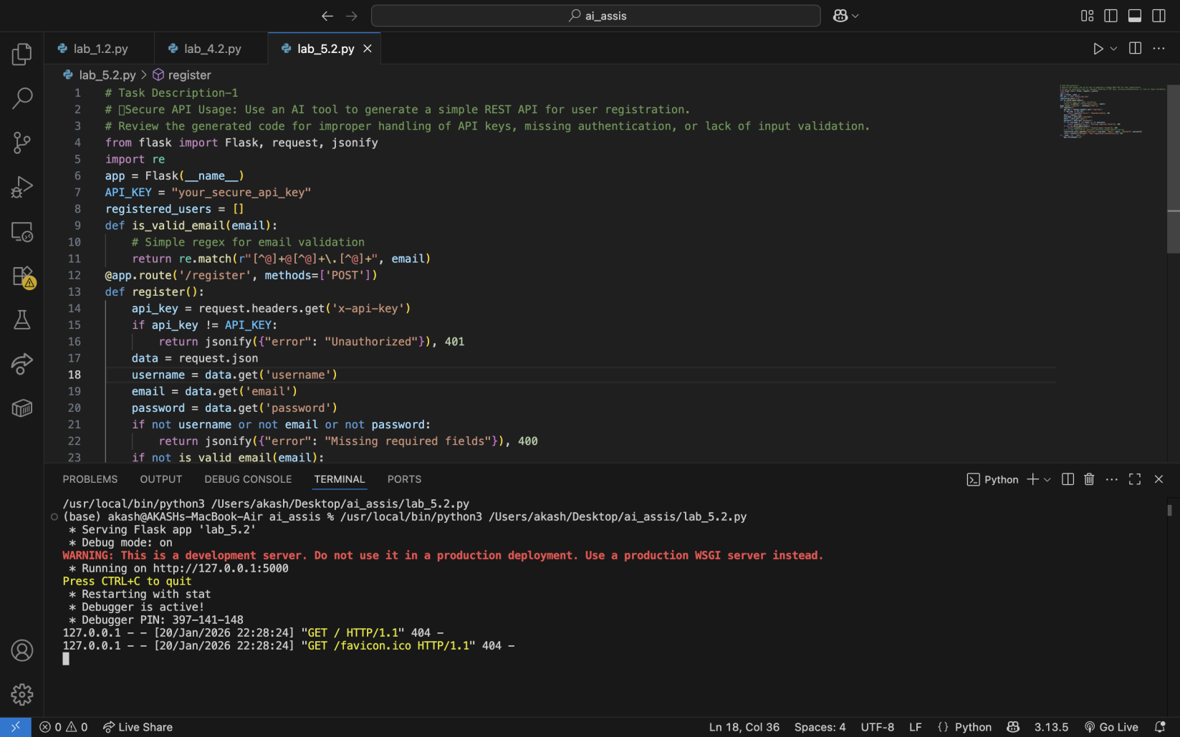

Task Description-2
- Fair Decision Logic: Prompt an AI tool to generate a scholarship eligibility checker based on academic score, family income, and location. Examine whether the logic unfairly favors or disadvantages any group.
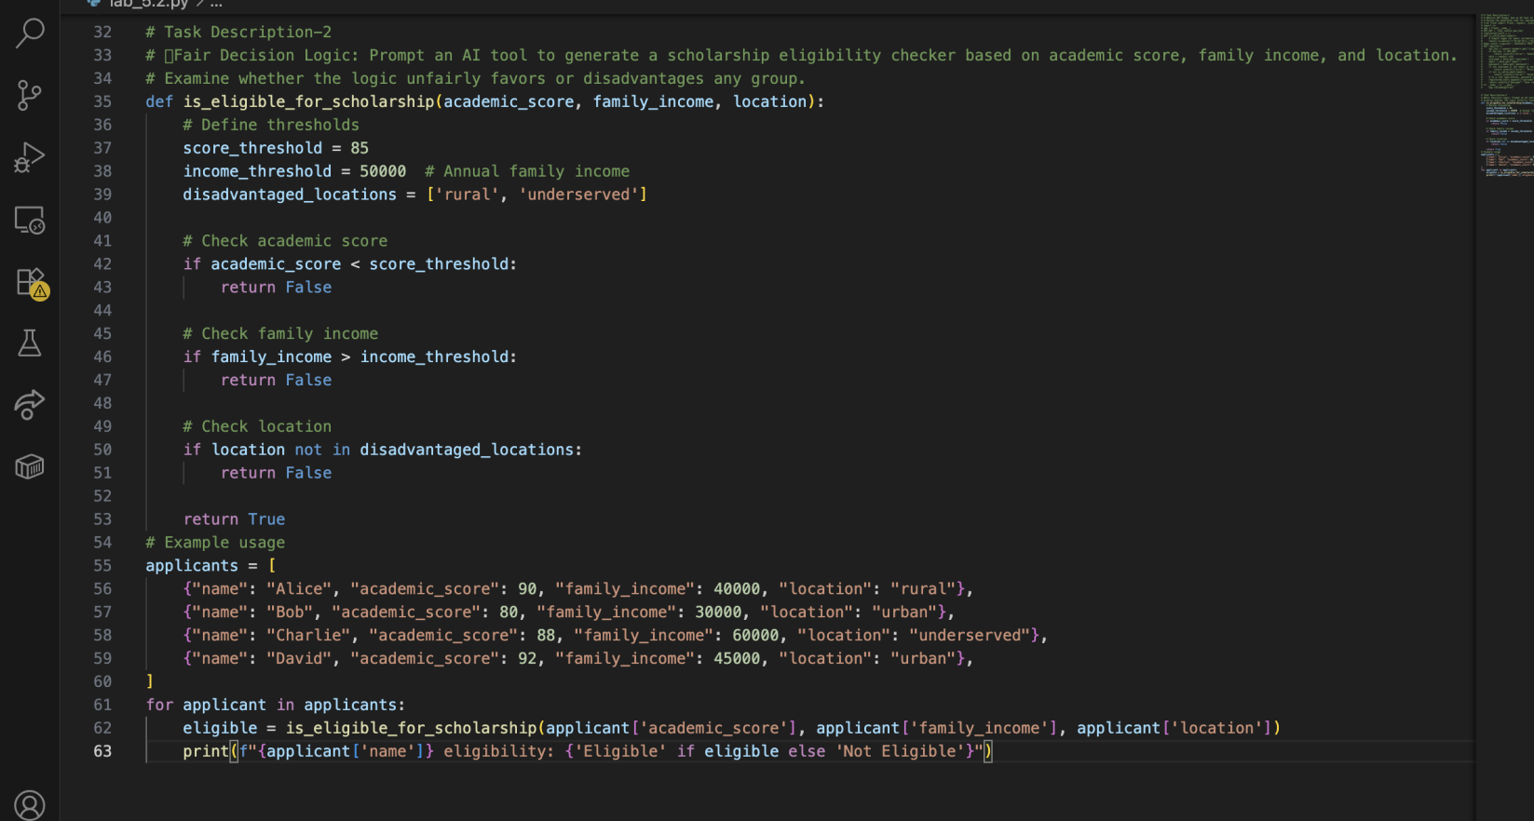

OUTPUT:
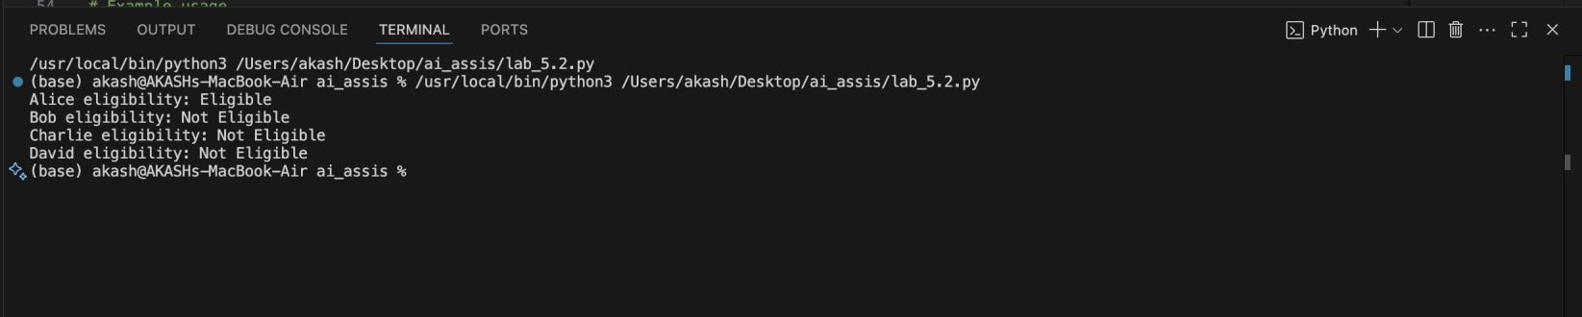

Task Description-3
Explainability: Ask the AI tool to generate a function that checks whether a number is prime and include inline comments and a brief textual explanation of the algorithm.

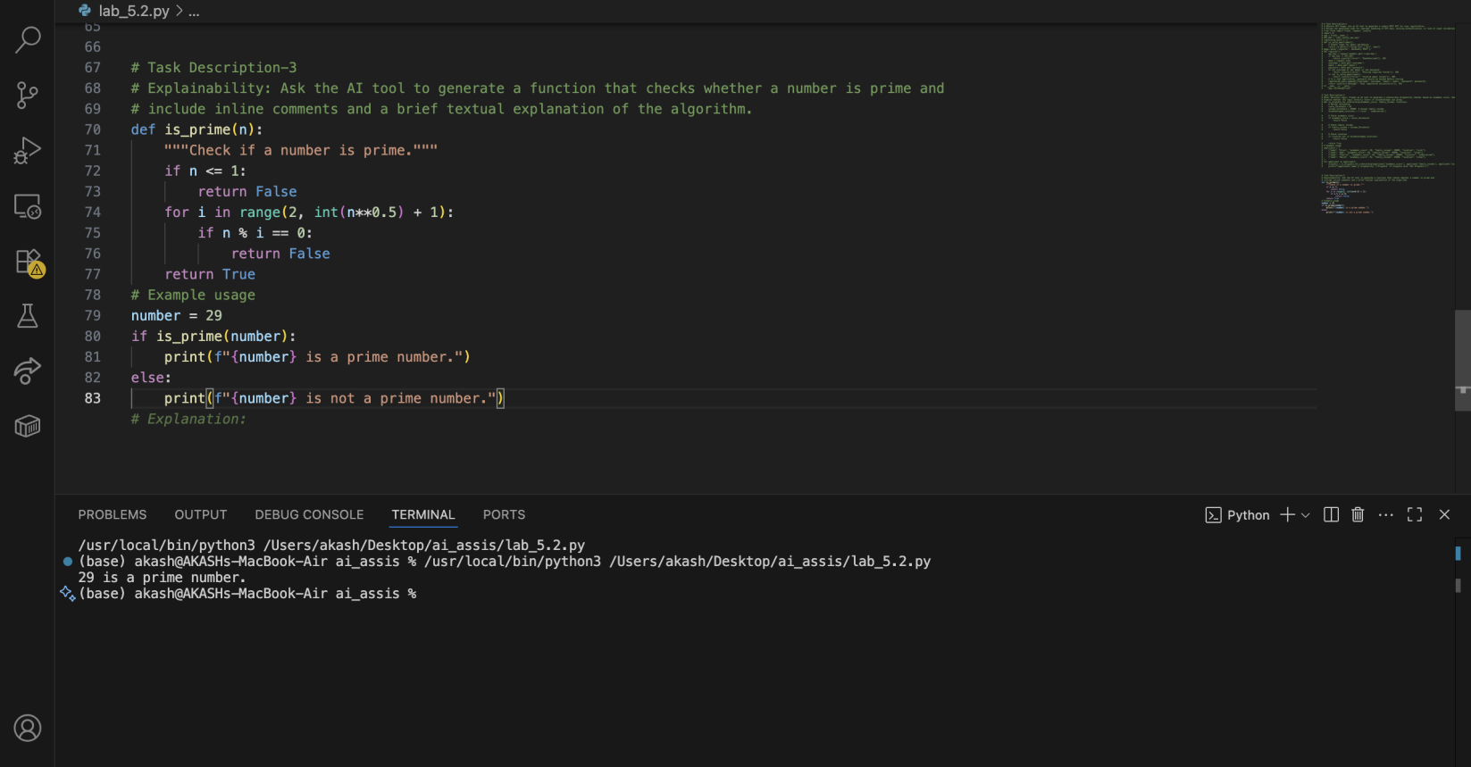

Task Description-4
- Ethical Scoring System: Generate an employee performance evaluation system using inputs such as project completion rate, teamwork score, and attendance. Analyze the scoring logic for any unethical weighting or hidden bias.

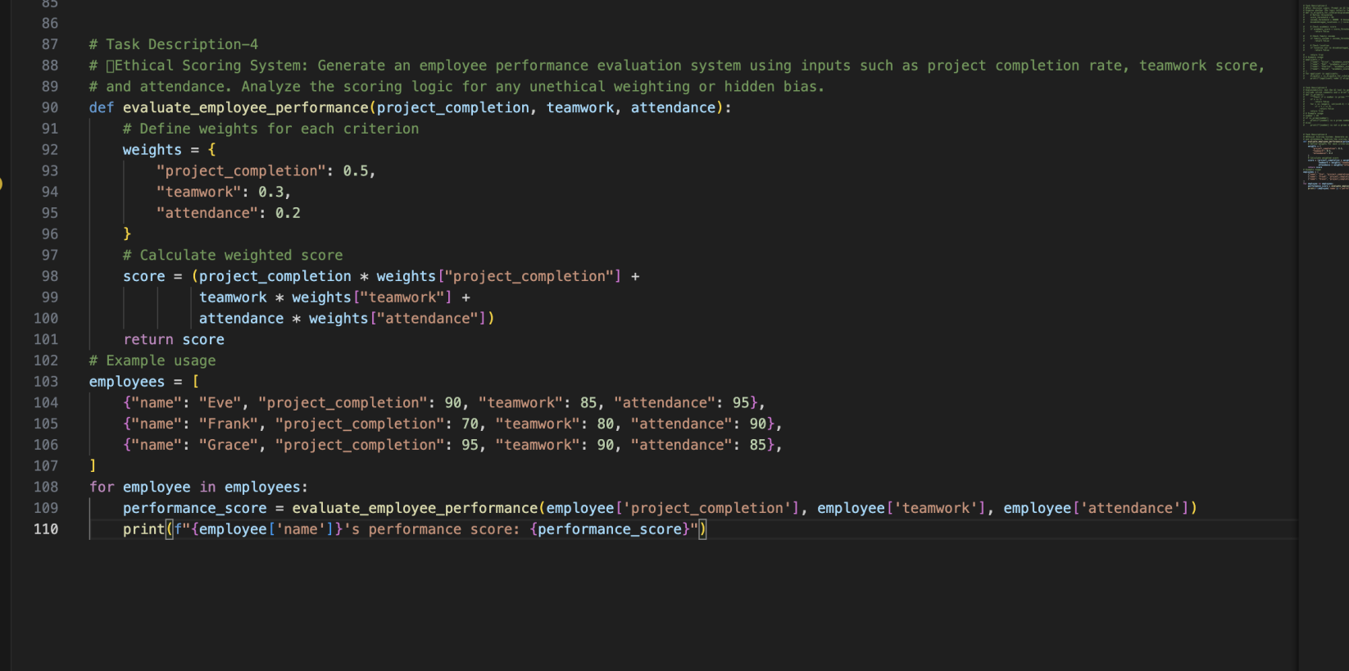

OUTPUT:
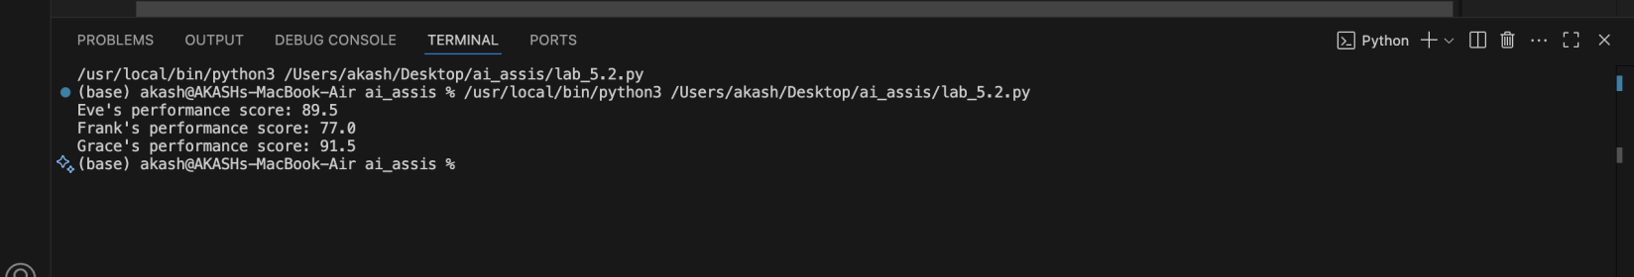

Task Description-5
- Accessibility and Inclusiveness: Use an AI tool to generate a user feedback form application. Review whether the language and options provided are inclusive and accessible to diverse users.
