SYSTEM ARCHITECTURE: -
Input/Ui=Collect users start location, destination, and algorithm choice.
Processing=Users Request, The Pathfinding modules (BFS, DFS, UCS, A*) using the campus graph.
Data Layer=Contains the campus Graph, Holds the building information and metadata (operating hours, facilities).
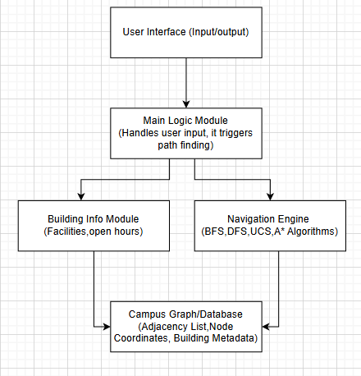
Output/Ui/Cli=Display path, Distance, walking time, Nodes explored. Shows building information.

BLOCK DIAGRAM: -

MODULES AND FEATURES: -
Ui=Take user input (start, end, algorithm), it gives output.
Pathfinding=BFS, DFS, UCS, A*, node exploration.
Campus Graph/Model=Adjacency list, node coordinates for A*, Campus map model.
Info Module=Building opening hours, facilities.
Performance Tracker=Counts node explored, measures distance, compares algorithm performance.
Database Layer=Stores and retrieves building data.

DATA DESIGN: -
Buildings Table= Stores Campus Locations with coordinates and descriptions. (Like Building name, type, description of building, Coordinates)
Paths Table= Defines the graph edges with distances and direction constraints. (Like Start destination, End destination, Distance)
Service Table= It holds the details about the what’s available inside each building for query responses. (Like Building name, what service available)
Algorithms query these tables to find paths and user responses with building information.
Coordinates support A* heuristic calculation for efficient searches.

