1.Prototype ChatBot: -
Using Tkinter I made User Interface. In the UI contains sections like Start, Destination, and Algorithms, and satellite view of university map.
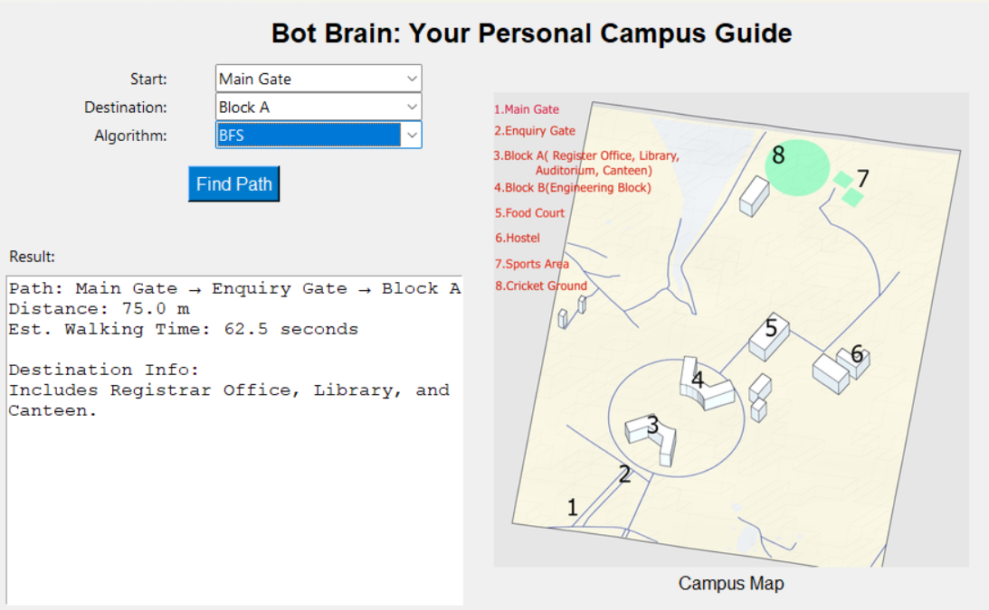

2.Working Data Base Connection: -
Open and maintain a live connection to campus data stored in a database (ex, SQLIte.)
Read campus building and path data from the database tables instead of relying on hardcoded dictionaries.
Query building details from the database to show accurate, up-to-date information.
Use the data fetched from the database as input to your path-finding algorithms to compute routes.
Send results back to the User Interface.

3.Navigation Integration: -
In BotBrain Project refers to linking your path-finding algorithms with UI and database so the system can:
Data Loading: Load nodes and edges from the database to create the in-memory graph structure for pathfinding.
Algorithm Execution: Run bfs, dfs, ucs, A* on the graph with selected start and destination points.
Result Formatting: Calculate path details nodes in path, total distance, time estimation.
UI Linking: Present results with paths and building info in the user interface.

