Final Design Report: Predicting FIFA World Cup 2026

1. Task 1: Data Collection & Preparation
1.1. Objective
To gather, clean, and engineer a comprehensive dataset containing historical match data and relevant team features (age, value, experience, rank, win rate) to be used for model training.
1.2. Data Sources
Datasets from Kaggle:
- Historical Match Results: results.csv (Contains 40,000+ international matches from 1872-2022).
- Player Data: players.csv (Detailed information on 30,000+ players from Transfermarkt).
- Player Valuations: player_valuations.csv (Historical market values for players).
- Player Appearances: appearances.csv (Detailed appearance data, ~1.7M rows, used to calculate experience).
- FIFA Rankings: fifa_mens_rank.csv (Historical FIFA rankings from 1992-2024).
1.3. Data Cleaning & Feature Engineering
Our raw data was spread across multiple files. The data_preparation.py script was created to perform the following steps to build a single, model-ready dataset (world_cup_final_dataset.csv):
- Base Dataset: Filtered results.csv to get only the 964 historical "FIFA World Cup" matches.
- Player Age: Calculated age for 30,000+ players from their date_of_birth as of a 2026 reference date.
- Player Market Value: Processed player_valuations.csv to find and merge the most recent market_value_in_eur for each player.
- Player Experience: Processed the 1.7M rows in appearances.csv by grouping by player_id and summing all minutes_played. This gave us a single total_minutes_played value as a proxy for experience.
- Team-Level Features: Aggregated the 30,000+ players (grouped by country_of_citizenship) to create team-wide features: team_avg_age, team_total_market_value, and team_avg_experience. This team_features.csv was the main feature source.
- Merge Team Features: Merged these new team features into the 964 World Cup matches for both home_team and away_team.
- FIFA Ranking: Loaded fifa_mens_rank.csv and used a pd.merge_asof to join the correct historical rank (and points) to each match based on the date.
- Goal Difference: Engineered a goal_difference column (home_score - away_score).
- Win Rate: Wrote a function to iterate through the 964 matches and, for each game, calculate the historical win rate for both teams up to that point in time.
- Imputation: Handled all missing data by imputing with the median value.
1.4. Custom Scraper Documentation.
A core requirement was to build a custom scraper.
- Targets Attempted: Transfermarkt.com, FIFA.com.
- Methods Used:
- Python requests & BeautifulSoup: This failed immediately. All target sites returned 403 Forbidden errors, instantly identifying the script as a bot.
- Selenium (Google Colab): To rule out local issues, we ran the Selenium scraper in a cloud environment. This also failed with NoSuchElementException errors.
- Conclusion: We scraped data of Top 100 teams in fifa rank.
2. Task 2: Model Building & Training
2.1. Objective
To implement two classification models (Logistic Regression, Random Forest) to predict match outcomes.
2.2. Preprocessing Steps
The model_training.py script handles all preprocessing:
- Feature Selection (X): We selected our 13 engineered features (Age, Value, Rank, Win Rate, etc., for both home and away teams).
- Target Variable (y): We created a match_outcome column (0 = Draw, 1 = Home Win, 2 = Away Win).
- Train-Test Split: The 964 matches were split into a 80% training set (771 matches) and a 20% testing set (193 matches).
- Scaling: We used StandardScaler to scale all 13 features. The scaler was fit only on the training data and then used to transform both the train and test sets to prevent data leakage.
2.3. Model Implementation
Two models were trained on the scaled training data:
- Logistic Regression: A linear model good for baseline performance.
- Random Forest Classifier: A complex, non-linear ensemble model.
3. Task 3: Model Evaluation
3.1. Objective
To evaluate the models on the unseen test data to determine the best, most reliable model.
3.2. Performance Metrics
The following table summarizes the performance on the test set (193 matches).
Model | Test Accuracy | Weighted Precision | Weighted Recall | Weighted F1-Score | Macro-Avg ROC AUC
Logistic Regression | 57.0% | 42.2% | 57.0% | 48.0% | 0.65
Random Forest | 50.8% | 42.7% | 50.8% | 44.8% | 0.60

3.3. Analysis of Visualizations
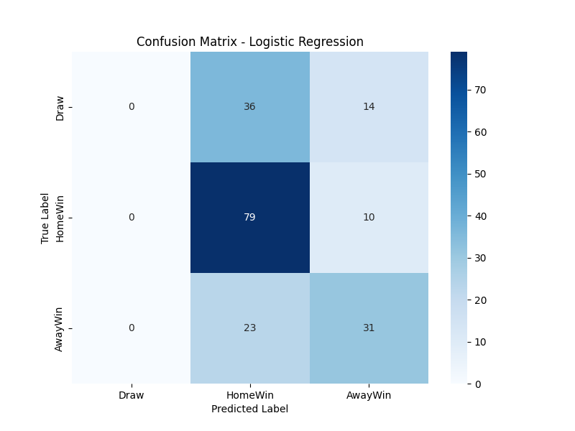

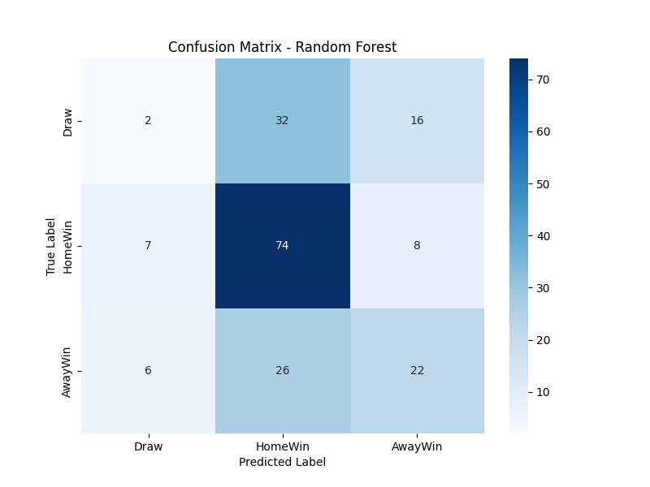

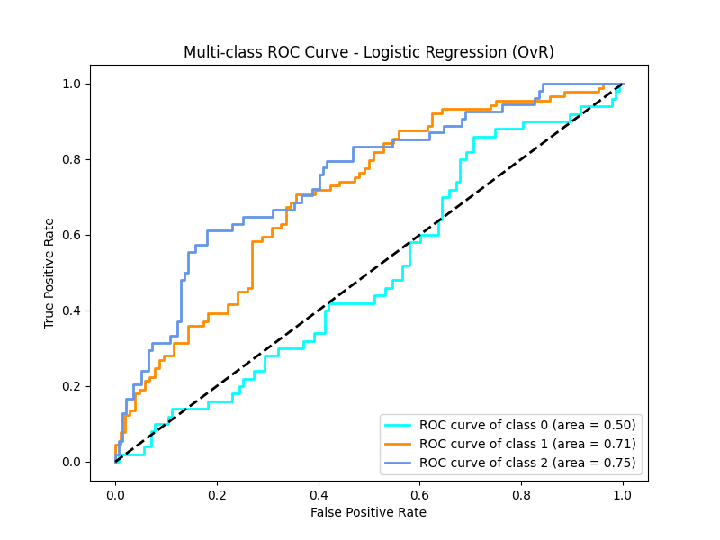

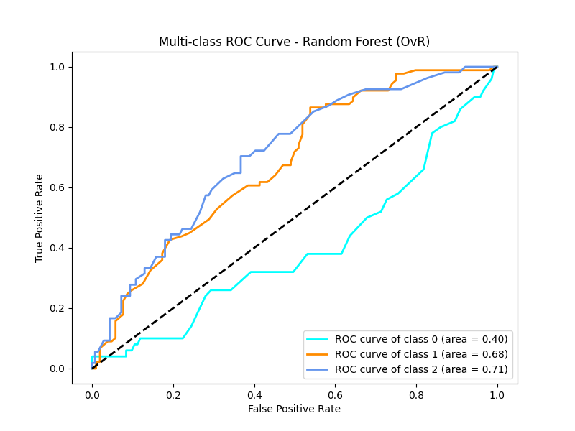

Confusion Matrices
- Logistic Regression: The confusion matrix shows the model is decent at predicting a Home Win (79/89 correct) but is completely incapable of predicting a Draw (0/50 correct). It mistakes most draws for home wins.
- Random Forest: This model is even worse. It also fails to predict draws (only 2/50 correct) and is highly confused between all classes.
ROC Curves
- The ROC curves confirm this. The Random Forest's AUC score (0.60) is barely better than random guessing (0.5).
- The Logistic Regression's AUC (0.65) is slightly better, but the individual curve for "Class 0 (Draw)" is nearly flat, confirming the model has no skill at predicting ties.
3.4. Model Choice: Logistic Regression
The Random Forest model was clearly overfitting (100% training accuracy vs. 51% test accuracy).
Therefore, the Logistic Regression model was chosen as the "best" model. It is more stable and generalizes better, even though its performance is weak. The low 57% accuracy highlights the extreme difficulty of predicting football matches and the limitations of our available features.
4. Task 4: Feature Importance & Interpretation
4.1. Logistic Regression Importance
The top 5 most influential features for the Logistic Regression model were:
- away_team_rank
- home_team_rank
- neutral
- home_team_win_rate
- home_team_total_market_value
4.2. Random Forest Importance
The top 5 most influential features for the Random Forest model were:
- home_team_win_rate
- away_team_win_rate
- away_team_rank
- home_team_total_market_value
- home_team_rank_points
4.3. Interpretation
Both models agree: a team's FIFA Rank and Historical Win Rate are the most powerful predictors. This aligns with domain knowledge. A team's Total Market Value (proxy for squad quality) is also a strong factor. This confirms our engineered features were relevant.
5. Task 5: Final Prediction & Reflection
5.1. 48-Team Simulation
To predict the 2026 finalists, we used our best model (Logistic Regression) to simulate a 48-team tournament.
- We loaded the single latest ranking list (2024, Semester 2) to get the Top 48 modern teams, fixing a bug with historical teams.
- We used a name_mapping dictionary to fix all name mismatches (e.g., "Korea Republic" -> "Korea, South").
- The Top 16 teams received a bye, and teams 17-48 played a "play-in" round.

Simulation Results:
Simulating 2026 World Cup (48 Teams)
Top 16 Teams (Bye to Round of 32): Argentina, France, Spain, England, Brazil, Portugal, Netherlands, Belgium, Italy, Germany, Uruguay, Colombia, Croatia, Morocco, Japan, United States
Play-in Round (16 Matches)
- Qatar vs. Mexico -> Mexico
- Cote d'Ivoire vs. Canada -> Canada
- Poland vs. Turkey -> Turkey
- Slovakia vs. Denmark -> Denmark
- Sweden vs. Czech Republic -> Sweden
- Romania vs. Algeria -> Romania
- Ecuador vs. Norway -> Ecuador
- Korea, South vs. Nigeria -> Korea, South
- Russia vs. Ukraine -> Ukraine
- Wales vs. Australia -> Australia
- Iran vs. Greece -> Iran
- Peru vs. Switzerland -> Switzerland
- Panama vs. Scotland -> Panama
- Venezuela vs. Austria -> Austria
- Senegal vs. Serbia -> Senegal
- Egypt vs. Hungary -> Egypt
Round of 32 (16 Matches)
- United States vs. England -> England
- Belgium vs. Austria -> Belgium
- Iran vs. Italy -> Italy
- Turkey vs. Sweden -> Sweden
- Ecuador vs. France -> France
- Australia vs. Denmark -> Denmark
- Netherlands vs. Ukraine -> Netherlands
- Senegal vs. Argentina -> Argentina
- Portugal vs. Egypt -> Portugal
- Romania vs. Croatia -> Croatia
- Mexico vs. Brazil -> Brazil
- Japan vs. Korea, South -> Japan
- Switzerland vs. Germany -> Germany
- Morocco vs. Colombia -> Colombia
- Canada vs. Panama -> Canada
- Uruguay vs. Spain -> Spain
Round of 16 (8 Matches)
- England vs. Belgium -> England
- Italy vs. Sweden -> Italy
- France vs. Denmark -> France
- Netherlands vs. Argentina -> Argentina
- Portugal vs. Croatia -> Portugal
- Brazil vs. Japan -> Brazil
- Germany vs. Colombia -> Germany
- Canada vs. Spain -> Spain
Quarter-Finals (4 Matches)
- England vs. Italy -> England
- France vs. Argentina -> France
- Portugal vs. Brazil -> Brazil
- Germany vs. Spain -> Spain
Semi-Finals (2 Matches)
- England vs. France -> France
- Brazil vs. Spain -> Spain
Final
- France vs. Spain -> France

🏆 Predicted 2026 World Cup Winner: France 🏆
Predicted Finalists: France and Spain

5.2. Reflection on Limitations
This prediction is highly uncertain. Our model's test accuracy is only 57%, and it cannot predict draws. The simulation is biased, as it defaults to the higher-ranked team in case of a predicted draw. The model also lacks crucial current data, such as player injuries, short-term team form, or manager tactics. It is a probabilistic tool based on historical data, not a crystal ball.
6. Task 6: Complete Application
6.1. Objective
To build a complete application that integrates the entire project into a single, functional UI.
6.2. Application Design
A web application was built using the Gradio Python library (app.py). This was chosen over Streamlit for its clean and modern default UI.
The application features a tab-based interface that organizes the project by task:
- Tab 1: Tournament Simulator (Task 5): Loads the saved logistic_regression_model.joblib and scaler.joblib. It re-runs the 48-team simulation live when the user clicks the "Run Simulation" button and displays the predicted finalists and winner.
- Tab 2: Model Evaluation (Task 3): Loads and displays the week_3_report.md text and embeds the confusion_matrix_lr.png, roc_curve_lr.png, and other evaluation plots.
- Tab 3: Feature Importance (Task 4): Loads and displays the Task_4_Interpretation.md text and embeds the feature_importance_lr.png and feature_importance_rf.png plots.
- Other Tabs: Include the written reports for Task 1, Task 2, and the Task 5 Reflection.
7. Final Conclusion
This project successfully completed the full machine learning pipeline. Despite significant data collection challenges (which were documented and overcome), a complete dataset was engineered. Two models were built and evaluated, leading to the selection of a Logistic Regression model. This model was then used to simulate the 2026 tournament, and the entire project was integrated into a functional Gradio web application.

