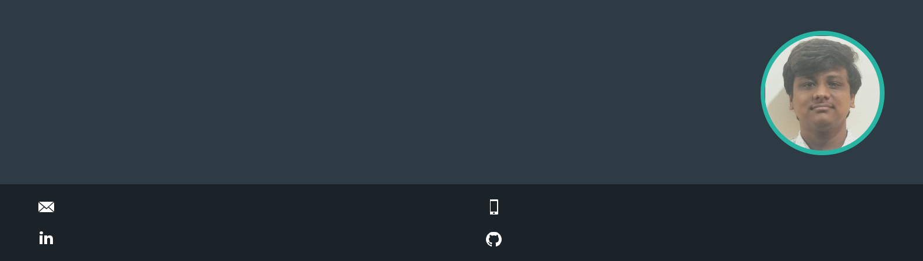
AKASH S

Full Stack Developer

Practical and versatile self learner who adds creativity to solve problems and commited to a life long learning.

akashsan362000@gmail.com

linkedin.com/in/akash-s-67b2391b6

EDUCATION

B.E - Electronics and Communication
R.M.K. College of Engineering and Technology

07/2017 - Present, | 8.527

HSC
N K S Vivekananda Vidyalaya Junior College

2016 - 2017, 91.6%

SSLC
N K S Vivekananda Vidyalaya Junior College

2014 - 2015, 9.8

PROJECTS

Instagram

MERN Stack - https://instagram632000.herokuapp.com/

COVID - 19 Tracker

React - https://covid---19---tracker-daac5.web.app/

Alan AI News App

React - https://news-app-c39fc.web.app/

Hackers Poll

MERN Stack - https://hackerpoll36.herokuapp.com/

Real time vehicle detection

YOLO v3 (You only look once) Algorithm

CORPORATE TRAINING

Data Science using Python
Glosys Technology Solutions Pvt. Ltd.

01/2019 - 05/2019,

INTERNSHIP

Full Stack Web Development
Glosys Technology Solutions Pvt. Ltd.
01/2020 – 06/2020,

+91 - 894 608 7368

github.com/AkashSanthosh36

PROFESSIONAL SKILLS
ReactJs
NodeJs
MongoDB
REST API
Machine Learning
SQL
Microservices
Docker
Git

PROGRAMMING SKILLS

- C
- Python
- Javascript

PERSONAL SKILLS

- Team Building and Collaborative
- Reliable and Consistent
- Lifelong Learner

LANGUAGES


English

Tamil


Malayalam

INTERESTS

Full Stack Development Artificial Intelligence


Machine Learning

