SSL Messages dumped from WireShark:

1.TLSv1.2 Record Layer: Handshake Protocol: Client Hello

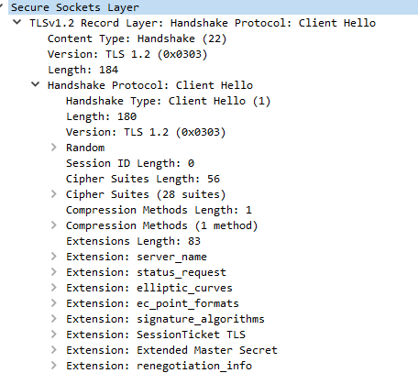

2. Server Hello, Certificate, Certificate Status, Server Key Exchange, Server Hello Done

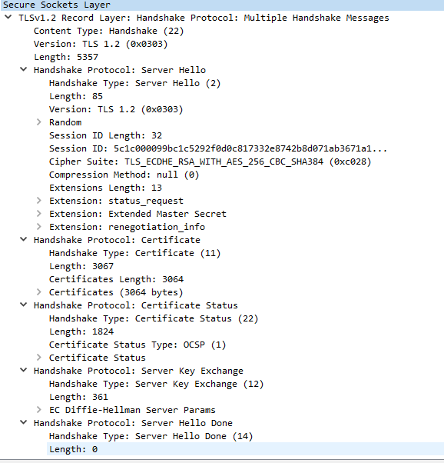

3. Client Key Exchange, Change Cipher Spec, Encrypted Handshake Message

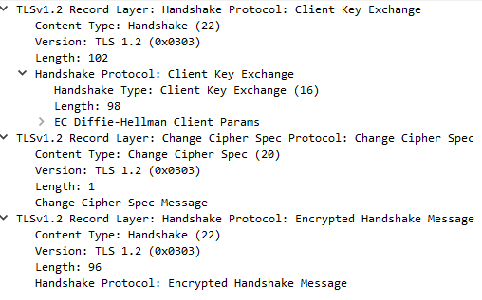

4. Change Cipher Spec, Encrypted Handshake Message

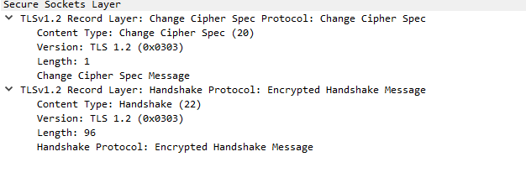

5.Client Hello:

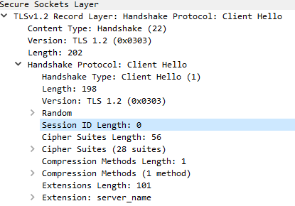

6. Server Hello, Certificate, Certificate Status, Server Key Exchange, Server Hello Done

7.

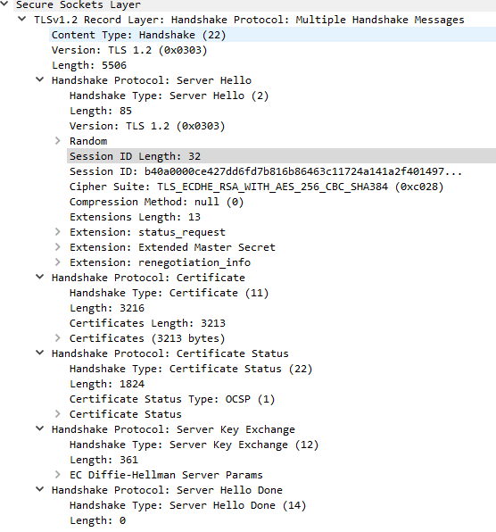

7. Client Key Exchange, Change Cipher Spec, Encrypted Handshake Message

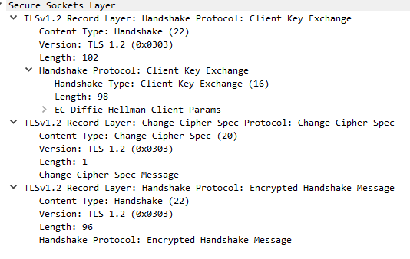

8. Change Cipher Spec, Encrypted Handshake Message

