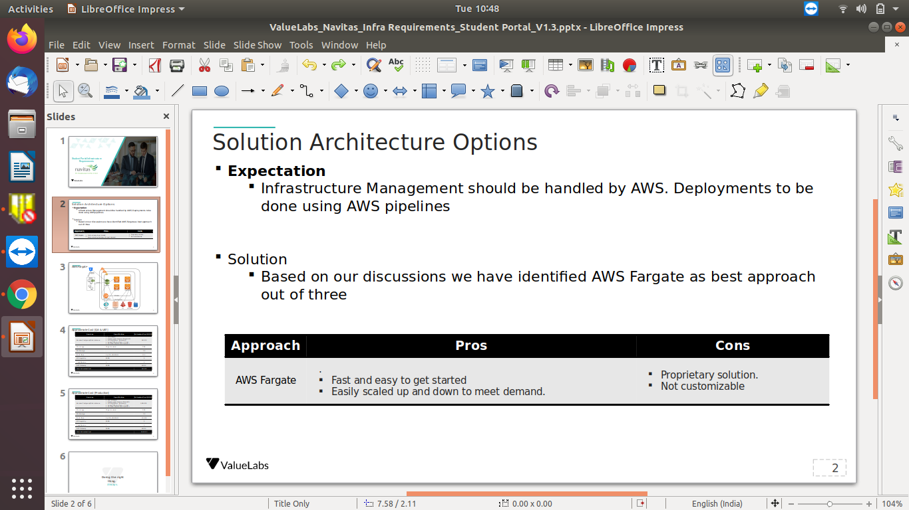

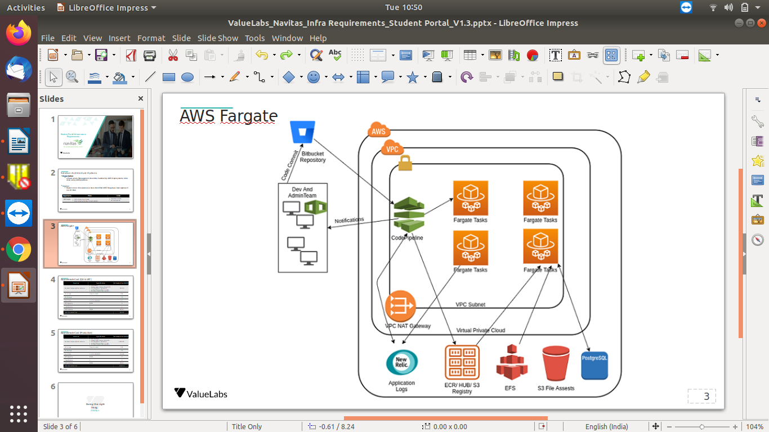

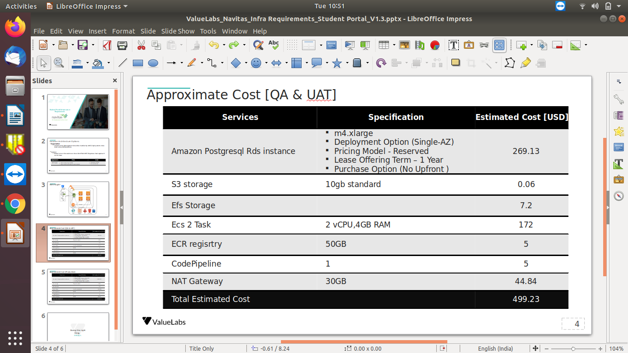

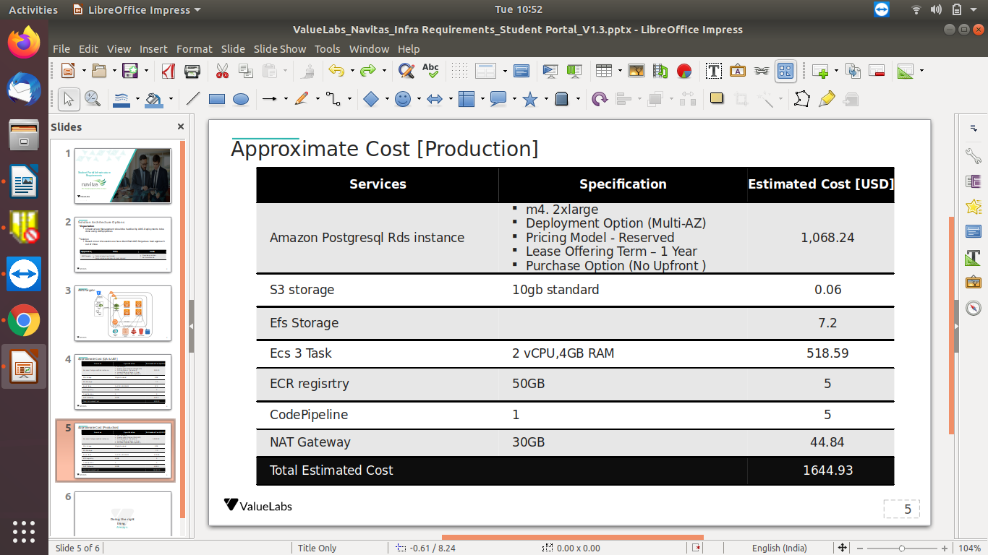

***Timeline – Plan of Action***

|  |  |
| --- | --- |
| **Actions** | **Timeline** |
| CloudFormation Templates – Basic Structure | 7 days |
| Preliminary Development Testing (Connetions and basic functionality) | 4 days |
| Re-iteration and changes | 4 days |
| Development Deployment (Including final tests) | 2 day |
| Production Deployment | 1 day |
| Infrastructure Test | 2 day |