**Project Report – INT 301**

**Open Source Technologies**

* Introduction

Hardware and software monitoring open source software are tools that allow users to keep track of their computer systems' performance and health. These tools provide real-time monitoring and reporting of various hardware and software components, including CPU usage, memory usage, disk utilization, network traffic, and other vital system parameters. Hardware and software monitoring open source software are widely used by system administrators, IT professionals, and computer enthusiasts to diagnose and troubleshoot issues and optimize system performance. They provide detailed information about system resource utilization and can help identify potential problems before they cause significant issues.

* Objective of the project

To successfully assess the ongoing software and hardware system detail with live monitoring of temperature and current usage of components

* Description of the project

This project aims to successfully conduct the usage of one of the various hardware and software monitoring open source software. Hardware and software monitoring open source software are essential tools for ensuring the health and optimal performance of computer systems. By regularly monitoring system resources, users can proactively address any issues and ensure that their systems are running efficiently.

* Scope of the project

Hardware and software monitoring open source software is a critical tool for system administrators and IT professionals to monitor the performance of their computer systems. Hardware monitoring tools monitor the physical components of a system such as CPU, RAM, and hard drives, while software monitoring tools monitor the software applications and services running on the system. Open source software monitoring tools are freely available for download, and their source code can be modified and distributed by anyone. This makes them an attractive option for businesses and organizations that need to monitor their systems but want to avoid the high cost of proprietary software solutions.

* Analysis Report

Hardware and software monitoring open source software are tools designed to monitor and track the performance of computer hardware and software components. These tools are used by system administrators and IT professionals to ensure that computer systems are running optimally and to detect and troubleshoot any issues that may arise. Hardware monitoring open source software focuses on monitoring the physical components of a computer system, including the CPU, RAM, hard drives, and network interfaces. These tools typically collect data such as temperature, voltage, and utilization levels to provide administrators with a real-time view of system health. Some popular open source hardware monitoring tools include lm-sensors, OpenHardwareMonitor, and Psensor.

Software monitoring open source software, on the other hand, is designed to monitor the performance of software applications and services running on a system. These tools typically collect data such as CPU and memory usage, network traffic, and response times to provide administrators with a comprehensive view of software performance. Both hardware and software monitoring open source software provide administrators with a range of features and capabilities. For example, these tools may offer customizable dashboards and alerts, detailed reporting capabilities, and the ability to integrate with other tools and systems. Additionally, many open source monitoring tools are highly extensible, allowing administrators to modify and customize the software to meet their specific needs.

Overall, hardware and software monitoring open source software provide critical insights into system performance and health. By leveraging these tools, administrators can identify and resolve issues quickly, leading to a more stable and efficient computing environment.

* System snapshots

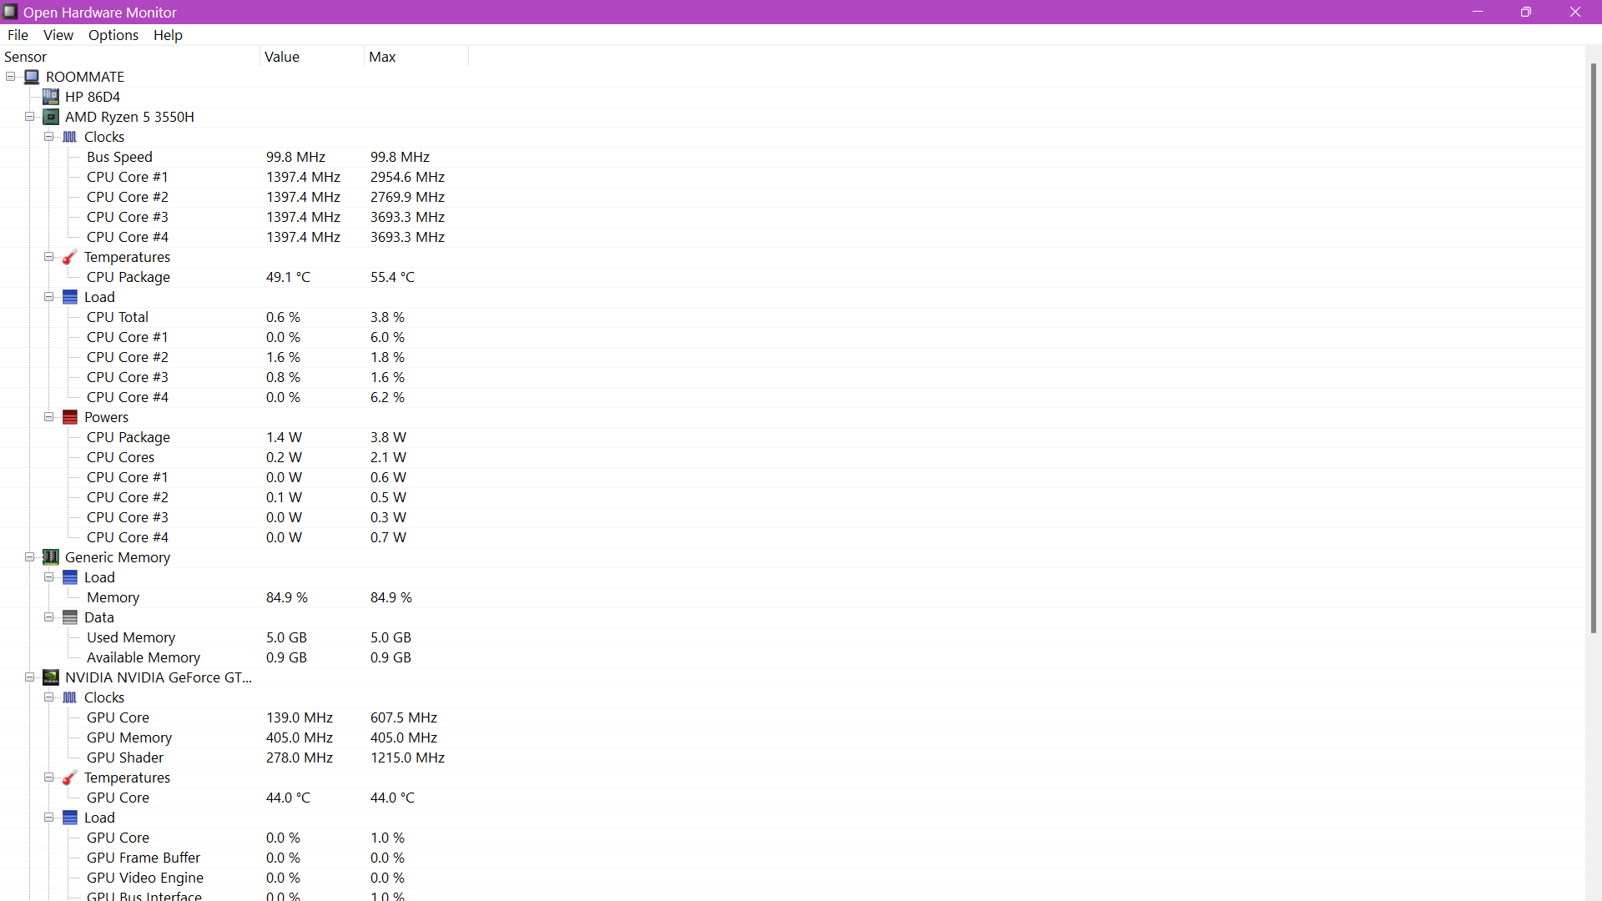Hardware used – Open Hardware Monitor

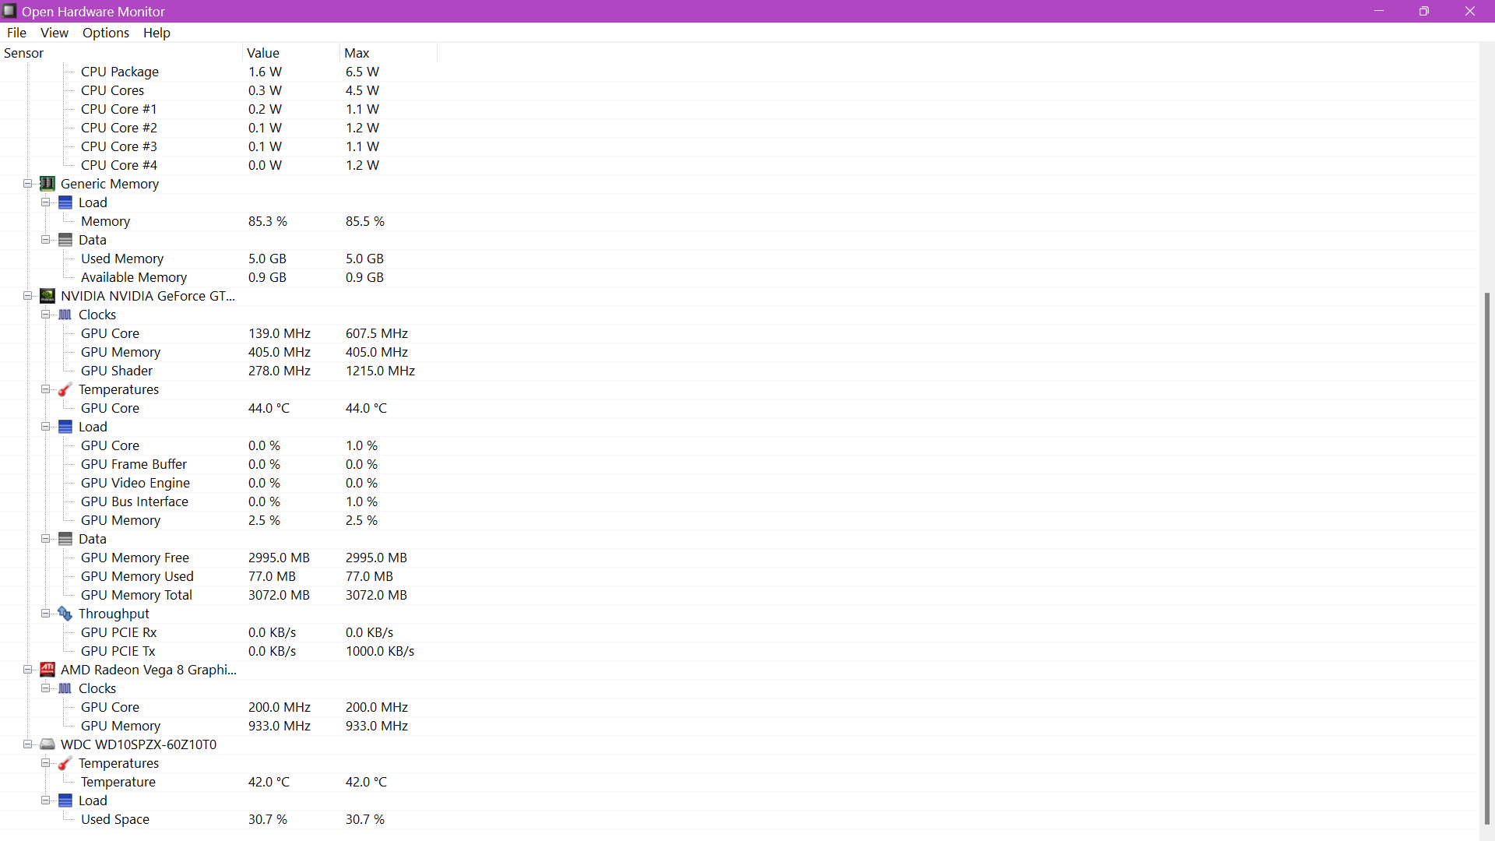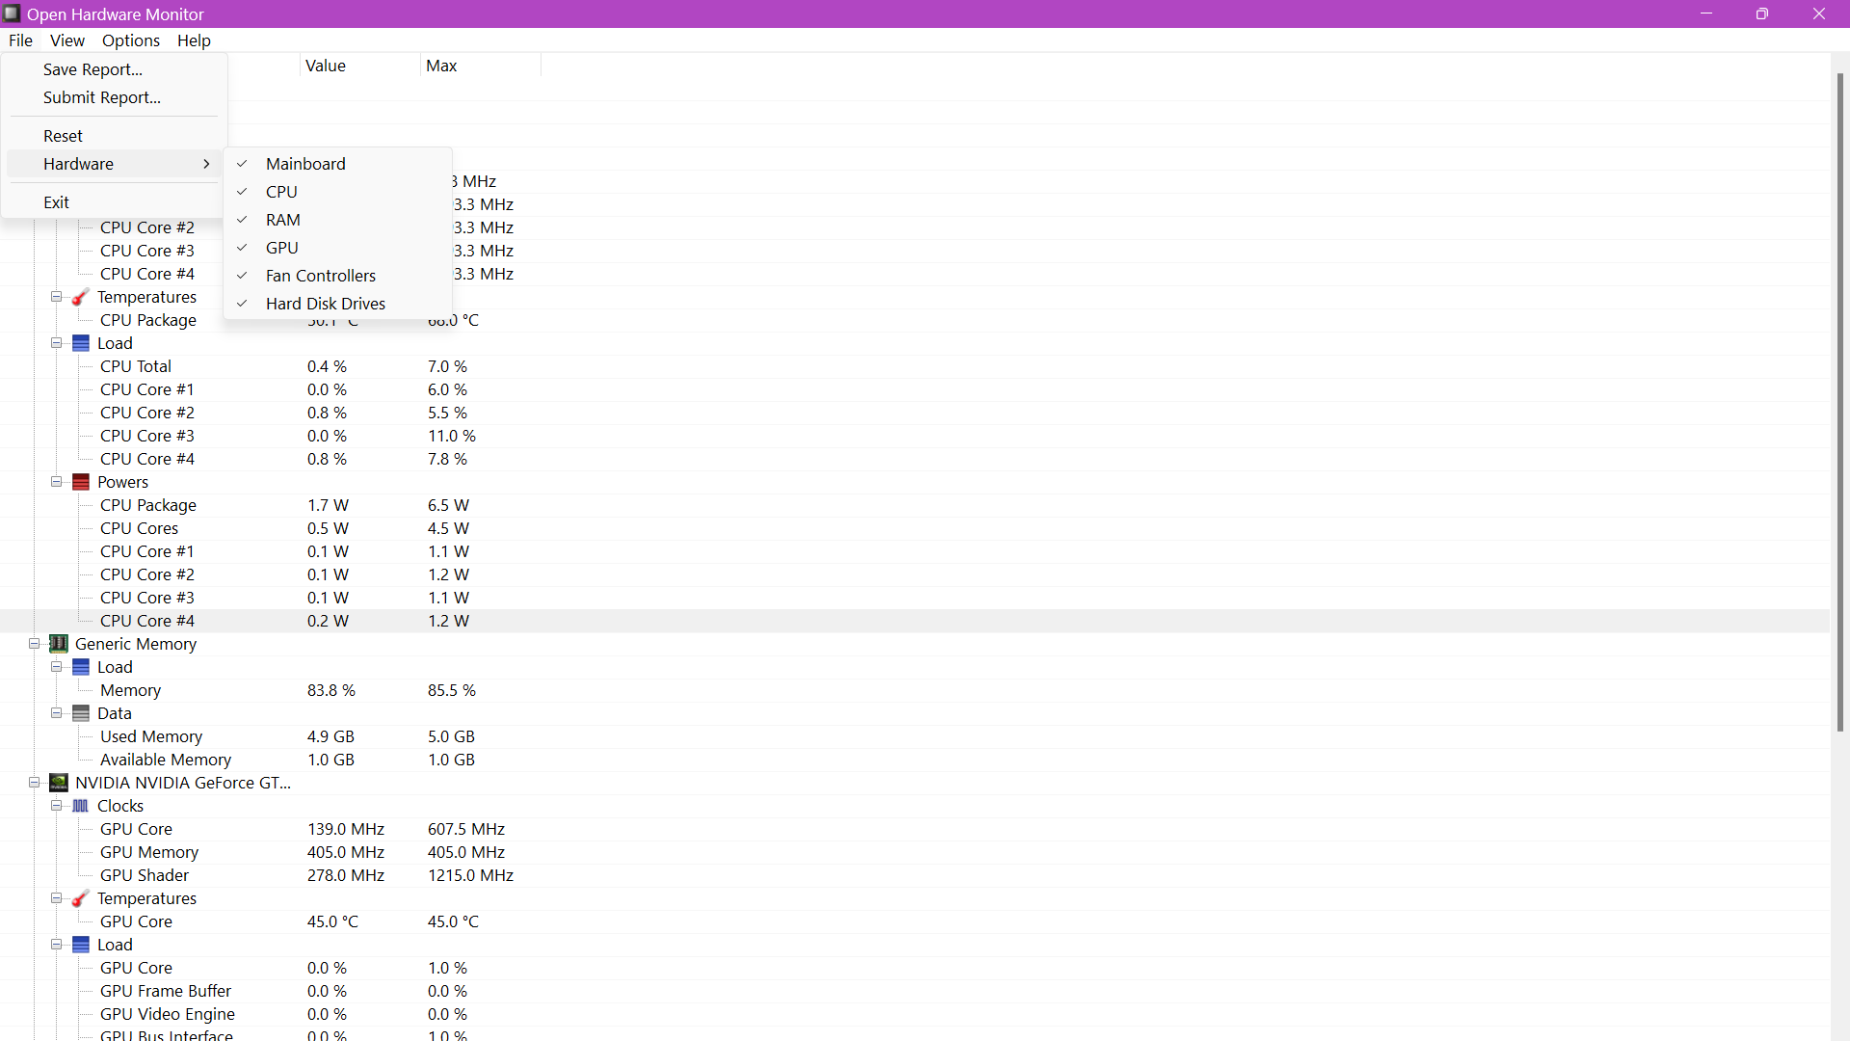

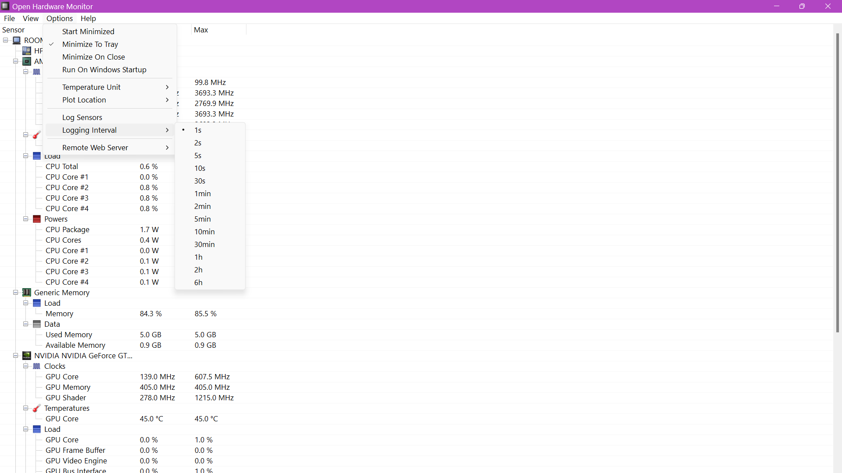

* **Bibliography**

I would like to thank my mentor, Rajeshwar Sharma for providing me this opportunity to be able to use an open source software for assessing the details of components used in the device. It was because of his knowledge that made my concepts clear and led a path towards successful completion of the project.