**CUSTOM VIEW**

**Topic:** Android app to demonstrate custom Button, Radio Button, Check Box through Custom View.

Name of Student: Akash Sharma

Registration Number: 11704669

Section: KM002

Roll No: B44

1. **Introduction**

Custom View is a sophisticated and powerful componentized model for building your UI, based on the fundamental layout classes. A partial list of available widgets includes [Button](https://developer.android.com/reference/android/widget/Button), [TextView](https://developer.android.com/reference/android/widget/TextView), [EditText](https://developer.android.com/reference/android/widget/EditText), [ListView](https://developer.android.com/reference/android/widget/ListView), [CheckBox](https://developer.android.com/reference/android/widget/CheckBox), [RadioButton](https://developer.android.com/reference/android/widget/RadioButton), [Gallery](https://developer.android.com/reference/android/widget/Gallery), [Spinner](https://developer.android.com/reference/android/widget/Spinner), and the more special-purpose [AutoCompleteTextView](https://developer.android.com/reference/android/widget/AutoCompleteTextView), [ImageSwitcher](https://developer.android.com/reference/android/widget/ImageSwitcher), and [TextSwitcher](https://developer.android.com/reference/android/widget/TextSwitcher)

1. **Screenshot**

2.1 activity_main layout

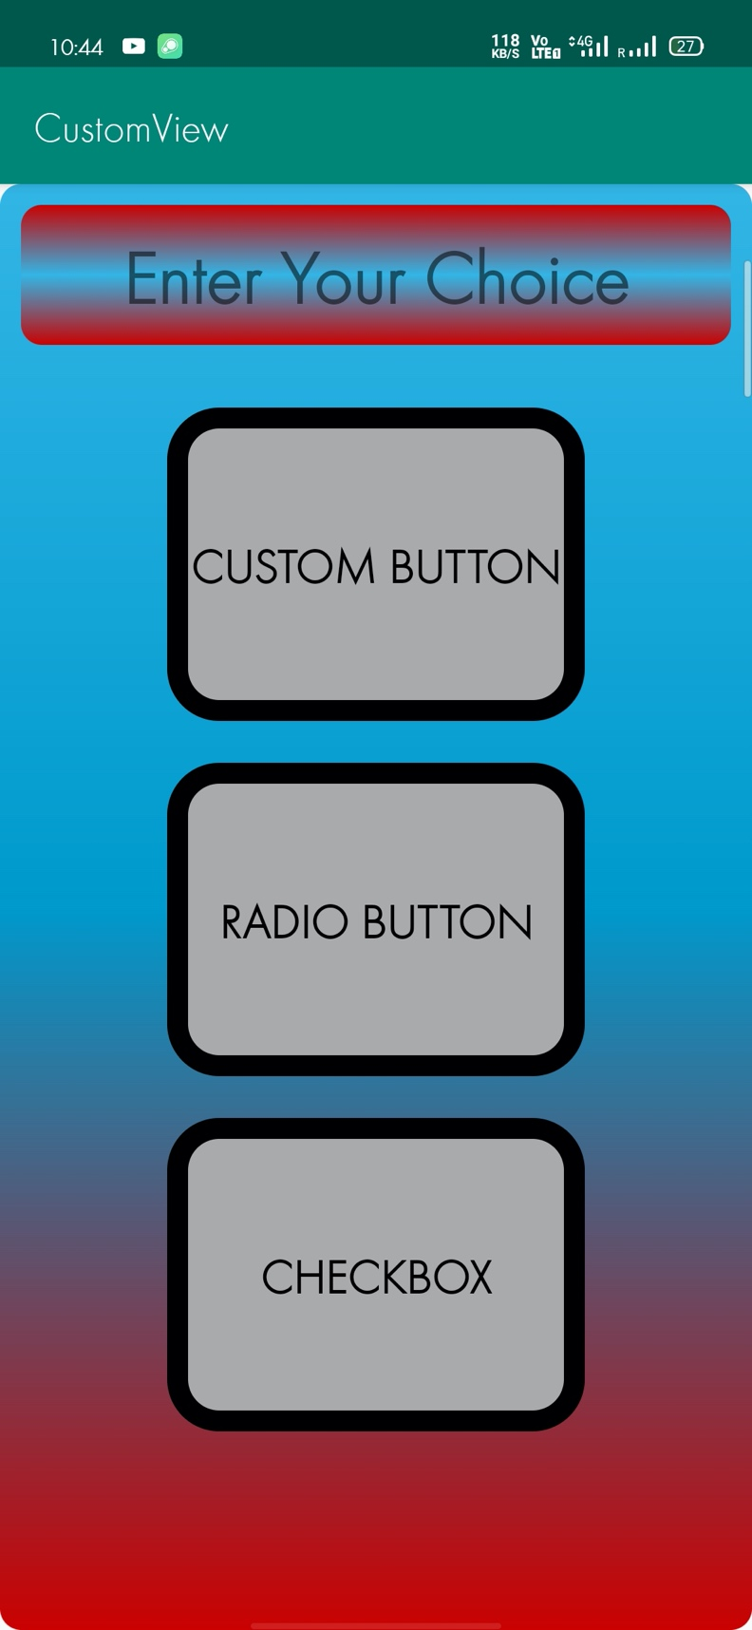

2.2 Custom Button Layout

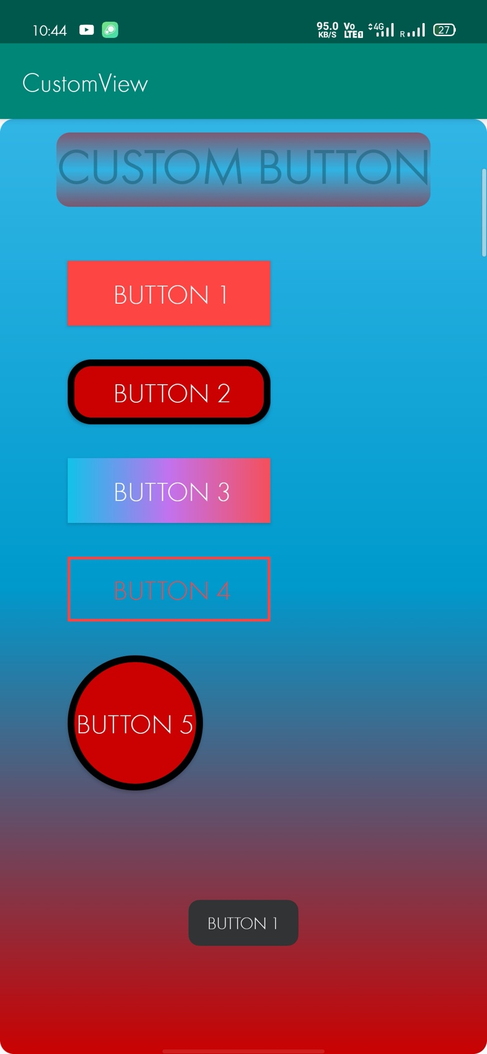

2.3 Radio Button Layout

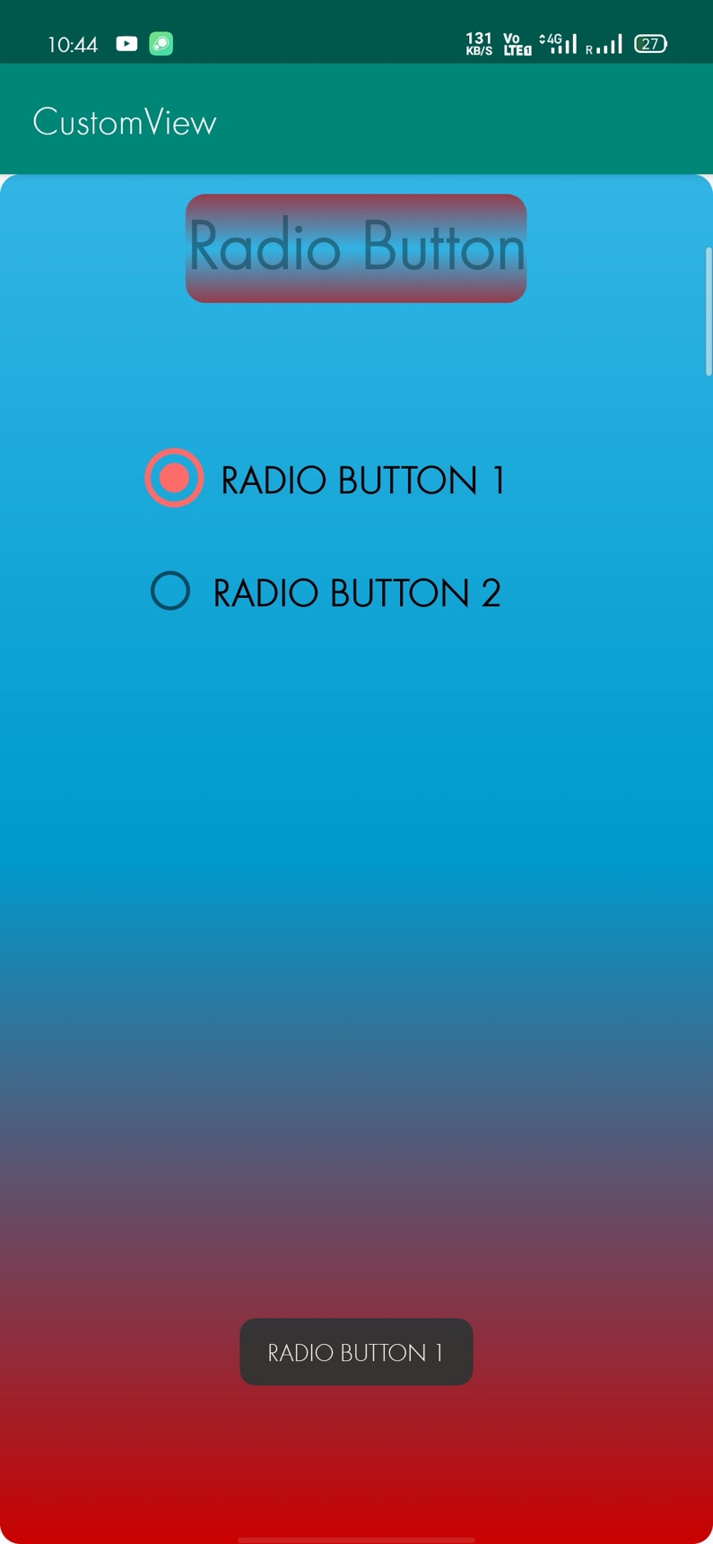

2.4 Check Box Layout

