1. **Write a program to configure routing with authentication with sharing information with and without login?**

**App.js**

import "./App.css";

import React from "react";

import { Link, Route, Routes } from "react-router-dom";

import Home from "../src/Pages/Home";

import Courses from "../src/Pages/Courses";

import Live from "../src/Pages/Live";

import Contact from "../src/Pages/Contact";

function App() {

  return (

    <div className="container">

<nav class="navbar bg-warning border-bottom border-body" data-bs-theme="dark">

<nav class="navbar navbar-expand-lg bg-body-primary">

  <div class="container-fluid">

    <a class="navbar-brand">Arpitha A T</a>

    <button class="navbar-toggler" type="button" data-bs-toggle="collapse" data-bs-target="#navbarNavDropdown" aria-controls="navbarNavDropdown" aria-expanded="false" aria-label="Toggle navigation">

      <span class="navbar-toggler-icon"></span>

    </button>

    <div class="collapse navbar-collapse" id="navbarNavDropdown">

      <ul class="navbar-nav">

        <li class="nav-item">

          <a class="nav-link active" aria-current="page">

            <Link to="/" class="list">

                Home

            </Link></a>

        </li>

        <li class="nav-item">

          <a class="nav-link">

              <Link to="/course" class="list">

                Courses

              </Link></a>

        </li>

        <li class="nav-item">

          <a class="nav-link">

              <Link to="/live" class="list">

                Live course

              </Link></a>

        </li>

        <li class="nav-item">

          <a class="nav-link">

              <Link to="/contact" class="list">

                Contact

              </Link></a>

        </li>

      </ul>

    </div>

  </div>

</nav>

</nav>

      {/* Defining routes path and rendering components as element */}

      <Routes>

        <Route path="/" element={<Home />} />

        <Route path="/course" element={<Courses />} />

        <Route path="/live" element={<Live />} />

        <Route path="/contact" element={<Contact />} />

      </Routes>

    </div>

  );

}

export default App;

**Home.js**

import React from 'react';

const Home = () => {

  return <div className='container1'>

      <div class="box">

       Welcome to <span color='red'>HOME PAGE.</span> Public information can be displayed here.

      </div>

    </div>;

};

export default Home;

**Courses.js**

import React from 'react'

function Courses() {

  return (

    <div className='container1'>

    <div class="box">

     This is <span>COURCES</span> component

    </div>

  </div>

  )

}

export default Courses;

**Live.js**

import React from 'react'

function Live() {

  return (

    <div className='container1'>

    <div class="box">

      This is <span>LIVE</span> component

    </div>

  </div>

  )

}

export default Live;

**Contact.js**

import React from 'react'

function Contact() {

  return (

    <div className='container1'>

      <div class="box">

      This is <span>CONTACT</span> component

      </div>

    </div>

  )

}

export default Contact;

**OUTPUT :**

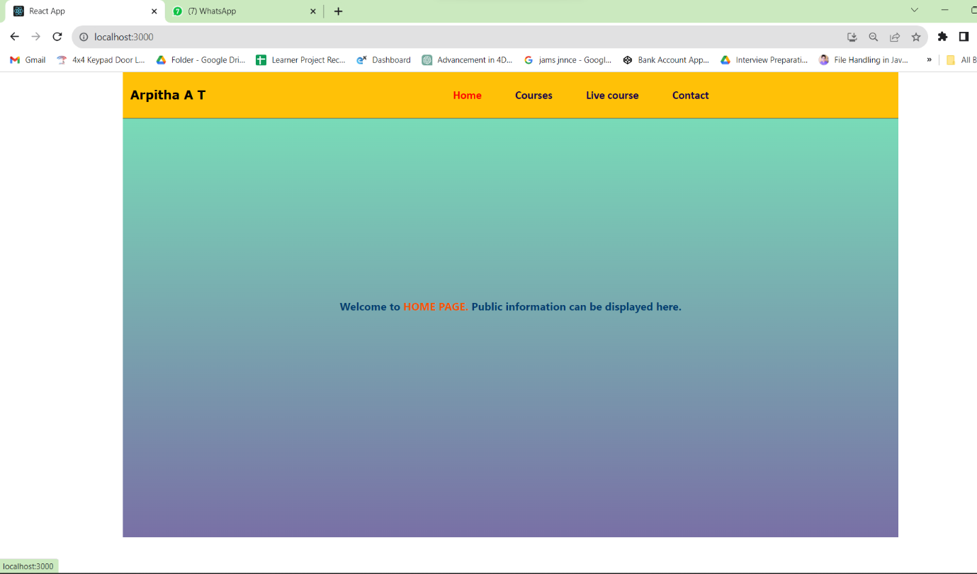

**Home page view(Default)**

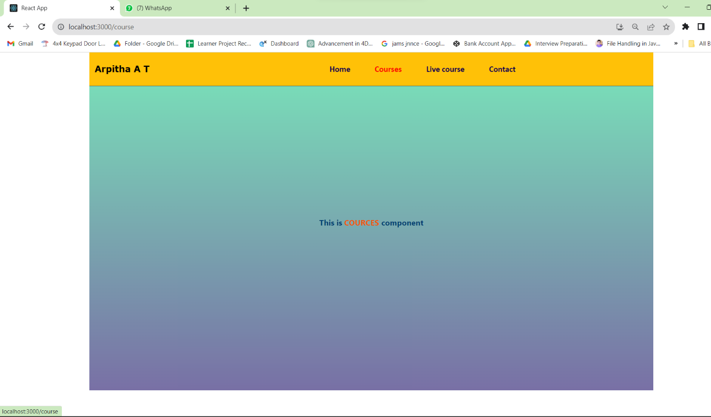

**Courses page view**

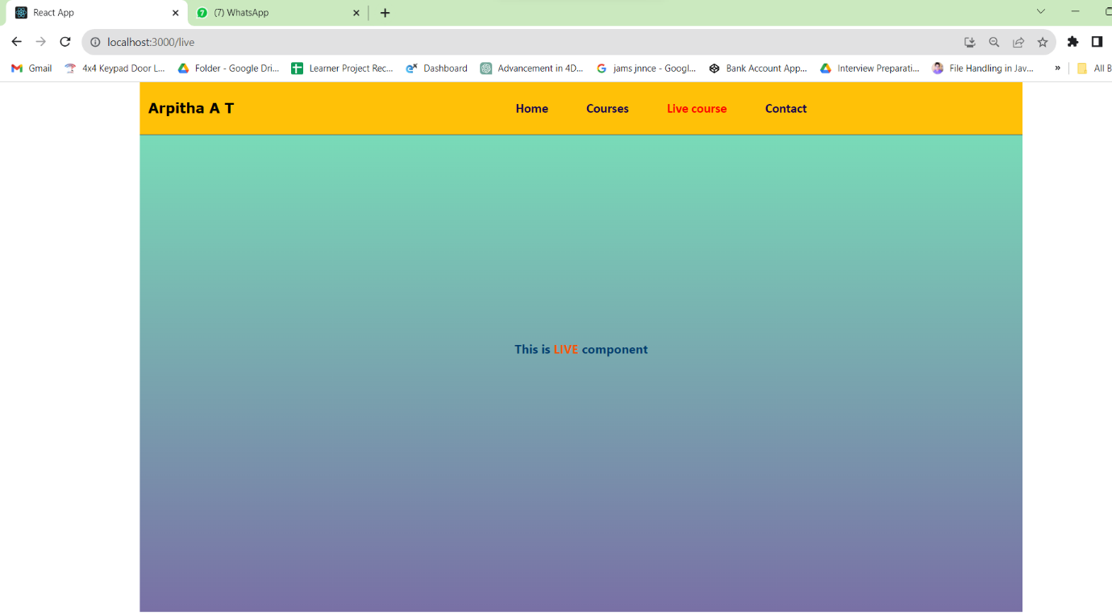

**Live page view**

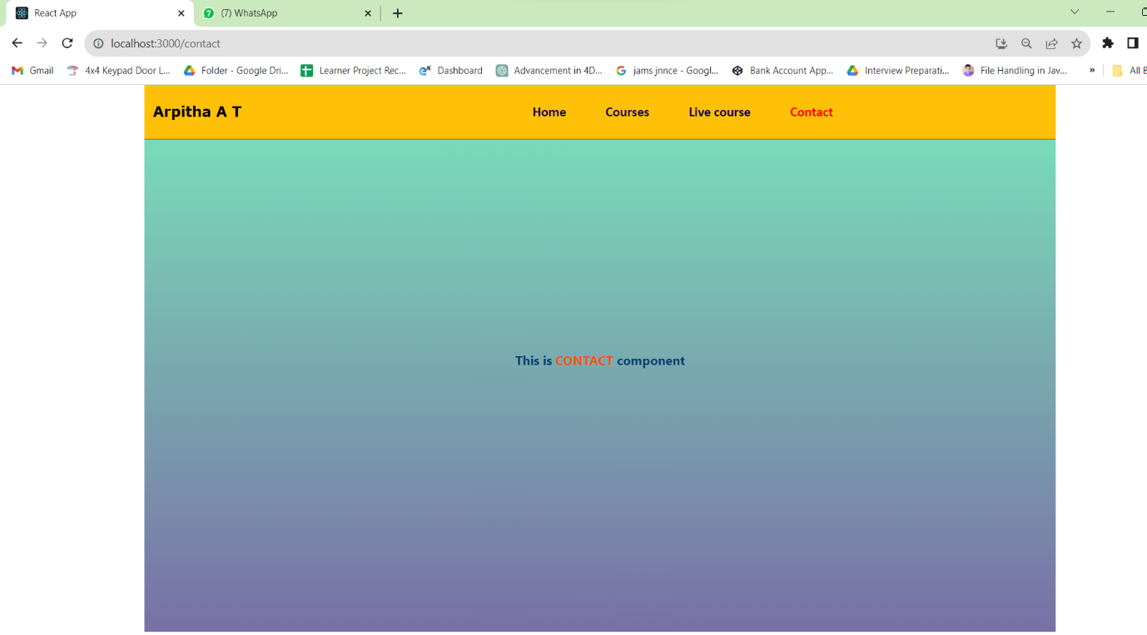

**Contact page View**