Sensors which are inside the area covered can also be detected if the no. of divisions of ϴ(Theta) are increased. Here we are using pi/150. If pi/200 is used (simulation time will increase), not detection sensors inside the area will reduced.

While performing in real life, the anchors will move in the given path but while simulations, the anchors will be like jumping from point to point.

In every trial results varies between 92-99, which is quite good performance with moderate tolerance and number of path generated for anchor. If tolrence become 0, the number of paths generated will also increase which will increase efficiency on the other hand, it will increase the cost of the execution.

**FIRST TRIAL**

>> circle3(20,25,60,40,100,25)

SENSER 1=(29.874273,23.185368)

SENSER 2=(51.772005,49.853189)

SENSER 3=(98.957618,27.179917)

SENSER 4=(45.667220,55.552113)

SENSER 5=(88.901235,44.257984)

SENSER 6=(113.629920,30.605982)

SENSER 7=(95.025502,27.130410)

SENSER 8=(101.903845,23.425850)

SENSER 9=(88.605181,58.586313)

SENSER 10=(62.795887,25.794918)

SENSER 11=(24.858970,19.404083)

SENSER 12=(13.304426,22.512603)

SENSER 13=(39.588477,20.526310)

SENSER 14=(98.054262,31.901119)

SENSER 15=(62.534646,46.458583)

SENSER 16=(14.431532,37.527009)

SENSER 17=(41.597842,20.077163)

SENSER 18=(68.953988,51.836258)

SENSER 19=(23.827569,40.347058)

SENSER 20=(108.219765,11.949431)

SENSER 21=(35.794098,29.791216)

SENSER 22=(106.788508,30.084875)

SENSER 23=(33.239429,32.037491)

SENSER 24=(68.909946,24.768264)

SENSER 25=(1.771640,42.165888)

SENSER 26=(60.809658,22.875966)

SENSER 27=(7.791784,21.514798)

SENSER 28=(28.110149,12.210243)

SENSER 29=(97.653550,23.606076)

SENSER 30=(6.429021,22.503095)

SENSER 31=(92.999301,9.917857)

SENSER 32=(109.466268,19.152347)

SENSER 33=(39.573560,12.254140)

SENSER 34=(92.065768,4.198389)

SENSER 35=(114.004074,9.492587)

SENSER 36=(34.373504,41.227747)

SENSER 37=(16.937979,30.725199)

SENSER 38=(86.559231,55.730708)

SENSER 39=(87.852462,44.990881)

SENSER 40=(48.878352,14.369502)

SENSER 41=(62.502057,13.144642)

SENSER 42=(101.086548,39.775975)

SENSER 43=(97.948234,47.632656)

SENSER 44=(56.292624,18.571499)

SENSER 45=(82.509510,59.211133)

SENSER 46=(92.392065,49.774851)

SENSER 47=(84.730172,35.720185)

SENSER 48=(90.344894,29.803332)

SENSER 49=(103.815918,4.081662)

SENSER 50=(116.225513,5.925379)

SENSER 51=(65.637250,24.178195)

SENSER 52=(12.844819,43.449970)

SENSER 53=(73.641882,46.978092)

SENSER 54=(67.994470,48.679150)

SENSER 55=(69.213103,56.641752)

SENSER 56=(104.574258,30.456132)

SENSER 57=(94.658780,28.381838)

SENSER 58=(99.456204,19.348895)

SENSER 59=(117.137584,16.692662)

SENSER 60=(8.739697,45.073416)

SENSER 61=(99.742634,55.340286)

SENSER 62=(39.242915,48.244156)

SENSER 63=(64.590040,27.797693)

SENSER 64=(98.490030,57.114390)

SENSER 65=(9.152747,42.520264)

SENSER 66=(28.191173,23.933733)

SENSER 67=(32.174931,49.950799)

SENSER 68=(119.444857,38.985059)

SENSER 69=(84.474340,55.938192)

SENSER 70=(82.518306,34.101235)

SENSER 71=(45.701704,38.074769)

SENSER 72=(43.587435,24.457167)

SENSER 73=(44.243967,28.103926)

SENSER 74=(60.409661,54.632147)

SENSER 75=(24.771723,20.316221)

SENSER 76=(68.895075,29.215946)

SENSER 77=(31.466278,34.775608)

SENSER 78=(105.399324,3.657013)

SENSER 79=(52.905176,5.055480)

SENSER 80=(67.588514,32.358635)

SENSER 81=(92.166948,13.985416)

SENSER 82=(70.483409,27.538432)

SENSER 83=(103.317783,39.650166)

SENSER 84=(42.465500,20.831178)

SENSER 85=(30.446172,57.151689)

SENSER 86=(35.784119,9.504365)

SENSER 87=(43.355647,44.497746)

SENSER 88=(84.708001,42.053530)

SENSER 89=(0.747094,22.460736)

SENSER 90=(108.179474,19.100690)

SENSER 91=(71.649951,17.867711)

SENSER 92=(15.001726,23.301340)

SENSER 93=(98.122529,58.870542)

SENSER 94=(103.438780,5.029253)

SENSER 95=(40.525439,14.167750)

SENSER 96=(38.136647,59.066904)

SENSER 97=(65.790107,44.955076)

SENSER 98=(101.022208,10.013382)

SENSER 99=(108.371713,6.307448)

SENSER 100=(89.411172,43.762316)

The visited sensers are

Senser 1

Senser 2

Senser 3

Senser 4

Senser 5

Senser 6

Senser 7

Senser 8

Senser 10

Senser 11

Senser 12

Senser 13

Senser 14

Senser 15

Senser 16

Senser 17

Senser 18

Senser 19

Senser 20

Senser 21

Senser 22

Senser 23

Senser 24

Senser 25

Senser 26

Senser 27

Senser 28

Senser 29

Senser 30

Senser 31

Senser 32

Senser 33

Senser 34

Senser 35

Senser 36

Senser 37

Senser 38

Senser 39

Senser 40

Senser 41

Senser 42

Senser 43

Senser 44

Senser 46

Senser 47

Senser 48

Senser 49

Senser 50

Senser 52

Senser 53

Senser 54

Senser 55

Senser 56

Senser 57

Senser 58

Senser 59

Senser 60

Senser 62

Senser 63

Senser 64

Senser 65

Senser 66

Senser 67

Senser 68

Senser 69

Senser 70

Senser 71

Senser 72

Senser 73

Senser 74

Senser 75

Senser 76

Senser 77

Senser 78

Senser 80

Senser 81

Senser 82

Senser 83

Senser 84

Senser 86

Senser 87

Senser 88

Senser 89

Senser 90

Senser 91

Senser 92

Senser 94

Senser 95

Senser 96

Senser 97

Senser 98

Senser 99

Senser 100

**Total visited sensers out of 100 are = 93 + 3 (SENSERS INSIDE THE AREA COVERED)=96**

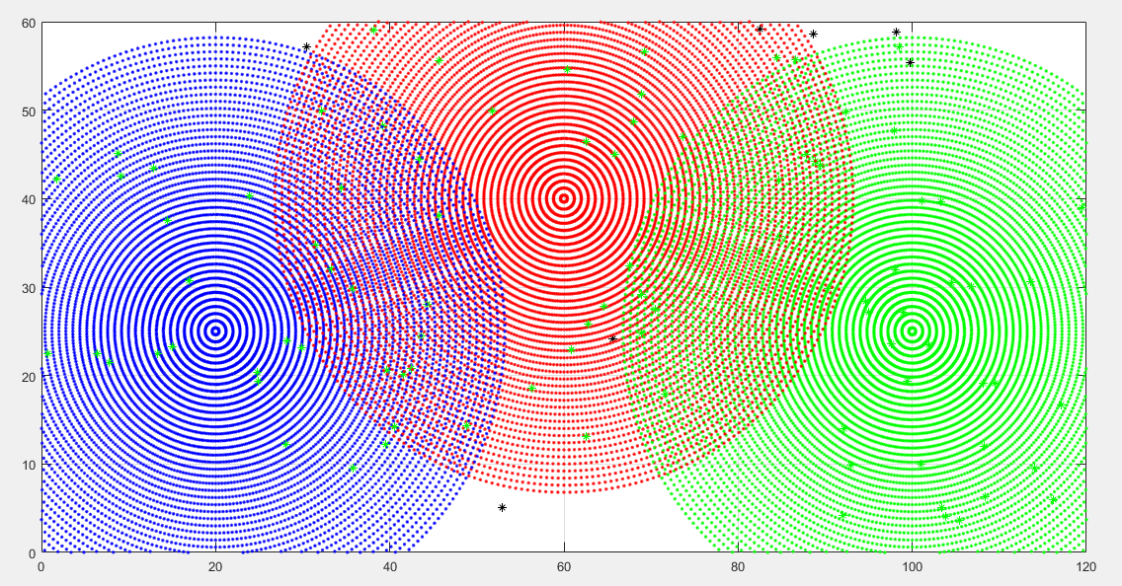

**SECOND TRIAL**

>> circle3(20,25,60,40,100,25)

SENSER 1=(86.096352,8.005906)

SENSER 2=(53.494680,30.527234)

SENSER 3=(63.658835,51.583023)

SENSER 4=(81.326989,48.350296)

SENSER 5=(63.749144,57.353750)

SENSER 6=(8.001233,32.491082)

SENSER 7=(33.799241,28.854020)

SENSER 8=(82.183654,12.495503)

SENSER 9=(72.979319,19.570570)

SENSER 10=(105.701664,8.003677)

SENSER 11=(12.288935,57.547014)

SENSER 12=(18.348240,9.152285)

SENSER 13=(18.666311,5.374164)

SENSER 14=(54.530947,40.133742)

SENSER 15=(99.756202,47.414108)

SENSER 16=(85.525310,28.355850)

SENSER 17=(85.030578,57.483569)

SENSER 18=(60.693067,18.303187)

SENSER 19=(94.777342,14.183218)

SENSER 20=(28.116340,27.881964)

SENSER 21=(74.326416,36.919764)

SENSER 22=(14.714868,7.427612)

SENSER 23=(34.135079,44.143968)

SENSER 24=(49.356972,49.738914)

SENSER 25=(112.213694,23.943999)

SENSER 26=(6.265366,34.271166)

SENSER 27=(89.720397,19.214613)

SENSER 28=(59.152118,13.299165)

SENSER 29=(112.712849,28.938317)

SENSER 30=(64.799530,13.263426)

SENSER 31=(11.513400,3.609925)

SENSER 32=(98.341065,46.288698)

SENSER 33=(23.483488,53.707089)

SENSER 34=(82.116018,39.410789)

SENSER 35=(118.845744,2.021508)

SENSER 36=(50.910392,29.399020)

SENSER 37=(70.020536,4.996185)

SENSER 38=(79.218556,3.138313)

SENSER 39=(66.819664,42.721515)

SENSER 40=(58.549275,37.056039)

SENSER 41=(25.653309,38.739520)

SENSER 42=(45.677075,6.222770)

SENSER 43=(45.301382,15.771648)

SENSER 44=(28.954274,37.375443)

SENSER 45=(62.751331,24.794265)

SENSER 46=(26.135044,51.513217)

SENSER 47=(103.320990,17.036341)

SENSER 48=(73.847142,46.769370)

SENSER 49=(114.581677,55.176195)

SENSER 50=(46.177884,9.758581)

SENSER 51=(95.610170,6.829031)

SENSER 52=(19.058916,21.349687)

SENSER 53=(101.731028,34.966872)

SENSER 54=(70.341320,55.550279)

SENSER 55=(69.009392,0.598644)

SENSER 56=(97.125274,36.528502)

SENSER 57=(57.589642,16.106409)

SENSER 58=(30.971566,28.860572)

SENSER 59=(27.280978,2.916138)

SENSER 60=(20.309018,15.506778)

SENSER 61=(23.749207,36.341584)

SENSER 62=(98.844437,48.636898)

SENSER 63=(96.268442,42.486803)

SENSER 64=(103.125343,46.865071)

SENSER 65=(24.455622,59.600595)

SENSER 66=(11.234943,39.037113)

SENSER 67=(25.821183,14.632386)

SENSER 68=(40.762537,11.871740)

SENSER 69=(60.820005,57.045479)

SENSER 70=(47.352866,35.067890)

SENSER 71=(72.784470,42.878572)

SENSER 72=(48.184362,51.521461)

SENSER 73=(110.458198,45.050333)

SENSER 74=(34.271005,47.808947)

SENSER 75=(17.131900,30.273011)

SENSER 76=(73.282554,42.227804)

SENSER 77=(46.000792,43.721006)

SENSER 78=(106.474162,3.350899)

SENSER 79=(16.585961,51.783899)

SENSER 80=(50.609578,24.678850)

SENSER 81=(115.096961,45.014718)

SENSER 82=(117.719654,14.010948)

SENSER 83=(11.547211,23.074932)

SENSER 84=(60.032706,34.215352)

SENSER 85=(117.195792,29.571311)

SENSER 86=(48.105944,59.699416)

SENSER 87=(31.319761,39.919483)

SENSER 88=(115.710794,40.269062)

SENSER 89=(35.900983,31.867592)

SENSER 90=(0.175581,53.027329)

SENSER 91=(48.526063,18.072335)

SENSER 92=(114.069791,27.638892)

SENSER 93=(34.517701,5.077598)

SENSER 94=(69.861760,9.184122)

SENSER 95=(8.771317,34.833887)

SENSER 96=(34.441770,21.715205)

SENSER 97=(86.978963,51.498701)

SENSER 98=(41.749882,57.704736)

SENSER 99=(114.428286,12.362243)

SENSER 100=(92.189383,36.931913)

The visited sensers are

Senser 1

Senser 2

Senser 3

Senser 4

Senser 5

Senser 6

Senser 7

Senser 8

Senser 9

Senser 10

Senser 11

Senser 12

Senser 13

Senser 14

Senser 16

Senser 17

Senser 18

Senser 20

Senser 21

Senser 22

Senser 23

Senser 24

Senser 25

Senser 26

Senser 27

Senser 28

Senser 29

Senser 31

Senser 32

Senser 33

Senser 34

Senser 35

Senser 36

Senser 38

Senser 39

Senser 40

Senser 41

Senser 42

Senser 43

Senser 44

Senser 45

Senser 46

Senser 47

Senser 48

Senser 50

Senser 51

Senser 52

Senser 53

Senser 54

Senser 56

Senser 57

Senser 58

Senser 59

Senser 60

Senser 61

Senser 62

Senser 63

Senser 64

Senser 66

Senser 67

Senser 68

Senser 69

Senser 70

Senser 71

Senser 72

Senser 73

Senser 74

Senser 75

Senser 76

Senser 77

Senser 78

Senser 79

Senser 80

Senser 81

Senser 83

Senser 84

Senser 85

Senser 86

Senser 87

Senser 88

Senser 89

Senser 91

Senser 92

Senser 93

Senser 94

Senser 95

Senser 96

Senser 97

Senser 98

Senser 100

**Total visited sensers out of 100 are = 90 + 6(SENSERS INSIDE THE AREA COVERED)=96**

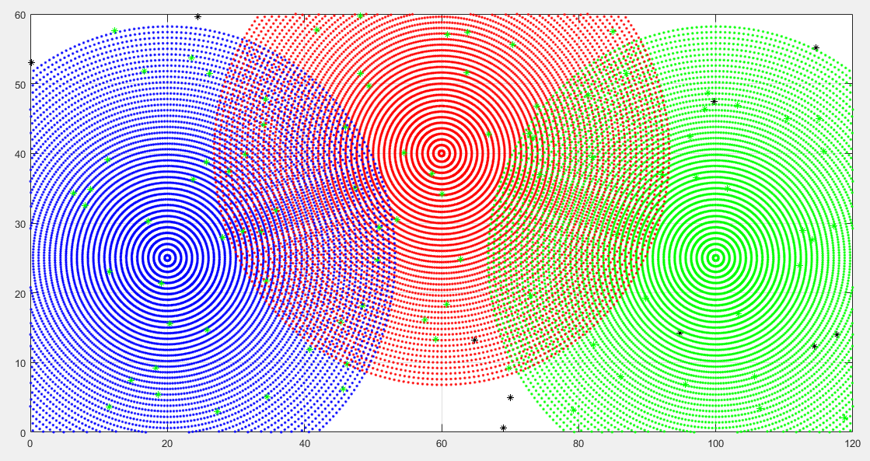

**THIRD TRIAL**

>> circle3(20,25,60,40,100,25)

SENSER 1=(110.270698,36.152236)

SENSER 2=(84.256587,44.620497)

SENSER 3=(46.212273,15.090227)

SENSER 4=(4.411168,28.327372)

SENSER 5=(77.408679,16.738196)

SENSER 6=(62.143309,14.739998)

SENSER 7=(35.700981,39.028446)

SENSER 8=(106.967197,51.666388)

SENSER 9=(25.189809,23.945635)

SENSER 10=(106.545963,15.391681)

SENSER 11=(116.016193,37.149441)

SENSER 12=(19.841492,49.571942)

SENSER 13=(78.683172,32.787155)

SENSER 14=(30.159514,2.409383)

SENSER 15=(28.005050,21.666776)

SENSER 16=(76.014604,59.165886)

SENSER 17=(24.858798,45.425036)

SENSER 18=(106.359373,28.333792)

SENSER 19=(19.069623,48.655247)

SENSER 20=(57.180930,6.977252)

SENSER 21=(105.086474,38.111183)

SENSER 22=(11.673762,54.506367)

SENSER 23=(4.201923,2.384982)

SENSER 24=(118.628147,41.170896)

SENSER 25=(45.202703,30.259455)

SENSER 26=(91.619482,2.932488)

SENSER 27=(87.111319,42.079684)

SENSER 28=(55.066899,34.937689)

SENSER 29=(40.690776,10.237525)

SENSER 30=(47.903208,55.186632)

SENSER 31=(27.125452,21.660402)

SENSER 32=(38.947442,5.014927)

SENSER 33=(61.519864,49.971889)

SENSER 34=(108.553620,43.415755)

SENSER 35=(45.959499,17.881023)

SENSER 36=(83.005396,52.827416)

SENSER 37=(110.945797,4.875167)

SENSER 38=(57.920762,7.695903)

SENSER 39=(30.349339,53.037692)

SENSER 40=(23.553230,7.281219)

SENSER 41=(65.243399,18.877245)

SENSER 42=(45.844910,47.492356)

SENSER 43=(100.701538,40.814183)

SENSER 44=(50.030641,38.573388)

SENSER 45=(25.689774,37.036248)

SENSER 46=(81.022938,36.061409)

SENSER 47=(41.557140,21.864082)

SENSER 48=(20.577729,47.721694)

SENSER 49=(59.120029,21.277371)

SENSER 50=(93.007344,14.208288)

SENSER 51=(101.380014,48.991618)

SENSER 52=(101.547404,22.211211)

SENSER 53=(45.987544,51.680085)

SENSER 54=(55.669103,34.232893)

SENSER 55=(83.436817,57.655036)

SENSER 56=(65.557558,38.194594)

SENSER 57=(68.507099,55.626729)

SENSER 58=(103.651868,10.190355)

SENSER 59=(21.443884,14.610262)

SENSER 60=(90.213523,11.948063)

SENSER 61=(117.952861,42.578322)

SENSER 62=(21.052337,51.497844)

SENSER 63=(109.129378,57.699785)

SENSER 64=(68.471964,33.772754)

SENSER 65=(21.199345,30.820744)

SENSER 66=(65.816630,9.916647)

SENSER 67=(59.267165,32.107036)

SENSER 68=(23.856859,37.390135)

SENSER 69=(3.157847,19.127458)

SENSER 70=(63.959944,19.606424)

SENSER 71=(72.262853,21.715964)

SENSER 72=(16.190476,54.828810)

SENSER 73=(76.867060,39.526449)

SENSER 74=(81.039640,44.673463)

SENSER 75=(101.061309,30.999430)

SENSER 76=(18.224244,22.839856)

SENSER 77=(98.522328,10.281863)

SENSER 78=(39.597034,57.988319)

SENSER 79=(96.755112,13.331276)

SENSER 80=(119.972775,3.824322)

SENSER 81=(51.057974,24.260289)

SENSER 82=(48.035146,6.715359)

SENSER 83=(50.917293,36.812753)

SENSER 84=(118.567354,13.194047)

SENSER 85=(42.489729,15.974513)

SENSER 86=(34.979764,11.303372)

SENSER 87=(2.743155,26.964251)

SENSER 88=(29.236823,52.123593)

SENSER 89=(63.433292,54.848110)

SENSER 90=(116.871621,35.125558)

SENSER 91=(14.277046,55.591955)

SENSER 92=(71.227293,53.016918)

SENSER 93=(50.937112,36.435443)

SENSER 94=(8.491630,55.486346)

SENSER 95=(77.049530,6.269980)

SENSER 96=(84.027009,23.748260)

SENSER 97=(10.188570,12.868732)

SENSER 98=(29.855868,13.599188)

SENSER 99=(84.360527,45.249155)

SENSER 100=(65.674396,33.209005)

The visited sensers are

Senser 1

Senser 2

Senser 3

Senser 4

Senser 5

Senser 6

Senser 7

Senser 8

Senser 9

Senser 10

Senser 11

Senser 12

Senser 13

Senser 14

Senser 15

Senser 16

Senser 17

Senser 18

Senser 19

Senser 20

Senser 21

Senser 22

Senser 23

Senser 24

Senser 25

Senser 26

Senser 27

Senser 28

Senser 29

Senser 30

Senser 31

Senser 32

Senser 33

Senser 34

Senser 35

Senser 36

Senser 37

Senser 38

Senser 39

Senser 40

Senser 41

Senser 42

Senser 43

Senser 44

Senser 45

Senser 46

Senser 47

Senser 48

Senser 49

Senser 50

Senser 51

Senser 52

Senser 53

Senser 54

Senser 55

Senser 56

Senser 57

Senser 58

Senser 59

Senser 60

Senser 61

Senser 62

Senser 64

Senser 65

Senser 66

Senser 67

Senser 68

Senser 69

Senser 70

Senser 71

Senser 72

Senser 73

Senser 74

Senser 75

Senser 76

Senser 77

Senser 79

Senser 80

Senser 81

Senser 82

Senser 83

Senser 84

Senser 85

Senser 86

Senser 87

Senser 88

Senser 89

Senser 90

Senser 91

Senser 92

Senser 93

Senser 94

Senser 96

Senser 97

Senser 98

Senser 99

Senser 100

**Total visited sensers out of 100 are = 97 + 2 (SENSERS INSIDE THE AREA COVERED)=99**

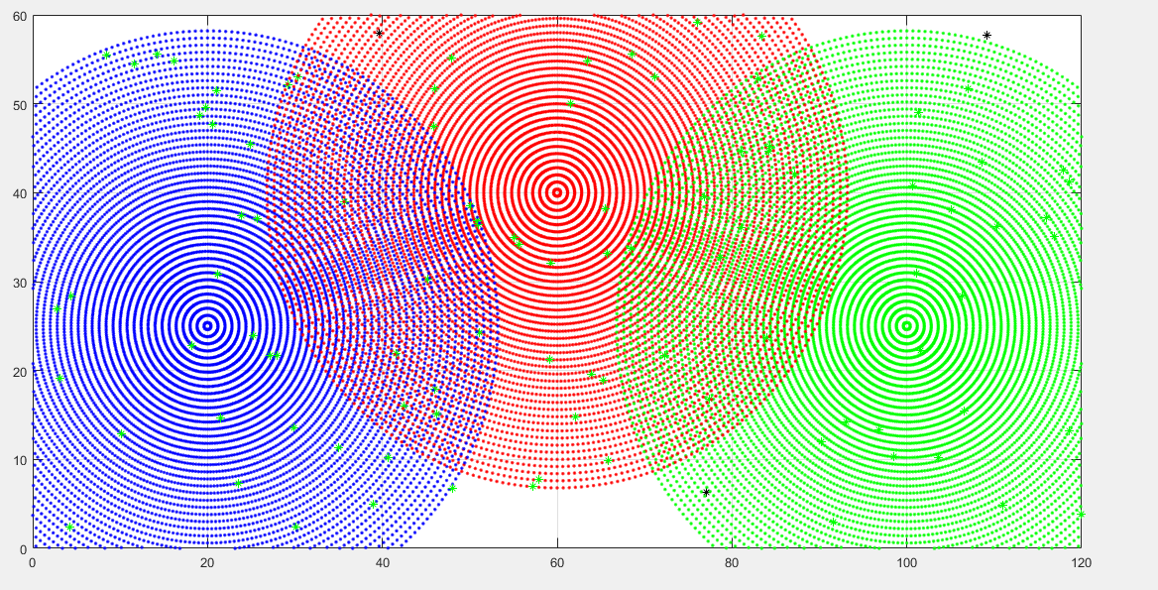

**FORTH TRIAL**

>> circle3(20,25,60,40,100,25)

SENSER 1=(75.668735,59.127417)

SENSER 2=(76.113384,36.027337)

SENSER 3=(109.102435,34.250198)

SENSER 4=(40.250391,57.428349)

SENSER 5=(52.790775,36.092556)

SENSER 6=(86.431483,40.726701)

SENSER 7=(25.531081,4.897403)

SENSER 8=(32.937529,52.051103)

SENSER 9=(67.122848,27.877666)

SENSER 10=(51.636108,46.439155)

SENSER 11=(78.470451,39.463756)

SENSER 12=(19.322509,25.942610)

SENSER 13=(60.610330,22.519937)

SENSER 14=(57.644667,20.545284)

SENSER 15=(93.257573,23.036632)

SENSER 16=(85.386771,28.856004)

SENSER 17=(87.501627,56.253554)

SENSER 18=(62.070528,54.184125)

SENSER 19=(26.183117,52.393160)

SENSER 20=(9.923152,27.924205)

SENSER 21=(2.631579,48.496833)

SENSER 22=(21.505140,9.923535)

SENSER 23=(21.792416,41.486194)

SENSER 24=(25.651622,17.886292)

SENSER 25=(92.200218,30.069006)

SENSER 26=(109.135777,3.471174)

SENSER 27=(52.410231,34.335285)

SENSER 28=(67.808059,49.428994)

SENSER 29=(15.131859,18.007007)

SENSER 30=(0.254643,57.066441)

SENSER 31=(91.955924,45.078250)

SENSER 32=(16.663780,20.959173)

SENSER 33=(18.160867,29.803241)

SENSER 34=(97.038270,37.972128)

SENSER 35=(82.608180,38.374213)

SENSER 36=(87.518607,51.590742)

SENSER 37=(75.234646,10.835482)

SENSER 38=(68.796786,9.813969)

SENSER 39=(108.726208,4.640567)

SENSER 40=(40.624158,34.837053)

SENSER 41=(57.028219,48.319229)

SENSER 42=(63.693377,13.638620)

SENSER 43=(85.138197,8.917953)

SENSER 44=(78.973942,38.038953)

SENSER 45=(27.516750,10.933681)

SENSER 46=(19.962301,8.976425)

SENSER 47=(24.329688,57.297534)

SENSER 48=(1.909001,57.450861)

SENSER 49=(3.083074,58.266640)

SENSER 50=(35.711481,31.504385)

SENSER 51=(103.480705,53.784294)

SENSER 52=(22.681267,39.643173)

SENSER 53=(112.947713,58.542428)

SENSER 54=(12.952230,10.733954)

SENSER 55=(89.586171,2.968111)

SENSER 56=(8.554186,29.347531)

SENSER 57=(101.987259,59.822487)

SENSER 58=(0.527114,32.556448)

SENSER 59=(103.361781,54.548341)

SENSER 60=(101.442067,52.732373)

SENSER 61=(89.541869,7.049363)

SENSER 62=(61.082671,10.129906)

SENSER 63=(99.733380,55.680651)

SENSER 64=(20.338131,53.024239)

SENSER 65=(46.543547,22.954168)

SENSER 66=(32.574351,52.072989)

SENSER 67=(88.980295,26.872364)

SENSER 68=(85.156663,56.659877)

SENSER 69=(20.894145,14.675777)

SENSER 70=(76.911495,48.516751)

SENSER 71=(102.404521,23.887059)

SENSER 72=(13.859257,4.816857)

SENSER 73=(43.256114,49.734333)

SENSER 74=(25.753165,47.462419)

SENSER 75=(78.562598,1.568787)

SENSER 76=(94.293154,55.353783)

SENSER 77=(59.077576,50.040699)

SENSER 78=(15.762442,45.587008)

SENSER 79=(111.088342,49.962454)

SENSER 80=(31.128139,12.781306)

SENSER 81=(62.677774,23.841426)

SENSER 82=(57.493174,59.634218)

SENSER 83=(72.537415,56.694519)

SENSER 84=(58.853066,26.276794)

SENSER 85=(92.718669,44.643994)

SENSER 86=(53.148488,3.180003)

SENSER 87=(10.538621,47.879157)

SENSER 88=(78.669885,1.940133)

SENSER 89=(66.848020,43.188093)

SENSER 90=(13.248966,12.998843)

SENSER 91=(97.322426,8.319713)

SENSER 92=(105.827904,55.413364)

SENSER 93=(1.530668,22.629555)

SENSER 94=(20.137403,32.413368)

SENSER 95=(12.199492,2.356065)

SENSER 96=(111.987493,58.295513)

SENSER 97=(43.311362,38.652324)

SENSER 98=(8.153676,12.474720)

SENSER 99=(4.752462,28.161559)

SENSER 100=(18.011607,59.478415)

The visited sensers are

Senser 1

Senser 2

Senser 3

Senser 5

Senser 6

Senser 7

Senser 8

Senser 9

Senser 10

Senser 11

Senser 12

Senser 13

Senser 14

Senser 15

Senser 16

Senser 18

Senser 19

Senser 20

Senser 21

Senser 22

Senser 23

Senser 24

Senser 25

Senser 26

Senser 27

Senser 28

Senser 29

Senser 31

Senser 32

Senser 33

Senser 34

Senser 35

Senser 36

Senser 37

Senser 38

Senser 39

Senser 40

Senser 41

Senser 42

Senser 43

Senser 44

Senser 45

Senser 46

Senser 47

Senser 50

Senser 51

Senser 52

Senser 54

Senser 55

Senser 56

Senser 58

Senser 59

Senser 60

Senser 61

Senser 62

Senser 63

Senser 65

Senser 66

Senser 67

Senser 68

Senser 69

Senser 70

Senser 71

Senser 72

Senser 73

Senser 74

Senser 75

Senser 76

Senser 77

Senser 78

Senser 79

Senser 80

Senser 81

Senser 82

Senser 83

Senser 84

Senser 85

Senser 87

Senser 88

Senser 89

Senser 90

Senser 91

Senser 92

Senser 93

Senser 94

Senser 95

Senser 97

Senser 98

Senser 99

**Total visited sensers out of 100 are = 89 + 3 (SENSERS INSIDE THE AREA COVERED)=92**

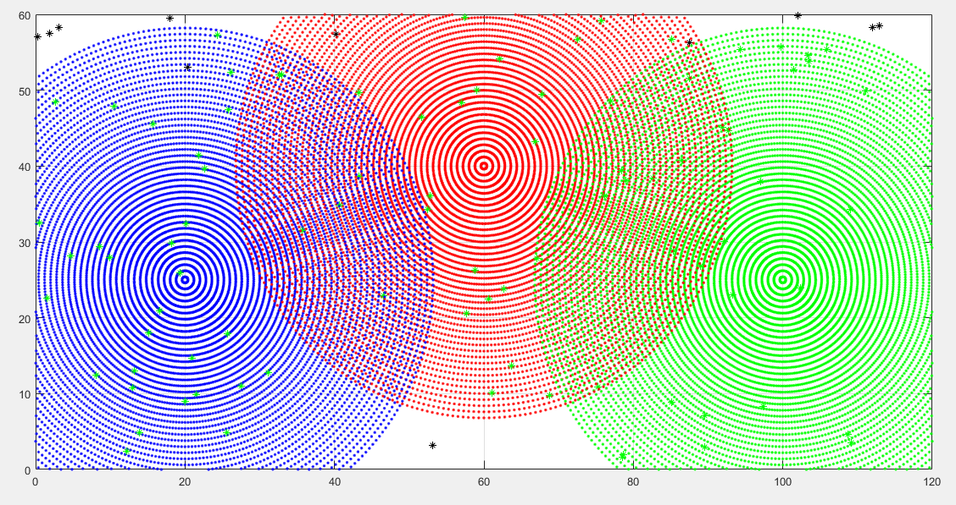

**FIFTH TRIAL**

>> circle3(20,25,60,40,100,25)

SENSER 1=(51.247482,57.322326)

SENSER 2=(86.909644,34.853503)

SENSER 3=(64.830949,42.326471)

SENSER 4=(0.603466,46.950947)

SENSER 5=(111.223149,0.497739)

SENSER 6=(98.955401,46.040152)

SENSER 7=(119.656427,13.659184)

SENSER 8=(110.345065,38.519958)

SENSER 9=(12.638422,16.089655)

SENSER 10=(91.661252,48.330609)

SENSER 11=(12.510360,28.185527)

SENSER 12=(26.287427,55.362474)

SENSER 13=(38.438716,51.452629)

SENSER 14=(31.181600,52.683777)

SENSER 15=(22.592114,45.551630)

SENSER 16=(3.802716,38.540349)

SENSER 17=(68.024510,22.584573)

SENSER 18=(25.505806,47.529410)

SENSER 19=(17.453218,29.348547)

SENSER 20=(1.541490,11.196721)

SENSER 21=(58.227655,50.293565)

SENSER 22=(16.926836,43.933019)

SENSER 23=(82.928030,2.069557)

SENSER 24=(58.662872,58.283425)

SENSER 25=(13.494166,44.592826)

SENSER 26=(76.624965,35.650975)

SENSER 27=(59.834702,34.071160)

SENSER 28=(51.180510,4.574367)

SENSER 29=(34.870398,33.680103)

SENSER 30=(76.000016,55.846552)

SENSER 31=(117.332299,5.615793)

SENSER 32=(79.408193,36.166374)

SENSER 33=(56.858144,21.375381)

SENSER 34=(57.069413,40.261321)

SENSER 35=(115.157424,5.345056)

SENSER 36=(95.729095,35.446545)

SENSER 37=(109.463611,6.067759)

SENSER 38=(35.195357,3.095292)

SENSER 39=(60.495382,46.102545)

SENSER 40=(33.958245,13.521615)

SENSER 41=(39.754757,27.195081)

SENSER 42=(88.486157,30.593139)

SENSER 43=(45.901703,54.328993)

SENSER 44=(115.830930,37.696041)

SENSER 45=(15.843740,37.098107)

SENSER 46=(45.962412,59.471625)

SENSER 47=(34.419274,42.371486)

SENSER 48=(64.224708,11.592662)

SENSER 49=(82.732212,3.027300)

SENSER 50=(22.132094,2.739499)

SENSER 51=(106.204980,50.387663)

SENSER 52=(14.178629,24.624891)

SENSER 53=(14.427431,34.325551)

SENSER 54=(113.926816,15.383110)

SENSER 55=(118.783852,20.988482)

SENSER 56=(25.022685,39.949630)

SENSER 57=(116.801365,37.361989)

SENSER 58=(7.624547,22.410572)

SENSER 59=(19.950184,13.876685)

SENSER 60=(6.265036,54.105379)

SENSER 61=(95.195004,22.380859)

SENSER 62=(99.846565,45.230073)

SENSER 63=(74.623572,23.645591)

SENSER 64=(43.113355,5.331148)

SENSER 65=(41.001240,32.920236)

SENSER 66=(55.265695,38.727142)

SENSER 67=(61.622501,48.865588)

SENSER 68=(11.661985,27.822814)

SENSER 69=(70.778099,11.230324)

SENSER 70=(73.359618,3.116519)

SENSER 71=(69.087234,50.540682)

SENSER 72=(59.967117,26.341493)

SENSER 73=(17.886850,1.696767)

SENSER 74=(90.800375,47.766374)

SENSER 75=(35.226671,6.912405)

SENSER 76=(45.010996,49.733625)

SENSER 77=(101.013190,39.914307)

SENSER 78=(115.216797,56.587074)

SENSER 79=(13.523939,38.897247)

SENSER 80=(57.696486,3.991242)

SENSER 81=(107.732547,29.833808)

SENSER 82=(92.556411,3.621734)

SENSER 83=(31.494896,39.064162)

SENSER 84=(16.032469,38.312744)

SENSER 85=(46.193171,45.941888)

SENSER 86=(78.349882,22.889344)

SENSER 87=(36.002230,20.408373)

SENSER 88=(110.271184,27.376009)

SENSER 89=(53.099634,27.251149)

SENSER 90=(113.433841,13.147137)

SENSER 91=(105.888336,1.192525)

SENSER 92=(41.011786,45.961647)

SENSER 93=(41.136444,37.128384)

SENSER 94=(54.362539,0.609756)

SENSER 95=(71.889740,36.094101)

SENSER 96=(77.930094,20.563238)

SENSER 97=(59.195911,42.106437)

SENSER 98=(106.536312,3.303471)

SENSER 99=(11.803434,38.986967)

SENSER 100=(91.688507,59.277536)

The visited sensers are

Senser 1

Senser 2

Senser 3

Senser 4

Senser 5

Senser 6

Senser 7

Senser 8

Senser 9

Senser 10

Senser 11

Senser 12

Senser 13

Senser 14

Senser 15

Senser 16

Senser 19

Senser 20

Senser 21

Senser 23

Senser 24

Senser 25

Senser 26

Senser 27

Senser 29

Senser 30

Senser 31

Senser 32

Senser 33

Senser 34

Senser 36

Senser 37

Senser 38

Senser 39

Senser 40

Senser 41

Senser 42

Senser 43

Senser 44

Senser 45

Senser 47

Senser 48

Senser 49

Senser 51

Senser 52

Senser 53

Senser 54

Senser 55

Senser 56

Senser 57

Senser 58

Senser 59

Senser 60

Senser 61

Senser 62

Senser 63

Senser 65

Senser 66

Senser 67

Senser 69

Senser 71

Senser 72

Senser 73

Senser 74

Senser 75

Senser 76

Senser 77

Senser 79

Senser 81

Senser 82

Senser 83

Senser 84

Senser 85

Senser 86

Senser 87

Senser 88

Senser 89

Senser 90

Senser 91

Senser 92

Senser 93

Senser 95

Senser 96

Senser 97

Senser 98

Senser 99

**Total visited sensers out of 100 are = 86 + 8 (SENSERS INSIDE THE AREA COVERED)=94**

