Akash Sinha
NU ID: 001344425
Assignment 3
- Code ->
https://github.com/AkashSinha24/INFO6205

- Results -> resultsAssignment4/union_find/assignment4.csv

- UF_HWQUPC Code
/src/main/java/edu/neu/coe/info6205/union_find/UF_HWQUPC.java

- WQUPC Code
/src/main/java/edu/neu/coe/info6205/union_find/UF_HWQUPC.java

- Output Result:

The following table shows the of number of uncompressed pairs and compressed pairs generated for the n number of objects along with the relation between the two pair values.

n | uncompressed_pairs | compressed_pairs
5 | 7.14 | 7.21
10 | 15.77 | 16.08
20 | 38.25 | 36.34
40 | 89.51 | 88.16
80 | 195.57 | 198.5
160 | 466.01 | 448.02
320 | 1055.92 | 1052.59
640 | 2265.57 | 2286.85
n Random Sorted Reverse Sorted Partially Sorted

- Conclusion:
- From the outputs it is evident that the values and the time complexity of the random pairs generated by the methods of Height weighted and Size weighted is almost similar and hence benchmarking is not needed
- Also, the time taken by uncompressed union find function is 1.5 times the time taken by the function of union find with path compression

- Screenshots of JUnit Test and Graph:

- The graph below illustrates the trend of the relation derived between number of pairs with Hight Weighted and Size weighted functions for different n values
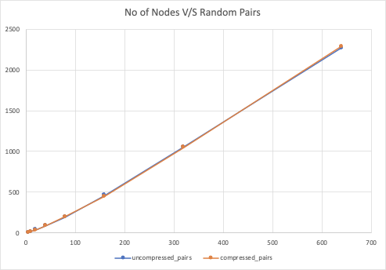

- The graph illustrates the time taken for executing Union Find functions with path compression and without path compression

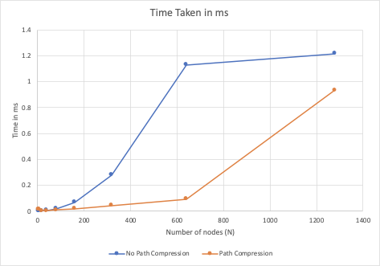

- Unit Tests Result screenshots UF_HWQUPC:

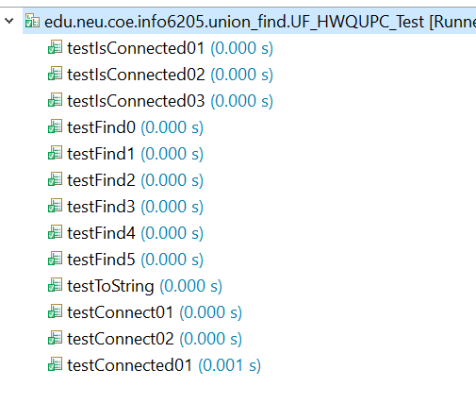

- Unit Tests Result screenshots WQUPC:

