Akash Sinha
NU ID: 001344425
Assignment 2
- Code ->
https://github.com/AkashSinha24/INFO6205

- Asignment2.java File -> /src/main/java/edu/neu/coe/info6205/Assignment2.java

- Results -> resultsAssignment2/insertion_sort/insertionSortResults.csv

- Insertion Sort Code
/src/main/java/edu/neu/coe/info6205/sort/simple/InsertionSort.java

- Insertion Sort Basic Code
/src/main/java/edu/neu/coe/info6205/sort/simple/InsertionSortBasic.java

- Timer Code
/src/main/java/edu/neu/coe/info6205/util/Timer.java

- Screenshots and Evidences:

The following table shows the mean time taken by N size of input arrays when they are
random, sorted, reverse or partially sorted.
n Random Sorted Reverse Sorted Partially Sorted
n | Random | Sorted | ReverseSorted | PartiallySorted
20 | 0.017636 | 0.001957 | 0.012336 | 0.007843
40 | 0.027021 | 0.00255 | 0.034886 | 0.010443
80 | 0.030707 | 0.0017 | 0.08885 | 0.010579
160 | 0.0708 | 0.002221 | 0.150564 | 0.02155
320 | 0.259179 | 0.003714 | 0.248886 | 0.044364
640 | 0.339571 | 0.0028 | 0.692093 | 0.174114
1280 | 1.388864 | 0.004664 | 2.898821 | 0.709336
2560 | 5.599571 | 0.010286 | 11.01576 | 2.831021
5120 | 22.61807 | 0.017629 | 47.54827 | 12.34509
10240 | 89.20018 | 0.035193 | 187.6463 | 50.59708
20480 | 403.0968 | 0.089171 | 865.4882 | 217.5173

- The chart which we can understand from the above result of my code is:

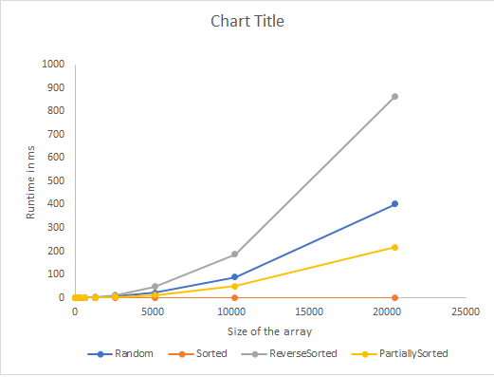

- Unit Tests Result screenshots of Benchmark Test and Insertion Sort Test

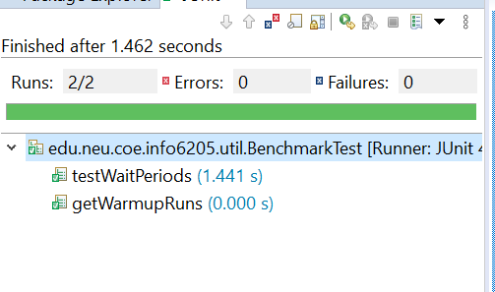

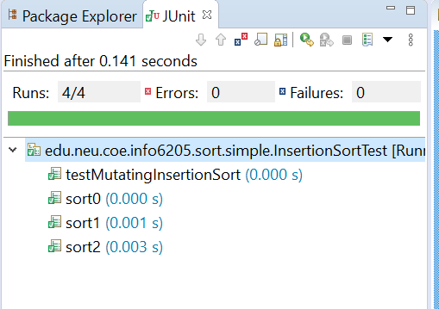

- Conclusion:

• Random sorted array also grows exponentially but not as much as that of reverse
sorted.
• Αν αλρεαδψ σorted array takes negligible amount of time to get sorted, even though the size of input array increases rapidly.
• Reverse sorted grow exponentially and takes most time to execute. It is of the
order of N2.
• Partially sorted also grows exponentially to the order of N2, but depends its
curve depends upon the number of initial elements sorted. The more percentage
of elements sorted initially; the less duration taken to sort.

