

**POSE-INVARIANT FACE RECOGNITION USING**

**MULTI-TASK FEATURE TRANSFORMATION LEARNING**

PRESENTED BY UNDER SUPERVISION OF

AKASH KRISHNA SRIVASTAVA – 2013UGCS031 Dr. KOUSHLENDRA KUMAR SINGH

DIKSHA – 2013UGCS050

H SNEHA – 2013UGCS044

Abstract --

Face images captured in unconstrained environments usually contain significant pose variation, which dramatically degrades the performance of algorithms designed to recognize frontal faces. This paper proposes a novel face identification framework capable of handling the full range of pose variations within±90° of yaw. The proposed framework first transforms the original pose-invariant face recognition problem into a partial frontal face recognition problem. A robust patch-based face representation scheme is then developed to represent the synthesized partial frontal faces. For each patch, a transformation dictionary is learnt under the proposed multitask learning scheme. The transformation dictionary transforms the features of different poses into a discriminative subspace. Finally, face matching is performed at patch level rather than at the holistic level.

**Introduction -**

Face recognition has been one of the most active research Topics in computer vision for more than three decades. It is a challenging problem which has received much attention during the recent years due to its potential multimedia applications in different fields such as 3D videoconference, security applications or video indexing.

Our approach mainly handle the identification problem of matching an arbitrary pose probe face with frontal gallery faces, which is the most common setting for both the research and application of pose-invariant face recognition (PIFR).

Pose problem usually combined with other factors, such as variations in illumination and expression, to affect the appearance of face images results into making an extent of appearance change caused by pose variation greater than that caused by differences in identity. Thus, the performance of frontal face recognition algorithms degrades dramatically when the images to be matched feature different poses. So, directly matching faces in different poses becomes difficult.

Method Proposed –

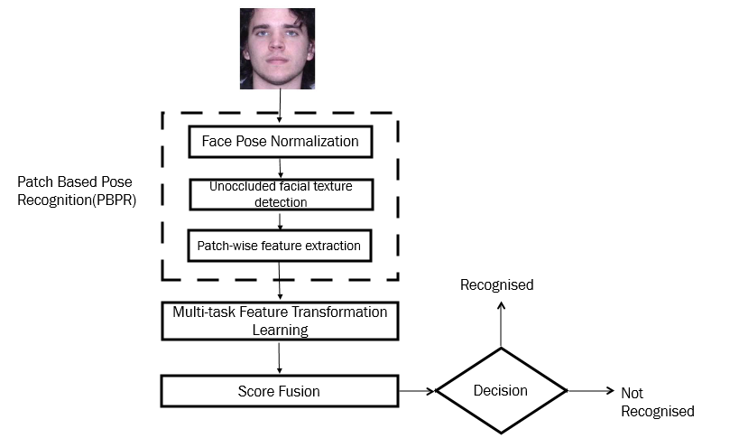

PBPR-MtFTL Framework for PIFR

Existing face representation tend to extract fixed length features from images with the assumption that all facial components are visible in the image. The PBPR scheme is flexible representation of the face where the length of the face is related to the pose.

PBPR consists of 3 steps :

1. Face pose normalization
   1. The five features i.e centre of the eyes, tip of the nose, corners of the mouth are detected manually or automatically . The coordinates of the occluded features are estimated.
   2. Using the orthographic projection model, a 3D genreic shape model is aligned to the 2D image.
   3. 2D is then back projected to 3D model and frontal face is rendered with textured 3D model.
2. Unoccluded Facial Texture Detection
   1. The 3D generic shape model is aligned with the 2D image and then projected to 2D plane to obtain the model roughly in the pose of the 2D image. The contour is then detected. Based on the contour of the 3D model, contour search is limited to certain region.
   2. Edge points are detected with the help of Boundary Detection algorithms.
   3. Facial contour is obtained by registration algorithms.
   4. This step is projected to the 3D model in the Face pose normalization step along with the facial texture. It is then projected to the rendered frontal face.
3. Patch wise Feature Extraction
   1. Normalised face is divided into patches.
   2. A patch is an unoccluded patch is 80% of pixels fall into unoccluded region.
   3. Unoccluded patch is divided into JxJ cells.
   4. DCP ( Dual Cross Patterns) is employed for feature extraction. DCP histogram from JxJ cells form raw feature of the patch.
   5. PCA is applied to each patch to project its features into a subspace.
   6. After the DCP-PCA, the patches represent the face image.

Advantage of this representation is that it is general and can be used for arbitary poses. However, since only five features are used will result in larger normalization error. This is an disadvantage of this representation.

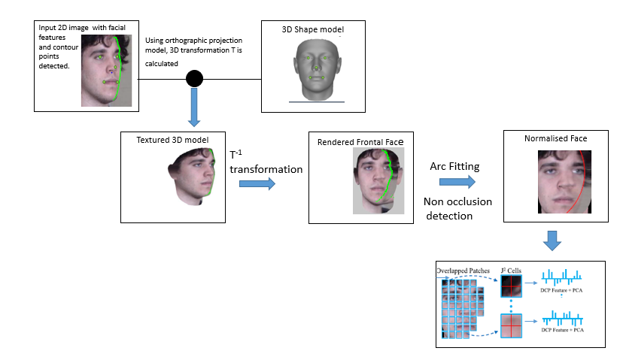

References

* H. T. Ho and R. Chellappa, “Pose-invariant face recognition using Markov random fields,” *IEEE Trans. Image Process.*, vol. 22, no. 4,pp. 1573–1584, Apr. 2013.
* A. B. Ashraf, S. Lucey, and T. Chen, “Learning patch correspondences for improved viewpoint invariant face recognition,” in *Proc. IEEE Conf. Comput. Vis. Pattern Recognit.*, Jun. 2008, pp. 1–8.
* A. Asthana, T. K. Marks, M. J. Jones, K. H. Tieu, and M. Rohith, “Fully automatic pose-invariant face recognition via 3D pose normalization,” in *Proc. IEEE Int. Conf. Comput. Vis.*, Nov. 2011, pp. 937–944.
* M. Kan, S. Shan, H. Zhang, S. Lao, and X. Chen, “Multi-view discriminant analysis,” in *Proc. 12th Eur. Conf. Comput. Vis.*, 2012, pp. 808–821.
* Z.-L. Sun, K.-M. Lam, and Q.-W. Gao, “Depth estimation of face images using the nonlinear least-squares model,” *IEEE Trans. Image Process.*, vol. 22, no. 1, pp. 17–30, Jan. 2013.
* Changxing Ding, Chang Xu, and Dacheng Tao “Multi-task Pose-Invariant Face Recognition”, IEEE TRANSACTIONS ON IMAGE PROCESSING, VOL. 24, NO. 3, MARCH 2015.
* R. Abiantun, U. Prabhu, and M. Savvides, “Sparse feature extraction for pose-tolerant face recognition,” *IEEE Trans. Pattern Anal. Mach. Intell.*, vol. 36, no. 10, pp. 2061–2073, Oct. 2014.
* X. Tan and B. Triggs, “Enhanced local texture feature sets for face recognition under difficult lighting conditions,” *IEEE Trans. Image Process.*, vol. 19, no. 6, pp. 1635–1650, Jun. 2010.
* C. Ding, J. Choi, D. Tao, and L. S. Davis. (2014). “Multi-directional multi-level dual-cross patterns for robust face recognition.” [Online]. Available: <http://arxiv.org/abs/1401.5311>
* X. Chai, S. Shan, X. Chen, and W. Gao, “Locally linear regression for pose-invariant face recognition,” *IEEE Trans. Image Process.*, vol. 16, no. 7, pp. 1716–1725, Jul. 2007.
* A. Li, S. Shan, X. Chen, and W. Gao, “Maximizing intra-individual correlations for face recognition across pose differences,” in *Proc. IEEE Conf. Comput. Vis. Pattern Recognit.*, Jun. 2009, pp. 605–611.
* T. Sim, S. Baker, and M. Bsat, “The CMU pose, illumination, and expression database,” *IEEE Trans. Pattern Anal. Mach. Intell.*, vol. 25, no. 12, pp. 1615–1618, Dec. 2003.
* P. J. Phillips, H. Moon, S. A. Rizvi, and P. J. Rauss, “The FERET evaluation methodology for face-recognition algorithms,” *IEEE Trans. Pattern Anal. Mach. Intell.*, vol. 22, no. 10, pp. 1090–1104, Oct. 2000.
* [R. Gross, I. Matthews, J. Cohn, T. Kanade, and S. Baker, “Multi-PIE,”*Image Vis. Comput.*, vol. 28, no. 5, pp. 807–813, 2010.