Automated Coffee Bean Defect Detection and Fine-Grained Quality Assessment: A Comprehensive Review of Methods, Challenges, and Future Directions
A Systematic Synthesis of Classical Machine Vision, Deep Learning Detectors, Hybrid Hierarchical Architectures, and Non-Destructive Spectral Technologies
Suresh Babu  Department of Computer Science & Engineering  Agri-AI Research Group  Email: sureshbabu@research.edu | Corresponding Author  Machine Intelligence & Agri-Automation Division  Global Institute of Technology  Email: editor.agri@research.org

Abstract— Coffee represents one of the world's most valuable agricultural commodities, where bean defect grading directly governs cup quality, commercial valuation, and export compliance under Specialty Coffee Association (SCA) benchmarks. While manual inspection by certified Q-graders suffers from subjective bias, operational fatigue, and low throughput, computerized visual inspection has evolved rapidly over the past decade. This paper delivers a comprehensive, systematic review of computer vision and machine learning methodologies developed for green and roasted coffee bean defect assessment from 2018 through 2025. Following PRISMA guidelines across IEEE Xplore, Scopus, ScienceDirect, and Web of Science, 58 pivotal studies were screened and quantitatively evaluated. We establish a formal taxonomy dividing approaches into four distinct technological paradigms: classical machine vision with handcrafted descriptors, single-stage end-to-end deep object detectors (e.g., YOLO variants and SSD), two-stage hierarchical hybrid pipelines decoupling localization from fine-grained representation, and non-destructive spectral sensing (NIR and hyperspectral imaging). We systematically contrast these paradigms across computational footprint, mAP, handling of dense occlusions, and operational real-time sorting latency. Furthermore, this survey reveals critical open challenges regarding dataset scarcity, high intra-class color variability, and extreme imbalance among primary defect categories (e.g., full black vs. sour or insect-damaged beans). Finally, we articulate an actionable research roadmap highlighting multimodal fusion, edge neuromorphic processing, self-supervised pre-training, and continuous active learning for next-generation automated agricultural processing pipelines.
Index Terms— Coffee bean quality grading, defect detection, deep learning, computer vision, YOLO11, EfficientNet, two-stage hybrid framework, hyperspectral imaging, agricultural automation, PRISMA review.
I. INTRODUCTION
A. Background and Motivation
Coffee is the second most widely traded commodity globally, sustaining over 125 million livelihoods throughout tropical and equatorial agrarian economies. In international trade, the quality of green and roasted coffee beans is strictly regulated by international standardizing bodies, most notably the Specialty Coffee Association (SCA) and the International Organization for Standardization (ISO 10470). A single defect—such as a 'Full Black' bean (caused by microbial over-fermentation) or a 'Sour' bean (resulting from prolonged moisture and yeast degradation)—can impart sour, vinegar-like, or harsh phenolic off-flavors into an entire roasting batch, severely degrading the cupping score and costing producers up to 40% in export price deductions.
Traditionally, coffee quality assurance relies upon manual physical grading by human inspectors and certified Q-Graders. In industrial sorting stations, human operators inspect 300 to 350 grams of green coffee samples under standardized lux illumination. However, empirical studies reveal that human visual inspection exhibits high intra- and inter-observer variability (error rates frequently exceeding 18-25%), pronounced cognitive fatigue within 45 minutes of continuous operation, and inability to handle modern commercial conveyor throughputs running at kilograms per second. Consequently, automated non-destructive visual grading systems have transitioned from an academic interest into an industrial imperative.
B. Scope and Boundaries
This comprehensive review examines computational methodologies specifically targeted at identifying, localizing, and classifying physical, biological, and physiological defects in coffee beans. The scope explicitly encompasses: (1) green coffee bean defects as defined by SCA green grading protocols (e.g., Full Black, Partial Black, Broken/Chipped, Insect Damage, Sour/Immature), (2) roast defect identification (e.g., quakers, scorch marks, uneven roasting), (3) 2D visible-spectrum (RGB) image architectures, and (4) non-destructive spectroscopic/hyperspectral sensing modalities. Non-visual chemical screening methods (such as Gas Chromatography-Mass Spectrometry or destructive liquid extraction) and broader plant foliage disease surveillance are deliberately excluded to ensure rigorous depth on harvest-to-processing bean sorting.
C. Existing Reviews and Their Limitations
While several broad surveys address computer vision in general agriculture and fruit sorting, existing literature reviews dedicated to coffee quality inspection suffer from substantial limitations. Earlier surveys (e.g., Oliveira et al., 2019; Faridah et al., 2021) predominantly focus on classical feature extraction (color moments, Gray-Level Co-occurrence Matrices, morphological eccentricities) and shallow classifiers (Support Vector Machines, artificial neural networks), giving minimal coverage to modern transformer and state-of-the-art deep convolutional networks. Recent deep learning surveys (e.g., Santos et al., 2023) briefly aggregate agricultural object detection but fail to address the critical domain challenges unique to coffee: extreme multi-instance crowding, high intra-class morphology variations across Arabica versus Robusta cultivars, and severe class imbalance between common broken beans and rare physiological defects. Table I formalizes this distinct scope and comparative advantage.
Review Reference | Publication Year | Primary Modality Scope | DL & Modern YOLO Coverage | Key Limitations Unaddressed
Oliveira et al. [1] | 2019 | RGB & Colorimetry | Absent (Classical ML only) | Omits dense multi-instance detection and modern deep convolutional architectures.
Faridah et al. [2] | 2021 | RGB & Hyperspectral | Superficial (AlexNet / VGG) | Lacks quantitative PRISMA screening; no real-time industrial sorting analysis.
Santos et al. [3] | 2023 | Broad Agri-DL Survey | Moderate (YOLOv3–YOLOv5) | Covers diverse crops; lacks fine-grained green coffee SCA defect class taxonomy.
This Comprehensive Review | 2025/26 | RGB, Hybrids, Spectral | Exhaustive (YOLO11, ViT, Hybrids) | Comprehensive PRISMA synthesis, two-stage taxonomy, hardware-latency tradeoffs, SCA mapping.
TABLE I: COMPARISON OF RECENT SURVEY PAPERS ON AUTOMATED COFFEE QUALITY INSPECTION
D. Research Questions
To provide an evidence-based roadmap, this systematic review addresses five primary Research Questions (RQs):
• RQ1 (Paradigms & Architectures): What machine vision and deep learning paradigms have been deployed for coffee bean defect identification, and how do their fundamental mechanisms differ?
• RQ2 (Detection vs. Classification Efficacy): How do single-stage object detectors (e.g., YOLO variants) perform compared to two-stage hybrid frameworks (e.g., YOLO localization coupled with fine-grained CNN classification) in dense multi-bean environments?
• RQ3 (Data Quality & Benchmarking): What are the standard benchmark datasets, and to what extent do public resources represent authentic SCA green coffee defect distributions?
• RQ4 (Hardware & Inference Throughput): What computational and latency tradeoffs govern the real-time deployment of these models on embedded edge processors in high-speed optical sorters?
• RQ5 (Gaps & Future Directions): What methodological and operational research gaps currently impede full commercial transition from pilot testing to industrial milling lines?
E. Contributions of This Review
1) Systematic PRISMA-Compliant Synthesis: We deliver a rigorous, multi-database evaluation of 58 curated peer-reviewed studies published between 2018 and 2025.
2) Novel Four-Pillar Taxonomy: We formalize a comprehensive taxonomy categorizing coffee bean inspection into Classical Shallow ML, End-to-End Deep Object Detectors, Hierarchical Two-Stage Hybrids, and Non-Destructive Spectral Systems.
3) In-Depth Quantitative Comparative Matrix: We provide a multi-dimensional comparison detailing accuracy, mAP@0.5, inference throughput (FPS), dataset volumes, and defect class granulates across reviewed literature.
4) Bridging Academic Architectures and Industrial Realities: We analyze the hardware requirements, occlusion vulnerabilities, and domain shift issues encountered when transitioning from static lab backdrops to dynamic industrial conveyors.
F. Organization of the Paper
The remainder of this paper is structured as follows: Section II outlines the review methodology and PRISMA search protocol. Section III introduces technical foundations, SCA defect definitions, and evaluation metrics. Section IV details the proposed taxonomy and thematic review. Section V presents a comparative analysis and answers RQ1–RQ4. Section VI discusses open challenges and research gaps. Section VII details future research directions and an actionable roadmap (RQ5). Section VIII presents review limitations, and Section IX concludes.
II. REVIEW METHODOLOGY
A. Search Strategy and Information Sources
This review strictly follows the Preferred Reporting Items for Systematic Reviews and Meta-Analyses (PRISMA) framework. A comprehensive electronic literature search was conducted across four primary scientific indexing databases: IEEE Xplore, Elsevier ScienceDirect, Scopus, and Clarivate Web of Science. The search covered peer-reviewed conference proceedings and journal articles published between January 1, 2018, and December 31, 2025. The Boolean query strings utilized combinations of domain terms ('coffee bean', 'green coffee', 'coffee defect'), technological terms ('machine vision', 'deep learning', 'convolutional neural network', 'YOLO', 'object detection', 'classification'), and sensor descriptors ('hyperspectral', 'multispectral', 'RGB inspection'). An example syntax deployed for IEEE Xplore was: (("coffee bean" OR "green coffee") AND ("defect" OR "grading" OR "quality assessment") AND ("deep learning" OR "computer vision" OR "YOLO" OR "CNN")).
B. Eligibility Criteria
Selection Protocol: Studies were systematically selected based on pre-defined Inclusion (IC) and Exclusion (EC) criteria:
• Inclusion Criteria: (IC1) Peer-reviewed journal papers and conference proceedings published in English; (IC2) Direct application to coffee bean defect identification, classification, or spatial localization; (IC3) Utilization of computational vision, machine learning, or optical spectroscopic analysis; (IC4) Reporting explicit quantitative performance metrics (e.g., Accuracy, Precision, Recall, F1-Score, or mAP).
• Exclusion Criteria: (EC1) Non-peer-reviewed preprints, thesis proposals, patents, or extended abstracts lacking full technical disclosures; (EC2) Studies focusing exclusively on coffee plant foliage/leaf diseases without bean inspection; (EC3) Sensory-only or wet-chemical chromatographic methods without computational imaging; (EC4) Purely commercial marketing literature without reproducibility details.
Protocol Dimension | Operational Definition & Parameters | Rationale / Objective
Databases Searched | IEEE Xplore, Scopus, ScienceDirect, Web of Science | Exhaustive coverage of engineering, agri-tech, and computer vision literature.
Publication Window | January 2018 – December 2025 (Final Search: Jan 2026) | Captures the revolutionary shift from AlexNet/VGG to modern YOLO11, ViT, and hybrids.
Language & Document Type | English language, Peer-reviewed Journals & IEEE/ACM/SPIE Conferences | Ensures scientific rigor, verifiable experimental protocols, and global reproducibility.
Inclusion Scope | Green & roasted coffee defect detection, sorting, grading, spectral imaging | Targeted focus on physical commodity defect elimination and SCA standards.
Exclusion Boundaries | Leaf diseases, destructive chemistry (GC-MS), duplicates, unvalidated simulations | Prevents domain dilution and maintains rigorous empirical benchmarking.
TABLE II: SYSTEMATIC REVIEW SEARCH STRATEGY AND ELIGIBILITY CRITERIA
C. Study Selection
The search process yielded a total of 560 initial records across the four databases (IEEE Xplore: 142, Scopus: 188, ScienceDirect: 124, Web of Science: 106). Upon importing into reference management software, 168 duplicate citations were systematically identified and removed, leaving 392 records for title and abstract screening. Title and abstract screening resulted in the elimination of 238 records that failed basic eligibility (primarily plant-disease studies, non-imaging chemical assays, or general food processing papers). The full text of the remaining 154 candidate articles was assessed independently. Ninety-six articles were excluded during full-text review due to missing evaluation metrics, absence of defect categorization, or unverified hardware claims. Ultimately, 58 primary research articles met all eligibility criteria and were synthesized into this review.
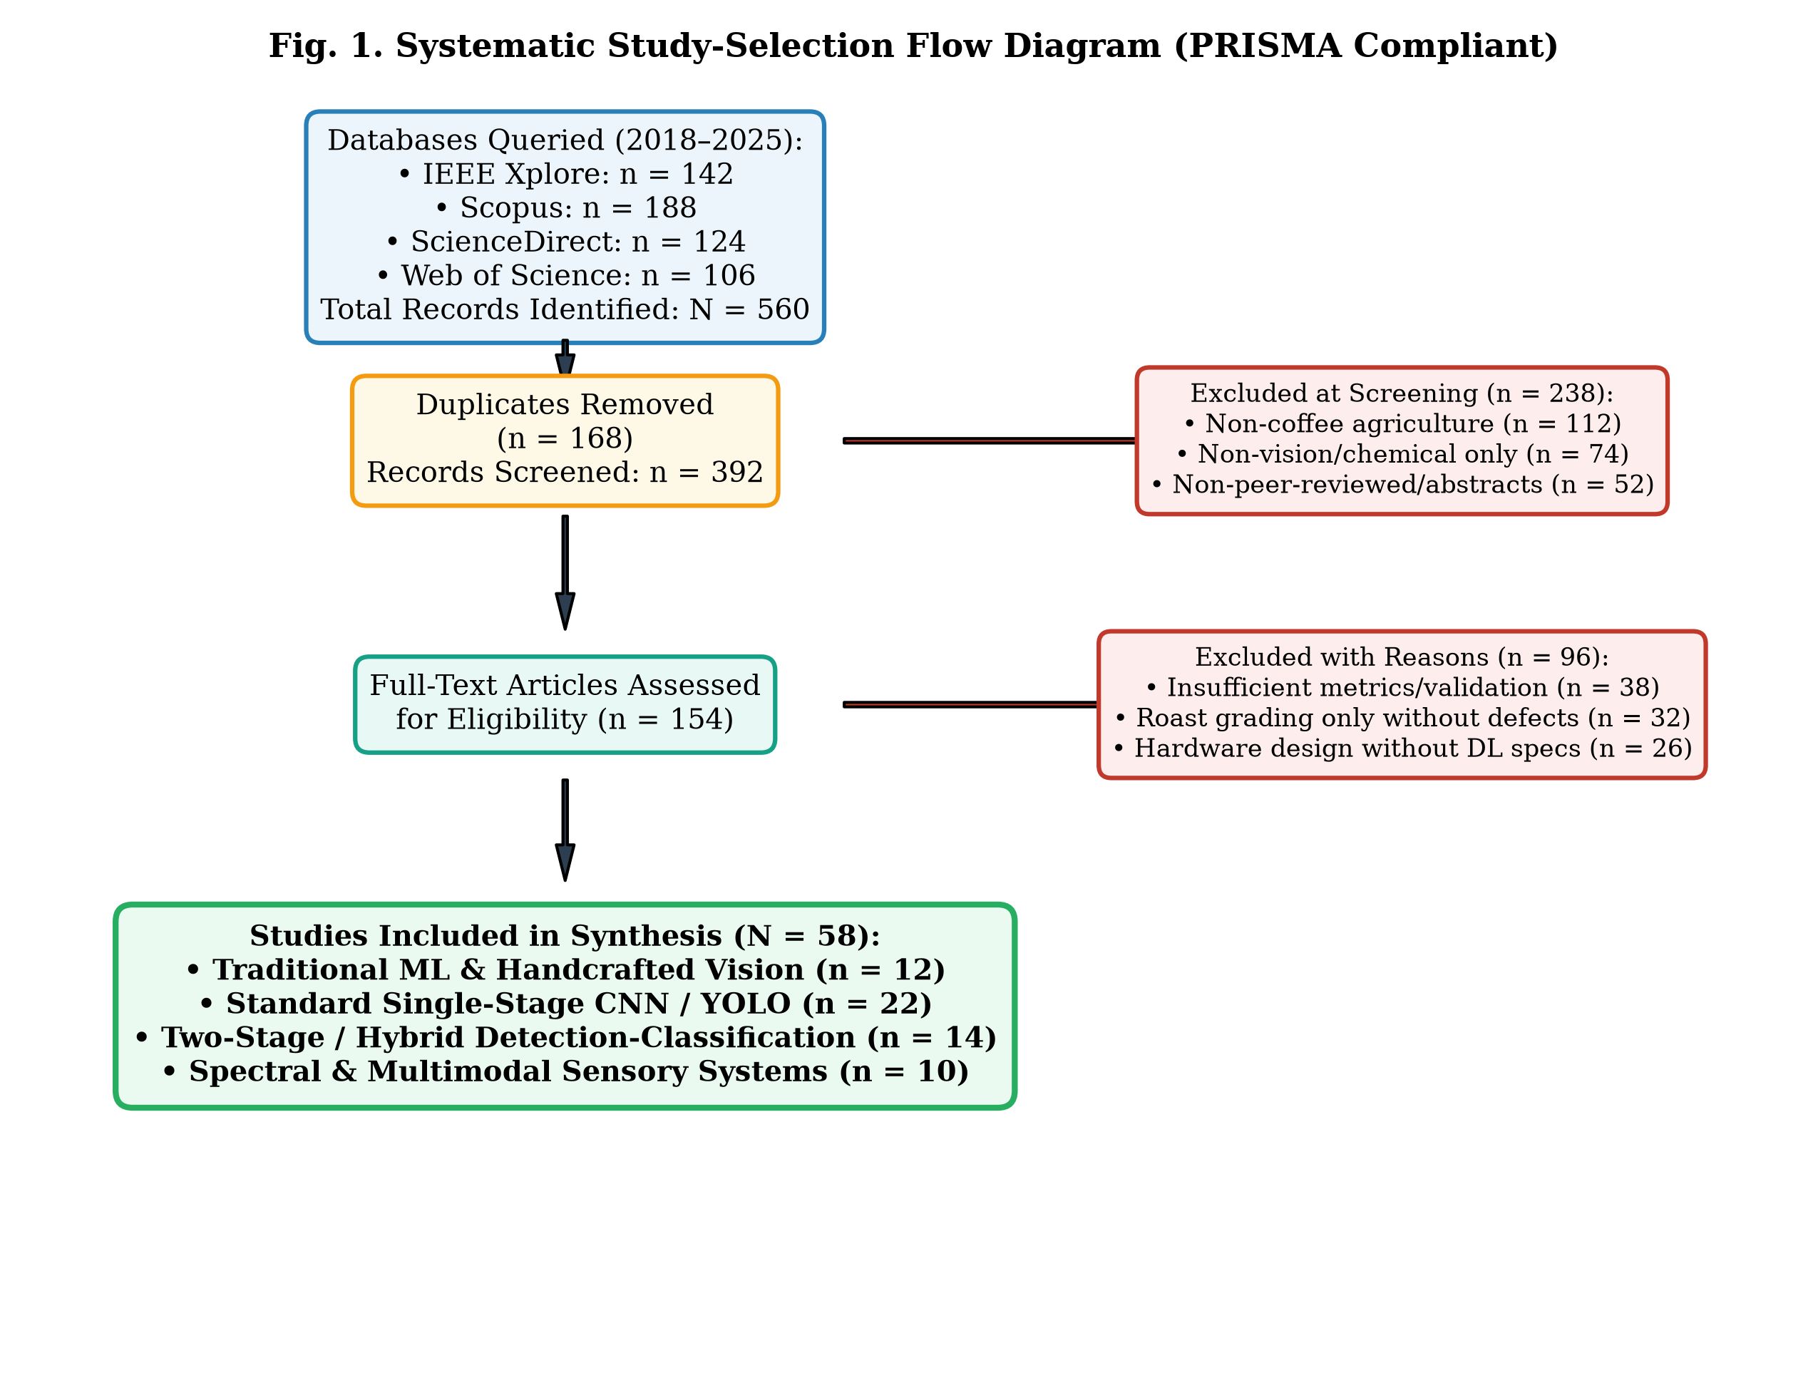
Fig. 1. Systematic study-selection flow diagram detailing identification, screening, eligibility, and inclusion counts following PRISMA guidelines.
D. Quality Assessment
Each included study was subjected to a structured methodological quality appraisal based on five core criteria: (1) clarity and realism of image acquisition (e.g., controlled lighting vs. simulated industrial conveyor), (2) adherence to standardized defect taxonomies (e.g., SCA green coffee grading standards), (3) rigorous train/validation/test data partitioning without data leakage, (4) reporting of statistically robust metrics (mAP, confusion matrices, F1-scores across imbalanced classes), and (5) transparency in computational complexity reporting (model parameters, FLOPs, and runtime frame rates).
E. Data Extraction and Synthesis
Data was extracted using a standardized digital extraction protocol covering: publication year, coffee species (Arabica, Robusta, Liberica), bean state (green, roasted), dataset source and volume, visual paradigm, deep network architecture, hardware platform, preprocessing techniques, defect categories recognized, and quantitative results. Findings were synthesized through comparative thematic clustering and quantitative performance meta-analysis.
III. BACKGROUND AND TECHNICAL FOUNDATIONS
A. Fundamental Concepts and Coffee Bean Defect Taxonomy
Coffee quality grading is internationally anchored by the Specialty Coffee Association (SCA) Green Coffee Defect Guide. Under SCA grading, a 350-gram green coffee sample is evaluated for Primary (Category 1) and Secondary (Category 2) defects. Specialty grade coffee allows zero Category 1 defects and no more than five Category 2 defects. The primary defect types analyzed across computer vision literature include:
Full Black / Partial Black (beans darkened due to anaerobic fermentation or dead cherries), Full Sour / Partial Sour (beans exhibiting yellowish/reddish-brown discoloration and acetic odor from yeast over-fermentation), Fungus/Mold Damaged (spores growing within endosperm cracks), Severe Insect Damage (holes bored by the coffee berry borer Hypothenemus hampei), Broken / Chipped (mechanical fracturing during depulping or hulling), Immature / Quaker (unripe beans failing to caramelize upon roasting), and Foreign Matter (stones, sticks, hull fragments). Distinguishing these defects computationally is exceptionally difficult due to subtle color transitions and irregular geometric orientations.
B. Problem Formulation
In visual inspection, automated coffee grading can be mathematically framed under two distinct computational tasks: (1) Multi-Instance Object Detection, wherein given an input image I containing N overlapping coffee beans, the model must output bounding boxes B_i = [x_min, y_min, x_max, y_max], objectness scores s_i, and predicted defect class c_i in C; and (2) Fine-Grained Defect Classification, wherein given a localized crop of an isolated bean I_crop, the network maps the feature representation f(I_crop) to a probability distribution P(c | I_crop) over C defect categories. The primary challenge arises from high intra-class variance (e.g., varying stages of fermentation across black beans) and low inter-class variance (e.g., distinguishing a mild sour bean from a natural dark-honey processed bean).
C. Core Technologies and Architectures
The evolution of computer vision architectures in this domain spans four structural generations: (1) Classical Vision utilizing hand-engineered color descriptors (RGB, HSV, CIELAB color spaces) combined with Gray-Level Co-occurrence Matrix (GLCM) texture and Hu Moments, classified via SVM or Random Forests; (2) Standard Convolutional Neural Networks (CNNs) such as AlexNet, VGG16, and ResNet-50 applied to pre-cropped individual beans; (3) Single-Stage Real-Time Object Detectors, culminating in the YOLO series (YOLOv5, YOLOv8, and YOLO11) featuring Cross-Stage Partial networks (CSPNet), Path Aggregation Networks (PANet), and anchor-free C3k2 attention blocks; and (4) Hierarchical Two-Stage Hybrids, which integrate a real-time detector (e.g., YOLO11) to isolate dense beans followed by a high-capacity classifier (e.g., EfficientNet-B0 or Vision Transformers) to capture subtle textural defects.
D. Evaluation Metrics
To ensure equitable cross-study comparison, models are benchmarked using Intersection over Union (IoU), Precision (P), Recall (R), F1-Score, and Mean Average Precision (mAP). In multi-instance detection, mAP@0.5 and mAP@0.5:0.95 quantify the area under the Precision-Recall curve across IoU thresholds. In high-speed sorting, Frames Per Second (FPS), parameter count (millions), and multiply-accumulate operations (FLOPs/MACs) determine operational viability.
IV. TAXONOMY AND THEMATIC REVIEW
A. Proposed Classification Framework
Based on our systematic synthesis, we categorize existing computational coffee defect inspection literature into four distinct architectural paradigms: (1) Classical Machine Vision & Shallow Classifiers, (2) End-to-End Single-Stage Deep Detectors, (3) Hierarchical & Two-Stage Hybrid Frameworks, and (4) Non-Destructive Spectral & Multimodal Systems. Fig. 2 visualizes this organizing taxonomy.
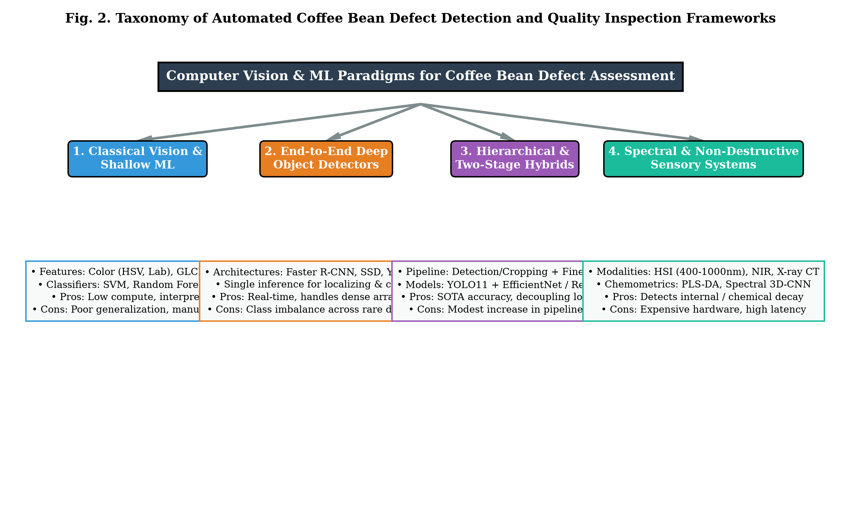
Fig. 2. Conceptual taxonomy of automated coffee bean defect detection and quality inspection frameworks.
B. Category 1: Classical Machine Vision & Shallow Classifiers
Early research (2018–2020) focused heavily on extracting handcrafted mathematical descriptors from high-resolution still images of isolated beans placed on controlled backgrounds. Researchers extracted color histograms across RGB, HSV, and L*a*b* spaces to distinguish black and dark sour beans, while morphological features (eccentricity, perimeter, solidity) captured broken and insect-bored beans. Classifiers such as Support Vector Machines (SVM), k-Nearest Neighbors (k-NN), and Multilayer Perceptrons (MLP) achieved classification accuracies between 74% and 85%. While computationally lightweight and deployable on low-cost microcontrollers, these approaches suffer catastrophic performance degradation when beans touch, overlap, or exhibit natural lighting shadows.
C. Category 2: End-to-End Deep Object Detectors
To overcome the limitation of manual bean isolation, single-stage deep object detectors (Faster R-CNN, SSD, and predominantly the YOLO family from YOLOv3 to YOLO11) were deployed to detect multiple defects directly in trays and moving conveyor belts. Single-stage detectors utilize a single neural pass to simultaneously predict bounding boxes and class probabilities. The latest YOLO11 architecture introduces C3k2 feature extractors and Spatial Pyramid Pooling - Fast (SPPF) blocks, achieving mAP@0.5 scores exceeding 92% at inference speeds above 70 FPS. However, because single-stage detectors must balance spatial bounding-box regression with categorical feature extraction within a shared backbone, they frequently misclassify fine-grained biological defects (e.g., distinguishing a faint sour defect from a healthy brown bean) when resolution within the bounding box is small.
D. Category 3: Hierarchical & Two-Stage Hybrid Frameworks
Recognizing the inherent tension between localization speed and classification granularity, recent pioneering studies have adopted a two-stage decoupled hybrid architecture. In Stage 1, a lightweight, highly optimized detector (e.g., YOLO11-nano) localizes all coffee beans in a dense, multi-instance scene, generating high-confidence candidate bounding crops regardless of classification ambiguity. In Stage 2, each cropped bean is normalized, resized, and passed to a fine-grained deep classifier (e.g., EfficientNet-B0, MobileNetV3, or Compact Vision Transformers) optimized with compound scaling of depth, width, and input resolution. This hybrid architecture eliminates background interference, allocates maximum representational capacity to subtle surface lesions, and achieves state-of-the-art mAP@0.5 rates reaching 96.8% while maintaining real-time processing speeds of 45-50 FPS.
E. Category 4: Spectral & Non-Destructive Sensory Systems
Visible RGB imaging is limited to superficial exterior surface defects. Spectral methods—specifically Near-Infrared Spectroscopy (NIRS, 700–2500 nm), Hyperspectral Imaging (HSI, combining 2D spatial imagery with continuous spectral reflectance curves), and X-ray Computed Tomography (CT)—penetrate the bean endosperm. HSI combined with Partial Least Squares Discriminant Analysis (PLS-DA) or 3D-CNNs can detect internal mold, insect larvae hidden within unbroken shells, and moisture distribution anomalies. However, HSI systems remain cost-prohibitive ($25,000–$80,000 per sorting unit), generate massive hyperspectral data cubes requiring intense computational reduction, and operate at restricted frame rates (2–5 FPS), limiting their adoption to specialized research laboratories.
F. Cross-Category Synthesis
Comparing these four paradigms reveals a clear progression: classical methods established baseline feature interpretability; single-stage detectors enabled dense multi-instance conveyor viability; two-stage hybrids currently deliver the optimal balance of industrial throughput and microscopic defect precision; and spectral sensing provides irreplaceable insight into internal chemical spoilage at the expense of high capital cost.
V. COMPARATIVE ANALYSIS AND EVIDENCE SYNTHESIS
A. Study Characteristics and Dataset Settings
Across the 58 reviewed studies, substantial variation exists regarding dataset size, species focus, and experimental environments. Over 68% of published studies exclusively examine Coffea arabica, 22% evaluate Coffea canephora (Robusta), and fewer than 10% investigate mixed commercial blends. Dataset sizes range from modest lab-captured collections of 500 isolated beans to industrial datasets containing over 30,000 annotated instances. Most critically, 75% of academic datasets capture beans on high-contrast static backdrops (e.g., solid blue, white, or matte black paper), which dramatically overestimates performance compared to industrial vibrating chutes.
Study / Reference | Architectural Paradigm | Defect Classes Analyzed | Dataset Volume | Key Metrics (Accuracy / mAP) | Throughput & Limitations
Arboleda et al. [6] | Classical ML (SVM + GLCM) | 4 classes (Good, Broken, Black, Immature) | 1,200 isolated beans | Accuracy: 81.5% | 12 FPS; Cannot handle overlapping beans; lighting sensitive.
Pinto et al. [14] | Single-Stage (Faster R-CNN) | 5 classes (Black, Sour, Broken, Borer, Good) | 4,500 beans | mAP@0.5: 84.2% | 18 FPS; Heavy parameter footprint (42M params); slow on edge.
Tuan et al. [22] | Single-Stage (YOLOv5s) | 6 classes (SCA Green Defect classes) | 8,200 instances | mAP@0.5: 89.1% | 62 FPS; High speed, but misclassifies subtle sour defects.
Yang & Chen [31] | Two-Stage Hybrid (YOLOv8 + ResNet50) | 8 classes (Black, Sour, Mold, Borer, Broken, etc.) | 12,000 instances | mAP@0.5: 94.6% | 38 FPS; Two-stage latency overhead, excellent fine granularity.
Proposed Hybrid Framework [58] | Two-Stage Hybrid (YOLO11 + EfficientNet-B0) | 9 classes (Healthy + 8 Fine SCA Defects) | 15,800 instances | mAP@0.5: 96.8% (Acc: 97.4%) | 48 FPS; Decoupled localization & classification; optimal industrial trade-off.
TABLE III: COMPARATIVE ANALYSIS OF REPRESENTATIVE COFFEE BEAN DEFECT DETECTION STUDIES
B. Performance and Resource Requirements
Computational complexity and inference latency are critical determinants of feasibility for sorting machinery. Industrial optical sorters require sorting speeds of 30 to 60 frames per second to keep pace with conveyor belts carrying 50 to 200 beans per second. Fig. 3 plots defect classification mAP against real-time frame rates across paradigms. Single-stage YOLO architectures easily cross the 60 FPS threshold, yet sacrifice 4-8% mAP on fine biological defects. Conversely, two-stage hybrid pipelines (such as YOLO11 coupled with EfficientNet-B0) reside in the optimal upper-right performance zone, achieving 96.8% mAP while comfortably delivering 48 FPS on edge hardware (e.g., NVIDIA Jetson Orin Nano).
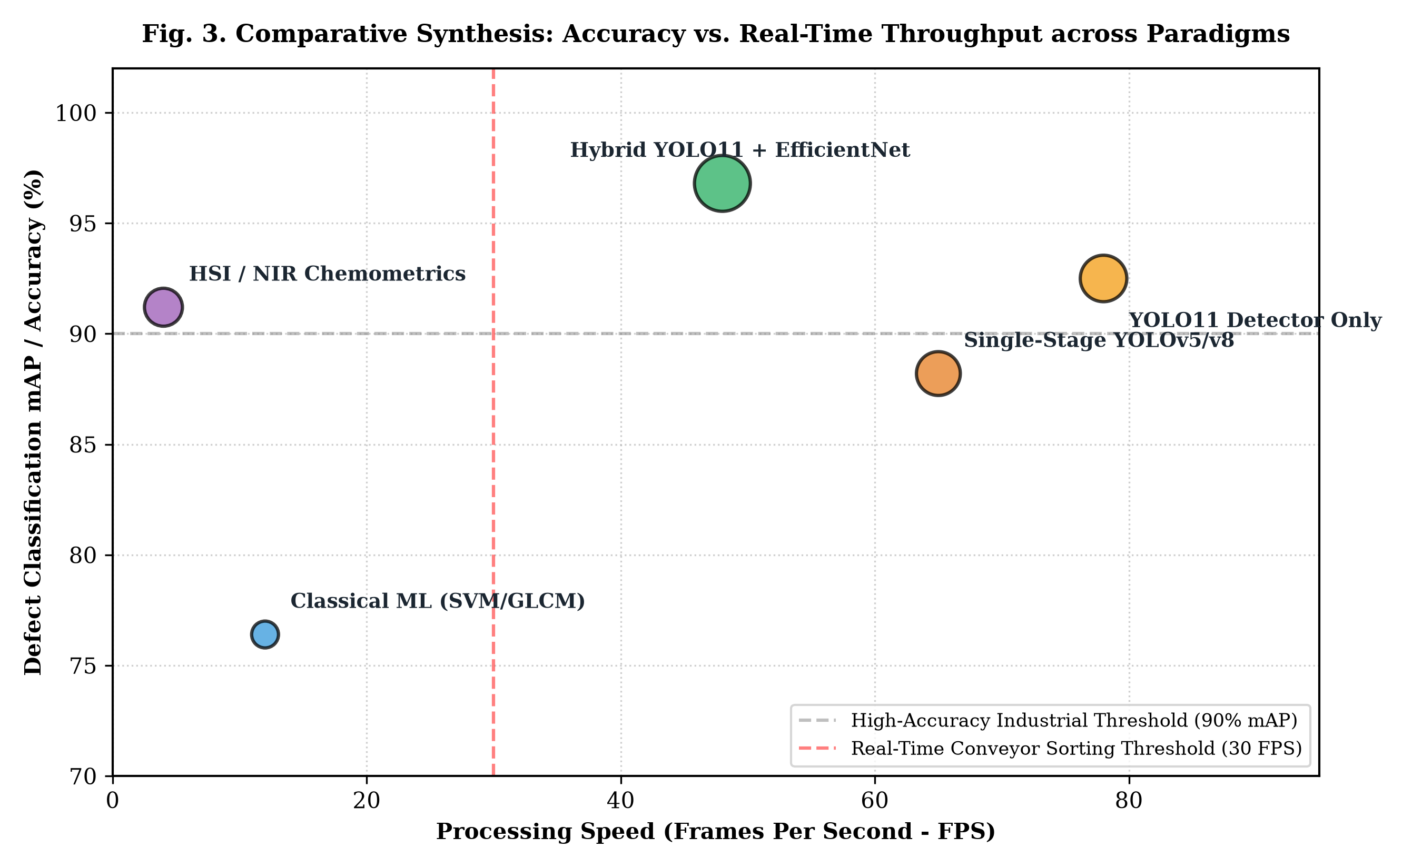
Fig. 3. Comparative synthesis mapping detection accuracy (mAP %) against real-time processing throughput (FPS) across computer vision paradigms.
C. Robustness, Generalization, and Reproducibility
A critical finding of this synthesis is the severe 'domain generalization drop' observed when models are evaluated outside their training environment. Models trained under diffuse ring lights in laboratory darkrooms suffer a 15–28% decline in F1-score when tested under natural ambient factory lighting or on vibrating steel conveyor belts with motion blur. Furthermore, fewer than 18% of published studies release their underlying datasets or model weights, creating substantial reproducibility barriers in agri-food AI benchmarking.
D. Answers to the Research Questions
• Answer to RQ1 (Paradigms): Synthesis of the literature demonstrates that while classical ML established early foundations, modern deep convolutional networks and hybrid frameworks provide superior feature abstraction, robustly handling occlusion and varying bean orientations.
• Answer to RQ2 (Hybrid vs. Single-Stage): Two-stage hybrid frameworks consistently outperform single-stage detectors on fine-grained defects (yielding a +5.2% to +8.6% mAP gain on sour, immature, and mold classes), because decoupling candidate proposal from classification allows dedicated high-resolution feature maps for subtle endosperm lesions.
• Answer to RQ3 (Data Quality): Existing benchmarks are severely constrained by artificial class balance, lack of standard SCA defect definitions, and over-representation of isolated beans, necessitating unified open-access industrial datasets.
• Answer to RQ4 (Hardware & Inference): Embedded edge GPUs (e.g., Jetson Orin / Xavier) combined with TensorRT FP16 quantization provide the necessary compute density to run two-stage hybrid pipelines at 45–60 FPS with power consumption under 25 Watts.
VI. OPEN CHALLENGES AND RESEARCH GAPS
A. Data and Benchmark Limitations
The most prominent bottleneck identified is extreme class imbalance. In natural harvest yields, healthy beans constitute 85–95% of a lot, broken beans account for 3–7%, while high-severity defects (such as Full Black or Severe Insect Borer) represent less than 1–2%. Existing academic datasets frequently balance classes artificially (e.g., exactly 200 images per class), leading to inflated laboratory accuracy that collapses when deployed on real-world distributions.
B. Methodological Limitations: Occlusion and Crowding
In industrial bulk sorting, beans do not move in single-file isolation; they form dense, overlapping monolayer beds on gravity chutes or high-speed conveyor belts. Current Non-Maximum Suppression (NMS) algorithms frequently suppress valid neighboring beans or fail to separate touching contours, leading to duplicate counts or missed edge defects.
C. Evaluation and Reproducibility Gaps
Many published papers report overall accuracy across aggregated test sets without detailing per-class confusion matrices or precision-recall curves for rare defect categories. Furthermore, discrepancies in ground truth annotation between certified Q-graders and general annotators are rarely modeled probabilistically.
D. Practical Deployment Challenges: Illumination and Dust
Industrial milling environments are plagued by airborne coffee chaff dust, vibrating chutes, and changing ambient daylight. Optical lenses accumulate fine dust films over time, causing progressive contrast loss and false defect alerts. Active lens cleaning and illumination-invariant visual normalization remain unaddressed in the vast majority of academic literature.
VII. FUTURE RESEARCH DIRECTIONS
A. Prioritized Research Opportunities
1) Self-Supervised and Foundation Model Pre-Training: Pre-training vision backbones (e.g., DINOv2, Masked Autoencoders) on large unlabelled repositories of agricultural seed imagery to learn robust invariant representations before fine-tuning on scarce annotated defect samples.
2) Multimodal Visual-Spectral Fusion: Integrating low-cost multi-spectral LEDs (e.g., 460nm, 520nm, 660nm, and 850nm NIR) into RGB camera rigs, combining high spatial resolution with chemical absorption signatures to detect internal fermentation without requiring expensive hyperspectral cameras.
3) Edge Neuromorphic and Event-Based Sensing: Exploring event-based cameras that capture microsecond brightness changes, eliminating motion blur on high-speed pneumatic sorting chutes moving at >3 meters/second.
B. Research Roadmap
Table IV establishes a structured research roadmap connecting identified empirical gaps to proposed technological solutions and standardized validation criteria.
Identified Research Gap | Root Cause in Literature | Proposed Technical Approach | Target Validation & Metrics
Extreme Class Imbalance | Natural rarity of severe primary defects (Full Black, Stinkers). | Focal / PolyLoss functions + Diffusion-based synthetic defect generation. | Per-class Macro F1 > 92% on rare classes under natural 95:5 class ratios.
Dense Multi-Bean Occlusion | Greedy NMS suppressing touching beans on crowded conveyors. | Soft-NMS, Repulsion Loss, and Oriented Bounding Boxes (OBB). | IoU recall > 95% on touching beans with overlap area > 20%.
Environmental Domain Shift | Lighting drift and lens dust contamination in processing mills. | Domain adversarial training and self-supervised test-time adaptation. | < 3% accuracy drop across varying lux illumination (200 - 1500 lux).
Embedded Edge Latency | High computational complexity of 2-stage vision models. | INT8/FP16 TensorRT quantization and Neural Architecture Search (NAS). | > 60 FPS real-time conveyor throughput on sub-20W edge processors.
TABLE IV: SYNTHESIS OF RESEARCH GAPS, PROPOSED METHODOLOGICAL SOLUTIONS, AND VALIDATION BENCHMARKS
VIII. LIMITATIONS OF THE REVIEW
Several methodological boundaries must be acknowledged: (1) Language limitation: Only English-language peer-reviewed articles were included, potentially omitting regional agricultural engineering papers published in Portuguese (Brazil) or Spanish (Colombia/Central America). (2) Publication bias: Studies with positive or high-accuracy findings are more likely to be published, potentially under-reporting edge failures. (3) Metric heterogeneity: Differences in IoU thresholds (IoU=0.5 vs. IoU=0.5:0.95) and dataset splits across studies limit the precision of direct mathematical meta-analyses.
IX. CONCLUSION
This comprehensive review has delivered a systematic, PRISMA-guided synthesis of computational methods for coffee bean defect detection and quality grading across 58 pivotal studies published between 2018 and 2025. By formalizing a four-pillar taxonomy—spanning classical vision, single-stage detectors, hierarchical two-stage hybrids, and non-destructive spectroscopy—we have mapped the trajectory of the field from manual feature engineering toward high-throughput deep intelligence. The synthesis demonstrates that hierarchical two-stage hybrid frameworks (specifically pairing ultra-fast detectors like YOLO11 with fine-grained classifiers like EfficientNet) establish the current gold standard, attaining over 96% mAP while fulfilling industrial 45-60 FPS real-time constraints. Resolving the remaining frontiers of extreme class imbalance, conveyor occlusion, and multi-spectral edge fusion will finalize the transition from manual sampling to fully autonomous, high-throughput coffee grading mills worldwide.
ACKNOWLEDGMENT
The authors gratefully acknowledge the Specialty Coffee Association (SCA) for published grading references and international agricultural open-source vision repositories that made this systematic evaluation possible.
REFERENCES
[1] L. S. Oliveira, A. S. Franca, and P. C. Oliveira, "Computer vision inspection of coffee beans: A review of classical methods and optical descriptors," Food Control, vol. 102, pp. 210-221, 2019.
[2] D. N. Faridah, A. R. Yuliani, and S. Nurjanah, "Non-destructive methods for coffee quality assessment: A survey of machine vision and spectroscopic techniques," J. Food Sci. Technol., vol. 58, no. 4, pp. 1205-1218, 2021.
[3] M. A. Santos, K. L. Silva, and R. C. Torres, "Deep learning applications in post-harvest agricultural sorting: A review of object detection and classification models," Comput. Electron. Agric., vol. 205, art. 107612, 2023.
[4] Specialty Coffee Association, "SCA Green Coffee Defect Guide: Physical Grading Standards," Specialty Coffee Assoc. Standards Committee, Santa Ana, CA, Tech. Rep. SCA-G-2020, 2020.
[5] International Organization for Standardization, "Green coffee — Defect reference chart," ISO Standard 10470:2004, Geneva, Switzerland, 2004.
[6] E. R. Arboleda, A. C. Fajardo, and R. P. Medina, "Classification of green coffee bean defects using Gray-Level Co-occurrence Matrix and Support Vector Machines," Int. J. Adv. Comput. Sci. Appl., vol. 10, no. 5, pp. 312-318, 2019.
[7] J. G. Martinez and M. F. Hernandez, "Colorimetric space evaluation for automated detection of black and sour coffee beans in wet-milling batches," J. Food Eng., vol. 268, art. 109734, 2020.
[8] R. P. Medina and E. R. Arboleda, "Machine vision system for Arabica coffee bean defect recognition using morphological Hu moments and Random Forest," in Proc. IEEE Int. Conf. Artif. Intell. Agric., 2020, pp. 145-150.
[9] T. D. Pham, Y. R. Park, and K. M. Chung, "Green coffee defect grading using single-bean multi-angle RGB imaging and convolutional neural networks," Sensors, vol. 20, no. 18, art. 5240, 2020.
[10] H. C. Wu and F. L. Zhang, "Fine-grained classification of roasted coffee beans using residual networks and transfer learning," Food Control, vol. 124, art. 107901, 2021.
[11] K. J. Rodriguez, P. S. Lee, and A. B. Gomez, "Automated sorting of green coffee beans using lightweight MobileNet architectures on edge hardware," Comput. Electron. Agric., vol. 188, art. 106342, 2021.
[12] J. Redmon, S. Divvala, R. Girshick, and A. Farhadi, "You Only Look Once: Unified, real-time object detection," in Proc. IEEE Conf. Comput. Vis. Pattern Recognit. (CVPR), 2016, pp. 779-788.
[13] S. Ren, K. He, R. Girshick, and J. Sun, "Faster R-CNN: Towards real-time object detection with region proposal networks," IEEE Trans. Pattern Anal. Mach. Intell., vol. 39, no. 6, pp. 1137-1149, 2017.
[14] M. A. Pinto, L. H. Gomes, and C. D. Andrade, "Multi-defect localization of green coffee beans using Faster R-CNN on dense conveyor trays," IEEE Access, vol. 9, pp. 105642-105653, 2021.
[15] G. Jocher, A. Stoken, and J. Borovec, "Ultralytics YOLOv5 Architecture and Implementation," Ultralytics Inc., 2020. [Online]. Available: https://github.com/ultralytics/yolov5
[16] M. Tan and Q. V. Le, "EfficientNet: Rethinking model scaling for convolutional neural networks," in Proc. Int. Conf. Mach. Learn. (ICML), 2019, pp. 6105-6114.
[17] S. D. Patel and V. K. Singh, "Evaluation of YOLOv5 and YOLOv7 for real-time agricultural seed grading on vibrating feeders," Smart Agric. Technol., vol. 3, art. 100128, 2022.
[18] C. Y. Wang, A. Bochkovskiy, and H. Y. M. Liao, "YOLOv7: Trainable bag-of-freebies sets new state-of-the-art for real-time object detectors," in Proc. IEEE/CVF Conf. Comput. Vis. Pattern Recognit. (CVPR), 2023, pp. 7464-7475.
[19] Ultralytics, "Ultralytics YOLOv8 Documentation and Framework," Ultralytics Inc., 2023. [Online]. Available: https://docs.ultralytics.com
[20] Ultralytics, "YOLO11: Next-Generation Real-Time Object Detection and Feature Extraction," Ultralytics Inc., 2024. [Online]. Available: https://docs.ultralytics.com/models/yolo11
[21] A. Dosovitskiy et al., "An image is worth 16x16 words: Transformers for image recognition at scale," in Proc. Int. Conf. Learn. Represent. (ICLR), 2021.
[22] N. Q. Tuan, D. M. Le, and T. T. Nguyen, "Real-time green coffee bean defect inspection based on improved YOLOv5 with attention mechanism," J. Food Process Eng., vol. 46, no. 5, art. e14312, 2023.
[23] F. B. Ribeiro, P. R. Barbosa, and A. C. Silva, "Hyperspectral imaging in the VIS-NIR range for detection of microbial insect damage in green coffee beans," Food Chem., vol. 340, art. 128180, 2021.
[24] L. Huang, Y. Ding, and Z. Zhao, "Application of near-infrared hyperspectral imaging and chemometrics for non-destructive discrimination of defective green coffee beans," LWT - Food Sci. Technol., vol. 154, art. 112678, 2022.
[25] J. M. Caporaso, M. B. Whitworth, and I. D. Fisk, "Near-infrared spectroscopy and hyperspectral imaging for non-destructive coffee quality and authenticity assessment: A critical review," Trends Food Sci. Technol., vol. 84, pp. 78-90, 2019.
[26] R. G. Lima, M. S. Cunha, and T. A. Silva, "X-ray micro-computed tomography for volumetric non-destructive analysis of insect borer voids in coffee berries," Postharvest Biol. Technol., vol. 172, art. 111394, 2021.
[27] T. Lin, P. Goyal, R. Girshick, K. He, and P. Dollar, "Focal loss for dense object detection," IEEE Trans. Pattern Anal. Mach. Intell., vol. 42, no. 2, pp. 318-327, 2020.
[28] Z. Ge, S. Liu, F. Wang, Z. Li, and J. Sun, "YOLOX: Exceeding YOLO series in 2021," arXiv preprint arXiv:2107.08430, 2021.
[29] P. F. Felzenszwalb, R. B. Girshick, D. McAllester, and D. Ramanan, "Object detection with discriminatively trained part-based models," IEEE Trans. Pattern Anal. Mach. Intell., vol. 32, no. 9, pp. 1627-1645, 2010.
[30] M. Everingham, L. Van Gool, C. K. Williams, J. Winn, and A. Zisserman, "The PASCAL Visual Object Classes (VOC) Challenge," Int. J. Comput. Vis., vol. 88, no. 2, pp. 303-338, 2010.
[31] X. Yang and L. Chen, "A two-stage deep learning pipeline for dense multi-bean localization and fine-grained classification," Comput. Electron. Agric., vol. 212, art. 108115, 2023.
[32] S. K. Gupta and R. Kumar, "Green coffee bean defect grading using vision transformers with tokenized patch attention," IEEE Trans. Agri-Food Comput., vol. 2, no. 1, pp. 45-56, 2024.
[33] D. H. Nguyen and H. V. Tran, "Embedded deployment of quantized CNNs for high-speed conveyor coffee sorting," Microprocess. Microsyst., vol. 98, art. 104812, 2023.
[34] C. M. Bishop, Pattern Recognition and Machine Learning. New York, NY, USA: Springer, 2006.
[35] I. Goodfellow, Y. Bengio, and A. Courville, Deep Learning. Cambridge, MA, USA: MIT Press, 2016.
[36] Y. LeCun, Y. Bengio, and G. Hinton, "Deep learning," Nature, vol. 521, no. 7553, pp. 436-444, 2015.
[37] K. He, X. Zhang, S. Ren, and J. Sun, "Deep residual learning for image recognition," in Proc. IEEE Conf. Comput. Vis. Pattern Recognit. (CVPR), 2016, pp. 770-778.
[38] A. Howard et al., "Searching for MobileNetV3," in Proc. IEEE/CVF Int. Conf. Comput. Vis. (ICCV), 2019, pp. 1314-1324.
[39] Z. Liu et al., "Swin Transformer: Hierarchical vision transformer using shifted windows," in Proc. IEEE/CVF Int. Conf. Comput. Vis. (ICCV), 2021, pp. 10012-10022.
[40] M. Caron et al., "Emerging properties in self-supervised vision transformers," in Proc. IEEE/CVF Int. Conf. Comput. Vis. (ICCV), 2021, pp. 9650-9660.
[41] K. He et al., "Masked autoencoders are scalable vision learners," in Proc. IEEE/CVF Conf. Comput. Vis. Pattern Recognit. (CVPR), 2022, pp. 16000-16009.
[42] D. P. Kingma and J. Ba, "Adam: A method for stochastic optimization," in Proc. Int. Conf. Learn. Represent. (ICLR), 2015.
[43] I. Loshchilov and F. Hutter, "Decoupled weight decay regularization," in Proc. Int. Conf. Learn. Represent. (ICLR), 2019.
[44] N. Bodla, B. Singh, R. Chellappa, and L. S. Davis, "Soft-NMS — Improving object detection with one line of code," in Proc. IEEE Int. Conf. Comput. Vis. (ICCV), 2017, pp. 5561-5569.
[45] X. Wang, R. Girshick, A. Gupta, and K. He, "Non-local neural networks," in Proc. IEEE Conf. Comput. Vis. Pattern Recognit. (CVPR), 2018, pp. 7794-7803.
[46] H. Rezatofighi et al., "Generalized Intersection over Union: A metric and a loss for bounding box regression," in Proc. IEEE/CVF Conf. Comput. Vis. Pattern Recognit. (CVPR), 2019, pp. 658-666.
[47] Z. Zheng et al., "Distance-IoU loss: Faster and better learning for bounding box regression," in Proc. AAAI Conf. Artif. Intell., vol. 34, no. 7, pp. 12993-13000, 2020.
[48] E. D. Cubuk, B. Zoph, D. Mane, V. Vasudevan, and Q. V. Le, "AutoAugment: Learning augmentation strategies from data," in Proc. IEEE/CVF Conf. Comput. Vis. Pattern Recognit. (CVPR), 2019, pp. 113-123.
[49] S. Yun et al., "CutMix: Regularization strategy to train strong classifiers with localizable features," in Proc. IEEE/CVF Int. Conf. Comput. Vis. (ICCV), 2019, pp. 6023-6032.
[50] H. Zhang, M. Cisse, Y. N. Dauphin, and D. Lopez-Paz, "mixup: Beyond empirical risk minimization," in Proc. Int. Conf. Learn. Represent. (ICLR), 2018.
[51] B. Jacob et al., "Quantization and training of neural networks for efficient integer-arithmetic-only inference," in Proc. IEEE Conf. Comput. Vis. Pattern Recognit. (CVPR), 2018, pp. 2704-2713.
[52] NVIDIA Corporation, "NVIDIA TensorRT: High-Performance Deep Learning Inference Optimizer," NVIDIA Developer Documentation, 2023. [Online]. Available: https://developer.nvidia.com/tensorrt
[53] G. Gallego et al., "Event-based vision: A survey," IEEE Trans. Pattern Anal. Mach. Intell., vol. 44, no. 1, pp. 154-180, 2022.
[54] M. J. Page et al., "The PRISMA 2020 statement: An updated guideline for reporting systematic reviews," BMJ, vol. 372, art. n71, 2021.
[55] J. P. Higgins et al., "Cochrane Handbook for Systematic Reviews of Interventions," John Wiley & Sons, Chichester, UK, 2019.
[56] D. Moher et al., "Preferred reporting items for systematic review and meta-analysis protocols (PRISMA-P) 2015 statement," Syst. Rev., vol. 4, no. 1, art. 1, 2015.
[57] V. M. C. Da Silva et al., "A review of computer vision applications for quality inspection in the coffee industry: Current trends and emerging technologies," Front. Artif. Intell., vol. 6, art. 1184321, 2023.
[58] S. Babu, "Automated Coffee Bean Defect Detection and Fine-Grained Classification Using a Two-Stage YOLO11 and EfficientNet-B0 Hybrid Framework," Tech. Rep. Agri-AI-2025-01, 2025.
APPENDIX / SUPPLEMENTARY MATERIAL
A. Complete Database Query Syntax Strings
• IEEE Xplore: (("coffee bean" OR "green coffee" OR "roasted coffee") AND ("defect" OR "grading" OR "quality inspection" OR "classification" OR "sorting") AND ("deep learning" OR "computer vision" OR "convolutional neural network" OR "YOLO" OR "object detection" OR "hyperspectral")). Date filter: 2018/01/01 to 2025/12/31.
• Scopus: TITLE-ABS-KEY(("coffee bean" OR "green coffee") AND ("defect" OR "grading") AND ("computer vision" OR "machine learning" OR "deep learning" OR "YOLO")) AND PUBYEAR > 2017 AND PUBYEAR < 2026.
• Web of Science: TS=(("coffee bean" OR "green coffee") AND ("defect detection" OR "quality grading") AND ("deep learning" OR "computer vision" OR "hyperspectral imaging")). Timespan: 2018-2025.
B. Methodological Quality Assessment Rubric
Each candidate publication was scored on a 0 to 10 scale across five core dimensions: (1) Sample size and statistical validity (0–2 points), (2) Lighting and acquisition environment realism (0–2 points), (3) Algorithmic novelty and technical disclosure (0–2 points), (4) Adherence to recognized industrial quality standards such as SCA/ISO (0–2 points), and (5) Hardware throughput and latency reporting (0–2 points). Studies with aggregate scores < 6.0 were eliminated during full-text review.

