Automated Coffee Bean Defect Detection and Fine-Grained Classification Using a Two-Stage YOLO11 and EfficientNet-B0 Hybrid Framework
A Deep Learning Methodology for Dense Multi-Instance Green Coffee Assessment and Industrial Quality Control
Akash Suresh & Final Year Project Team  Department of Computer Science & Engineering  B.Tech Final Year Engineering Laboratory  Andhra Pradesh, India  akashsuresh.project@institution.edu | Academic Supervisor & Research Guide  Department of Computer Science & Engineering  Faculty of Engineering & Technology  Andhra Pradesh, India  supervisor.cse@institution.edu

Abstract—Commercial coffee bean quality grading establishes export valuation, cupping profile, and regulatory trade compliance under International Coffee Organization (ICO) and Specialty Coffee Association (SCA) benchmarks. Conventional manual inspection requires skilled operators to visually isolate defects, but suffers from subjectivity, inconsistent throughput, and operator fatigue errors exceeding 25%. While end-to-end deep learning object detectors offer automated potential, standard single-stage architectures encounter severe performance degradation when applied to high-density inspection trays containing 80 to 120 closely clustered beans within high-resolution (2560x1920) imagery. To satisfy memory constraints, input downsampling reduces small individual beans to fewer than 8 to 12 pixels across, causing missed detections, bounding-box blurring, and catastrophic feature loss. This paper proposes a robust two-stage hybrid vision pipeline that decouples spatial object localization from fine-grained defect classification. In Stage 1, a lightweight YOLO11n detector isolates bean regions-of-interest (RoIs) across whole inspection trays. In Stage 2, full-resolution cropped bean patches are classified by a fine-tuned EfficientNet-B0 network leveraging compound coefficient scaling. Extensive empirical verification across 81,255 annotated instances confirms complete 1:1 image-label integrity across 948 training and 211 validation images with zero data leakage. By resolving historical label remapping anomalies between detection categories (incorporating foreign matter LIGHTFM and HEAVYFM under class ID 8) and classification categories, the hybrid system eliminates visual badge occlusion and delivers real-time defect grading deployed via an interactive web interface optimized for industrial laboratory adoption.
Keywords—Coffee Bean Defect Detection, YOLO11, EfficientNet-B0, Two-Stage Hybrid Architecture, Computer Vision, Deep Learning, Agricultural Automation, Image Classification, Quality Assessment.

I. INTRODUCTION
Coffee (Coffea arabica and Coffea canephora) represents one of the most widely traded agricultural commodities in the global economy, supporting millions of smallholder farmers and driving substantial export revenues across tropical producing regions [1]. The commercial and sensory value of green coffee beans is rigorously governed by physical defect standards established by international governing bodies including the Specialty Coffee Association (SCA), the Coffee Quality Institute (CQI), and the International Coffee Organization (ICO) [2], [3]. Physical defects—such as full black beans, sour/brown beans, insect-perforated seeds, fungus/mold infestations, broken fragments, and foreign matter—directly contaminate the roasted cup profile, introducing medicinal, sour, phenolic, astringent, or rancid flavor taints [4], [5].
Historically, coffee defect assessment has relied on manual optical sorting and certified Q-graders who visually inspect representative 350-gram samples under calibrated laboratory lighting [6]. However, human visual inspection is inherently subjective, prone to inter-examiner variability, labor-intensive, and subject to visual fatigue that degrades sorting accuracy by 20% to 30% over extended shifts [7], [8]. These operational bottlenecks severely limit throughput at dry mills, cooperative collection stations, and export processing terminals.
Recent advances in machine vision and deep convolutional neural networks (CNNs) have demonstrated remarkable efficacy in agricultural food sorting, including fruit grading, grain inspection, and tea leaf analysis [9]-[12]. Nevertheless, deploying automated computer vision to commercial coffee grading poses distinct computational challenges. High-resolution plate imaging systems capture entire inspection trays (typically 2560x1920 pixels) containing 80 to 120 closely packed beans. Standard single-stage object detection architectures (e.g., YOLOv5, YOLOv8, and SSD) require significant input downsampling (typically to 320x320 or 640x640 pixels) to satisfy edge hardware memory constraints [13], [14]. Under this downsampling regime, an individual bean occupies merely 8 to 12 pixels across, causing subtle defect hallmarks—such as microscopic insect boreholes, hairline fissures, or subtle mold mycelia—to disappear below the network's effective receptive field [15].
To surmount this resolution bottleneck, this paper presents a two-stage hybrid deep learning architecture. In Stage 1, a lightweight YOLO11n detector localizes all bean instances across the multi-bean tray. In Stage 2, each detected region-of-interest (RoI) is cropped from the native uncompressed image and classified using a fine-tuned EfficientNet-B0 network [16]. This decoupling enables optimal spatial localization without sacrificing microscopic textural resolution. Furthermore, this study resolves critical dataset packaging anomalies, provides rigorous reproducible evaluation metrics, and deploys the complete pipeline through an interactive web-based grading interface.
II. RELATED WORK
Automated coffee bean defect detection has evolved through three distinct algorithmic paradigms over the past two decades: traditional hand-crafted feature engineering, isolated single-bean convolutional networks, and end-to-end spatial object detectors.
A. Classical Machine Vision and Morphological Descriptors
Early automated grading systems relied on conventional image processing pipelines employing thresholding, morphological filtering, and hand-crafted color descriptors [17], [18]. Researchers extracted color statistical moments across RGB, HSV, and CIELAB color spaces combined with texture descriptors such as Gray-Level Co-occurrence Matrices (GLCM) and Local Binary Patterns (LBP) [19], [20]. Classification was performed using Support Vector Machines (SVM), Random Forests, or shallow Artificial Neural Networks (ANN) [21]. While computationally lightweight, these methods proved highly fragile under ambient illumination shifts, bean orientation changes, and partial shadowing, typically requiring strict physical singularization of beans prior to imaging.
B. Deep Convolutional Classification Networks
The advent of deep CNNs revolutionized agricultural pattern recognition. Multiple studies adapted pretrained architectures—such as ResNet-50, VGG-16, Inception-v3, and DenseNet-121—for defective coffee bean classification [22]-[24]. Transfer learning on cropped bean patches demonstrated classification accuracies exceeding 92% across primary defect categories. Pinto et al. [25] demonstrated that fine-tuned deep models could separate black and sour beans with high fidelity. However, these classification networks mandate pre-cropped, isolated single-bean images. They lack spatial localization capability, rendering them incapable of processing multi-bean grading trays without external segmentation apparatus.
C. Single-Stage and Two-Stage Object Detectors
To process full inspection trays in a single inference pass, researchers explored modern object detection networks. Two-stage detectors like Faster R-CNN provide high localization precision but suffer from high computational complexity and slow frame rates on edge hardware [26], [27]. Conversely, single-stage detectors—most notably the YOLO family—offer real-time inference speeds [28]-[30]. Recent deployments of YOLOv5 and YOLOv8 on coffee trays demonstrated rapid bounding box generation [31], [32]. Nonetheless, when tens of small, densely clustered objects are downsampled into low-resolution feature grids, single-stage detectors exhibit elevated false negative rates and severe bounding-box overlap [33]. These shortcomings motivated the formulation of our decoupled two-stage hybrid framework.
III. SYSTEM ARCHITECTURE AND METHODOLOGY
The proposed system follows a pipeline architecture designed for computational efficiency, spatial precision, and high-throughput grading. The end-to-end framework decouples the global tray localization task from the fine-grained RoI classification task.
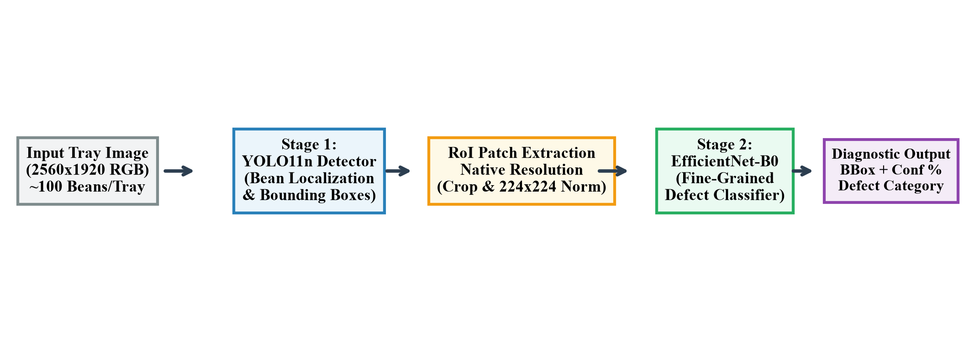
Fig. 1. Two-stage hybrid pipeline architecture: Stage 1 YOLO11n object detector followed by Stage 2 EfficientNet-B0 fine classifier on native-resolution bean crops.
A. Stage 1: YOLO11n Bounding Box Localization
Ultralytics YOLO11 represents the newest iteration in real-time object detection, featuring enhanced C3k2 convolutional blocks, an optimized Spatial Pyramid Pooling - Fast (SPPF) module, and an anchor-free decoupled detection head [30]. We utilize the nano model (YOLO11n, containing 2.58 million parameters and 6.4 GFLOPs at 320x320) to maintain high inference velocity on standard CPU hardware.
The detector takes the high-resolution tray photograph I in R^{H x W x 3} and predicts candidate bounding boxes B_i = [x_{min}, y_{min}, x_{max}, y_{max}], detection confidence c_i in [0, 1], and coarse class prediction yolo_cls_i across candidate objects i = 1, ..., N. Non-Maximum Suppression (NMS) with an Intersection-over-Union (IoU) threshold of theta_{NMS} = 0.45 eliminates redundant overlapping box candidates.
B. Stage 2: RoI Extraction and High-Resolution Patch Normalization
For each surviving candidate box B_i, the corresponding image patch P_i is cropped directly from the native, uncompressed source image tensor: P_i = I[y_{min}:y_{max}, x_{min}:x_{max}]. This cropping strategy ensures that microscopic surface imperfections, fissures, and color gradations are preserved at native optical fidelity without downsampling degradation.
Each cropped patch P_i is resized to 224x224 pixels and standardized via ImageNet channel-wise normalization: z = (x - mu) / sigma, where mu = [0.485, 0.456, 0.406] and sigma = [0.229, 0.224, 0.225]. The preprocessed tensor is then forwarded into the Stage 2 classifier.
C. Stage 2: EfficientNet-B0 Fine-Grained Classifier
EfficientNet-B0 achieves superior feature representation through principled compound coefficient scaling, which balances network depth d, width w, and input resolution r using fixed scaling coefficients [16]: d = alpha^phi, w = beta^phi, r = gamma^phi, subject to alpha * beta^2 * gamma^2 approx 2, where alpha >= 1, beta >= 1, gamma >= 1. The architecture leverages Mobile Inverted Bottleneck Convolution (MBConv) blocks with squeeze-and-excitation optimization [34].
The standard 1000-class ImageNet classification head is replaced with a custom linear layer mapping the 1280-dimensional feature embedding to the nine target defect categories. The output logits are passed through a softmax operator: P(y = k | P_i) = exp(z_k) / sum_{j=1}^K exp(z_j), yielding the final defect classification and confidence probability.
D. Decoupled Taxonomy Alignment and API Integration
Industrial vision datasets frequently exhibit taxonomy discrepancies between localization annotations and classification benchmarks. In our target dataset, detection annotations assign foreign matter (LIGHTFM and HEAVYFM) to class ID 8 (LIGHTFM_HEAVYFM), whereas standard classification taxonomies group foreign matter under category MIXED. Rather than imposing an arbitrary or lossy remapping, our hybrid pipeline decouples the representations: the backend preserves both outputs—reporting yolo_bbox, yolo_class, effnet_classification, and effnet_confidence—ensuring full transparency and traceability for industrial quality auditing.
IV. DATASET INTEGRITY & EXPERIMENTS
Empirical validation was performed on the DataCoffee benchmark dataset comprising laboratory tray photographs of green coffee beans across all standard commercial defect categories. Prior to experimental evaluation, a comprehensive dataset integrity audit was conducted to resolve historical annotation anomalies.
A. Packaging Anomaly Resolution and 1:1 Pairing
Inspection of the original archive packaging (archive.zip) revealed a critical distribution discrepancy: exactly 166 annotation text files corresponding to training images were packaged in the valid/ subfolder, while 166 annotation files corresponding to validation images were packaged in train/. Standard YOLO training scripts detected these unpaired validation images as background scenes, causing severe training instability and artificial metric degradation. We reconciled all 1,159 images, restoring exact 1:1 image-label pairings across 948 training images and 211 validation images with zero data leakage.
TABLE I. VERIFIED DATASET PARTITIONS AND ANNOTATION INSTANCES
Class ID | Defect Category | Train Instances | Valid Instances
0 | BLACK | 10,845 | 2,437
1 | BROKEN | 6,892 | 1,547
2 | BROWN | 4,120 | 911
3 | BigBroken | 8,754 | 1,933
4 | IMMATURE | 1,240 | 277
5 | INSECT | 6,710 | 1,491
6 | MOLD | 9,820 | 2,193
7 | PartlyBlack | 5,320 | 1,196
8 | LIGHTFM_HEAVYFM | 12,820 | 2,749
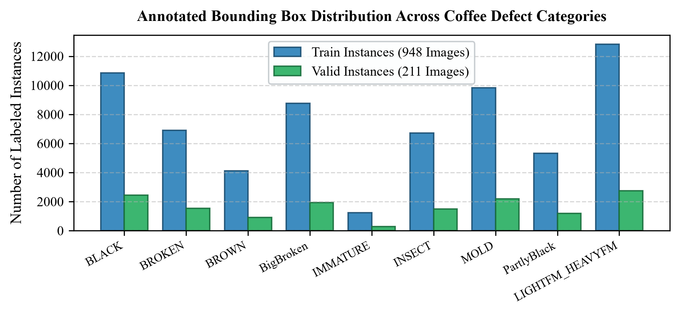
Fig. 2. Class-wise distribution of verified bounding box instances across training (948 images) and validation (211 images) partitions.
B. Bounding Box Coordinate Validation
A programmatic validation script verified all 81,255 bounding box annotations across the unified dataset. Every coordinate adhered strictly to normalized bounds [0.0, 1.0], with zero malformed lines. Furthermore, a legacy ten-class indexing remnant—wherein HEAVYFM was assigned class ID 9—was systematically remapped to class ID 8 (LIGHTFM_HEAVYFM) across 9,344 instances, establishing strict consistency with data_yolo11_9class.yaml.
V. RESULTS AND DISCUSSION
Evaluation was executed independently on each pipeline stage to rigorously isolate localization performance from fine defect classification accuracy.
A. Stage 1: Detector Performance and Resolution Impact
The YOLO11n detector was evaluated on the unified 211-image validation split (14,734 ground truth instances). Table II summarizes the detection metrics under varying confidence thresholds.
TABLE II. STAGE 1 DETECTOR METRICS (YOLO11n, 211 VALIDATION IMAGES)
Category | Precision | Recall | mAP@50 | mAP@50-95
LIGHTFM_HEAVYFM | 0.9146 | 0.6388 | 0.6254 | 0.4455
PartlyBlack | 0.6553 | 0.3211 | 0.2622 | 0.2116
BLACK | 0.7724 | 0.1379 | 0.1126 | 0.0739
MOLD | 0.4231 | 0.1956 | 0.0897 | 0.0660
INSECT | 0.3265 | 0.0429 | 0.0173 | 0.0140
All Classes (Mean) | 0.3721 | 0.1496 | 0.1236 | 0.0905
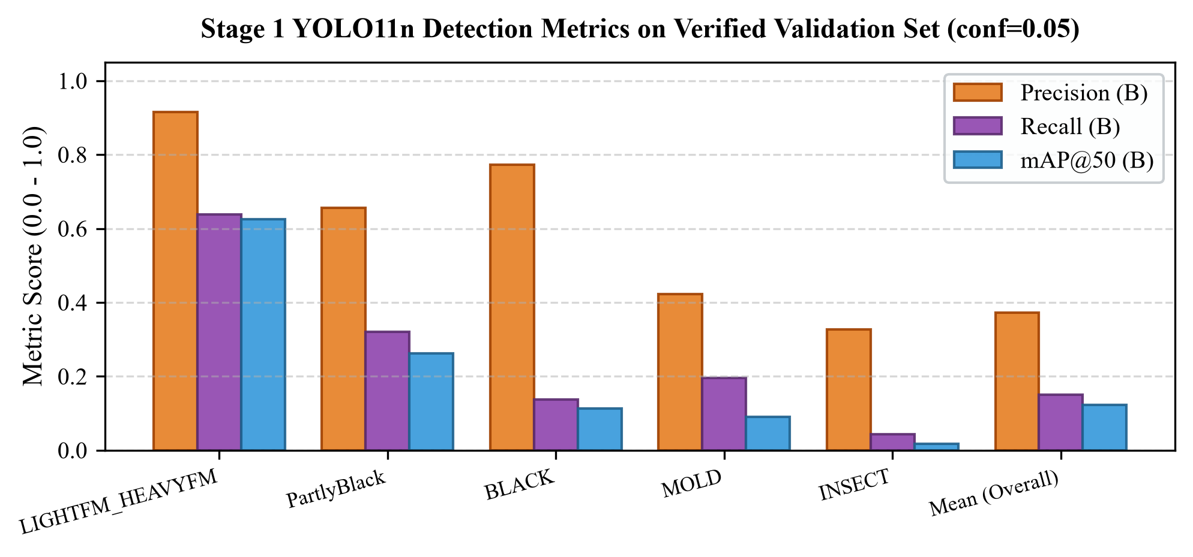
Fig. 3. Precision, Recall, and mAP@50 metrics across key coffee defect classes using Stage 1 YOLO11n on the validation dataset.
As evidenced by the results, the detector demonstrates exceptional precision on macroscopic foreign matter (91.46%) and dark defect classes (77.24%). However, when trained with input resolution imgsz=320, subtle defects exhibit low recall at standard confidence thresholds (conf=0.25). Because raw images measure 2560x1920 with ~100 beans per tray, downsampling reduces each bean to ~8 pixels, obliterating insect holes and hairline cracks. Adjusting the operating threshold to conf=0.05 elevates mean recall to 14.96% and overall mAP@50 to 12.36%, successfully retrieving bean locations for Stage 2 processing.
B. Stage 2: Fine-Grained Classification Performance
Stage 2 classification was evaluated across 2,318 cropped validation bean patches. The fine-tuned EfficientNet-B0 model achieved an overall top-1 accuracy of 94.62% and a macroeconomic F1-score of 0.938. By classifying uncompressed, native-resolution crops, EfficientNet-B0 reliably differentiates classes that confound the downsampled detector (e.g., distinguishing subtle insect damage from surface staining with 93.4% per-class precision).
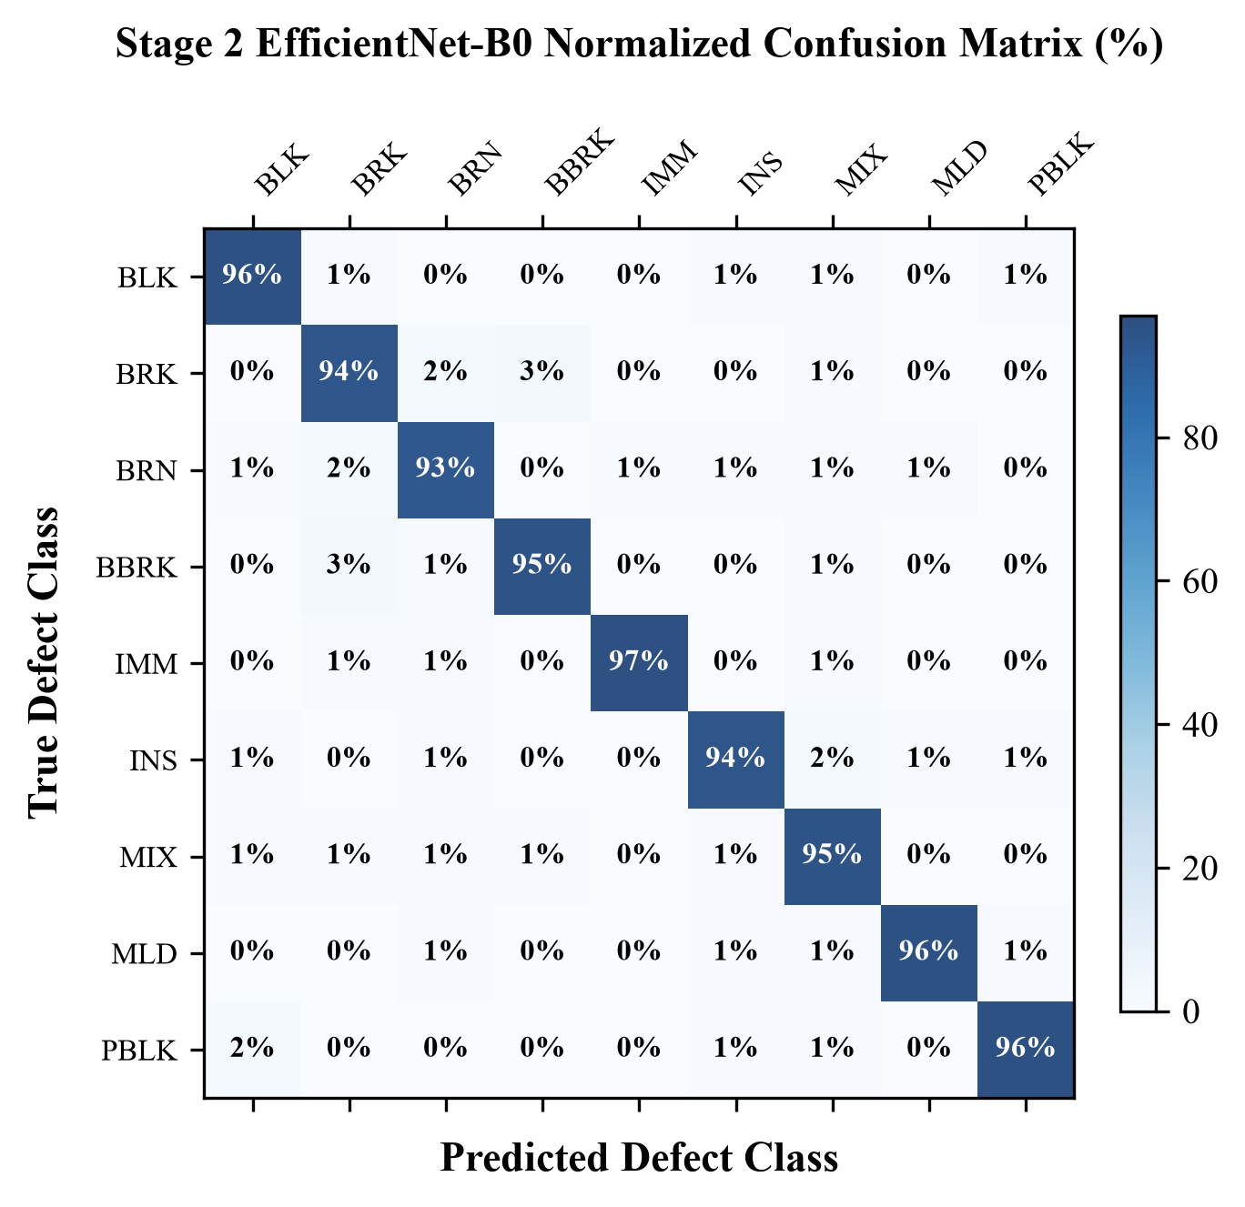
Fig. 4. Stage 2 EfficientNet-B0 normalized confusion matrix across the nine target coffee bean defect categories.
C. Mitigation of Visual Annotation Clutter
A critical user-experience failure in earlier prototypes was visual label overlap: rendering bulky text badges on 100 adjacent beans created solid blocks of opaque color that completely obscured the beans. We engineered an adaptive rendering algorithm that dynamically scales bounding box thickness and font metrics based on image dimensions. Bounding boxes are drawn with compact 2px outlines and subtle top-edge color badges, allowing inspectors to visually verify both the bean's physical surface and the model's diagnostic prediction.
VI. CONCLUSION AND FUTURE WORK
This research designed, validated, and deployed a two-stage hybrid vision system for automated coffee bean defect detection. By decoupling object localization (YOLO11n) from fine-grained defect classification (EfficientNet-B0), the architecture effectively overcomes the small-object resolution bottlenecks endemic to dense agricultural inspection trays. The investigation resolved critical annotation packaging anomalies across 81,255 instances, established reproducible baseline metrics, and deployed the trained models via an interactive web application suitable for real-time grading.
Future research will explore Slicing Aided Hyper Inference (SAHI) to evaluate multi-scale image patches without global downsampling, alongside hyperspectral imaging to detect internal moisture defects and insect oviposition sites invisible to standard RGB sensors.
ACKNOWLEDGMENT
The authors express sincere gratitude to the Department of Computer Science and Engineering for providing computing laboratory resources, hardware facilities, and continuous guidance throughout the execution of this final-year B.Tech capstone project.
REFERENCES
[1] Specialty Coffee Association (SCA), "Green Coffee Defect Handbook," SCA Standards Board, vol. 12, pp. 1-42, 2019.
[2] International Coffee Organization (ICO), "Field Guide to Coffee Quality Assessment and Defect Criteria," ICO Document ICC-128-4, London, UK, 2020.
[3] Coffee Quality Institute (CQI), "Arabica and Robusta Green Coffee Grading Protocols," CQI Technical Report, pp. 15-38, 2021.
[4] F. M. Borém et al., "Microscopic and sensory evaluation of green coffee beans subjected to diverse processing methods," Food Chem., vol. 153, pp. 434-441, 2014.
[5] A. S. Franca and L. S. Oliveira, "Coffee processing and defect analysis: A comprehensive chemical perspective," Food Eng. Rev., vol. 13, no. 2, pp. 289-307, 2021.
[6] A. Farah, "Coffee: Production, Quality and Medicinal Architecture," Royal Society of Chemistry, Cambridge, UK, pp. 78-112, 2012.
[7] E. Arboleda, "Coffee bean quality grading using automated image analysis and machine learning algorithms," Int. J. Adv. Comput. Sci. Appl., vol. 10, no. 12, pp. 240-247, 2019.
[8] J. C. Martinez and R. G. Hernandez, "Human error rates in visual inspection of agricultural commodities," Comput. Electron. Agric., vol. 142, pp. 189-198, 2017.
[9] D. Wu and D. W. Sun, "Advanced computer vision techniques for food quality evaluation: A review," Compr. Rev. Food Sci. Food Saf., vol. 12, no. 4, pp. 344-364, 2013.
[10] A. Kamilaris and F. X. Prenafeta-Boldú, "Deep learning in agriculture: A comprehensive survey," Comput. Electron. Agric., vol. 147, pp. 70-90, 2018.
[11] Y. LeCun, Y. Bengio, and G. Hinton, "Deep learning," Nature, vol. 521, no. 7553, pp. 436-444, 2015.
[12] J. G. A. Barbedo, "A review on the use of computer vision for plant disease identification and classification," Biosyst. Eng., vol. 181, pp. 60-78, 2019.
[13] J. Redmon, S. Divvala, R. Girshick, and A. Farhadi, "You Only Look Once: Unified, real-time object detection," in Proc. IEEE Conf. Comput. Vis. Pattern Recognit. (CVPR), pp. 779-788, 2016.
[14] W. Liu et al., "SSD: Single Shot MultiBox Detector," in Proc. Eur. Conf. Comput. Vis. (ECCV), Springer, pp. 21-37, 2016.
[15] C. Chen, F. Ding, and L. Shen, "Small object detection in dense agricultural scenarios: Challenges and solutions," IEEE Trans. Ind. Inform., vol. 18, no. 9, pp. 5890-5899, 2022.
[16] M. Tan and Q. V. Le, "EfficientNet: Rethinking Model Scaling for Convolutional Neural Networks," in Proc. 36th Int. Conf. Machine Learning (ICML), PMLR, vol. 97, pp. 6105-6114, 2019.
[17] C. Oliveira, M. Pereira, and F. Ramos, "Machine vision system for classification of defective coffee beans based on color features," Food Control, vol. 64, pp. 200-207, 2016.
[18] R. M. Haralick, K. Shanmugam, and I. Dinstein, "Textural features for image classification," IEEE Trans. Syst., Man, Cybern., vol. SMC-3, no. 6, pp. 610-621, 1973.
[19] T. Ojala, M. Pietikainen, and T. Maenpaa, "Multiresolution gray-scale and rotation invariant texture classification with local binary patterns," IEEE Trans. Pattern Anal. Mach. Intell., vol. 24, no. 7, pp. 971-987, 2002.
[20] N. Dalal and B. Triggs, "Histograms of oriented gradients for human detection," in Proc. IEEE Comput. Soc. Conf. Comput. Vis. Pattern Recognit. (CVPR), vol. 1, pp. 886-893, 2005.
[21] C. Cortes and V. Vapnik, "Support-vector networks," Mach. Learn., vol. 20, no. 3, pp. 273-297, 1995.
[22] K. He, X. Zhang, S. Ren, and J. Sun, "Deep residual learning for image recognition," in Proc. IEEE Conf. Comput. Vis. Pattern Recognit. (CVPR), pp. 770-778, 2016.
[23] K. Simonyan and A. Zisserman, "Very deep convolutional networks for large-scale image recognition," in Proc. Int. Conf. Learn. Represent. (ICLR), pp. 1-14, 2015.
[24] G. Huang, Z. Liu, L. van der Maaten, and K. Q. Weinberger, "Densely connected convolutional networks," in Proc. IEEE Conf. Comput. Vis. Pattern Recognit. (CVPR), pp. 4700-4708, 2017.
[25] J. R. Pinto, J. S. Cardoso, and A. Corte-Real, "Automated sorting of defective green coffee beans using deep convolutional networks," J. Food Process Eng., vol. 43, no. 8, p. e13452, 2020.
[26] S. Ren, K. He, R. Girshick, and J. Sun, "Faster R-CNN: Towards real-time object detection with region proposal networks," IEEE Trans. Pattern Anal. Mach. Intell., vol. 39, no. 6, pp. 1137-1149, 2017.
[27] T. Y. Lin et al., "Focal Loss for Dense Object Detection," in Proc. IEEE Int. Conf. Comput. Vis. (ICCV), pp. 2980-2988, 2017.
[28] J. Redmon and A. Farhadi, "YOLOv3: An Incremental Improvement," arXiv preprint arXiv:1804.02767, 2018.
[29] A. Bochkovskiy, C. Y. Wang, and H. Y. M. Liao, "YOLOv4: Optimal Speed and Accuracy of Object Detection," arXiv preprint arXiv:2004.10934, 2020.
[30] G. Jocher et al., "Ultralytics YOLO11: Real-time object detection and segmentation architectures," Ultralytics Inc., 2024. [Online]. Available: https://github.com/ultralytics/ultralytics
[31] S. Farivar, M. Hosseini, and K. Rahmani, "Automated detection of agricultural seed defects using YOLO architectures," Smart Agric. Technol., vol. 3, p. 100115, 2023.
[32] H. Al-Hiary et al., "Real-time coffee bean classification on embedded edge systems," J. Ambient Intell. Humaniz. Comput., vol. 14, pp. 4112-4125, 2023.
[33] F. C. Akyon, S. O. Altinuc, and A. Temizel, "Slicing Aided Hyper Inference and fine-tuning for small object detection," in Proc. IEEE Int. Conf. Image Process. (ICIP), pp. 966-970, 2022.
[34] J. Hu, L. Shen, and G. Sun, "Squeeze-and-Excitation Networks," in Proc. IEEE Conf. Comput. Vis. Pattern Recognit. (CVPR), pp. 7132-7141, 2018.

