

**KLE SOCIETY’S**

**CHIDANAND.B.KOREPOLYTECHNIC, CHIKODI KARNATAKA 2024-2025**

**DEPARTMENT OF COMPUTER SCIENCE & ENGINEERING ASYNOPSIS REPORT ON**

**“HOTEL MANAGEMET SOFTWARE”**

Submitted for partial fulfillment of the requirement of the award of the

# DIPLOMA IN COMPUTER SCIENCE & ENGGINEERING

UNDER THE GUDENCE OF

Miss.Sarita Khot (Lecturer)

Mr. Rajashekar Bendawade(Lecturer)

A

Synopsis

Submitted by: -

**Abhishek Shintre 339CS23701**

**Yuvaraj Kadam 339CS22059**

**Siddarth Mali 339CS22051**

**Akash Talikoti 339CS22007**



**KLE SOCIETY’S**

**CHIDANAND.B.KORE POLYTECHNIC,CHIKODI**

DEPARTMENT OF COMPUTER SCIENCE & ENGINEERING

# CERTIFICATE

Certified that this Synopsis report entitled “HOTEL MANAGEMENT SOFTWARE” which is submitted by Mr.Abhishek Shintre Reg No.339CS23701, a bonafied student of Chidanand B Kore Polytechnic in Partial fulfillment for the award of Diploma in Computer Science & Engineering during the year September 2024-2025 is record of student own work carried out under my/our guidance. It is certified that all corrections/suggestion. The indicated for internal Assessment have been incorporated in the Report and one copy of being deposited on polytechnic library.

The Synopsis report has been approved as it satisfies the academic requirement in respect of Project work prescribed for the said diploma. It is further understood that by this certificate the undersigned do not endorse or approved any statement made, opinion expressed or conclusion drawn there in but approved the project only for purpose for which it is submitted.

Guide Head of Department Principle

Name and Signature of Examiner

1

2

**Table Content**

|  |  |  |
| --- | --- | --- |
|  |  |  |
|  |  |  |
|  |  |  |
|  |  |  |
|  |  |  |
|  |  |  |
|  |  |  |
|  |  |  |
|  |  |  |
|  |  |  |
|  |  |  |
|  |  |  |
|  |  |  |
|  |  |  |
|  |  |  |

# Abstract of Project

The main aim of science technology is to understand natural event. We feel this event with our mind, which is main part of our body. Computer is also gift of science, which also works like a brain, but the manner speed at so many other properties are much more than a men’s brain.

Modern age is an age of computer. Computer has just become a part of our life. The computer education in India was started in somewhere in sixties. Now with the advent of microcomputer, it has become possible to have mass education in this field. The major advantage of computer is speed which calculated the relative of output comes. Computer can store much information and solve our problem within very short duration.

So keeping these things in views, I have computerized my small project work “**Hotel Management Software**”. I have maintained this project work on the suitable en advance language i.e. ”PHP”.

# Literature Survey

A literature review evaluates the information within any published literature related to the topic or research question you choose. The literature review is meant to analyze the published literature related to your topic. A literature review reflects upon what has already been written about (methodical or theoretical), what the existing literature contributes to the field, and how your topic corresponds with the literature. If your topic exposes a gap in the existing research in your field, make note of that in the literature review

# OBJECTIVE

The objectives of the system are-

* Guest Satisfaction.
* Operational Efficiency.
* Financial Performance.
* Staff Management.
* Marketing and Sales.

This software package can be readily used by non- programming personal avoiding human handled chance of error. This project is used by two types of users-

1. Customer
2. Builder

Our Building Management Application enables customers to create accounts, view available projects, and apply for specific jobs.

Builders can post job openings, maintain daily updates, and generate reports on project status and worker performance.

Authorized administrators have secure access to user management and system updates, ensuring the application remains current and secure.

The system is designed to be scalable, allowing easy upgrades and the addition of new features to meet evolving requirements.

# SCOPE

The project has a large scope as it has the following which help in making it easy to use, understand and modify it:

* Guest Services
* Housekeeping
* Financial Management
* Marketing and Sales
* Management of Market data

This website can be used by non-programming personal avoiding human handled chance of error. This project is by two types of users:

1.Owner

2.Staff Member

**Main Points are: -**

* Event Management
* Quality Control
* Cultural and Social Activities
* Franchise Management
* Customer Management

# System Design

**The systems development life cycle (SDLC)**

The system development life cycle (SDLC), also referred to as the application development life cycle, is a term used in systems engineering, information systems and software engineering to describe a process for planning, creating testing, and deploying an information system. The system's development life- cycle concept applies to a hardware and software configurations, as a system can be composed of hardware only, software only, or a combination of both.

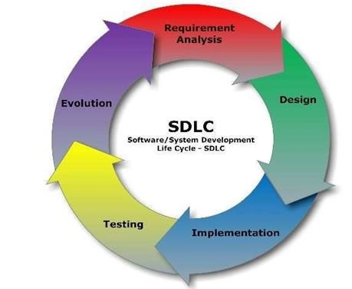

**Planning and Requirement Analysis**

Requirement analysis is the most important and fundamental stage in SDLC in performed by the senior members of the team with inputs from the customer, the sales department, market surveys and experts in the industry. This information is then used to plan the basic project approach and to conduct product feasibility study in the economic, operational, and technical areas.

# Defining Requirements

Once the requirement analysis is done the next step is to clearly define and document the product requirements and get them approved from the customer or the market analysis.

This is done through (SRS) Software Requirement Specification document which consists of all the product requirements to be designed and developed during the project life cycle.

# Hardware / Software Requirement (minimum)

**Hardware:**

* C.P.U : Core 2 Due
* Motherboard: Intel chip/original based Pentium pc
* RAM : 1 GB
* Monitor :colour (SVGA)
* Resolution : 800*600
* HDD : 160 GB

**Software:**

* Operating system : windows 11
* IDE : Notepad or Dream viewer
* Design : Photo Shop
* Server : Wamp Server
* Browser : Preferred Chrome

# Input / Output Requirement

The input and output requirements of hotel management software typically involve various aspects.

**Input requirements may include:**

1. Guest information such as names, contact details, and preferences.
2. Reservation details like check-in and check-out dates, room preferences, and special requests.
3. Room availability and rates.
4. Staff information for scheduling and task assignments.
5. Financial data for billing and invoicing.

**Output requirements may include:**

1. Confirmation of reservations and room assignments.
2. Guest check-in and check-out information.
3. Reports on occupancy rates, revenue, and guest feedback.
4. Housekeeping schedules and room status updates.
5. Financial reports for accounting purposes.

**Entity Diagram:**

The Entity Diagram was originally proposed by Peter for the design of the relation data base system, components is identified for the ERD; data objects, attributes, relationships and various types of indicators. The primary purpose of the Entity Diagram is, was originally proposed by Peter Chen for the design of Relational Database System. The Entity model is extremely useful in mapping and interactions of real world enterprise.

The primary purpose of the E-R-Diagram is to represent data object and their relationship.

**Table (Entity):**

* Contact
* Login
* Customer
* Booking
* **Relationship Between Customer and Manager**

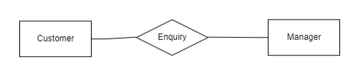

* **Relationship Between Manager and Query**

* **Relationship Between Customer and Login**

# ER Diagram

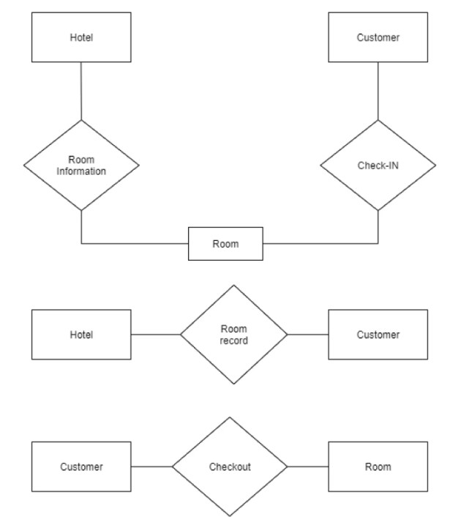

**UML Diagram**

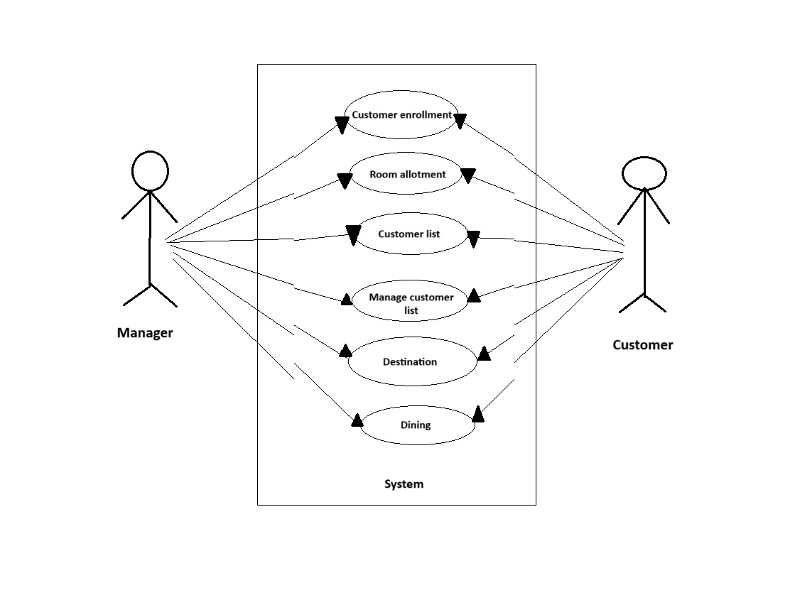

# DFD Diagram

**Context Diagram**

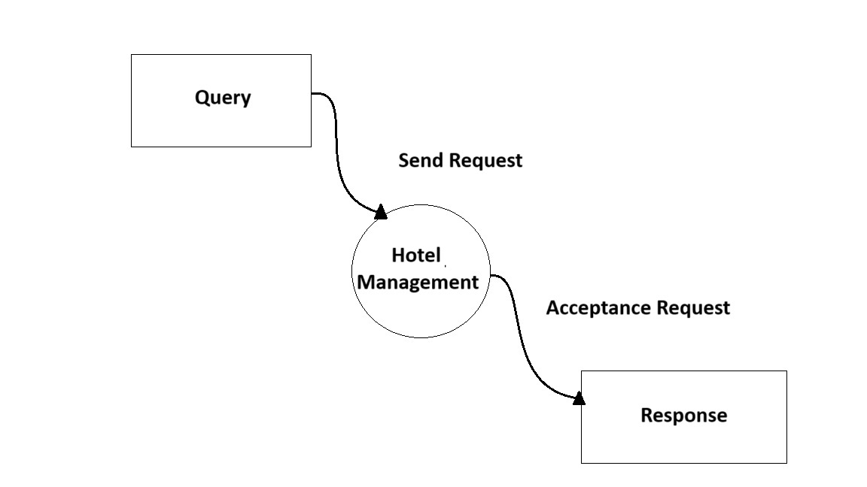

**Hotel Management Level1 DFD**

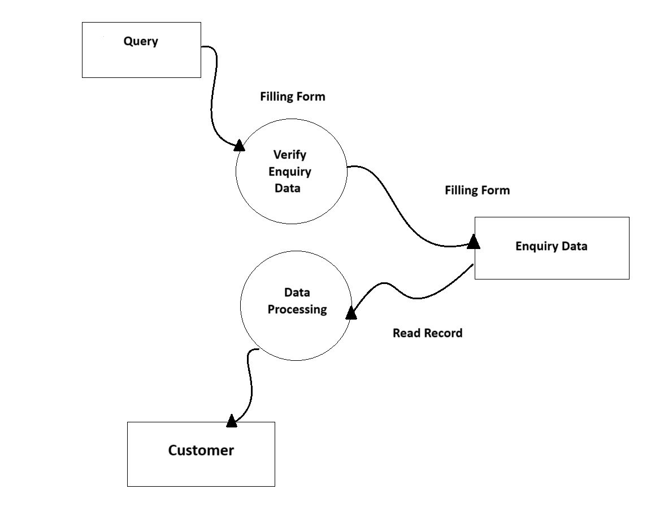

# Advantages

1. Save time on admin tasks
2. Develop strong relationships with your guests
3. Increase your online visibility
4. Implement an effective revenue management system
5. Manage distribution functions
6. Increase bookings
7. Accurate daily reports
8. Prevent double bookings and manual errors

# Disadvantages

1. Readiness of the Hotel Organization
2. Data Cleansing Process Is Difficult
3. It Is Costly to Adopt a CRM

# Future Scope

The future scope of the Taj Mahal Hotel, one of the most iconic and luxurious hotels in the world, looks promising. With its rich history, impeccable hospitality, and prime location, the hotel can continue to attract high-end travellers and maintain its reputation as a top-tier destination.

Embracing sustainable practices, incorporating cutting-edge technology for guest convenience, and expanding its offerings to include unique experiences and services could further enhance its appeal.

Additionally, collaborating with local communities for cultural immersion and investing in staff training to ensure exceptional service can solidify its position as a leader in the hospitality industry.

**Conclusion**

In conclusion, effective hotel management is crucial for the smooth operation and success of any lodging establishment. Utilizing hotel management software can streamline processes, enhance guest experiences, and ultimately contribute to the overall efficiency and profitability of the hotel.

The future scope of renowned hotels like the Taj Mahal Hotel lies in embracing innovation, sustainability, and personalized services to continue delivering exceptional hospitality experiences to guests from around the world.

**REFRENCES:**

* **http://**[**www**](L)**.w3schools.com/php/**
* [**www.stackoverflow.com**](http://www.stackoverflow.com)
* [**http://php.net/manual/en/inex.php**](http://php.net/manual/en/inex.php)
* [**http://www.tutorialspoint.com/mysql/**](http://www.tutorialspoint.com/mysql/)
* [**https://en.Wikipedia.org/wiki/Real_estate**](https://en.Wikipedia.org/wiki/Real_estate)