**Software Requirements Specification (SRS) Document**

|  |  |
| --- | --- |
|  | <Making 105 a smart classroom, DASS-Team-21,  Archit Goyal, Priyanshu Madaan, Vishal Verma, Akash Verma> |

# Brief problem statement

Converting H-105 from a normal classroom to a smart classroom.  
(-Controlling IR devices like AC, Projector, controlling lights based on the layout and occupancy, measuring CO2, Humidity and using that data to control cooling).

# System requirements

Android Studio, Arduino IDE, IOT Devices, Relays, Android Tablet.  
(Java).

Arduino library that may be used:

|  |  |
| --- | --- |
| **Library** | **Details** |
| Agir | A Girs infrared server for the Arduino platform |
| HeatpumpIR | Heatpump / Air Conditioner infrared control |
| IRremoteESP8266 | Send and receive infrared signals with multiple protocols (ESP8266/ESP32) |
| Accessories | This is a library for Arduino to handle accessories like lights, motors |
| WiFi | Helps in connecting to wifi |
| HTTPClient | Requests to server from board |
| SoftwareSerial | Input / Output from serial monitor |
| stdio | For standard input/output |

# Users profile

**Admin**:  
 The administrator has intermediate level of skills. The person has skills to create and format complex tables and manage table data. The administrator of the system shall feed the schedule in the system which will be used to automatically setup the environment.

**Faculty/Instructor**:  
 The person has intermediate level of skills. The person has skills to create and format complex tables and manage table data. They can change the settings according to the requirements at the run time depending on sudden changes in the conditions.

**Students**:  
 The person has basic to intermediate level of skills. The person has skills use operate applications. They can also change the settings according to the requirements at the run time depending on sudden changes in the conditions but with certain constraints like they cannot change the projector configurations etc.

# Feature requirements (described using use cases)

|  |  |  |  |
| --- | --- | --- | --- |
| **No.** | **User Case Name** | **Description** | **Release** |
| 1 | Turn Overhead lights on /Off | Control overhead lights based on the layout and occupancy of the seats from App |  |
| 2 | Dim Lights | Dim lights on changing the mode / turning the projector ON from App |  |
| 3 | Turn Green Board Spotlights On/Off | Control Green board spotlights based on the usage of Board from App |  |
| 4 | Turn Sound System On/Off | Based on the requirement of visual aids turn sound system on/off from app |  |
| 5 | Control Sound System Volume | Volume Control from the Android App |  |
| 6 | Measure CO2, Humidity | Measure the CO2 and Humidity both indoors and outdoors in real time |  |
| 7 | Auto-Control AC and evaporator | Process CO2 and humidity to control the AC and Evaporator to control the temperature automatically |  |
| 8 | Control AC | All AC control available on the android app to control the AC Units |  |
| 9 | Control Projector | All projector controls accessible from single app. |  |

**Use case diagram**

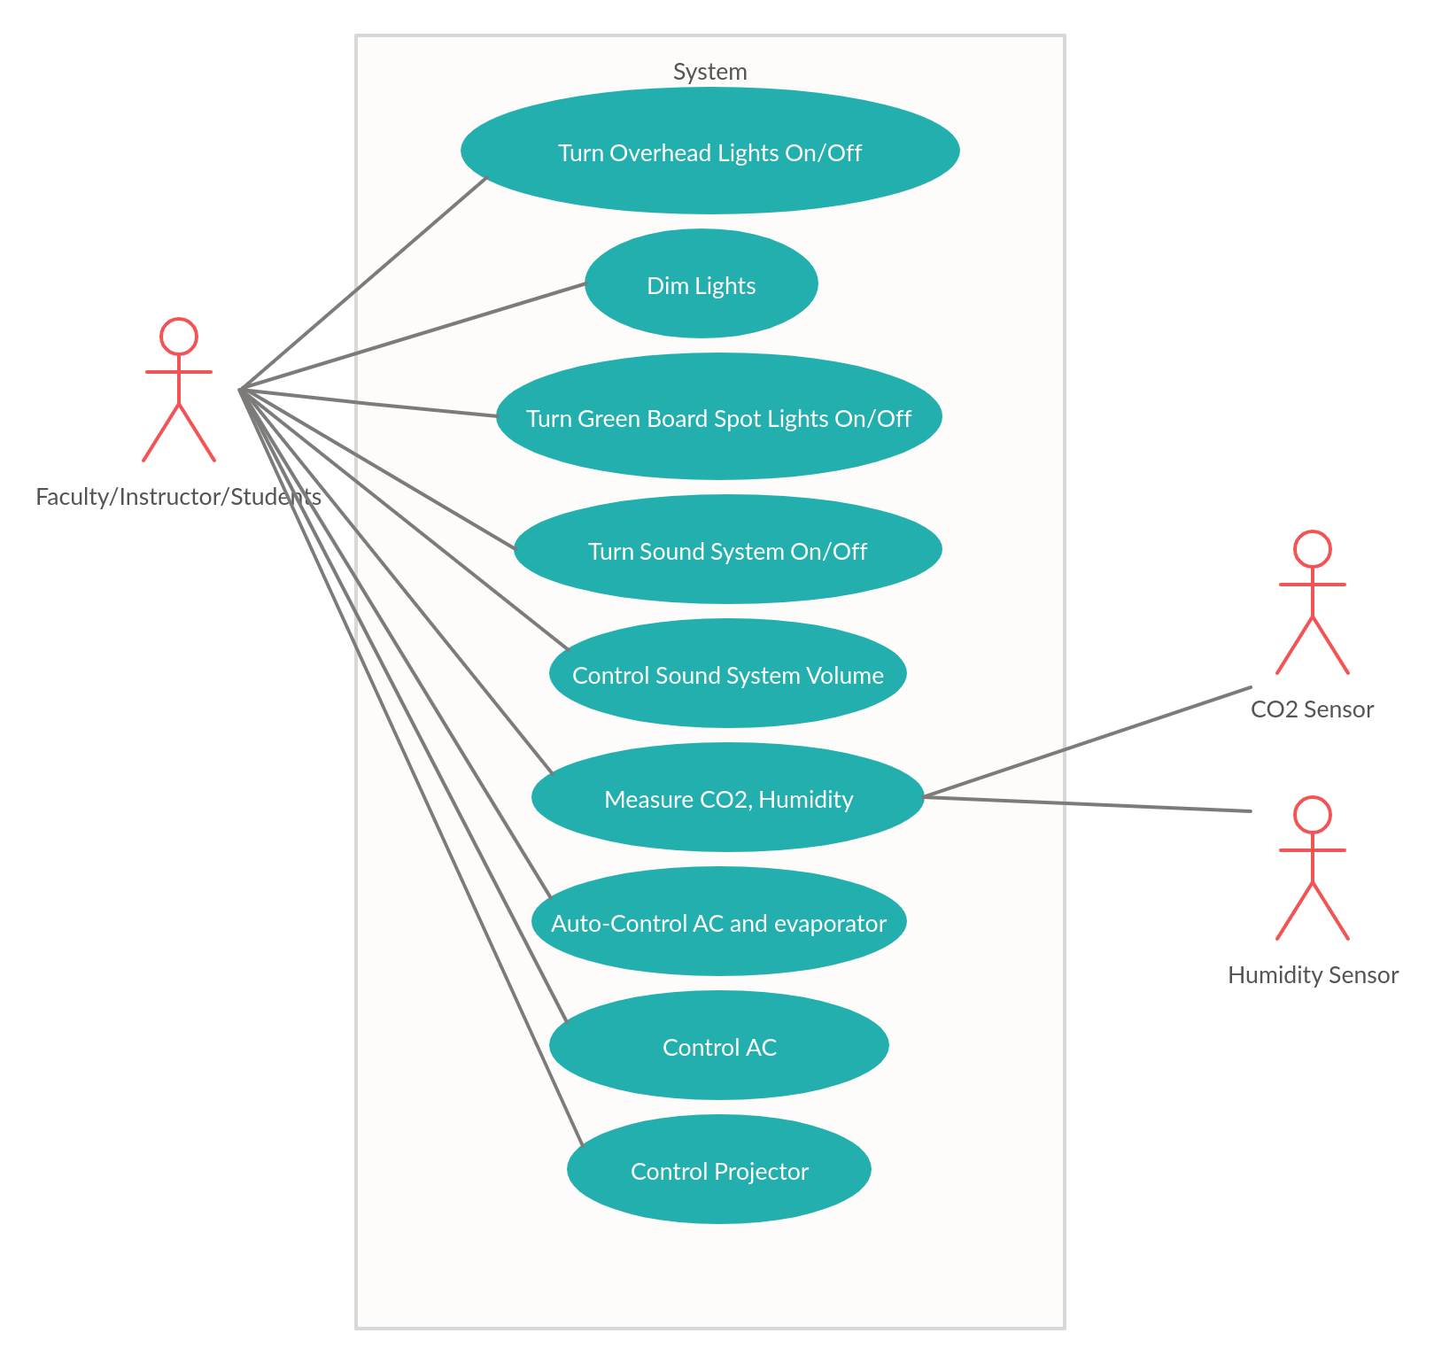

**Use case description**

|  |  |
| --- | --- |
| **Use Case Number:** | UC-01 |
| **Use Case Name:** | Turn Overhead Lights On/Off |
| **Overview:** | Control overhead lights based on the layout and occupancy of the seats from App |
| **Actors:** | Faculty/Instructor/Student |
| **Pre condition:** | None |
| **Flow:** | Main (success) Flow: 1. Select a layout from the app.2).Press Apply to activate the setup. |
|  | Alternate Flows: None |
| **Post Condition:** | None |

|  |  |
| --- | --- |
| **Use Case Number:** | UC-02 |
| **Use Case Name:** | Dim Lights |
| **Overview:** | Dim lights on changing the mode / turning the projector ON from App |
| **Actors:** | Faculty/Instructor/Student |
| **Pre condition:** | None |
| **Flow:** | Main (success) Flow: 1. Move the slider to adjust the light |
|  | Alternate Flows: None |
| **Post Condition:** | None |

|  |  |
| --- | --- |
| **Use Case Number:** | UC-03 |
| **Use Case Name:** | Turn Green Board Spotlights On/Off |
| **Overview:** | Control Green board spotlights based on the usage of Board From App |
| **Actors:** | Faculty/Instructor/Student |
| **Pre condition:** | None |
| **Flow:** | Main (success) Flow: 1)Press the button to toggle the spot lights. |
|  | Alternate Flows: None |
| **Post Condition:** | None |

|  |  |
| --- | --- |
| **Use Case Number:** | UC-04 |
| **Use Case Name:** | Turn Sound System On/Off |
| **Overview:** | Based on the requirement of visual aids turn sound system on/off from app |
| **Actors:** | Faculty/Instructor/Student |
| **Pre condition:** | None |
| **Flow:** | Main (success) Flow: 1). Press the button to switch on the Sound System |
|  | Alternate Flows: None |
| **Post Condition:** | None |

|  |  |
| --- | --- |
| **Use Case Number:** | UC-05 |
| **Use Case Name:** | Control Sound System Volume |
| **Overview:** | Volume Control from the Android App |
| **Actors:** | Faculty/Instructor/Student |
| **Pre condition:** | None |
| **Flow:** | Main (success) Flow: 1). Use the slider to change the volume |
|  | Alternate Flows: None |
| **Post Condition:** | None |

|  |  |
| --- | --- |
| **Use Case Number:** | UC-06 |
| **Use Case Name:** | Measure CO2, Humidity |
| **Overview:** | Measure the CO2 and Humidity both indoor and outdoors in realtime |
| **Actors:** | Faculty/Instructor/Student |
| **Pre condition:** | None |
| **Flow:** | Main (success) Flow: 1)Tap the panel to view the current reading of various physical quantities. |
|  | Alternate Flows: None |
| **Post Condition:** | None |

|  |  |
| --- | --- |
| **Use Case Number:** | UC-07 |
| **Use Case Name:** | Auto-Control AC and evaporator |
| **Overview:** | Process CO2 and humidity to control the AC and Evaporator to control the temperature automatically |
| **Actors:** | Faculty/Instructor/Student |
| **Pre condition:** | None |
| **Flow:** | Main (success) Flow: 1) Click the Button to Auto select the environment temperature. |
|  | Alternate Flows: None |
| **Post Condition:** | None |

|  |  |
| --- | --- |
| **Use Case Number:** | UC-08 |
| **Use Case Name:** | Control AC |
| **Overview:** | All AC control available on the android app to control the AC Units |
| **Actors:** | Faculty/Instructor/Student |
| **Pre condition:** | None |
| **Flow:** | Main (success) Flow: 1).Click the AC panel to adjust the setting |
|  | Alternate Flows: None |
| **Post Condition:** | None |

|  |  |
| --- | --- |
| **Use Case Number:** | UC-09 |
| **Use Case Name:** | Control Projector |
| **Overview:** | All projector controls accessible from single app. |
| **Actors:** | Faculty/Instructor/Student |
| **Pre condition:** | None |
| **Flow:** | Main (success) Flow: 1).Tap the Projector to access projector options. |
|  | Alternate Flows: None |
| **Post Condition:** | None |