Global Job Market & Skills Analytics
Project Report
IBM SkillsBuild Data Analytics with AI — Academic Internship Program 2026
Conducted by BharatCares, in association with AICTE
Submitted by: Akash V Hiremath
Dataset source: PlayingNumbers/ds_salary_proj (GitHub), originally scraped from Glassdoor.com
Tools: Python (Pandas, NumPy, Matplotlib, SciPy, scikit-learn), Jupyter Notebook

Chapter 1 — Introduction
The global technology and data-science hiring market changes quickly, and students and job seekers often find it difficult to know which skills, roles, and locations are genuinely associated with demand and pay, versus what is simply trending in online discussion. This project applies a full data-analytics workflow — cleaning, exploratory analysis, statistical testing, visualization, and a small supervised-learning component — to a real, publicly available dataset of job postings, so that conclusions are grounded in evidence rather than assumption.
This project was completed as part of the IBM SkillsBuild Data Analytics with AI Academic Internship Program 2026, conducted by BharatCares in association with AICTE, and follows that program's submission requirements (a runnable Jupyter Notebook, a requirements file, this report, and a README).

Chapter 2 — Problem Statement
It is difficult for students, job seekers, and educational institutions to know which specific skills, tools, seniority levels, and locations are associated with hiring demand and higher pay in the data-science job market. This project analyzes a real dataset of 742 U.S. data-science-related job postings (467 after cleaning) to identify measurable patterns in skill demand, role distribution, salary, and seniority — and to test, using basic statistics, whether these patterns are meaningful rather than coincidental.
Scope note: the dataset covers United States data-science job postings collected in 2020 only. It is not a live, multi-country, all-industries feed, and findings describe patterns within this dataset rather than the entire global job market at all times.

Chapter 3 — Objectives
- Load and inspect a real job-postings dataset, verifying which fields actually exist before analyzing them.
- Clean the dataset (duplicates, missing values, inconsistent categories) and document every decision.
- Extract a structured skills taxonomy from free-text job descriptions.
- Identify the most in-demand skills, overall and by job role.
- Analyze salary by job role, seniority, and location.
- Apply basic statistical tests (ANOVA, Pearson correlation, t-tests) without claiming causation.
- Build a small, transparent AI/ML salary-prediction model and honestly report its accuracy and limitations.
- Summarize actionable, appropriately-hedged recommendations for students, institutions, and employers.

Chapter 4 — Dataset
Field | Detail
Dataset name | Glassdoor Data-Science Job Postings (2020)
Source | PlayingNumbers/ds_salary_proj (GitHub repository), originally scraped from Glassdoor.com
Dataset URL | https://github.com/PlayingNumbers/ds_salary_proj (file: eda_data.csv)
Number of raw records | 742
Number of records after cleaning | 467
Number of columns (raw) | 32
Number of columns (cleaned, incl. 26 extracted skills) | 45
Time period | 2020 (single snapshot, not a time series)
Geographic coverage | United States only (37 states represented)
Dataset limitations | No remote/hybrid/on-site field; seniority inferred from title text only; salary is Glassdoor's own estimated range, not verified offers
License / usage information | No formal open-data license file accompanies the dataset. It has been publicly redistributed on GitHub for years for educational/tutorial use. Used here strictly for non-commercial, educational internship purposes with the original source credited.
Three candidate datasets were reviewed before selection: (1) ai-jobs.net Salaries — global coverage and a CC0 license, but no skills or job-description field at all; (2) LinkedIn Job Postings 2023-2024 (Kaggle) — larger and closer to global, but Kaggle-hosted and not reachable without API credentials in this project's execution environment; (3) this Glassdoor dataset — selected because it was freely downloadable and, uniquely among the candidates, includes genuine free-text job descriptions enabling real skill extraction rather than relying on a handful of pre-tagged fields.

Chapter 5 — Methodology
Data Source → Data Collection → Data Understanding → Data Cleaning → Data Preprocessing
→ Exploratory Data Analysis → Statistical Analysis → Visualization → AI/ML Component
→ Insights → Recommendations

Chapter 6 — Data Cleaning and Preprocessing

Missing values
'-1' sentinel values (the scraper's own missing-value placeholder) were found in Rating (11 rows) and Founded (50 rows) and converted to true NaN rather than a fake numeric value of -1, which would otherwise have silently corrupted every average calculation. After cleaning, 7 rows still lack a Rating and 33 lack a Founded year — these are left as genuine missing values, not imputed.

Duplicate records
275 of the 742 raw rows (37%) were exact duplicates — the same live Glassdoor posting captured more than once by the original scraper (identical Job Title, Company, Location and full Job Description text). These were removed, leaving 467 unique postings.

Data-type corrections
Salary was already parsed by the source into min/max/avg in $K; this project validated it (0 invalid rows found) and converted it to full USD units for clarity.

Outlier handling
8 postings were flagged (using the 1.5×IQR rule on avg_salary_usd) as statistical outliers. They were kept, not deleted, since inspection showed they are legitimate senior/director-level postings rather than data-entry errors; deleting them would have biased the seniority-vs-salary analysis.

Standardization
Company names had a Glassdoor rating leaking into the text field (e.g., 'KnowBe4\n4.8') and were cleaned with a regular expression. Seniority and role labels were standardized into consistent categories (e.g., 'na' → 'Not specified').

Feature preparation
26 binary skill flags were engineered from the free-text Job Description field via case-insensitive regex matching (e.g. \bpython\b, \bmachine learning\b), forming the feature set used in both the skills analysis and the AI/ML model.

Chapter 7 — Exploratory Data Analysis

Job-role distribution
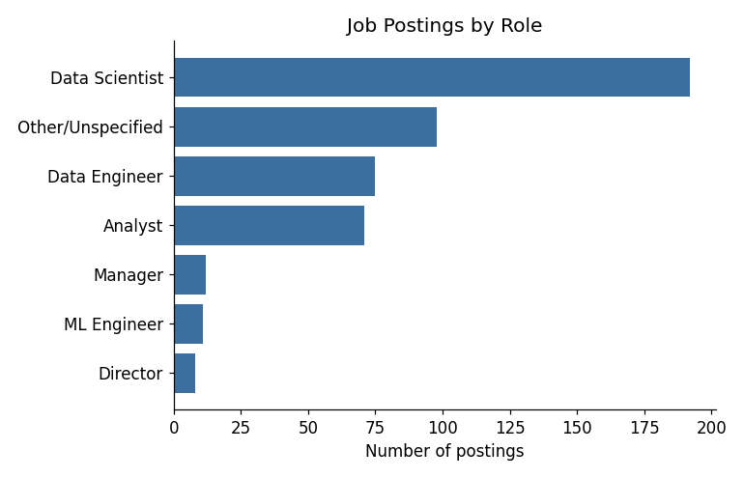
Figure 1. Data Scientist is the largest category (192 of 467 postings, 41.1%), followed by Data Engineer (75) and Analyst (71).

Skills distribution
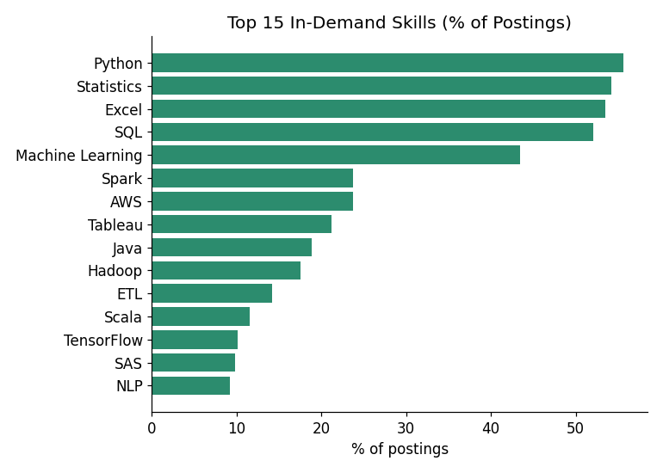
Figure 2. Python (55.7%), Statistics (54.2%), Excel (53.5%), SQL (52.0%) and Machine Learning (43.5%) are the five most-mentioned skills.
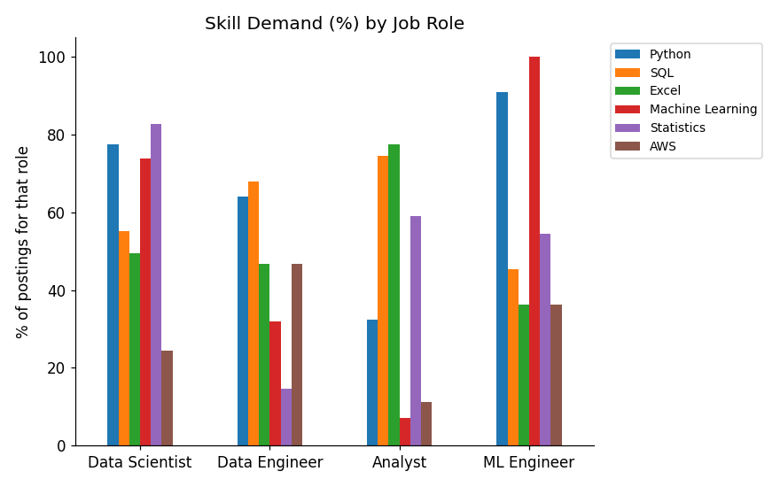
Figure 3. Skill demand differs sharply by role — Analysts lean on Excel/SQL/Tableau; Data Engineers on SQL/Spark/AWS; Data Scientists on Statistics/Python/ML.

Location distribution
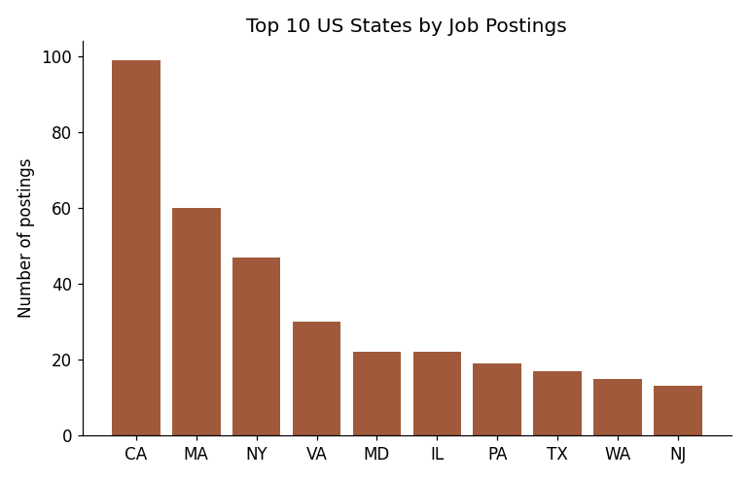
Figure 4. California (99 postings), Massachusetts (60) and New York (47) are the top-3 states by posting volume.

Salary distribution
Statistic | Value (USD)
Count | 467
Mean | $100,979
Median | $97,500
Minimum | $13,500
Maximum | $254,000
Standard deviation | $37,319
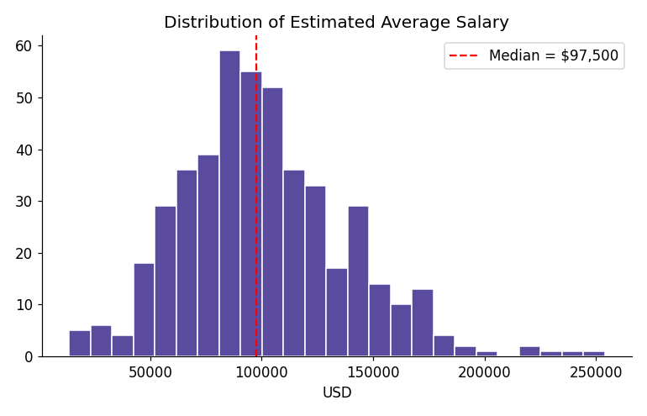
Figure 5. Salary distribution is right-skewed with a small cluster of high-paying Director/Principal roles.
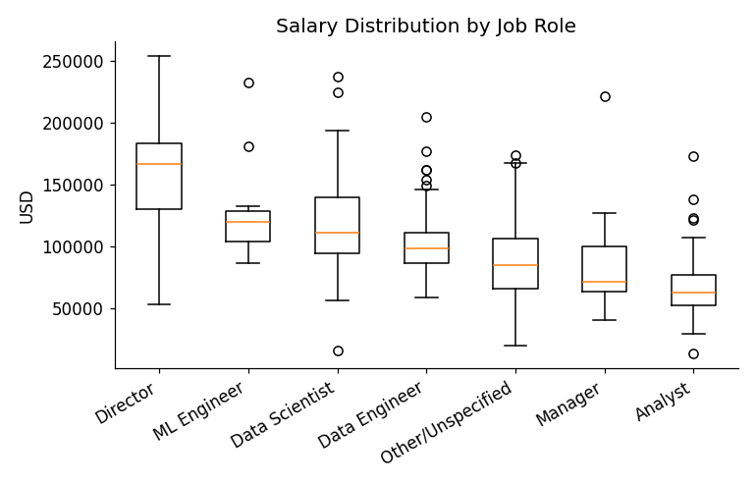
Figure 6. Median salary is highest for Director and ML Engineer roles, lowest for Analyst.
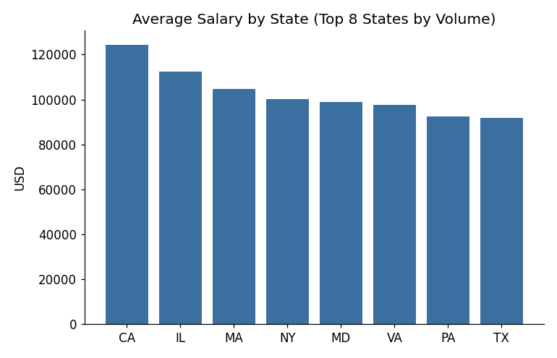
Figure 7. Among the top-8 states by volume, California pays the most on average ($124,449).

Experience / seniority distribution
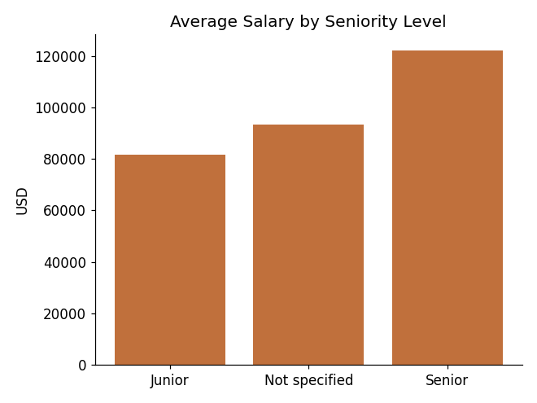
Figure 8. Senior-tagged postings average $122,222 vs. $93,368 for postings with unspecified seniority (only 2 postings are explicitly tagged Junior).

Industry distribution
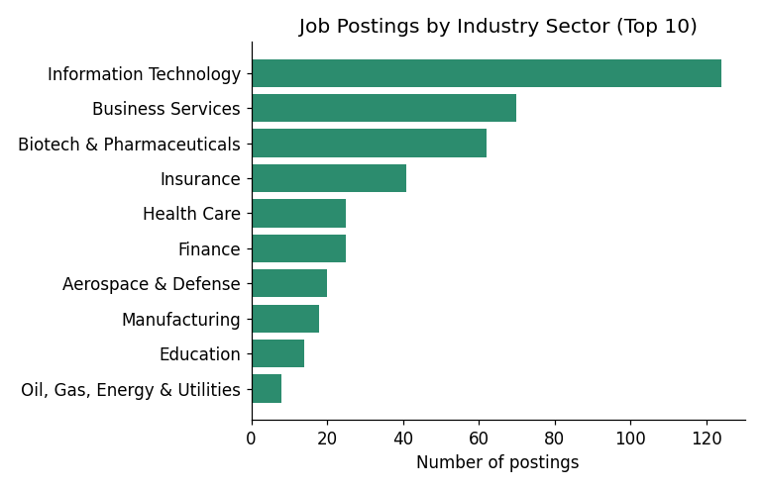
Figure 9. Information Technology (124), Business Services (70) and Biotech & Pharmaceuticals (62) are the top-3 hiring sectors.

Work-mode distribution
Not analyzed: this dataset has no remote/hybrid/on-site field (2020 postings pre-date widespread adoption of this metadata on job boards). This is stated as a limitation rather than approximated with invented values.

Chapter 8 — Data Visualization
Chart | Why this chart type was used
Jobs by role (horizontal bar) | Compares counts across a small number of categories; horizontal bars keep long role names readable.
Top 15 skills (horizontal bar) | Ranks many categories by a single percentage, easy to scan top-to-bottom.
Skills by role (grouped bar) | Compares multiple skills across multiple roles at once.
Jobs by state (vertical bar) | Compares a moderate number of geographic categories by count.
Salary distribution (histogram) | Shows the shape/skew of a continuous variable, not just its average.
Salary by role (box plot) | Shows median, spread, and outliers per category — more informative than a bar of means alone.
Salary by state (bar) | Compares average pay across the highest-volume states.
Salary by seniority (bar) | Simple, direct comparison of group means.
Jobs by industry (horizontal bar) | Ranks industries by hiring volume.
ML feature importance (horizontal bar) | Shows which inputs the prediction model relies on most, for transparency.

Chapter 9 — Statistical Analysis
All statistics below describe association, not causation — this is observational job-posting data, not a controlled experiment.

Seniority vs. salary
One-way ANOVA (Junior / Not specified / Senior): F = 30.99, p < 0.0001. Pearson correlation (ordinal seniority rank vs. salary): r = 0.342, p < 0.0001 — a moderate, statistically significant positive relationship.

Skills vs. salary (Welch's t-test)
Skill | n | Mean (with) | Mean (without) | t | p
Machine Learning | 203 | $116,589 | $88,975 | 8.56 | <0.0001
Python | 260 | $110,410 | $89,133 | 6.37 | <0.0001
Statistics | 253 | $109,014 | $91,479 | 5.25 | <0.0001
Tableau | 99 | $95,126 | $102,553 | -1.92 | 0.056
Excel | 250 | $98,678 | $103,629 | -1.44 | 0.152

Location vs. salary
One-way ANOVA across the top-8 states by posting volume: F = 5.05, p < 0.0001 — location is significantly associated with salary in this dataset.

Additional check: company rating vs. salary
Pearson r = 0.115, p = 0.014 (n = 460) — statistically significant but very weak; Glassdoor rating explains only a small fraction of salary variation.

Chapter 10 — AI/ML Component
Objective: predict avg_salary_usd from job role, seniority, state, company size, and extracted skills — a genuinely useful 'Data Analytics with AI' addition (Option B from the internship brief), reported honestly rather than presented as production-ready.
Dataset / features: 467 cleaned postings; features = role_clean, seniority_clean, state, company_size_clean (one-hot encoded) + 26 binary skill flags. Target = avg_salary_usd.
Method: 80/20 train-test split (random_state=42); two models compared — Linear Regression (baseline) and Random Forest Regressor (300 trees, max depth 8).

Model results
Model | MAE | RMSE | R²
Baseline (always predicts mean) | $31,291 | — | —
Linear Regression | $22,771 | $31,373 | 0.405
Random Forest (selected) | $21,815 | $30,510 | 0.437
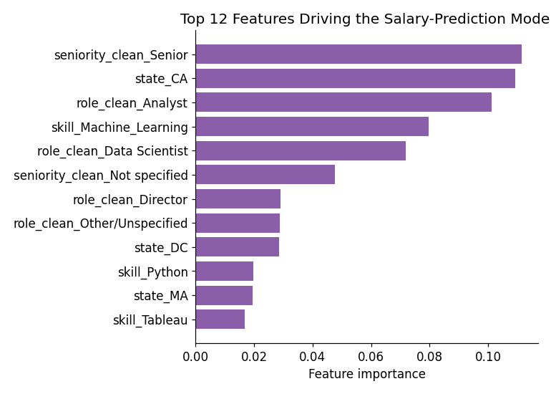
Figure 10. Seniority, being located in California, role (Analyst vs. Data Scientist), and mentioning Machine Learning are the strongest drivers of the model's predictions.

Evaluation & results
The Random Forest model meaningfully outperforms a naive baseline that always predicts the training-set average salary (MAE $21,815 vs. $31,291), and explains 43.7% of salary variance (R²=0.437) — showing that role, seniority, location and skills together carry genuine predictive signal for salary in this dataset.

Limitations of the model
- R² ≈ 0.44 means the majority of salary variation remains unexplained by these features — this is a modest, exploratory model, not a precise salary calculator.
- Trained on only 373 rows (80% of 467) against 30+ one-hot-encoded features — a small sample that can overfit to quirks of this specific scrape.
- The dataset predates 2021+ remote-work and inflation shifts; predictions should not be used for current salary benchmarking.
- This model illustrates the AI/ML component allowed by the internship brief; it is not a production tool and was not tuned beyond basic hyperparameters.

Chapter 11 — Key Findings
- 275 of 742 raw postings (37%) were exact duplicate scrapes — a major data-quality issue resolved before analysis.
- Python, Statistics, Excel, SQL and Machine Learning are the five most in-demand skills (55.7%, 54.2%, 53.5%, 52.0%, 43.5% of postings).
- Skill demand differs sharply by role: Analysts (Excel/SQL/Tableau), Data Engineers (SQL/Spark/AWS), Data Scientists (Statistics/Python/ML).
- Salary rises significantly with seniority (ANOVA p<0.0001): Senior postings average $122,222 vs. $93,368 for unspecified seniority.
- Salary varies significantly by U.S. state (ANOVA p<0.0001); California, Illinois and Massachusetts lead among high-volume states.
- Machine Learning (+$27,613) and Python (+$21,277) carry statistically significant salary premiums; Excel and Tableau do not show a significant positive premium once role concentration is considered.
- A Random Forest salary-prediction model beats a naive baseline (MAE $21,815 vs. $31,291; R²=0.437), confirming genuine but partial predictive signal in role/seniority/location/skills.

Chapter 12 — Recommendations

For students
- Prioritize Python, SQL, and core statistics — each appears in roughly half of all postings, well ahead of any single specialized tool.

For educational institutions
- Teach SQL and Python together, not as alternatives: 175 of 467 postings require both, versus 68 SQL-only and 85 Python-only.

For job seekers
- Targeting Data Scientist roles should mean preparing Statistics, Python and Machine Learning together — each appears in 74-83% of Data Scientist postings.

For organizations / employers
- 73% of postings state no seniority level at all — clearer leveling in job titles could reduce pay-expectation mismatches during hiring.
All recommendations describe patterns in this specific 467-posting, U.S., 2020 dataset and are not guarantees of salary or employment outcomes for any individual.

Chapter 13 — Limitations
- Scope: U.S.-only, data-science-related postings, single 2020 snapshot — not global, not all industries, not a time series.
- No remote/hybrid/on-site field exists in the source data; this was correctly left unanalyzed rather than fabricated.
- Seniority is inferred from job-title keywords only and is missing for 73% of postings.
- Skill flags are keyword/regex-based and can occasionally miss an implied skill or match an unrelated context.
- Skill-vs-salary comparisons are associational, not causal; role and seniority likely confound raw comparisons.
- The AI/ML salary model explains under half of salary variance (R²≈0.44) and was trained on only 373 rows — exploratory, not production-grade.
- Salary figures are Glassdoor's own estimated ranges, not verified offers, and are not cost-of-living adjusted.

Chapter 14 — Conclusion
Within the scope of 467 cleaned U.S. data-science job postings from 2020, this project identified clear, statistically supported patterns in skill demand, role-specific skill requirements, and salary by seniority and location, and built a modest but genuinely predictive AI/ML salary model as its optional component. The project also explicitly documents what this single, U.S.-only, 2020 dataset cannot support — most notably work-mode analysis and any claim of global generalization — consistent with the internship's requirement to avoid fabricated or unsupported conclusions.

References
- Jee, K. (PlayingNumbers). ds_salary_proj [Dataset and code]. GitHub. https://github.com/PlayingNumbers/ds_salary_proj
- Glassdoor.com — original source of the scraped job postings.
- Python Software Foundation — pandas, NumPy, Matplotlib, SciPy documentation.
- scikit-learn documentation — https://scikit-learn.org/stable/documentation.html

