**Prevent User Deletion if Assigned to an Incident**

**Category:** ServiceNow Application Developer

**Skills Required:**

Script, Business Rules, Glide Records and APIs, User and Group Management.

**Problem Statement:**

In an IT Service Management environment, users are frequently assigned to incidents for issue resolution and tracking. However, the current system lacks a validation mechanism to prevent the deletion of a user who is still actively assigned to incidents. This can lead to broken data references, loss of accountability, and disruption in workflow continuity.

There is a need to implement a safeguard that prevents such deletions unless all assigned incidents are closed or reassigned.

# User Creation

## Create Test Users

1. Go to ServiceNow >> All >> Users (under System Security)
2. Click on New
3. Create two users (e.g., kiran123,ajaykumar)
4. Submit and verify user records.

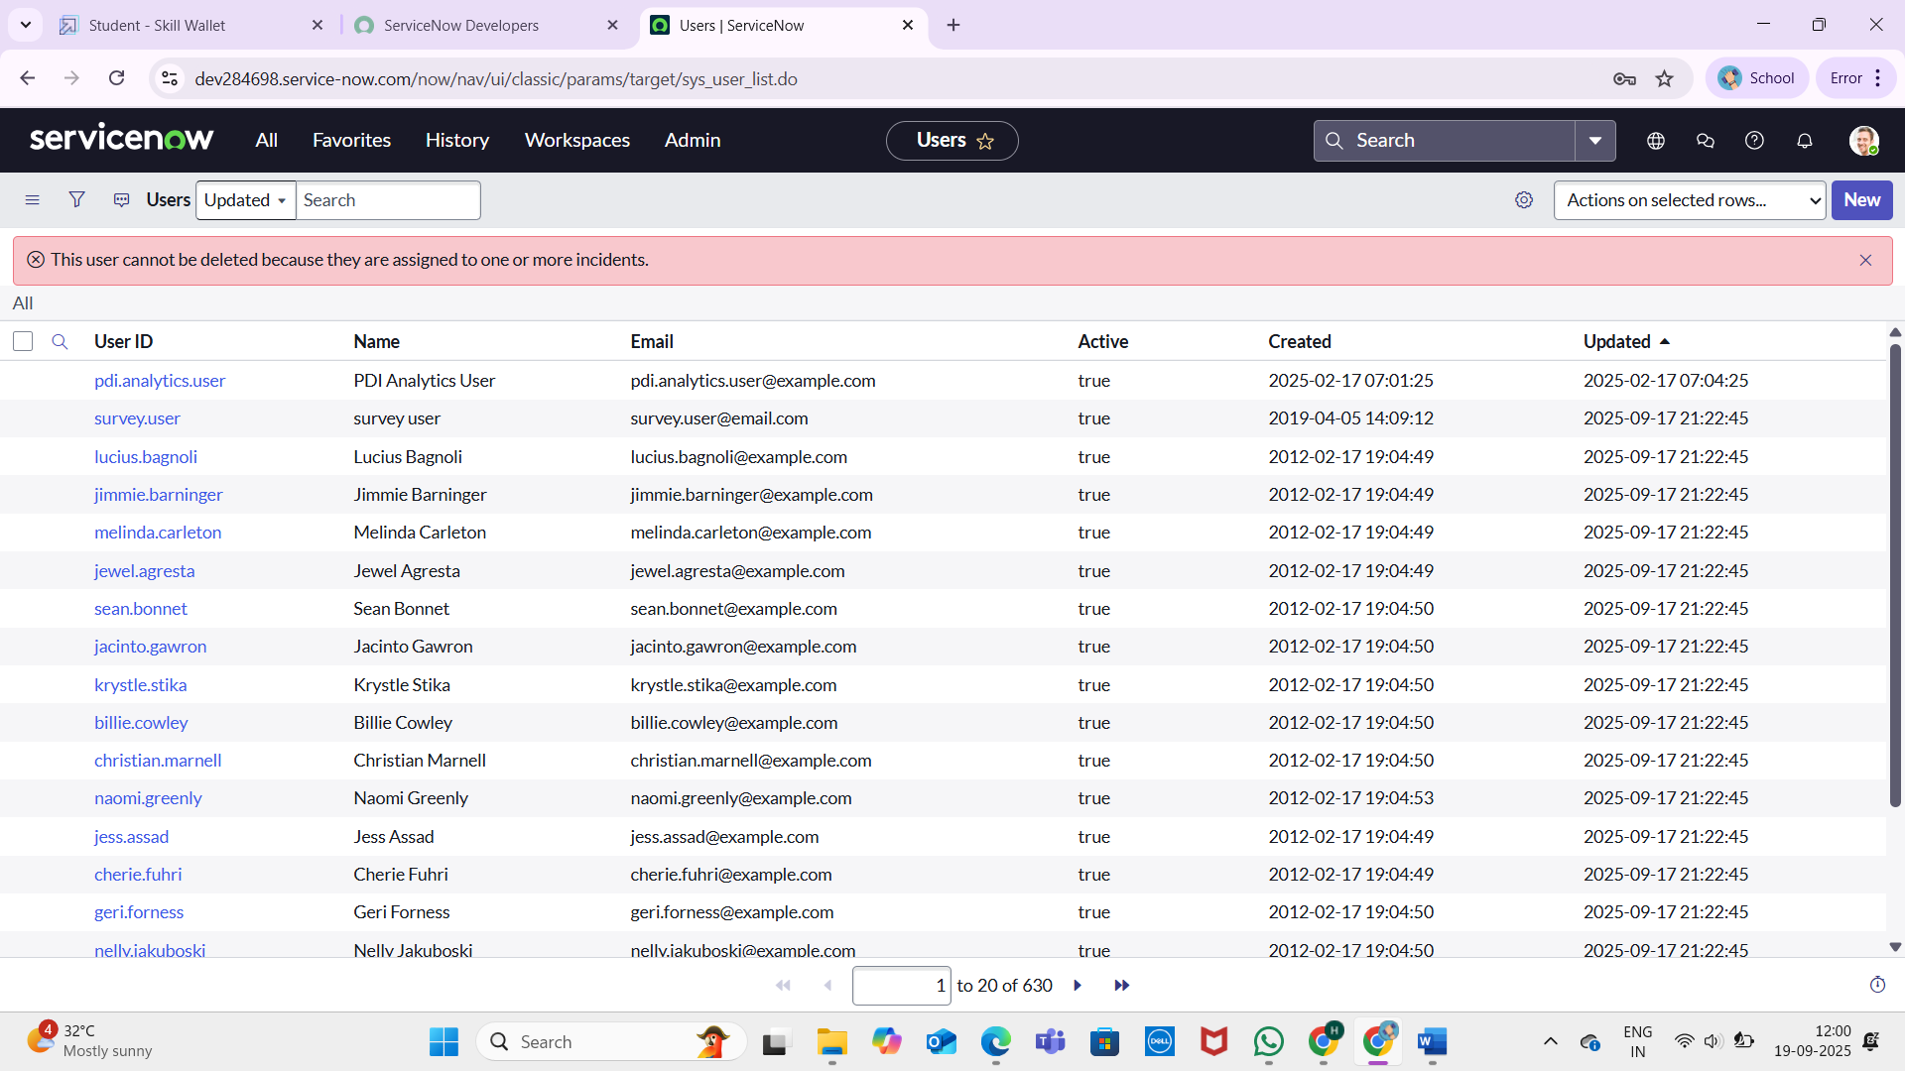

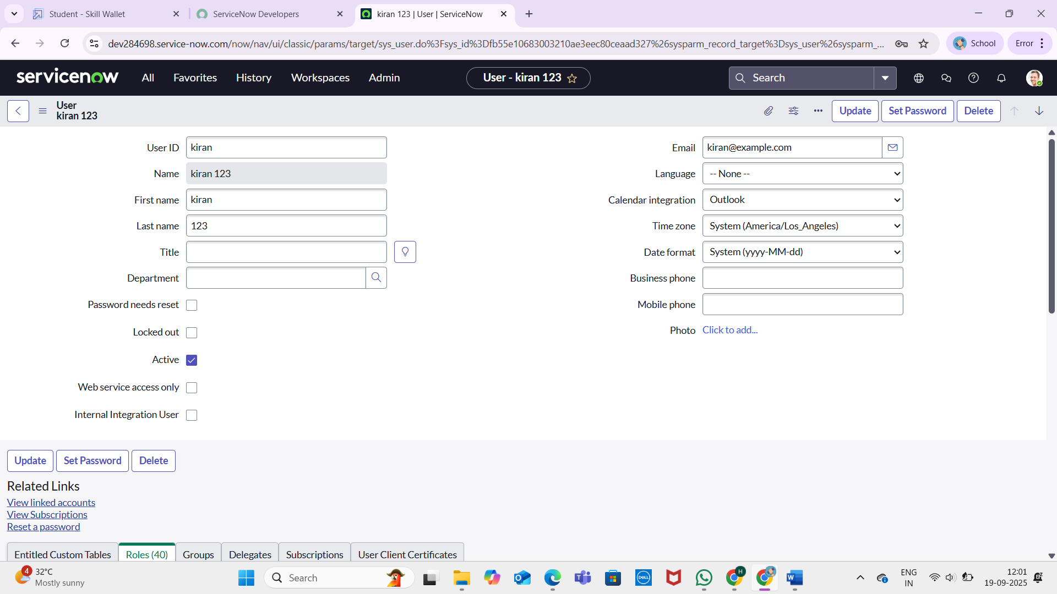

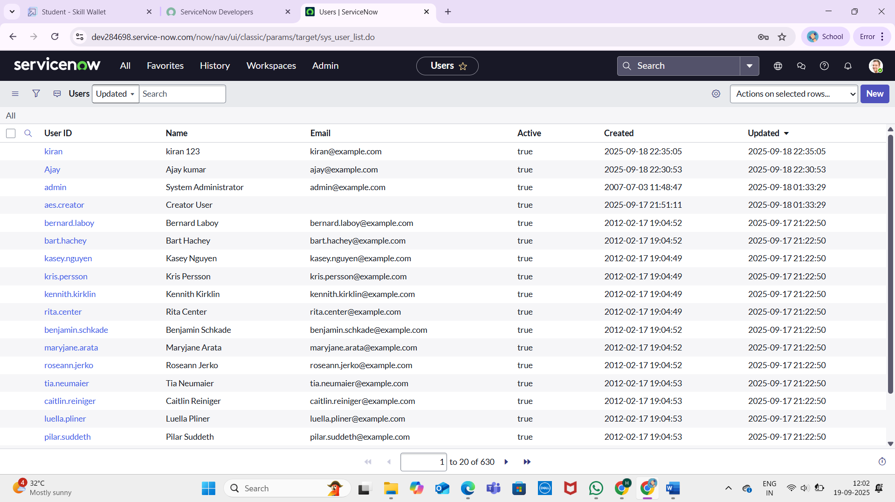

## Assign Incident to User Assign Incidents

1. Navigate to the Incident table.
2. Create a new incident and assign it to one of the created users (e.g., kiran123)
3. Keep the incident Active = true and State = In Progress

**Note:** To assign any user the user should have at least one role so assigned a role to the user before assigning incident

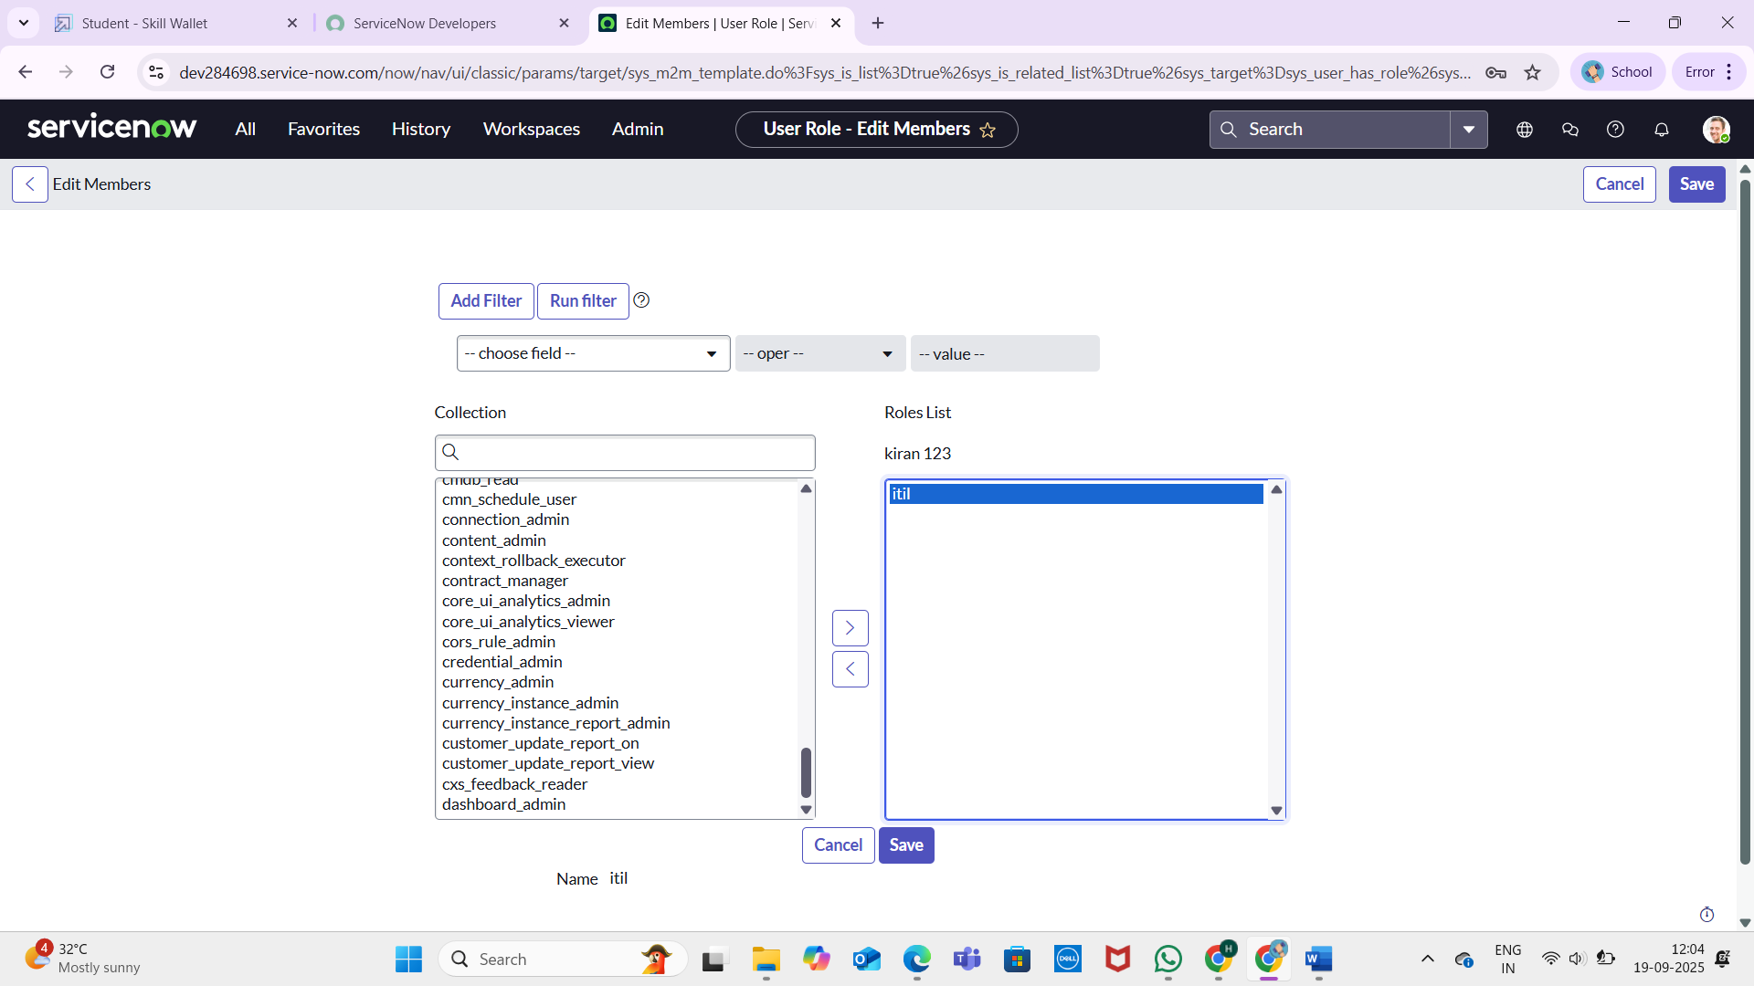

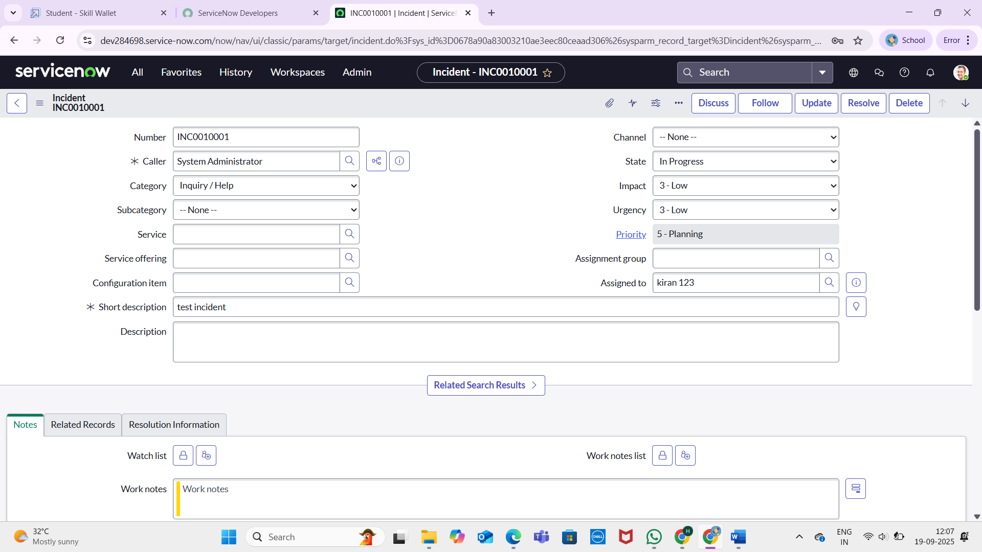

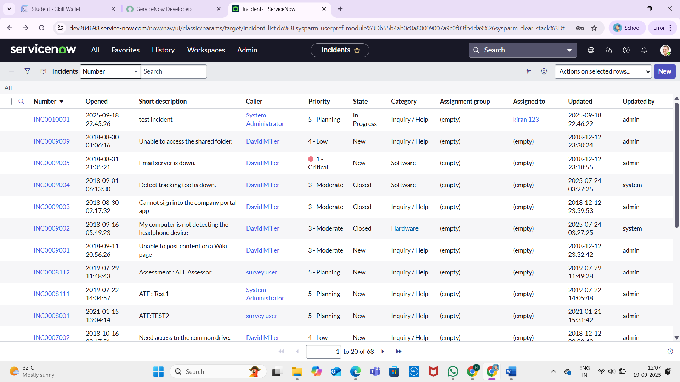

## Business Rule Creation Create Business Rule

1. Go to System Definition >> Business Rules
2. Click on New
3. Fill in:
4. Name: Prevent User Deletion if Assigned to an Incident
5. Table: sys_user
6. When: Before
7. Delete: Checked
8. Script : // Add your code here 9. Click submit.

SCRIPT :

/// (function executeRule(current, previous /*null when async*/) { var incGr = new GlideRecord('incident'); incGr.addQuery('assigned_to', current.sys_id); incGr.setLimit(1); // Just need to check existence

// incGr.addQuery('active', true); we can use the above or this line of code to check where the user is assigned with any incident incGr.query(); if (incGr.next()) {

gs.addErrorMessage('This user cannot be deleted because they are assigned to one or more incidents.'); current.setAbortAction(true);

}

// Add your code here

})(current, previous);

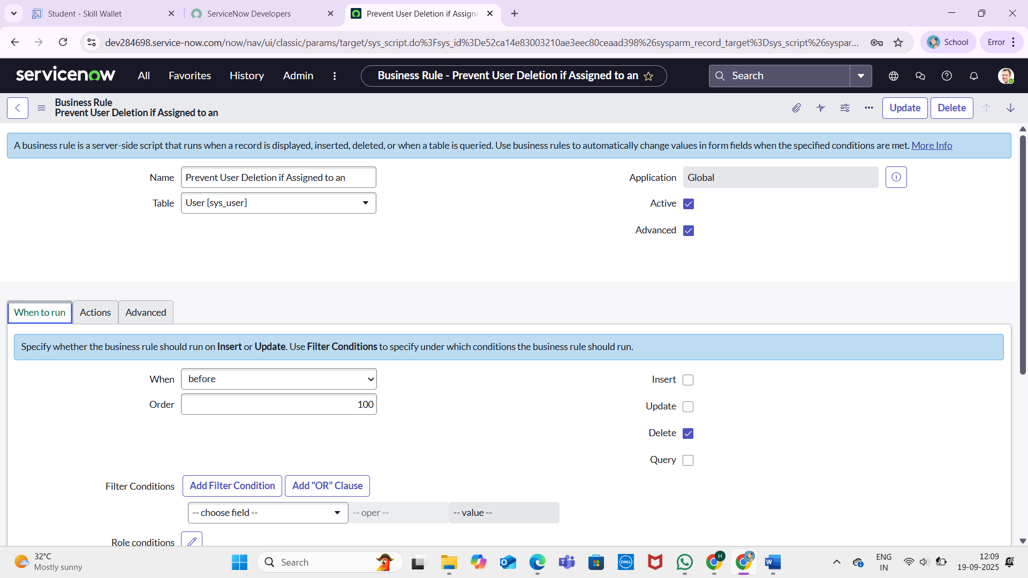

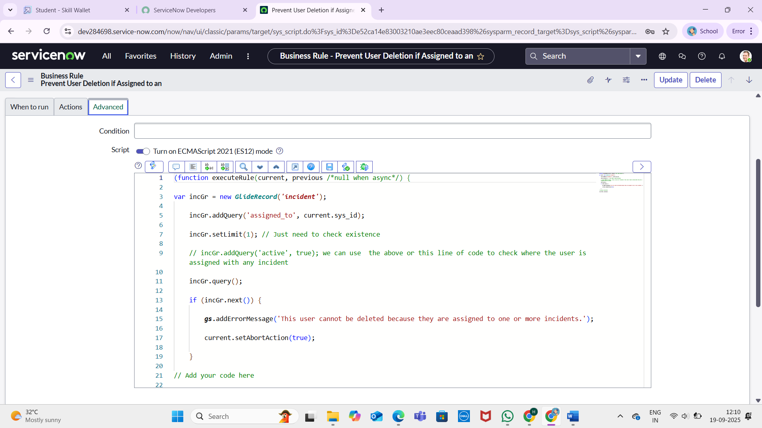

## Test Deletion Attempt to Delete Assigned User

1. Go to the user record (kiran123)
2. Click Delete
3. Verify that deletion is blocked with an error message

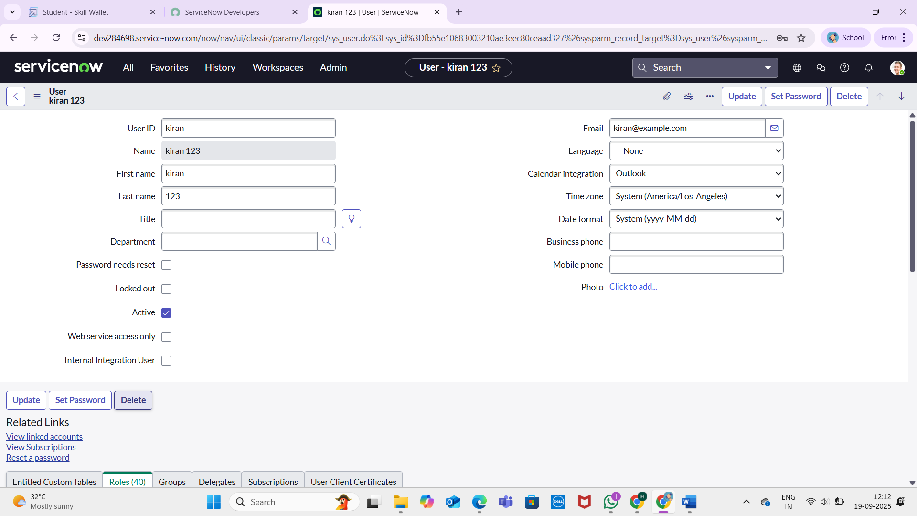

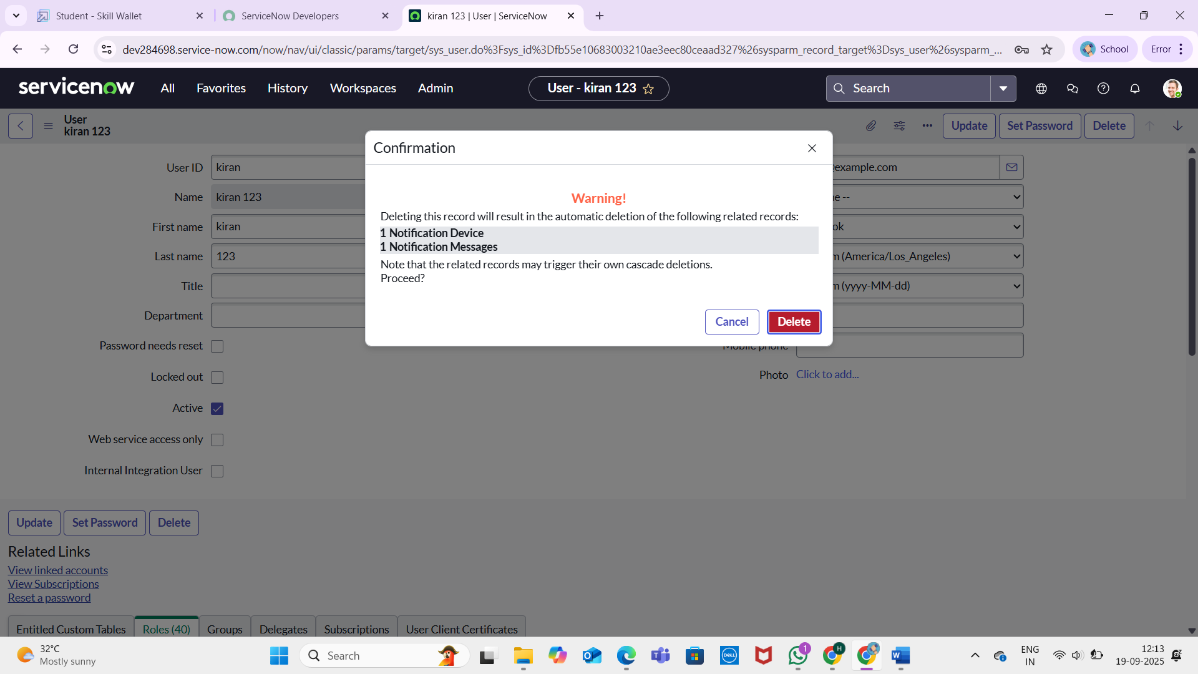

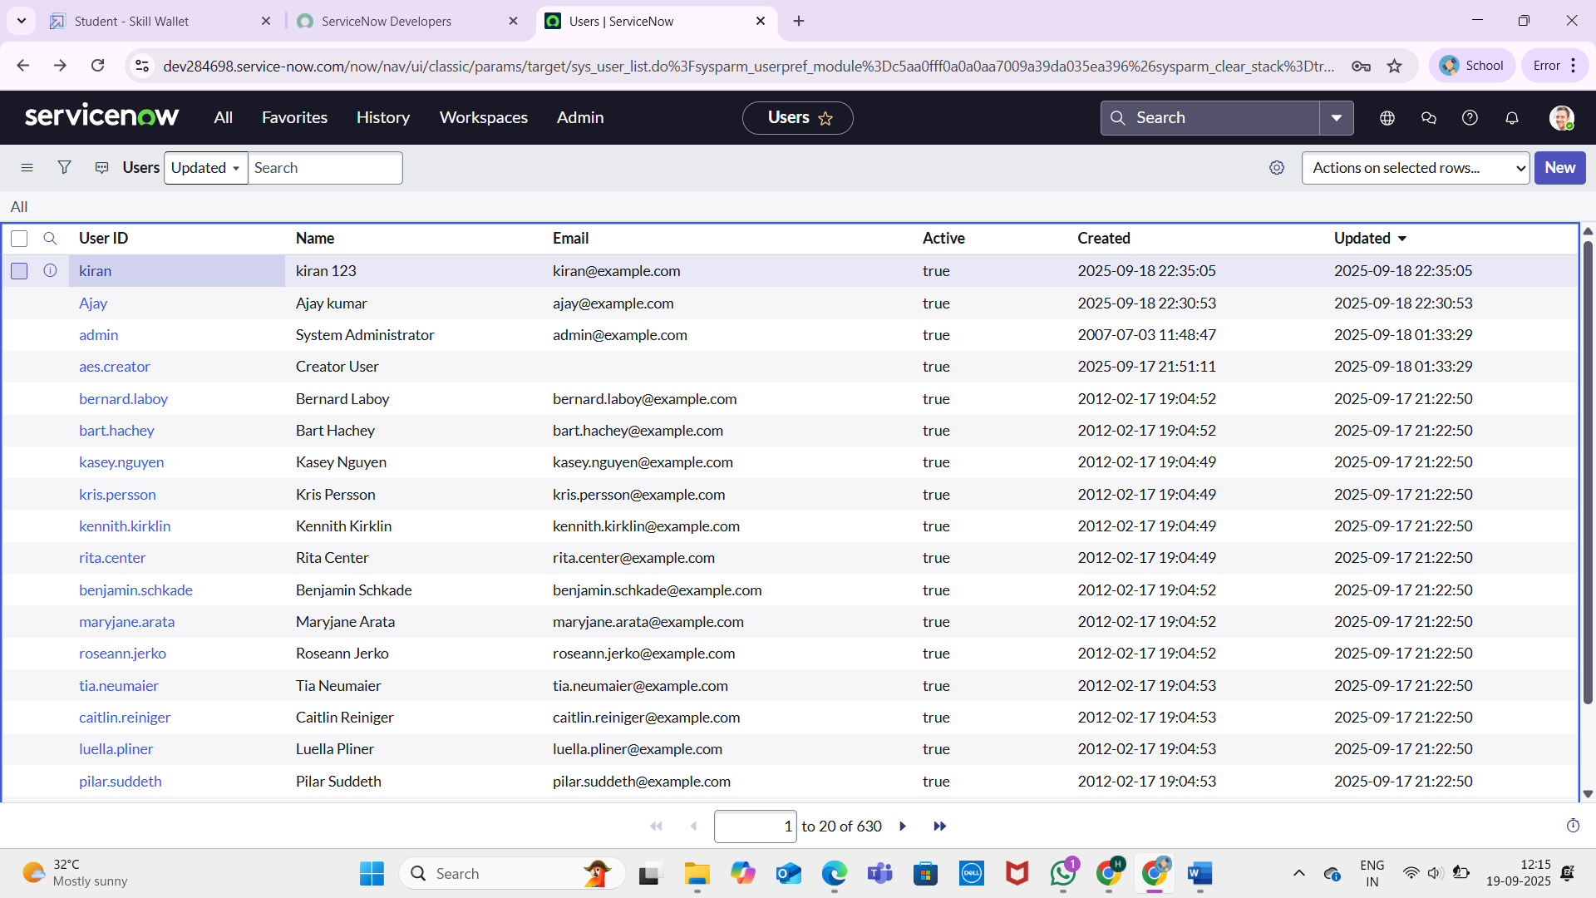

## Test With Unassigned User Attempt to Delete Unused User

1. Try deleting the second user (Ajay kumar) who is not assigned to any active incidents.
2. Deletion should succeed.

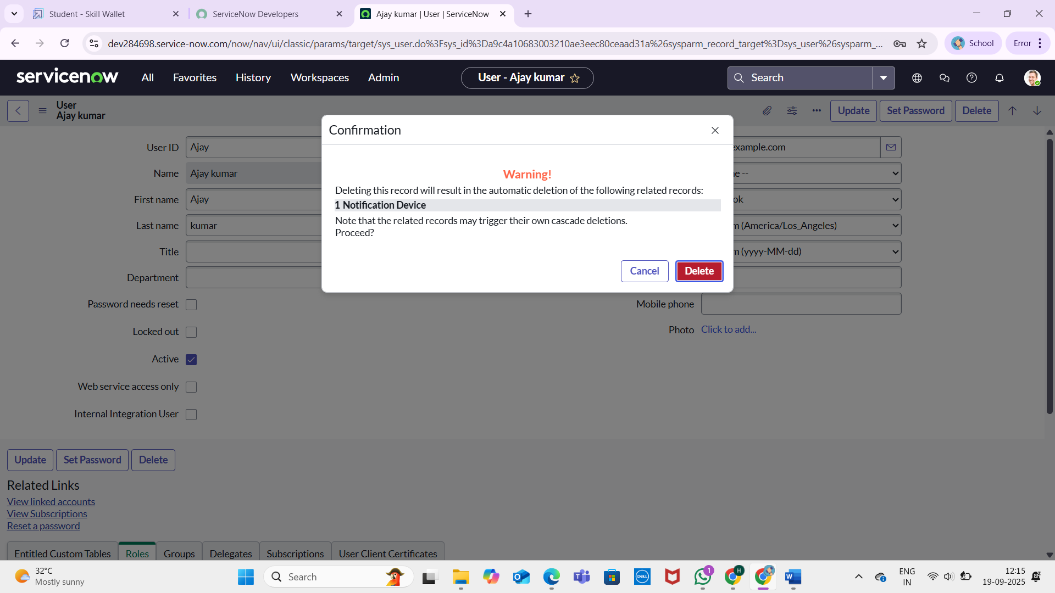

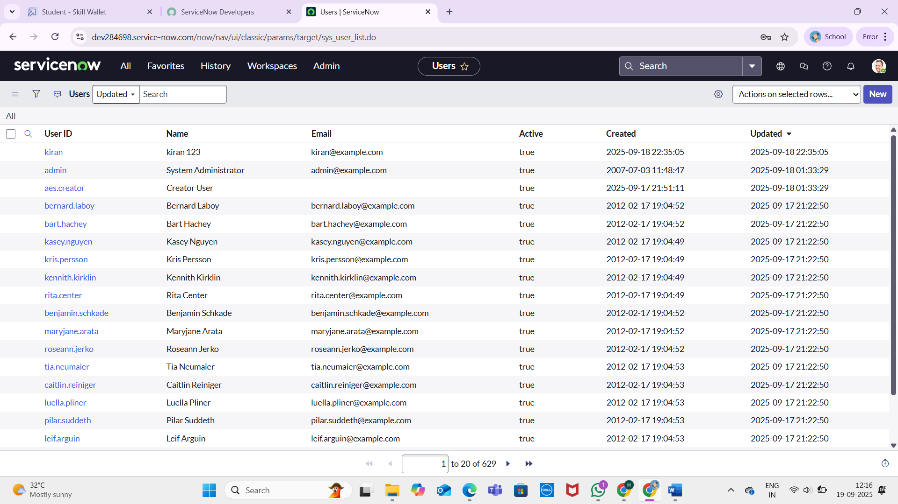

## Conclusion

This project provides a safeguard mechanism against accidental or improper deletion of users who are still involved in active incidents. By using a Business Rule on the sys_user table, ServiceNow administrators can ensure that incident ownership and workflow integrity remain intact. This solution upholds data consistency and promotes operational continuity within IT service processes.