***Assignment –1***

**Creating sample tables and inserting values.**

Create the following tables with the given structures and insert sample data as specified: -

Ans a)

Create table Salespeople

(

Snum int(4) ,

Sname varchar(10) ,

City varchar(10) ,

Comm float(3,2)

)

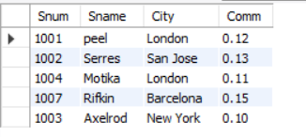

Ans b) Create table Customers

(

Cnum int(4),

Cname varchar(10),

City varchar(10),

Rating int(4),

Snum int(4)

)

insert into Customers values(2001, 'Hoffman', 'London', 100, 1001);

insert into Customers values(2002, 'Giovanni', 'Rome', 200, 1003);

insert into Customers values(2003, 'Liu', 'San Jose', 200, 1002);

insert into Customers values(2004, 'Grass', 'Berlin', 300, 1002);

insert into Customers values(2006, 'Clemens', 'London', 100, 1001);

insert into Customers values(2008, 'Cisneros', 'San Jose', 300, 1007);

insert into Customers values(2007, 'Pereira', 'Rome', 100, 1004);

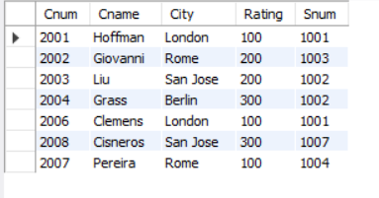

Ans c) Create table Orders

(

Onum int(4),

Amt float(7,2),

Odate date,

Cnum int(4),

Snum int(4)

)

insert into Orders values(3001, 18.69, '1990-10-03', 2008, 1007);

insert into Orders values(3003, 767.19, '1990-10-03', 2001, 1001);

insert into Orders values(3002, 1900.10, '1990-10-03', 2007, 1004);

insert into Orders values(3005, 5160.45, '1990-10-03', 2003, 1002);

insert into Orders values(3006, 1098.16, '1990-10-03', 2008, 1007);

insert into Orders values(3009, 1713.23, '1990-10-04', 2002, 1003);

insert into Orders values(3007, 75.75, '1990-10-04', 2004, 1002);

insert into Orders values(3008, 4723.00, '1990-10-05', 2006, 1001);

insert into Orders values(3010, 1309.95, '1990-10-06', 2004, 1002);

insert into Orders values(3011, 9891.88, '1990-10-06', 2006, 1001);

