***Assignment –4***

**Retrieving Information from Tables.**

1. Write a select command that produces the order number, amount, and date for all rows in the Orders table.

Ans :

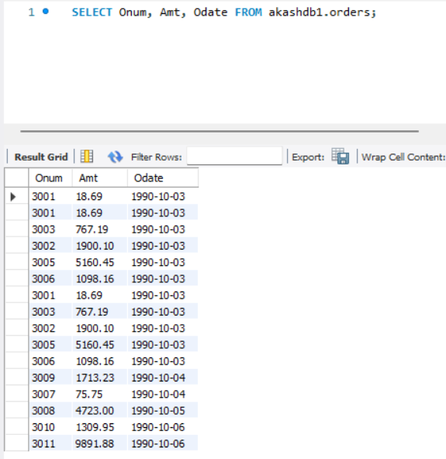

1. Write a query that produces all rows from the Customers table for which the salesperson’s number is 1001.

Ans=

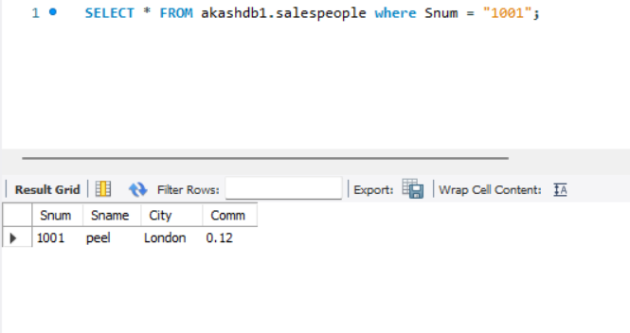

1. Write a query that displays the Salespeople table with the columns in the following order: city, sname, snum, comm.

Ans = SELECT city, sname, snum, comm

FROM salespeople;

4) Write a select command that produces the rating followed by the name of each customer in San Jose.

Ans = SELECT rating, cname FROM customers

WHERE city = 'San Jose';

1. Write a query that will produce the snum values of all salespeople (suppress the duplicates) with orders in the Orders table.

Ans = SELECT DISTINCT snum

FROM orders;