***Assignment –6***

**Using Special Operators in Conditions.**

1) Write two different queries that would produce all orders taken on October 3rd or 4th, 1990.

Ans = SELECT * FROM Orders

WHERE odate IN ('1990-10-03', '1990-10-04');

SELECT * FROM Orders

WHERE odate = '1990-10-03' OR odate = '1990-10-04';

2) Write a query that selects all of the customers serviced by Peel or Motika.

(Hint: the snum field relates the two tables to one another).

Ans =

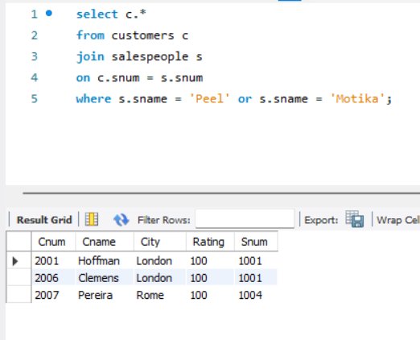

3) Write a query that will produce all the customers whose names begin with a letter from ‘A’ to ‘G’.

Ans =

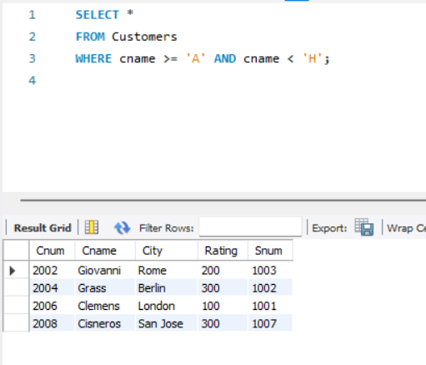

4) Write a query that selects all customers whose names begin with the letter ‘C’.

Ans=

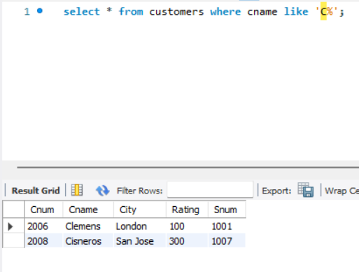

5) Write a query that selects all orders except those with zeroes or NULLs in the amt field.

Ans= select * from orders where amt is not null and amt != 0;