***Coding Assignment***

1. **Hello World Program: Write a Java program that prints "Hello World!!" to the console.**

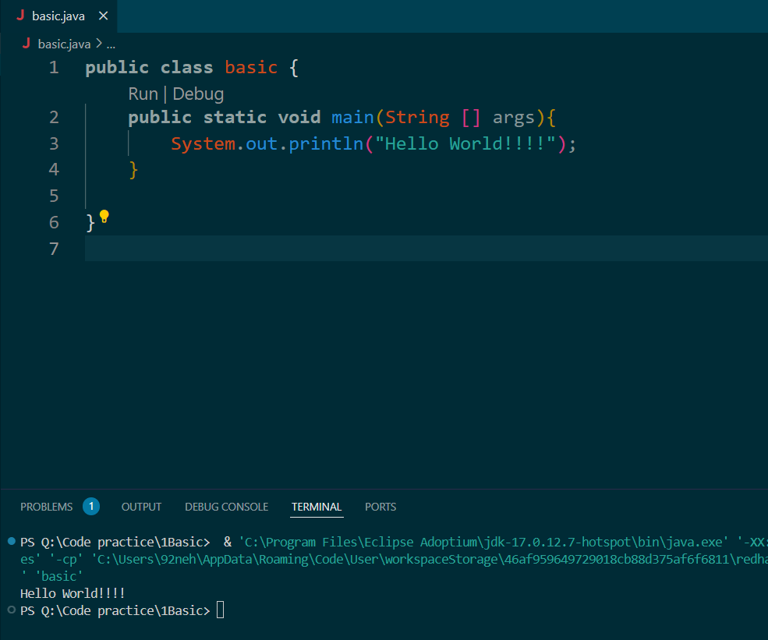

1. **Compile with Verbose Option**: Compile your Java file using the -verbose option with javac. Check the output.

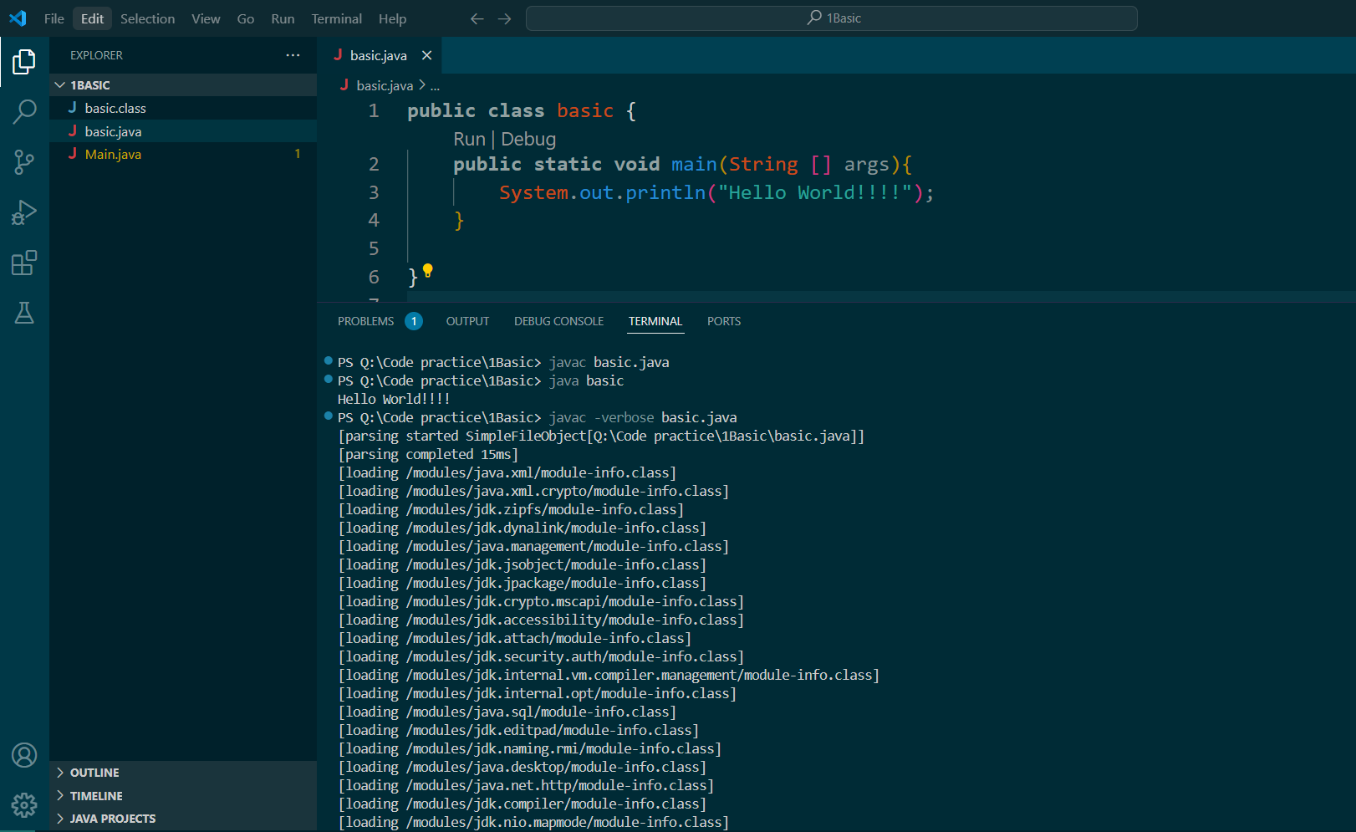

1. **Inspect Bytecode**: Use the javap tool to examine the bytecode of the compiled .class file. Observe the output.

