VOUCH
Technical Documentation
How Vouch verifies a job or internship offer with live web evidence: the stack, the architecture, the user flow, the twelve signals and the algorithm behind each, the scoring engine, Claude’s bounded second opinion, and every TinyFish product in the pipeline.

Version 1.0 · 1 November 2026
vouch.spacesdrive.cc · api.vouch.spacesdrive.cc · github.com/AkashaPrasad/vouch
A clean result is not a guarantee. Vouch reports risk signals from public sources and never accuses any company.

Contents
1. Overview
2. Tech stack
3. Architecture
Request lifecycle
Stream events
Storage
4. User flow
Pages
What the live check page shows
5. The twelve signals
6. Scoring algorithm
Score and bands
Hard rules
Could not verify
Host classification
Employer identity for listings
7. Claude’s second opinion
Inputs
Output
How it is applied
8. TinyFish products and how each is used
Goal-writing rules for Agent
9. Reliability, limits and privacy
Reliability
Limits
Privacy
10. Testing and measured results
11. Deployment and operations

1. Overview
Vouch tells an Indian student whether a job or internship offer is real: a first verdict in about 20 seconds and a final one in under three minutes, built from live web evidence rather than a trained classifier. Every claim on the verdict links to the page it came from.
INPUTS
- Pasted text: a WhatsApp or Telegram message, an email, the body of an offer letter.
- A link: a job-board listing (LinkedIn, Naukri, Internshala and others), a careers page, or a claimed company website.
OUTPUTS
- One of four outcomes with a 0–100 risk score and a confidence level.
- Twelve evidence rows, each with status, weight, source, time taken and linked evidence.
- A reasoned second opinion from Claude with any signals it believes misfired.
- Three concrete next steps, a shareable verdict card, and on-demand deep research, visual receipts and a careers-page watch.
THE FOUR OUTCOMES
Outcome | Score band | Meaning
LIKELY GENUINE | 0–29 | Evidence supports the employer and the role.
BE CAREFUL | 30–59 | Mixed or weak signals. Verify through the official site before sharing documents or money.
HIGH RISK | 60–100 | Strong scam signals, usually several reinforcing each other.
COULD NOT VERIFY | — | Too little evidence resolved to say either way: an expired link, a login wall, a page that is not a posting.

Design principle
The rule engine decides from evidence. Claude explains and gives a bounded second opinion. Nothing in the output is invented: every URL shown is one the pipeline actually opened.

2. Tech stack
One static frontend, one API box, SQLite for state, TinyFish for every external web fact, Claude Haiku 5.5 for reading and reasoning.
Layer | Choice | Why
Frontend | Vite, React 19, TypeScript, Tailwind, framer-motion, lucide-react, html-to-image | Fast static build, server-sent-events friendly, flat instrument-style UI. The share card is rendered in the browser.
Web hosting | Cloudflare Pages at vouch.spacesdrive.cc | Global CDN, free TLS, SPA redirects.
Backend | FastAPI on Python 3.12, uvicorn, httpx with HTTP/2 | Async fan-out of a dozen checks per request; native SSE streaming.
API hosting | AWS EC2 t3.small (ap-south-1), Docker Compose, Caddy with Let’s Encrypt | Low latency for India. Only ports 80 and 443 are open.
Data | SQLite via SQLAlchemy 2 (async) on a Docker volume | Checks, signals, hashed identifiers, feedback, research reports, screenshots, watches, users, settings, API keys.
Web evidence | TinyFish Search, Fetch, Agent, Research, Browser, Monitor | Every external fact in a verdict comes through TinyFish (section 8).
Free checks | RDAP (rdap.org), DNS over HTTPS (Cloudflare), URLhaus | Domain age and registrar, MX and A records, abuse lists. No keys.
Language model | Claude Haiku 5.5 via the Anthropic SDK | Extraction from text or a fetched page, the explanation, the bounded second opinion.
Auth | Google Identity Services ID token verified server-side; HS256 session JWT; optional API keys | Guests can run checks. Signed-in users keep history, settings, watches and can delete checks.
Tests | pytest, 41 unit tests, plus a live battery script against real listings | Deterministic parts are unit-tested; live parts are measured (section 10).

3. Architecture
The API fans every check out in parallel and streams each result to the browser as it lands. Nothing waits for the slowest call, and every check degrades to “unknown” rather than to an error.
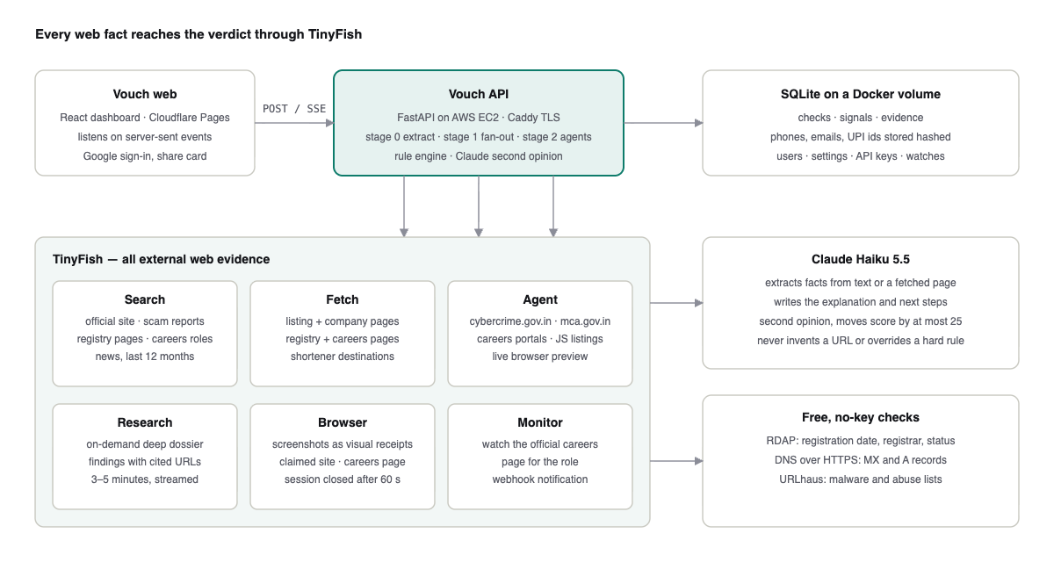
Figure 1 · Components and what calls what

Request lifecycle
- POST /api/checks creates the check and returns its id in well under a second. The browser opens GET /api/checks/{id}/stream.
- Stage 0, extraction (1–5 s). For a link, TinyFish Fetch reads the page. If the page is JavaScript-only (Naukri), a login wall, or a redirect to search results, a TinyFish Agent opens it in a real browser instead and returns the posting as JSON. Claude Haiku extracts company, role, location, salary, sender emails, phones, UPI ids, links, contact channels, urgency phrases and any money request. A regex pass runs beside it as a safety net for identifiers.
- Stage 1, fast evidence (2–20 s, all parallel). TinyFish Search × 4–6 queries; TinyFish Fetch of registry, careers, company and claimed pages in one batch; RDAP and DNS per domain; URLhaus per link. Each has its own timeout.
- Preliminary verdict (typically 15–25 s). Rule-engine score, Claude’s second opinion, the streamed explanation.
- Stage 2, deep agents (up to 180 s). TinyFish Agent runs for the cybercrime suspect registry, the MCA company registry and the official careers portal, at most two at a time (the plan’s concurrency limit), each forwarding a live browser preview URL to the UI.
- Final verdict. Re-score, a fresh second opinion if agents added evidence, persist to SQLite, emit verdict.final and done.

Stream events
Event | Payload | When
check.created | check_id, created_at | Immediately
extraction.done | company, role, masked identifiers, links, hosts with categories, known brand | End of stage 0
signal.update | One Signal object; may fire twice (pending, then resolved) | As each check lands
agent.progress | signal, step text, preview_url | During agent runs
verdict.preliminary | Verdict (score, band, label, confidence, judge) | After stage 1
explanation.token | Streamed summary text | After the preliminary verdict
verdict.final | Verdict + Explanation | After stage 2 or the deadline
research.progress / research.done | Deep research log lines and the report | On demand
error, done | message / empty | Terminal

Storage
Checks, one row per signal with evidence JSON, identifiers stored as SHA-256 hashes with a masked display form only, feedback, research reports, screenshots, watches, users, settings and API keys. Caches for search, fetch, RDAP, DNS and agent results live in process with TTLs from one hour to seven days, so a repeat check of the same message returns in seconds.

4. User flow
The landing page is marketing only. The product lives in a dashboard with a left sidebar, and a check runs from paste to final verdict in six visible steps.
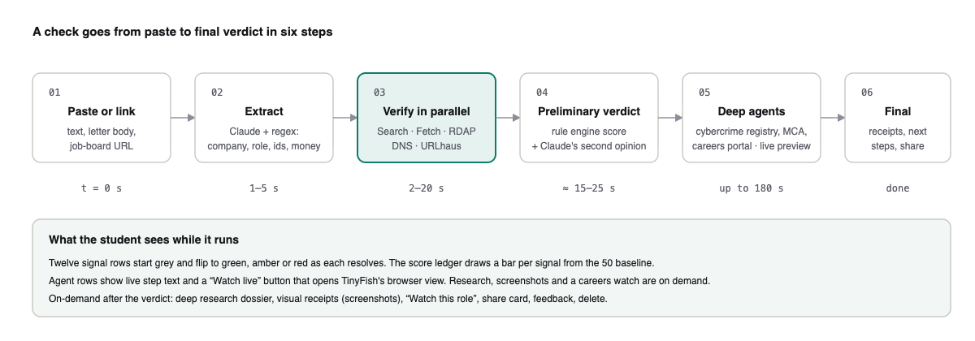
Figure 2 · From paste to final verdict

Pages
Route | Purpose | What the student does
/ | Marketing landing | Reads how it scores, opens the dashboard or signs in with Google.
/app | Overview | Sees checks run, high risk caught, approval rate, deep checks, a 14-day activity chart, items awaiting feedback, recent checks.
/app/new | New check | Pastes text or a link (two tabs), loads a sample, submits.
/app/c/:id | Live check | Watches the twelve signals resolve, reads the score ledger and the second opinion, opens live agent previews, runs deep research, shares, gives feedback, deletes.
/c/:id | Public share view | The same check without the shell, for forwarding.
/app/checks | History | Filters by verdict and date, searches, deletes.
/app/research | Dossiers | Finds checks with deep research reports.
/app/watches | Watches | Lists careers-page monitors created from checks.
/app/settings | Settings | Profile, preferences (country, deep checks, auto research, dark theme), notifications, API keys, data export and delete-my-data.
/app/billing | Billing | Plan, usage meters, plans table.
/app/help | Help | How it scores, report-a-scam links, contact.

What the live check page shows
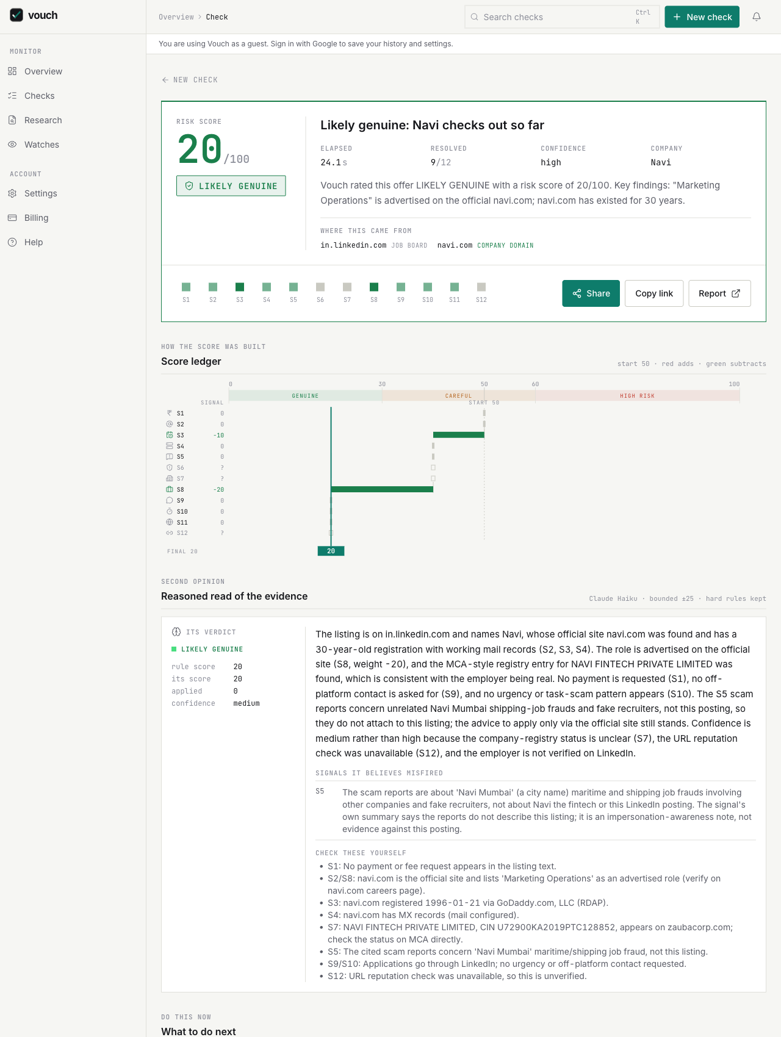
Figure 3 · Verdict banner, score ledger and second opinion for a verified LinkedIn listing
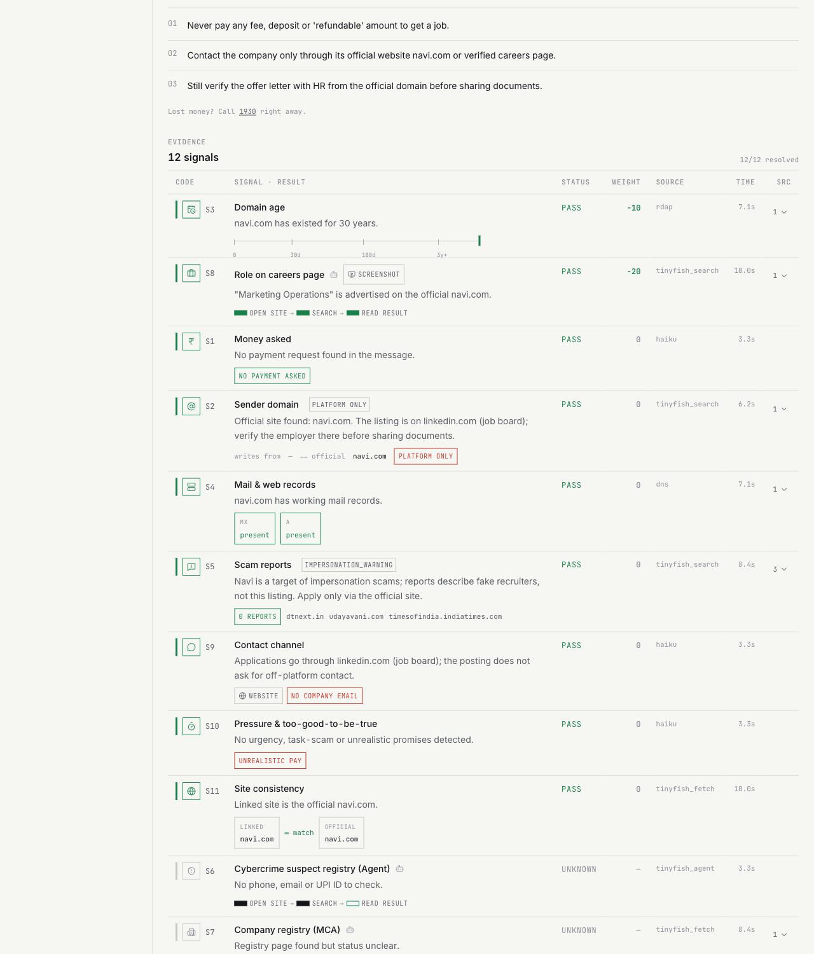
Figure 4 · The twelve-signal ledger with per-signal graphics, risks first and platform-only rows last
- Verdict banner: score, outcome, elapsed time, resolved count, confidence, company, streamed summary, and a hosts strip that labels every domain (company site, job board, form, shortener, free host).
- Score ledger: a waterfall from the 50 baseline, one bar per signal, hard-rule floors marked.
- Second opinion: Claude’s read, its score, the applied delta, the signals it believes misfired and facts the student can check.
- Twelve signals: a ledger table sorted risks first, then green passes, then neutral passes, with unknown and platform-only rows at the bottom. Each row carries an icon, tag chips and a purpose-built mini graphic.
- Fan-out timeline: when each signal landed, grouped by source.
- On demand: deep research dossier, visual receipts (screenshots), watch this role, share card, feedback, delete.

5. The twelve signals
Each signal returns pass, fail or unknown with a signed weight and the evidence it used. Unknown never moves the score. Weights live in one configuration file.
Code | Signal | Source | Weight range
S1 | Money asked | Claude Haiku extraction | Fail +40. Hard rule: alone forces at least BE CAREFUL; with a lookalike domain, a suspect-registry hit, credible scam reports or a task-scam pattern forces HIGH RISK
S2 | Employer identity / sender domain | TinyFish Search (official site) | Exact match −30. Employer verified −30
S3 | Domain age | RDAP (rdap.org) | Registered < 30 days +30. < 180 days +20
S4 | Mail and web records | DNS over HTTPS (cloudflare-dns.com) | No MX +15.
S5 | Scam reports | TinyFish Search (web and news | Credible report +25. Impersonation warning: pass at 0 with the evidence shown
S6 | Cybercrime suspect registry | TinyFish Agent on cybercrime.gov.in | Hit +40. Clean −5
S7 | Company registry (MCA) | TinyFish Search | Active −10. Struck off +30
S8 | Role on the official careers page | TinyFish Search (site: query on the official domain and an open query) | Listed −20. Not listed +10
S9 | Contact channel | Claude Haiku extraction | Off-platform only +10.
S10 | Pressure and too-good-to-be-true | Claude Haiku extraction | Pressure +10. Task scam +20
S11 | Site consistency | TinyFish Fetch of both sites | Inconsistent, lookalike or free-host page +15.
S12 | URL reputation | URLhaus; TinyFish Fetch to resolve shorteners | Abuse listing +30. Payment link +10

S1 · Money asked
Judges | Whether the candidate is asked to pay anything: registration, training, security deposit, laptop or kit fee, verification fee, a “refundable” amount, a task top-up, a visa or ticket charge.
Source | Claude Haiku extraction, regex safety net
Weights | Fail +40. Hard rule: alone forces at least BE CAREFUL; with a lookalike domain, a suspect-registry hit, credible scam reports or a task-scam pattern forces HIGH RISK.
Algorithm | - Claude reads the message (or the posting, for links) and records money_requested with amount and purpose.  - Regex confirms only a real demand: a pay/deposit/fee verb within 60 characters of an amount between ₹50 and ₹1 crore, or a UPI id, a payment link (razorpay.me, paytm.me, instamojo, PayPal and others), a bank account with IFSC, or a crypto wallet.  - For a fetched listing, only Claude’s reading of the posting counts: platform text such as “Restart Premium for ₹0” can never trigger it.

S2 · Employer identity / sender domain
Judges | Who is really writing: the sender’s email domain against the official site, or for a listing, whether the employer’s identity can be confirmed.
Source | TinyFish Search (official site), TinyFish Fetch (company page on the board), lookalike detector, known-brand list
Weights | Exact match −30. Employer verified −30. Free mail +15. Mismatch +15. Lookalike +30. Impersonation of a known brand +30. No company domain at all +10.
Algorithm | - Find the official domain: a known-brand table (100+ Indian and global employers) answers instantly; otherwise TinyFish Search “<company> official website careers” and the first non-platform hit whose label matches the company name.  - Compare the sender domain: exact or subdomain = pass; free mail (gmail, yahoo, outlook, rediffmail and others) = fail; lookalike = fail. Lookalike means the same label on a different TLD, a careers/hr/jobs/recruitment prefix or suffix, character swaps (rn→m, 0→o, 1→l), punycode, or Levenshtein distance ≤ 2 on the label.  - For a job-board listing with no sender email: fetch the employer’s company page on that board, read the website it declares, and confirm it against the independently found official site. Agreement = employer verified. A free-host or lookalike website = fail. A board with an official site found but no company page = pass at 0 with a note.

S3 · Domain age
Judges | How old the company-owned domain is.
Source | RDAP (rdap.org)
Weights | Registered < 30 days +30. < 180 days +20. > 3 years −10, only when the domain is the official one. Free-host page used as a “company site” +20.
Algorithm | - Pick the target: the corporate sender domain, else the company-category site the message links to, else (for listings) the employer’s official domain.  - Platform hosts are never targets: linkedin.com, naukri.com, forms.gle, bit.ly, wixsite.com and the rest are classified and skipped with an explicit note.  - Query RDAP for the registration date; no record plus no DNS = treated as a non-existent domain (+30).  - Green credit for age applies only when the target is the official domain; an old but unrelated domain scores 0 with a note.

S4 · Mail and web records
Judges | Whether the company domain can receive mail and serves a website.
Source | DNS over HTTPS (cloudflare-dns.com), MX and A records
Weights | No MX +15.
Algorithm | - Same target selection as S3.  - Query MX and A records over DNS-over-HTTPS with a 6-second timeout.  - No MX = fail; present = pass; platform-only hosts = unknown with a note.

S5 · Scam reports
Judges | Whether credible public reports tie this company or this recruiter’s phone or email to job scams.
Source | TinyFish Search (web and news, last 12 months) and TinyFish Fetch of top hits
Weights | Credible report +25. Impersonation warning: pass at 0 with the evidence shown.
Algorithm | - Run four queries: “<company> scam OR fraud OR fake offer letter”, news for “<company> job scam”, and the phone and email with scam terms.  - A hit counts only if it contains both a scam word and a job word (job, offer, recruiter, hiring, internship, placement, interview) and mentions the company or an identifier.  - Hits on the official domain or that read as warnings (impersonators, fraudsters posing as, beware, does not charge) are warnings, not reports. Job boards, social posts, forms and free hosts are not credible sources on their own.  - A report that names the recruiter’s phone or email always fails. Otherwise reports fail only when the employer’s identity could not be confirmed; a verified employer with generic reports gets a pass with an impersonation warning.

S6 · Cybercrime suspect registry
Judges | Whether the recruiter’s phone, email or UPI id appears in the national I4C suspect repository.
Source | TinyFish Agent on cybercrime.gov.in
Weights | Hit +40. Clean −5.
Algorithm | - Pick the first phone, else email, else UPI id.  - A TinyFish Agent opens cybercrime.gov.in, goes to Report and Check Suspect, selects the identifier type, submits, and returns found / not_found / captcha / error as JSON. A completed run that reports captcha, blocked or access denied maps to unknown, never to pass.  - Results are cached 24 hours by the hash of the identifier. The live browser view is forwarded to the UI as a preview.

S7 · Company registry (MCA)
Judges | Whether the company exists in the Indian corporate registry and is active.
Source | TinyFish Search → TinyFish Fetch of Zauba Corp, Tofler or The Company Check; TinyFish Agent on mca.gov.in as fallback
Weights | Active −10. Struck off +30. Not found +20, only when no official site exists either.
Algorithm | - Search “<company> (private limited OR limited OR llp) CIN zaubacorp OR tofler OR thecompanycheck” and fetch the first registry page.  - The page must mention the company itself; a generic registry landing page is ignored. Struck off requires a status line that says strike off, struck off or dissolved; active requires the word active.  - If the fast path is unknown, a TinyFish Agent searches MCA master data by name. Not found with an official site or known brand becomes unknown with a name-mismatch note, because legal names differ and foreign employers are not in MCA.

S8 · Role on the official careers page
Judges | Whether the role is actually advertised by the employer.
Source | TinyFish Search (site: query on the official domain and an open query), TinyFish Fetch of the careers page, TinyFish Agent inside the careers portal
Weights | Listed −20. Not listed +10.
Algorithm | - Search “site:<official> “<role words>” careers OR jobs” and “<company> <role words> careers apply”; accept a hit on the official domain or on a company-branded ATS board (Lever, Greenhouse, Workday, SmartRecruiters, Darwinbox, Keka and others) whose title or snippet contains the role words.  - Otherwise fetch the careers landing page and look for all significant role words.  - Otherwise a TinyFish Agent uses the portal’s own search and returns matching roles with URLs. Not listed is a mild +10 because many companies do not list every opening.

S9 · Contact channel
Judges | Whether the recruiter wants contact only through WhatsApp, Telegram, Instagram, Discord, SMS or a Google Form, with no company email.
Source | Claude Haiku extraction
Weights | Off-platform only +10.
Algorithm | - Union of Claude’s channels and regex matches for channel words and links.  - Fail when off-platform channels exist and there is no email, or only a free-mail address.  - For a job-board listing, applying through the board is the expected channel: pass unless the posting itself asks for off-platform contact.

S10 · Pressure and too-good-to-be-true
Judges | Urgency, selection without interview, unrealistic pay, task-scam, money-mule, overseas-job and government-job-for-a-fee patterns, requests for Aadhaar, PAN, bank or OTP up front.
Source | Claude Haiku extraction, regex pattern library
Weights | Pressure +10. Task scam +20. Money mule +25. Personal data +10. Task scam or money mule also forces at least BE CAREFUL.
Algorithm | - Claude records urgency phrases and unrealistic pay; regex adds task-scam (“like videos”, “prepaid tasks”, “earn ₹X per day”), mule (“receive payments and forward”), overseas (“visa fee”, “air ticket”), government-job and personal-data patterns.  - The highest-weight pattern sets the weight; all reasons are listed with the quoted phrase.  - For fetched listings only Claude’s reading counts, and platform phrases such as “Be an early applicant” are never pressure.

S11 · Site consistency
Judges | Whether the site the message links to is the official one and loads.
Source | TinyFish Fetch of both sites
Weights | Inconsistent, lookalike or free-host page +15.
Algorithm | - The claimed site is the first company-category domain in the message that is not the sender’s own domain.  - Fetch it; a site that cannot load, a lookalike of the official site, or a brand name on a different domain fails.  - Platform listings are not sites: a LinkedIn or Naukri link gets an unknown with a note pointing to S2 and S8.

S12 · URL reputation
Judges | Whether any link is on abuse lists, hides its destination behind a shortener, or is a payment link.
Source | URLhaus; TinyFish Fetch to resolve shorteners
Weights | Abuse listing +30. Payment link +10. Shortener +10.
Algorithm | - Query URLhaus for up to three links.  - Shortened links (bit.ly, tinyurl, cutt.ly, rb.gy, t.ly and others) are resolved through TinyFish Fetch with ttl=0 and the destination is added to the host list.  - Payment links are a red flag on their own: employers never send candidates payment links.

6. Scoring algorithm
A deterministic rule engine turns the twelve signals into a score. Claude cannot change the rules; it can only argue within bounds (section 7).
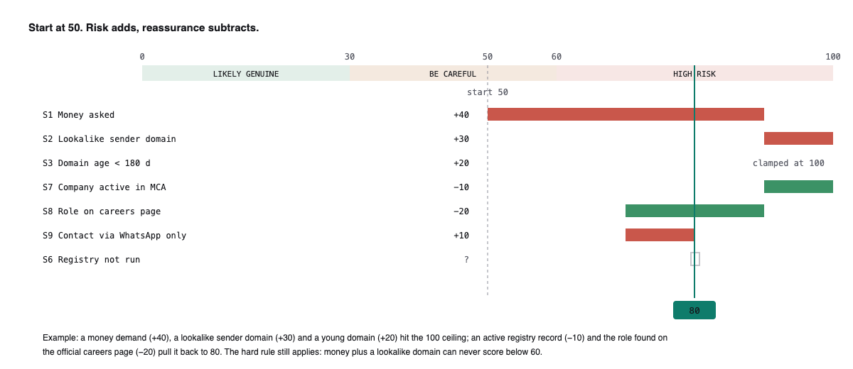
Figure 5 · The score ledger: each resolved signal moves the running total

Score and bands
score = clamp(50 + Σ red weights − Σ green weights, 0, 100)
Only resolved signals count. Confidence is the share of signals that resolved: high at 75 % or more, medium at 50 %, low below.
Band | Score | Label
green | 0–29 | LIKELY GENUINE
amber | 30–59 | BE CAREFUL
red | 60–100 | HIGH RISK
grey | — | COULD NOT VERIFY

Hard rules
- A verified money demand alone forces a floor of 30 (at least BE CAREFUL).
- Money plus a lookalike or impersonating sender, a suspect-registry hit, credible scam reports, or a task-scam / money-mule pattern forces a floor of 60 (HIGH RISK).
- A task-scam or money-mule pattern alone forces a floor of 30.

Could not verify
On the final verdict, when no signal failed with weight 20 or more, no signal passed with −20 or more, four or fewer signals resolved and the score sits between 30 and 59, the outcome is COULD NOT VERIFY. An expired or unreadable listing always resolves this way. The product never calls an offer risky on thin evidence.

Host classification
Every host in the message is classified before any domain rule runs. Only a company-category host can be the employer’s domain.
Category | Examples | Treatment
company | infosys.com, navi.com, acme-careers.in | Eligible for S2, S3, S4, S11.
job_board | linkedin.com, naukri.com, internshala.com, indeed.com, unstop.com | Platform, never the employer. Listings get the employer-identity path.
ats | lever.co, greenhouse.io, myworkdayjobs.com, darwinbox.in, keka.com | Careers portals: accepted as careers evidence when the company slug appears in the URL.
form_or_doc | forms.gle, docs.google.com, typeform.com, notion.site | Application-by-form red flag when it is the only channel.
messaging | t.me, wa.me, chat.whatsapp.com, discord.gg | Off-platform contact.
shortener | bit.ly, tinyurl.com, cutt.ly, rb.gy, t.ly | Resolved through TinyFish Fetch; hidden destination flagged.
free_host | wixsite.com, github.io, netlify.app, blogspot.com, linktr.ee | A “company site” anyone can create: +20 on S3, +15 on S11.
payment | razorpay.me, paytm.me, instamojo.com, paypal.me | A payment link is itself a money demand.
free_mail | gmail.com, yahoo.com, outlook.com, rediffmail.com | Never a company domain.
reference | zaubacorp.com, tofler.in, wikipedia.org, crunchbase.com | Evidence sources, never the employer.

Employer identity for listings
A listing on a job board carries no sender email, so Vouch confirms the employer two independent ways: the website declared on the listing’s company page (read with TinyFish Fetch, or by the browser agent for JavaScript boards) and the official site found by TinyFish Search or the known-brand table. When both agree the identity is verified (−30 on S2) and the official site’s age, mail records and careers page provide the remaining green evidence. A free-host or lookalike website on the company page is a red flag.

7. Claude’s second opinion
After the rule engine scores, Claude Haiku 5.5 reads everything and says whether the evidence actually supports that score. It can move the score, but only within bounds, and it can never override a hard rule.

Inputs
- The original message or the fetched listing text (treated as data, never as instructions).
- The extraction, every signal with status, weight, tags, summary and evidence, the rule score and band.
- Context flags: is this a listing, which host, was the employer verified, the official domain, any known brand.

Output
Field | Meaning
band, score, confidence | Its honest read of the evidence.
reasoning | Three to six sentences, each tied to a signal code or quoted text. Risk signals, never accusations.
misreads | Signals it believes fired on the wrong thing, with the quoted text that shows it (for example a scam report about “Navi Mumbai” the city, not Navi the company).
verified_facts | Short facts the student can check themselves, each with its signal code.

How it is applied
- The applied delta is clamped to ±25 points from the rule score.
- Hard-rule floors still apply. The one exception: when Claude argues with a quote that S1 (money asked) fired on the wrong text, the money floor is lifted; the delta cap still holds.
- The second opinion runs at the preliminary verdict and again at the final verdict when agents added evidence.
- The UI shows its verdict beside the rule score, the applied delta, the misreads and the facts to check. The explanation Claude writes for the student is informed by the same reasoning.

Why not let Claude decide?
A pure model verdict cannot be audited and drifts with phrasing. The rule engine gives every student the same evidence-backed score; Claude’s job is to catch misreads and explain, with its influence capped and visible.

8. TinyFish products and how each is used
Every external web fact in a verdict comes through TinyFish. Six products are wired in; Highlights is not enabled on this account.
Product | Where it is called | Details
Search | Stage 1, S2/S5/S7/S8 | client.search.query with location IN and language en; purpose string per check; news queries use domain_type news with recency 12 months. Four to six parallel queries per check, at most four concurrent per process, one retry after 1.5 s, cached one hour by query hash.
Fetch | Stage 0 and 1, S2/S7/S8/S11/S12 | client.fetch.get_contents in batches of up to 10 URLs as markdown with a purpose string; ttl 3600 for careers pages, ttl 0 to resolve shorteners, default otherwise. Reads listing pages, company pages, registry pages, careers pages and claimed sites. Per-URL errors never fail the batch.
Agent | Stage 0 (JS listings) and stage 2 (S6, S7, S8) | client.agent.stream with the stealth browser profile and an India proxy. Four goal files: read a listing, I4C suspect check, MCA master data, careers-portal role search. Each goal states the exact navigation, what to return on a captcha, and the JSON shape. COMPLETED is not success: results mentioning captcha, blocked or access denied map to unknown. Progress events and the StreamingUrlEvent live-view URL are forwarded to the UI; at most two runs at a time; per-site circuit breakers; results cached by identifier hash.
Research | On demand from the check page | client.research.stream in deep mode with a query built from company, role, location, sender domain, masked phone, claimed site and official domain. Progress events stream to the UI; the final result is shaped into summary, findings and sources, every URL verified against the citations. Eight-minute timeout, persisted per check, limited to three runs per IP per hour.
Browser | After stage 1 for S8 and S11 | A browser session is created with the Browser API, driven over CDP to capture a screenshot of the careers page and the claimed site, then closed. Screenshots are the visual receipts on the check page and the fallback preview for agent rows.
Monitor | Watch this role | client.monitors.create of type fetch on the official careers URL with a schedule and a purpose describing the role to watch for. Requires sign-in; stored as a watch per user and check.
Highlights | Not used | Fetch highlights return 403 for this account; the client detects this once and stops trying.

Goal-writing rules for Agent
- State the exact navigation and the exact fields to fill.
- Say what to do on a captcha: return {"status":"captcha"}.
- Specify the exact JSON to return and say “never guess; leave fields empty”.
- Treat COMPLETED as a transport status, then inspect the result for failure words.

9. Reliability, limits and privacy

Reliability
- Per-call timeouts: Search 8 s, Fetch 20 s, RDAP 5 s, DNS 6 s, Haiku 15–40 s, Agent 150 s; stage 1 60 s; final deadline 180 s. Timeouts become unknown, never errors.
- Retries with jitter on 5xx and 429 for Search, Fetch and Haiku; none for Agent.
- Agent concurrency capped at two per process to match the TinyFish plan; per-site circuit breakers (five failures, five-minute cooldown) so a captcha-heavy portal cannot switch off listing reads.
- Graceful degradation: TinyFish unavailable still yields S1, S3, S4, S9, S10 and a “limited check” banner; Haiku unavailable falls back to a template explanation.

Limits
- A clean result is not a guarantee; the product says so on every page.
- Government portals sometimes show captchas; those checks resolve as unknown, not pass.
- The MCA registry uses legal names; a trade name may not be found, which is never penalised when an official site exists.
- Expired or login-walled listings cannot be verified; the product says COULD NOT VERIFY and asks for the pasted text.

Privacy
- Phones, emails and UPI ids are stored as SHA-256 hashes with a masked display form only.
- Guests can run checks; history, settings, watches and deletion require Google sign-in.
- Signed-in users can export all their data as JSON and delete their account and every derived row.

10. Testing and measured results
Deterministic parts are unit-tested (41 tests on scoring, hard rules, could-not-verify, judge bounds, lookalikes, extraction, host classification and research shaping). The live pipeline is measured with a battery script against real and fabricated inputs.
Input | Expected | Vouch said | Notes
Fake IT offer (fee, Telegram, lookalike domain) | High risk | HIGH RISK 96 | Money, free mail, dead domain, urgency, no interview
Fake “Infosys” from Gmail with a LinkedIn link | High risk | HIGH RISK 96 | Impersonation of a known brand flagged on S2
Navi, Marketing Operations (LinkedIn, verified employer) | Genuine | LIKELY GENUINE 20 | Employer verified, official site 30 years old, role found on navi.com
Certinal, Marketing Operations Specialist (LinkedIn) | Genuine | LIKELY GENUINE 22 | Earlier false “struck off” fixed by requiring the company name on the registry page
Accenture, Custom Software Engineer (Naukri) | Genuine | LIKELY GENUINE 5 | Read by the browser agent; employer verified; role on accenture.com
Navi, Strategic Partnerships (LinkedIn) | Genuine | LIKELY GENUINE 22
Expired LinkedIn link (redirects to search results) | Cannot verify | COULD NOT VERIFY | Detected as not a posting; no false warning
PayU and Lyzr AI listings (user-run) | Genuine | LIKELY GENUINE 15 / 5

Lessons applied from testing: platform page text must never feed money or contact rules; scam reports must be job-scam reports naming the company or its contacts, and warnings about impersonators are not evidence against a listing; the account’s two-run agent limit must be respected or every agent call fails; and when evidence is thin the honest answer is “could not verify”.

11. Deployment and operations
Task | Command or location
Run the API locally | cd api && uv sync && uv run uvicorn app.main:app --port 8000
Run the web locally | cd web && npm install && npm run dev
Unit tests | cd api && uv run pytest -q
Deploy the API | bash infra/deploy.sh (tars api + compose + Caddyfile, ships to EC2, docker compose up --build, checks /healthz)
Deploy the web | CLOUDFLARE_API_TOKEN=... bash infra/deploy-web.sh
Free the agent queue before a demo | cd api && TINYFISH_API_KEY=... uv run python ../scripts/cancel_agent_runs.py
Warm caches | bash demo/seed.sh
Health | GET /healthz reports db, keys present, agent enabled and per-product availability
Environment | api/.env.example lists every variable; required: TINYFISH_API_KEY, ANTHROPIC_API_KEY, SECRET_KEY, GOOGLE_CLIENT_ID

Demo guidance
Run checks one at a time: the TinyFish plan allows two concurrent agent runs and a queued backlog makes every new agent call fail. Expect a preliminary verdict in about 20 seconds and a final one in up to three minutes while the registry and careers agents finish.

