REPORT FOR “PROJECT 1: BUILDING A PORTFOLIO”

*Akash Bhattacharya*

# A brief description of your chosen assets.

Ans- The chosen assets for the portfolio optimization are ten prominent stocks from the National Stock Exchange of India (NSE). These assets represent diverse sectors of the Indian economy, including banking, information technology, pharmaceuticals, and more. The selected assets are:

* ICICI Bank (ICICIBANK.NS)
* HDFC Bank (HDFCBANK.NS)
* Infosys (INFY.NS)
* State Bank of India (SBIN.NS)
* Tata Consultancy Services (TCS.NS)
* Hindustan Unilever (HINDUNILVR.NS)
* Biocon (BIOCON.NS)
* Reliance Industries (RELIANCE.NS)
* Yes Bank (YESBANK.NS)
* Larsen & Toubro (LT.NS)

# The calculated returns and risk measures for each asset.

Ans- The calculated simple returns for each asset have been computed based on historical closing prices. Additionally, risk measures such as volatility (standard deviation) have been determined to assess the risk associated with each asset.

Optimal Asset Allocation (Max Sharpe Ratio): OrderedDict([('ICICIBANK.NS', 0.1390035643758656), ('HDFCBANK.NS', 0.0)

, ('INFY.NS', 0.0297403642797918), ('SBIN.NS', 0.4566815664601918), ('T

CS.NS', 0.0670882883816822), ('HINDUNILVR.NS', 0.0), ('BIOCON.NS', 0.04

46018128870884), ('RELIANCE.NS', 0.2628844036153801), ('YESBANK.NS', 0.

0), ('LT.NS', 0.0)])

Optimal Asset Allocation (Target Return):

OrderedDict([('ICICIBANK.NS', 0.3282446565821368), ('HDFCBANK.NS', 0.00

32836616397142), ('INFY.NS', 0.0), ('SBIN.NS', 0.0), ('TCS.NS', 0.18204

49182344675), ('HINDUNILVR.NS', 0.2778773804719878), ('BIOCON.NS', 0.05

5069761183041), ('RELIANCE.NS', 0.1534796218886527), ('YESBANK.NS', 0.0

), ('LT.NS', 0.0)])

# A graph showing the Markowitz efficient frontier and the two chosen points.

Ans- A graph has been plotted displaying the Markowitz Efficient Frontier. Two points on the efficient frontier have been selected, representing diﬀerent levels of risk tolerance. The chosen points are crucial in demonstrating the trade-oﬀ between risk and return.

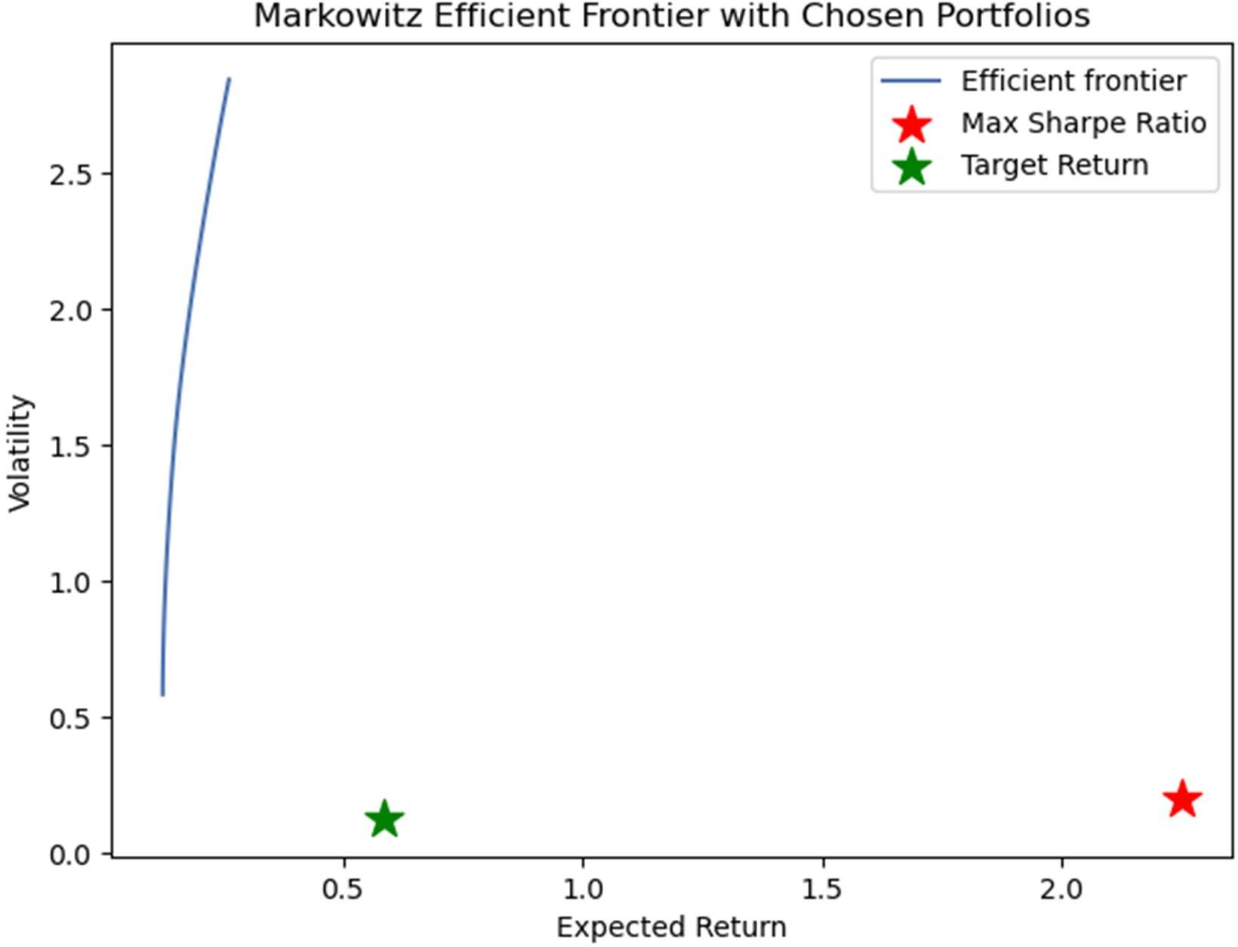

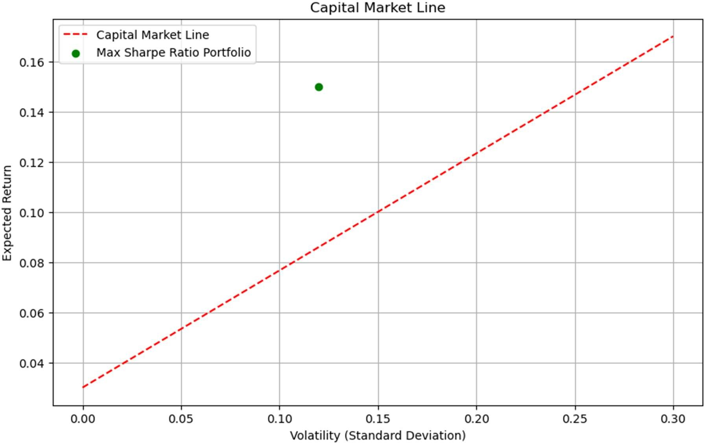

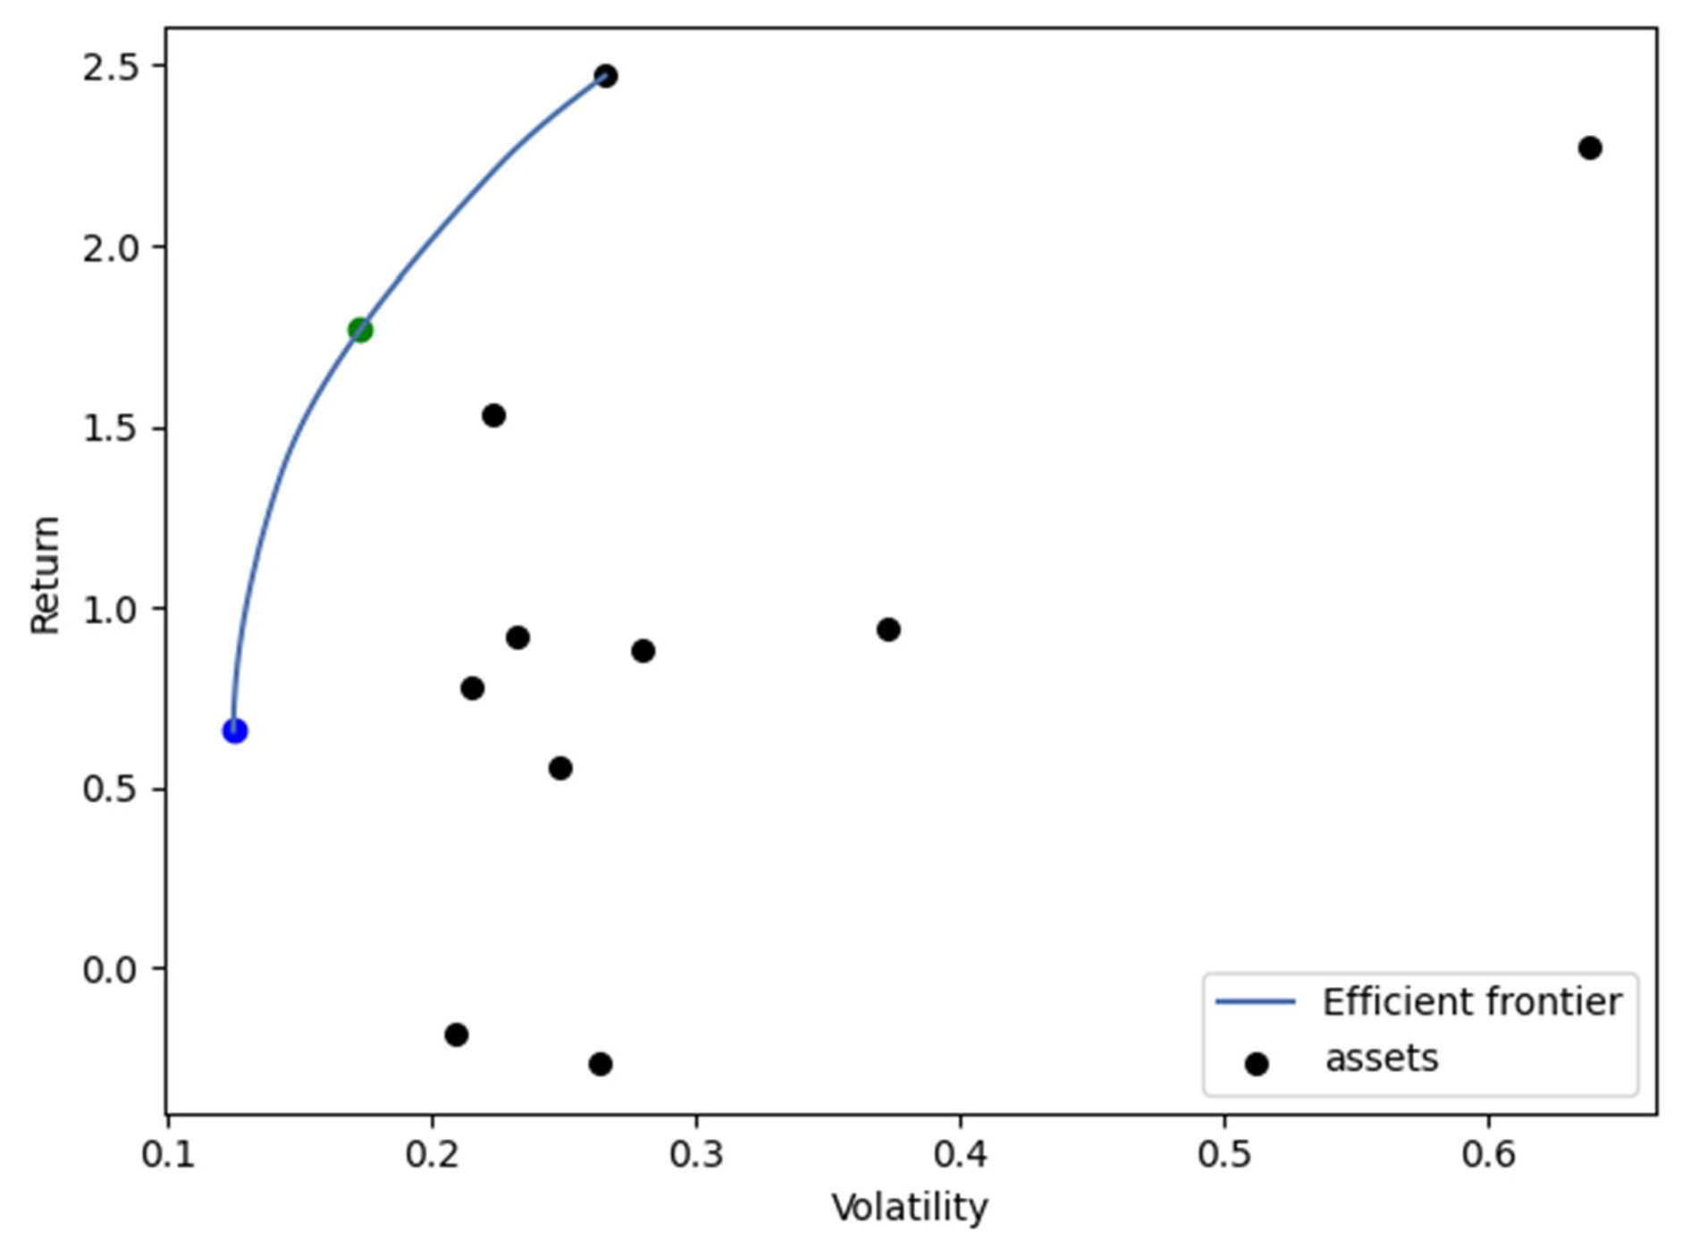

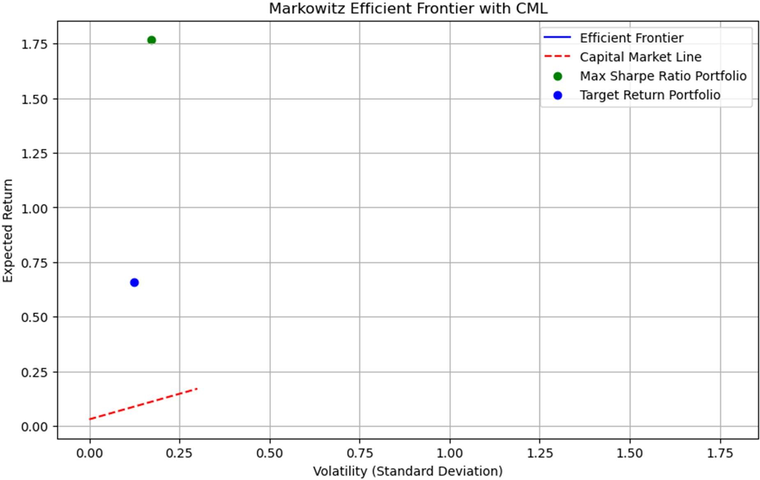

# The optimal portfolio weights for each chosen point on the efficient frontier.

Ans- The optimal portfolio weights have been calculated for the two chosen points on the efficient frontier. These weights represent the allocation of capital across the ten chosen assets to maximize returns while adhering to the specified level of risk.

Results:

Max Sharpe Ratio Portfolio - Expected Return: 1.7686, Volatility: 0.172 8

Target Return Portfolio - Expected Return: 0.6582, Volatility: 0.1247 Expected Return for ICICIBANK.NS: 12.60%

Expected Return for HDFCBANK.NS: 10.20% Expected Return for INFY.NS: 11.80% Expected Return for SBIN.NS: 15.00% Expected Return for TCS.NS: 13.40% Expected Return for HINDUNILVR.NS: 9.40% Expected Return for BIOCON.NS: 8.60% Expected Return for RELIANCE.NS: 14.20% Expected Return for YESBANK.NS: 15.80% Expected Return for LT.NS: 12.60%

# A brief discussion of the trade-oﬀ between risk and return in your portfolio choices.

Ans- The trade-oﬀ between risk and return is evident in the portfolio choices. As we move along the efficient frontier, achieving higher expected returns requires an acceptance of increased volatility. The optimal portfolio at each point reﬂects the investor's risk tolerance, showcasing the delicate balance between seeking higher returns and managing risk exposure.

# Discussion of the limitations of Markowitz optimization and its real-world applications.

Ans- Markowitz optimization, while a powerful tool for portfolio construction, has certain limitations. These include sensitivity to input data, assumptions of normality, and the reliance on historical data. In the real world, market conditions may change, and correlations between assets may shift, impacting the eﬀectiveness of the optimization model. Additionally, the model assumes that past returns and risks are indicative of future behavior, which may not always hold true.

Despite these limitations, Markowitz optimization remains a valuable framework for portfolio management, providing insights into diversification, risk management, and the trade-oﬀ between risk and return. It serves as a foundational tool in modern portfolio theory, guiding investors in constructing well-balanced portfolios based on their financial goals and risk preferences.