API Documentation

Base URI: <https://jsonplaceholder.typicode.com>

a)Create Users: Used to create users and store them in the database  
Method: POST  
API Endpoint: <https://jsonplaceholder.typicode.com/users>   
Request Body:   
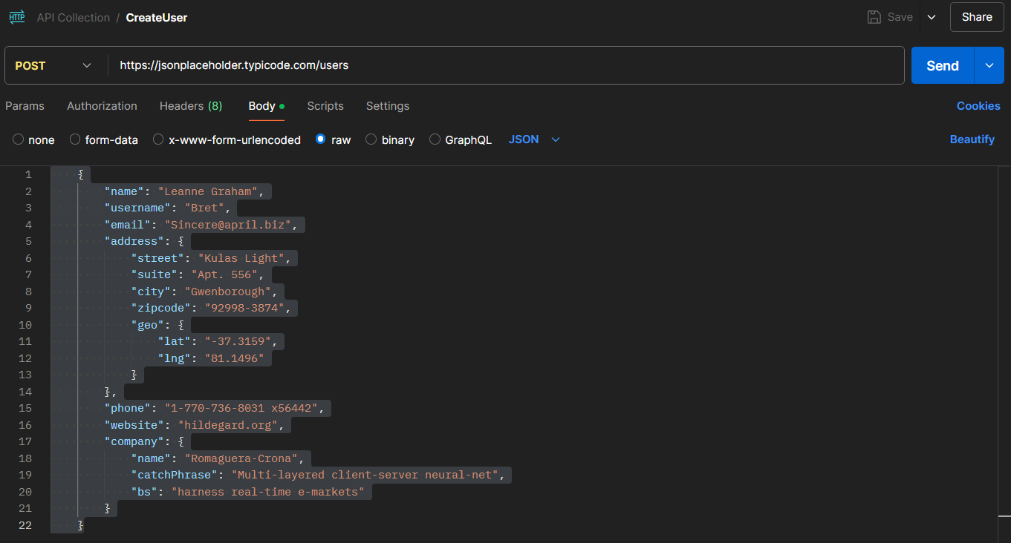

Response:  
  
b) Retrieve all Users: Used to retrieve all users that are stored in the database  
Method: GET  
API Endpoint: <https://jsonplaceholder.typicode.com/users>   
  
Response:

c) Retrieve specific user by id: Used to retrieve specific user based on id that are stored in the database  
Method: GET  
API Endpoint: <https://jsonplaceholder.typicode.com/users/3>

d) Update specific user by id: Used to retrieve specific user based on id that are stored in the database  
Method: PUT  
API Endpoint: <https://jsonplaceholder.typicode.com/users/3>  
  
Request Body:  
  
Response:   
  
e) Delete specific user by id: Used to retrieve specific user based on id that are stored in the database  
Method: DELETE  
API Endpoint: <https://jsonplaceholder.typicode.com/users/3>  
  
Request Body:

Response:  
  
