-------------------------------------------------------------------------------------------------------------------------

**Scala Lab Assignment no.12**

--------------------------------------------------------------------------------------------------------------------------------------

**Name :** Akash Manohar Borse

**Roll No.:** TAI&D61

**Subject:** Data Science

**Assignment :** Scala Lab Assignment

**1.Perform Hello world program in Scala**

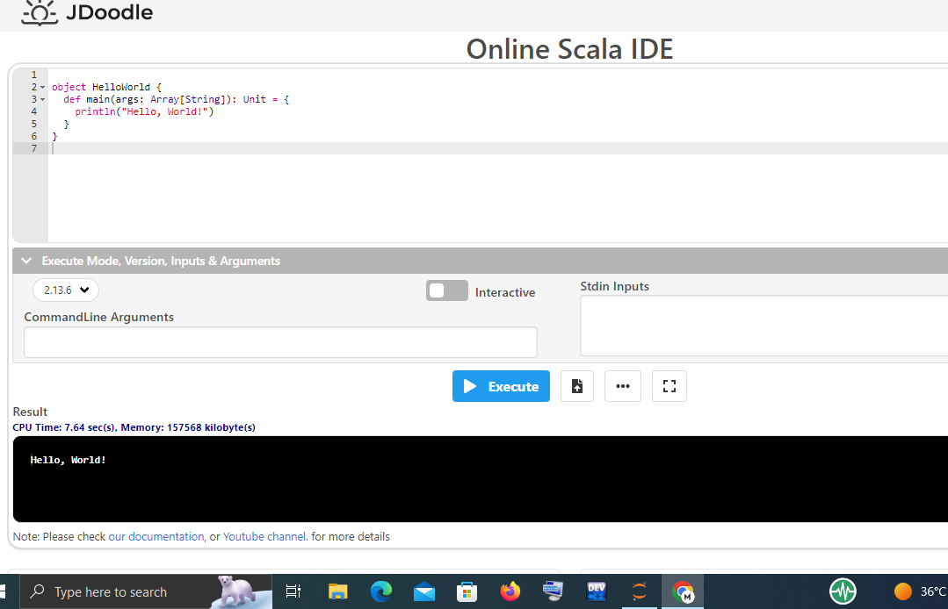

**2. Perform Addition of two numbers program in Scala**

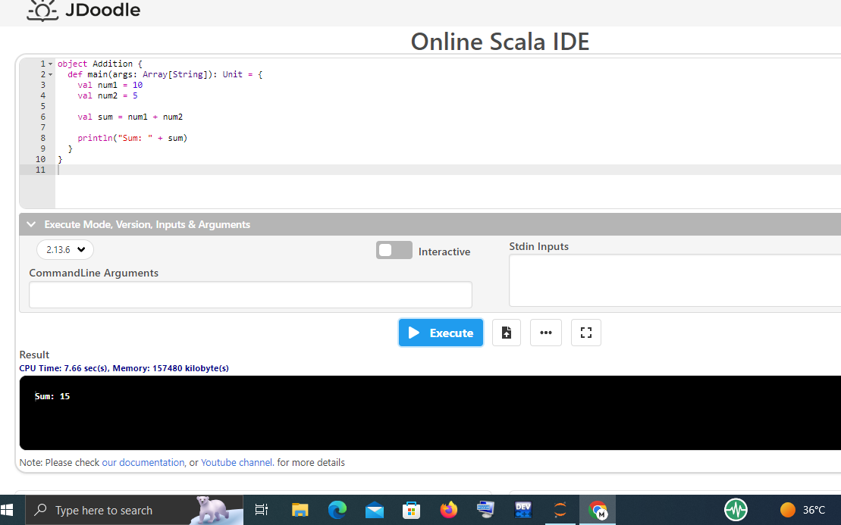

**3. Perform Multiplication table program in Scala**

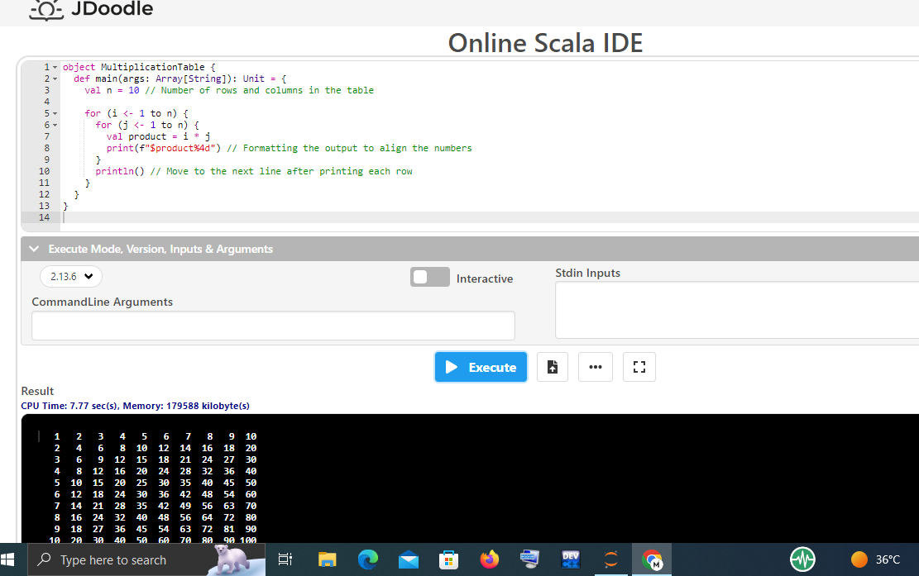

**4. Perform Odd & Even program in Scala**

