Chapter-1

INTRODUCTION

Overview
Chatbots have revolutionized the way humans interact with digital systems, finding applications in diverse fields such as education, healthcare, retail, and customer service. These intelligent systems are designed to simulate human conversation, enabling seamless communication between users and technology. This report delves into the development of Bard-Powered Bot, a state-of-the-art chatbot powered by the Bard API. The Bard API, an advanced natural language processing (NLP) platform, provides the backbone for the chatbot’s ability to understand and respond to user queries with remarkable accuracy and contextual awareness.

The Bard-Powered Bot project addresses key challenges associated with chatbot development, including natural language understanding, scalability, response accuracy, and user engagement. By leveraging the capabilities of the Bard API, this chatbot offers dynamic and meaningful conversations, enhancing user satisfaction. The project aims to bridge the gap between traditional rule-based systems and modern AI-driven conversational agents by providing a solution that is both user-friendly and technically robust. The development process focuses on creating a scalable architecture that supports concurrent user interactions while maintaining high performance and reliability.

In conclusion, the Bard-Powered Bot project highlights the transformative potential of AI-driven conversational agents. By combining cutting-edge technology with user-centric design, this chatbot sets a benchmark for future developments in the field of conversational AI. Its applications are vast, ranging from academic support and healthcare advice to customer service automation and e-commerce assistance. This report serves as a detailed account of the project’s journey, offering insights into the design, implementation, and future prospects of AI-powered chatbots.

1.2 Problem Statement
The development of the Bard-Powered Bot entails overcoming several critical challenges to deliver a chatbot that is both intelligent and efficient. One of the primary issues lies in achieving accurate natural language understanding. The chatbot must interpret diverse user inputs, including complex queries, ambiguous phrases, and informal language, which necessitates the integration of advanced NLP capabilities. Another challenge is ensuring that the responses generated are contextually relevant, as maintaining conversational coherence is essential for user engagement and satisfaction.
Scalability is another significant aspect, as the chatbot must handle multiple simultaneous interactions without experiencing performance degradation. This is especially crucial for real-time applications where users expect immediate and accurate responses. Furthermore, designing a system that integrates seamlessly with existing platforms, such as the Bard API, requires careful architectural planning to ensure smooth operation and interoperability.
User experience is also a key consideration. The chatbot must provide an intuitive and engaging interface that caters to a broad user base, from novice users to experienced individuals. Ensuring adaptability and customization is equally important, as the chatbot needs to cater to a variety of use cases across domains like education, healthcare, customer service, and e-commerce. By addressing these challenges, the Bard-Powered Bot aims to deliver a robust, scalable, and user-centric conversational agent that leverages the full potential of AI to transform digital interactions.
Key issues identified include:
- Performance Optimization: Ensuring the chatbot can handle high volumes of queries without lag or downtime is a critical challenge. This involves implementing efficient algorithms and optimizing backend systems for scalability.
- Natural Language Understanding (NLU): Accurately interpreting diverse user inputs, including ambiguous or slang phrases, is vital for providing meaningful and context-aware responses.
- Response Accuracy: Generating relevant and coherent responses across a variety of topics and maintaining conversational flow demands robust NLP integration.

- Scalability and Concurrency: The system must support multiple simultaneous interactions while maintaining performance, making scalability a fundamental requirement.
- User Experience Design: Creating an intuitive, accessible, and engaging interface is essential for ensuring widespread adoption and ease of use.
- Integration Complexity: Seamless integration with external APIs, such as the Bard API, requires a well-structured system architecture.
- Security and Privacy: Protecting user data through encryption and compliance with privacy standards is crucial to building trust and ensuring the system's reliability.
- Adaptability and Customization: Offering flexible configurations and features to adapt to various domains and user-specific requirements is necessary for broader applicability.

1.3 Objectives
- Enhance Natural Language Understanding: Utilize the Bard API’s advanced NLP capabilities to accurately interpret diverse user inputs, including complex queries and informal language.
- Provide Context-Aware Responses: Ensure that the chatbot generates coherent and relevant responses that maintain conversational flow and user engagement.
- Ensure Scalability and Performance: Design a system architecture that supports high concurrency and handles large volumes of user interactions without performance degradation.
- Deliver an Intuitive User Experience: Create a user-friendly and engaging interface that caters to a diverse audience, from novices to experienced users.
- Seamlessly Integrate with External Systems: Leverage the Bard API and other tools to provide smooth integration with existing platforms and services.
- Support Customization and Versatility: Allow the chatbot to be tailored for various domains, such as education, healthcare, and customer service, ensuring relevance and adaptability.
- Maintain Security and Privacy: Implement robust security measures, including data encryption and compliance with privacy standards, to protect user information and build trust.
- Enable Continuous Improvement: Incorporate logging and analytics to monitor chatbot performance and identify areas for refinement, ensuring the system evolves with user needs.

Chapter 2

LITERATURE SURVEY

The evolution of chatbots has been a subject of extensive study, focusing on their transition from rule-based systems to intelligent conversational agents. Early chatbots, such as ELIZA, relied on pattern matching and lacked contextual awareness. Over time, the integration of artificial intelligence and machine learning transformed these systems, enabling them to process and generate human-like responses.

Recent advancements in natural language processing (NLP) have further improved chatbot capabilities. For instance, pre-trained language models like GPT and Bard have shown significant progress in understanding and responding to user queries with contextual accuracy. Kumar and Wang discussed how machine learning algorithms have enabled chatbots to analyze user intent and provide personalized responses, emphasizing the importance of data-driven approaches in enhancing conversational AI.

Zhao and Liang explored automatic response generation techniques, highlighting the role of APIs in reducing the computational burden on developers. They noted that platforms like Bard API simplify chatbot development by providing access to pre-trained NLP models, thereby allowing developers to focus on user experience and customization.

The integration of user-friendly interfaces has also been a key area of research. According to Martin , intuitive interface design plays a critical role in improving user engagement, particularly for non-technical users. This aligns with the objectives of the Bard-Powered Bot, which prioritizes accessibility and ease of use.

The Bard-Powered Bot leverages these advancements to deliver a scalable, adaptable, and user-focused solution. By combining the Bard API's NLP capabilities with robust system architecture, the chatbot addresses key challenges such as natural language understanding, scalability, and user engagement.

Chapter 3

SOFTWARE REQURIMENTS AND SPECIFICATION
3.1 General description
The Bard-Powered Bot is designed as an intelligent conversational agent capable of delivering accurate and meaningful interactions across various domains. The application leverages the Bard API for natural language processing (NLP) to ensure context-aware responses. It incorporates a scalable architecture, allowing seamless handling of multiple user interactions concurrently. The bot supports customization for domain-specific use cases, making it adaptable to industries such as education, healthcare, and customer service.

The software is structured into three key components: a user-friendly frontend, a robust backend integrating the Bard API, and a data storage system for managing logs and analytics. The application is built with a focus on performance, reliability, and security to ensure user satisfaction and trust. By combining advanced technology with user-centric design principles, the Bard-Powered Bot aims to provide a superior conversational experience that meets the diverse needs of its users.

3.2 Software Requirements

1. Functional Requirements
- Natural Language Processing (NLP): Integration with the Bard API to handle user inputs, generate responses, and maintain conversational flow.
- User Interaction Management: Support for multi-turn conversations and dynamic query handling.
- Data Storage and Retrieval: Utilize a database (e.g., SQLite) for managing conversation logs and user data.
- Response Optimization: Enable real-time response generation with minimal latency.

2. Non-Functional Requirements
- Performance: Ensure response times of less than 2 seconds for seamless user interactions.
- Scalability: Support multiple concurrent user sessions without performance degradation.
- Reliability: Achieve 99.9% uptime with robust error-handling mechanisms.
- Security: Protect user data through encryption and compliance with data privacy standards.

3. System Requirements
- Operating System: Compatible with Windows 10/11, macOS, and Linux distributions.
- Hardware Requirements: Minimum 4GB RAM, 2GHz processor, and a dedicated GPU for advanced editing.
- Storage Space: Requires at least 500MB of free disk space for installation and temporary file storage.

Chapter 4
SYSTEM ARCHITECTURE

  - System Architecture

The system architecture of the Bard-Powered Bot is designed to ensure efficiency, scalability, and seamless integration. It is divided into three primary layers:
- Frontend Layer:
This layer is responsible for user interaction. It provides a user-friendly interface, developed using HTML, CSS, and JavaScript, that allows users to input queries and view chatbot responses.
Features include real-time messaging, adaptive design for multiple devices, and accessibility enhancements to cater to diverse user needs.
- Backend Layer:
The backend layer is the core of the system. It processes user queries, sends them to the Bard API for natural language processing, and formats the API responses for the frontend.
This layer is developed using Python and Flask, ensuring rapid API integration and response handling.
It includes mechanisms for context management to maintain conversational flow across multiple user interactions.
- Data Storage Layer:
This layer manages user data, including conversation logs, preferences, and analytics. It uses SQLite or PostgreSQL for efficient and secure data storage.
Data storage is designed to comply with privacy standards, ensuring encryption and secure access protocols.
- External Integration Layer:
The Bard API serves as the external integration layer, providing advanced natural language processing capabilities. This layer simplifies development by leveraging pre-trained models, enabling the chatbot to understand and respond to complex user queries.

4.2 Use Cases
The Bard-Powered Bot is designed to address a variety of real-world scenarios across multiple domains. Below are the key use cases:
- Education: Students interact with the chatbot to get assistance with academic queries, homework, or research guidance.
- Healthcare: Users consult the chatbot for basic medical information and advice.
- Customer Service: Businesses use the chatbot to handle customer inquiries and complaints.
- E-commerce: Shoppers use the chatbot for product recommendations and purchasing assistance.
- Human Resources: Organizations deploy the chatbot to streamline HR processes.
By addressing these diverse use cases, the Bard-Powered Bot demonstrates its versatility and potential to transform user experiences across industries, enhancing productivity and satisfaction.

Chapter 5
IMPLIMENTATION
5.1 Implimentation plan
The implementation of Bard Bot follows these steps:
- Requirement Analysis: Identify features (chatbot responses, user authentication) and tools (Bard API, MongoDB, Handlebars).
- System Design: Develop a modular architecture with:
  - Front-End: Dynamic templates (hbs) and static assets.
  - Back-End: Node.js server with Express.js and Bard API integration.
  - Database: MongoDB for user data with secure schema.
- Development: Implement the front-end, back-end, and database, ensuring API connectivity and secure password management using bcrypt.
- Testing: Conduct unit, integration, and user acceptance tests to ensure functionality.
- Deployment: Host on platforms like AWS or Heroku, managing credentials securely using dotenv.
- Maintenance: Monitor, update, and refine the application based on user feedback.

The plan ensures efficient collaboration, seamless functionality, and scalability for future enhancements.
Tools & Technologies: Node.js, Express.js, Bard API, MongoDB.

Chapter 6
SYSTEM TESTING
System testing ensures that the Bard Bot functions as expected in a fully integrated environment. It verifies the application's compliance with specified requirements, identifying and fixing any defects before deployment.
Objectives of System Testing
- Validate the chatbot's ability to handle user queries through the Bard API.
- Ensure seamless interaction between the front-end, back-end, and database.
- Verify secure user authentication and data handling.
Testing Types
- Functional Testing:
  - Test core functionalities like login, chatbot response accuracy, and user session management.
  - Validate Bard API integration and dynamic content rendering with hbs.
- Performance Testing:
  - Assess system response times under various loads.
  - Test the Bard API's performance during peak traffic.
- Security Testing:
  - Verify password encryption using bcrypt.
  - Ensure secure handling of API keys and sensitive data through dotenv.
- Integration Testing:
  - Check interaction between modules (e.g., user inputs processed by Bard API and rendered on the front-end).
  - Test database CRUD operations (Create, Read, Update, Delete).
- User Acceptance Testing (UAT):
  - Collect feedback from users to refine responses, user interface, and flow.
Testing Tools
- Postman: For API endpoint validation.
- MongoDB Compass: To monitor database operations.
- Browser Developer Tools: For front-end debugging and performance checks.

Chapter 7
RESULTS AND DISSCUSSION
The Bard Bot project demonstrates the successful implementation of a chatbot powered by the Bard API, integrated with MongoDB for user management, and rendered dynamically using Handlebars.
Results
- Functionality:
  - The chatbot responds effectively to user queries, leveraging the Bard API for intelligent and context-aware answers.
  - User authentication is secure, with passwords encrypted using bcrypt and stored in MongoDB.
- System Performance:
  - The application handles concurrent user interactions efficiently with minimal response latency.
  - The Bard API integration ensures high-quality responses, maintaining conversational relevance.
- User Interface:
  - Dynamic templates created with Handlebars provide an interactive and user-friendly interface.
  - Static assets (CSS, JavaScript) enhance usability and visual appeal.
- Deployment:
  - The application is successfully hosted on a platform (e.g., Heroku/AWS), ensuring global accessibility.
Discussions
- Project Strengths:
  - The modular design ensures scalability and easier debugging.
  - Integration of the Bard API provides advanced conversational capabilities.
  - Secure handling of user data aligns with industry standards.
- Challenges Faced:
  - Initial integration of the Bard API required detailed configuration to achieve accurate responses.
  - Managing database connections during peak loads required optimization of query handling.

- Improvements:
  - Enhanced the response handling by caching frequently asked queries for faster results.
  - Optimized database queries and reduced latency through indexing.
- Future Scope:
  - Implementing additional user features like voice input/output for accessibility.
  - Expanding the database to include user activity logs for better insights.
  - Training the chatbot to handle domain-specific queries for specialized use cases.

7.1 Snapshots

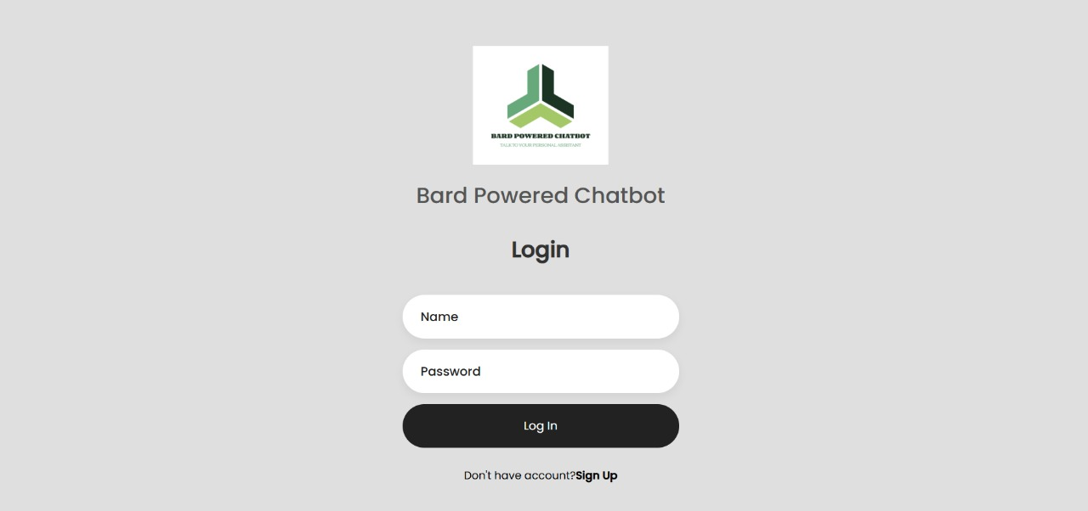

Fig 7.1 : User Login Interface

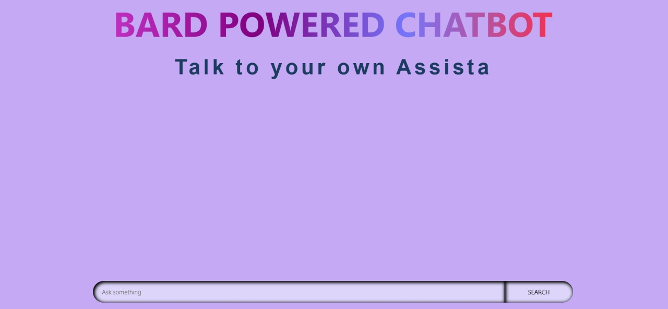

Fig 7.2 : Chatbot Interface

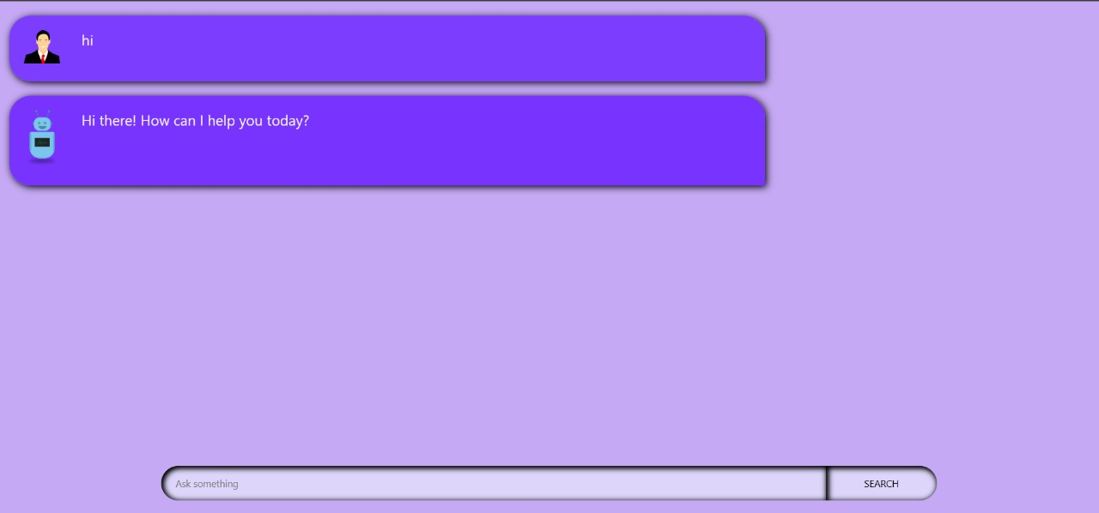

Fig 7.3 : Text Generation

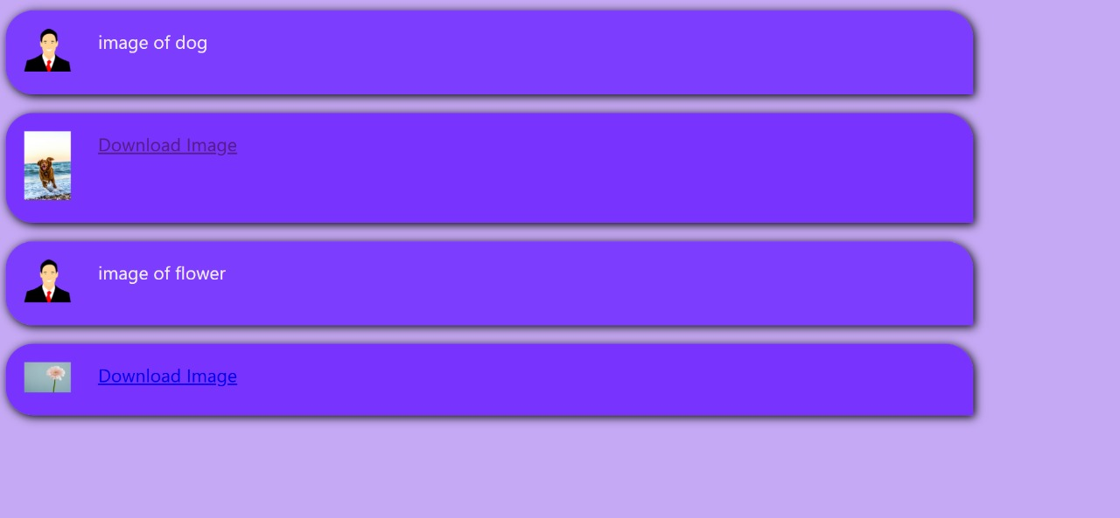

Fig 7.4 : Image Generation

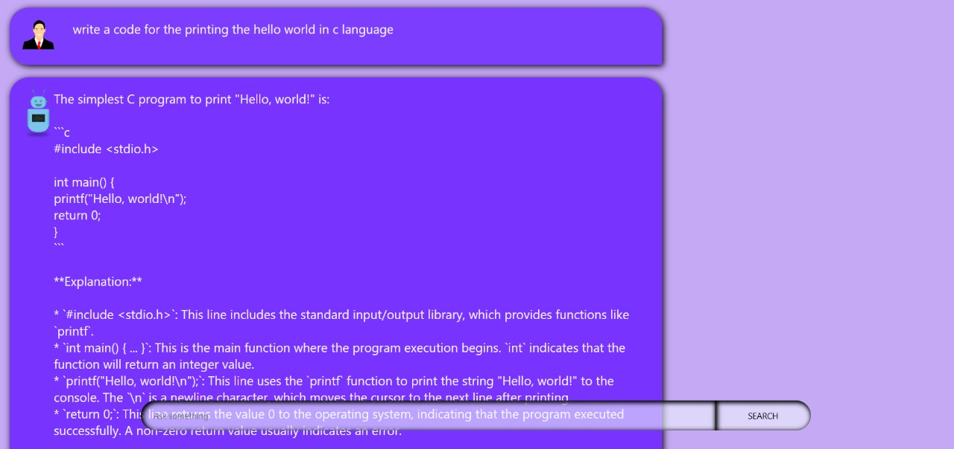

Fig 7.5 : Code Generation

APPLICATIONS

Content Creation Assistance
Creative Bot can assist writers, bloggers, and content creators by providing ideas, outlines, and suggestions for articles, blog posts, and social media content. It can help generate topics, refine ideas, and provide unique perspectives, streamlining the creative process and overcoming writer’s block.

Brainstorming and Ideation
The chatbot serves as a digital brainstorming partner, offering prompts and inspiration for users who need help generating innovative ideas. Whether for business, design, or academic projects, Creative Bot can help users explore diverse possibilities and new angles on topics of interest.

Creative Writing Support
For aspiring writers and students, Creative Bot can offer prompts, character development ideas, and plot suggestions, making it an ideal companion for creative writing exercises. It can guide users in developing story ideas, enhancing characters, and exploring narrative possibilities.

Educational Tool for Students
Students can use Creative Bot as a study aid for creative projects, presentations, and assignments. By engaging in a dialogue with the chatbot, students can refine their ideas, enhance critical thinking, and gain new insights, making it an effective tool for creative learning.

Marketing and Advertising Inspiration
In the marketing and advertising sectors, Creative Bot can generate campaign ideas, slogans, and taglines. It can assist marketers by offering creative approaches for reaching target audiences, suggesting innovative branding concepts, and helping with product descriptions.

CONCLUSION AND FUTURE ENHANCEMENTS

  - Conclusion
The Bard-powered bot project demonstrates the effective integration of modern AI technologies with web development frameworks to create an interactive and practical application. By leveraging the Google Bard API, the bot provides human-like responses, while the Unsplash API enhances the user experience by generating relevant images. The backend, developed in Node.js, ensures robust server-side functionality, and MongoDB provides a secure and scalable database for user login and data management. The use of HTML, CSS, and JavaScript ensures an intuitive and engaging user interface.
This project illustrates the potential of combining AI and web technologies to solve real-world problems, offering users an intelligent, responsive, and visually engaging tool.

  - Future Enhancements

Dynamic Image Generation
- Extend the image-generation feature by incorporating AI-based image synthesis tools like DALL-E or Stable Diffusion, enabling the bot to create unique image.
Customizable Themes and User Interface
- Allow users to personalize the bot appearance with fonts, and layout options for improved user experience.
- Include a dashboard to track user interactions, query trends, and usage optimization and insights.
Integration with IoT Devices
- Expand the bot’s utility by integrating it with IoT devices for smart home management.
Improved Security Measures
- Implement multi-factor authentication (MFA) for user logins.
- Ensure data encryption both in transit and at rest to maintain user privacy and security.
- Offline Functionality.

REFERENCES

  - Google:
https://www.google.com/
2. Bard API:
https://ai.google.dev/gemini-api/docs
3. Git-hub:
https://github.com/
4. MDN Web Docs:
https://developer.mozilla.org/en-US/
5. YouTube:
https://www.youtube.com/
6. ChatGPT:
https://openai.com/index/chatgpt/
7. Chat Blackbox AI:
https://www.blackbox.ai/

