Dr. AMBEDKAR INSTITUTE OF TECHNOLOGY
(An Autonomous Institute, Affiliated to Visvesvaraya Technological University, Belagavi, Accredited by NAAC, with ‘A’ Grade)
Near Jnana Bharathi Campus, Bengaluru – 560056
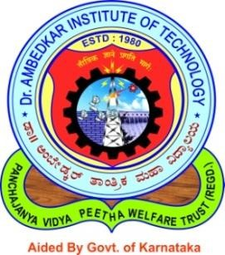
DEPARTMENT OF COMPUTER SCIENCE & ENGINEERING
A Mini-Project Report on

“Bard Powered Bot”

Submitted in partial fulfilment of the requirement for the award of the Degree of

Bachelor of Engineering
In
Computer Science & Engineering

Submitted by

Akash A | 1DA22CS006
Janardhan K | 1DA22CS066

For the academic year 2024-25

Under the Guidance of
Divya s
Assistant professsor, Dept. of CSBS,
Dr.AIT, Bengaluru – 56.
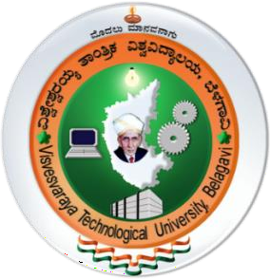
Visvesvaraya Technological University
Jnana Sangama, Belagavi, Karnataka 590018.

2024-2025
Dr. AMBEDKAR INSTITUTE OF TECHNOLOGY
(An Autonomous Institute, Affiliated to Visvesvaraya Technological University, Belagavi, Accredited by NAAC, with ‘A’ Grade)
Near Jnana Bharathi Campus, Bengaluru – 560056

DEPARTMENT OF COMPUTER SCIENCE & ENGINEERING
A Mini-Project Report on

“Bard Powered Bot”

Submitted in partial fulfilment of the requirement for the award of the Degree of

Bachelor of Engineering
In
Computer Science & Engineering

Submitted by

Akash A | 1DA15CS006
Janardhan K | 1DA15CS066

Under the Guidance of
Srinivasa A. H.
Associate Professor, Dept. of CSE,
Dr.AIT, Bengaluru – 56.


Visvesvaraya Technological University
Jnana Sangama, Belagavi, Karnataka 590018.

2024-2025

Dr. AMBEDKAR INSTITUTE OF TECHNOLOGY
(An Autonomous Institute, Affiliated to Visvesvaraya Technological University, Belagavi, Accredited by NAAC, with ‘A’ Grade)
Near Jnana Bharathi Campus, Bengaluru – 560056



DEPARTMENT OF COMPUTER SCIENCE & ENGINEERING



Certified that the Mini-Project work titled “Bard Powered Bot” carried out by Akash A and Janardhan K bearing the USNs 1DA22CS006 and 1DA22CS066, are bonafide students of Dr. Ambedkar Institute of Technology, Bengaluru, in partial fulfilment for the award of Degree in Bachelor of Engineering in Computer Science & Engineering of Dr. Ambedkar Institute of Technology during the academic year 2024-25. It is certified that all corrections/suggestions indicated during Internal Assessment have been incorporated in the Mini-Project report deposited in the department. The Mini-Project report has been approved as it satisfies the academic requirements in respect of Mini-Project work prescribed for the said Degree.

--------------------------- | ---------------------------- | ------------------------------
Signature of the Guide | Signature of the HOD | Signature of the Principal
Divya S,  Assistant Professor,  Department of CSBS,  Dr.AIT, Bengaluru -56. | Dr.Nandini N,  Professor and HEAD,  Department of CSE,  Dr.AIT, Bengaluru – 56. | Dr. M.N.Thippeswamy,  Principal,  Dr.AIT, Bengaluru – 56.

Viva-Voce Examination
Name of the Examiners Signature with Date
1.

2.

