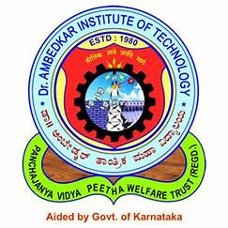 | Dr. Ambedkar Institute of Technology
 | Department of Computer Science & Engineering

Mini-Project (22CSM506)
Weekly Progress Report
Mini Project Batch-Id: | A17
Title of the Mini Project: | Bard Powered Bot

Sl. No | USN | Name | Contact Number | E-mail Id
1 | 1DA22CS006 | Akash A | 7975744144 | 1da22cs006.cs@drait.edu.in
2 | 1DA22CS066 | Janardhan k | 7795313859 | 1da22cs066.cs@drait.edu.in

Sl. No | Date | Topics Discussed | Signature of Guide

Signature of Coordinators Signature of HOD

