Agri-AI User Documentation
Welcome to the AI Crop Diagnosis System. This guide will help you navigate the mobile application and use its features to keep your crops healthy and productive.

Getting Started
While you can use most features of the app as a guest, creating an account allows you to save your diagnosis history and sync data across devices.

[!NOTE]
Login and Registration are optional.
You can proceed as a guest to use the core features like disease detection and chatbot assistance.

Registration
If you are a new user, fill in your details on the registration screen to create your profile.

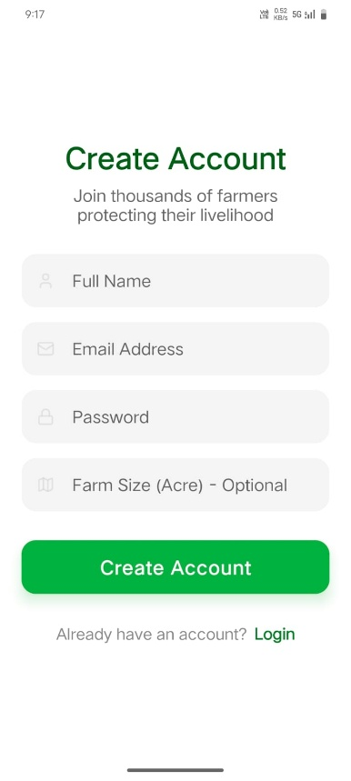

Login
Once registered, use your email and password to safely log in to your account.

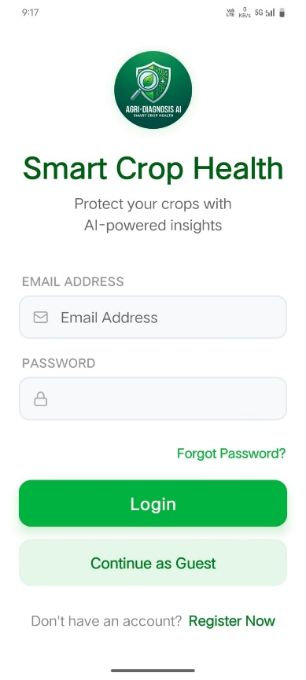

Dashboard (Home Screen)
The Dashboard is your central hub for all agricultural activities.
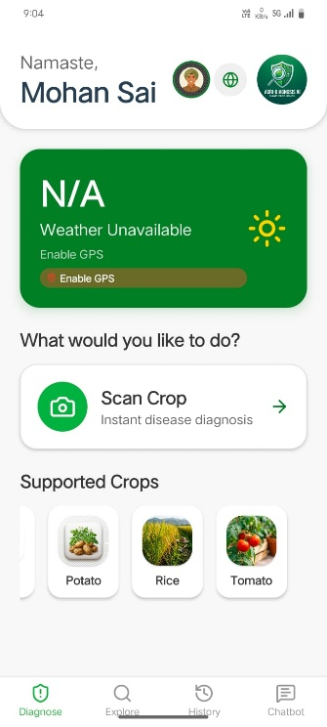

Key Features:
- Personalized Greeting: Welcomes you by name.
- Real-time Weather: Displays current temperature and weather conditions for your specific location. This is critical as many crop diseases are weather-dependent.
- Smart Scanning: A prominent "Scan Your Crop" button provides one-tap access to the AI diagnosis tools.
- Supported Crops: A quick-reference grid showing all crops currently supported by our AI models (Tomato, Rice, Potato, Grape, Maize).

Disease Detection (Scan Mode)
Capture or upload images for instant AI analysis.
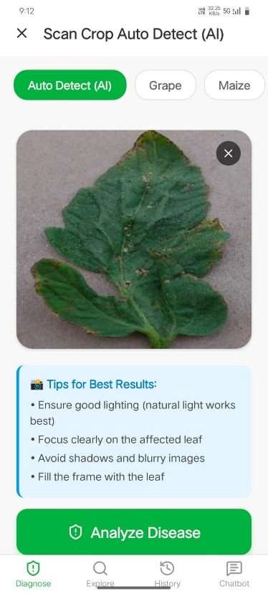

How to use:
1. Select Crop: Choose the crop you want to scan from the selection chips.
2. Take Photo: Use the built-in camera to take a clear photo of the affected plant.
3. Upload: Alternatively, you can upload an image from your phone's gallery.
4. AI Analysis: Tap "Analyze Disease" to send the image to our deep learning models for diagnosis.

[!TIP]
Ensure the photo is taken in good lighting and shows the symptoms clearly for the highest accuracy.

Diagnosis Results
Understand the health of your crop and get actionable advice.

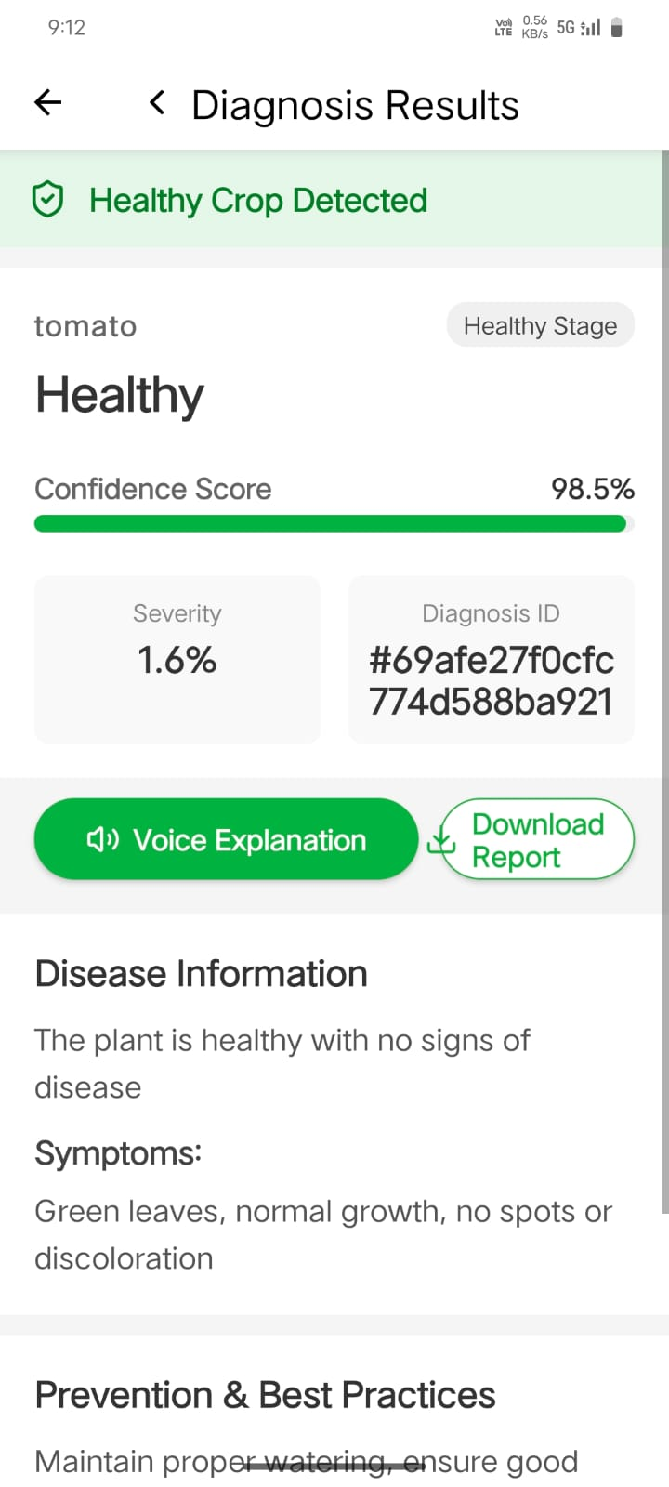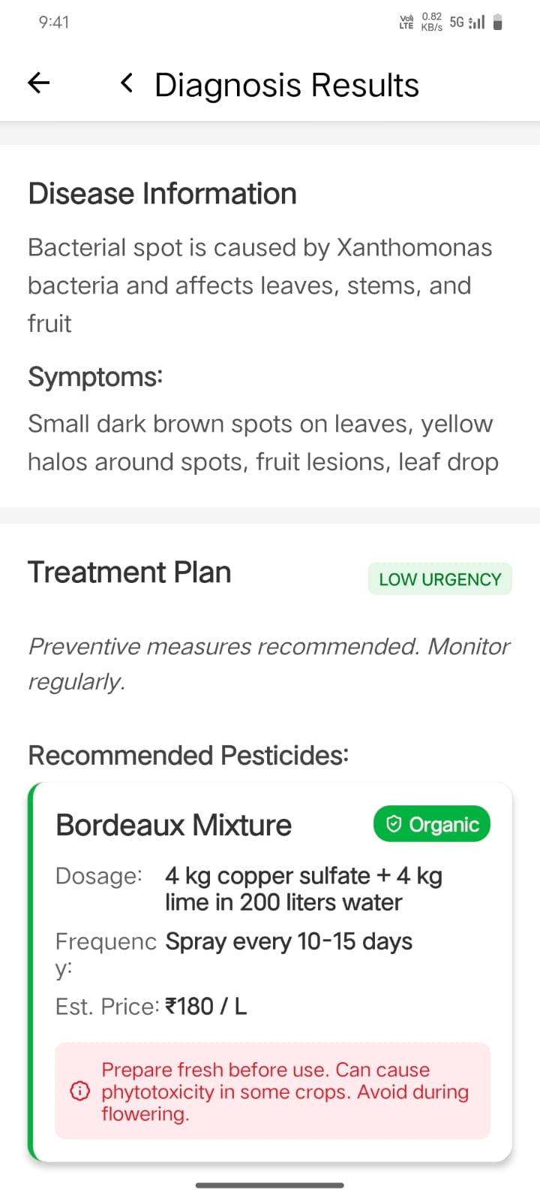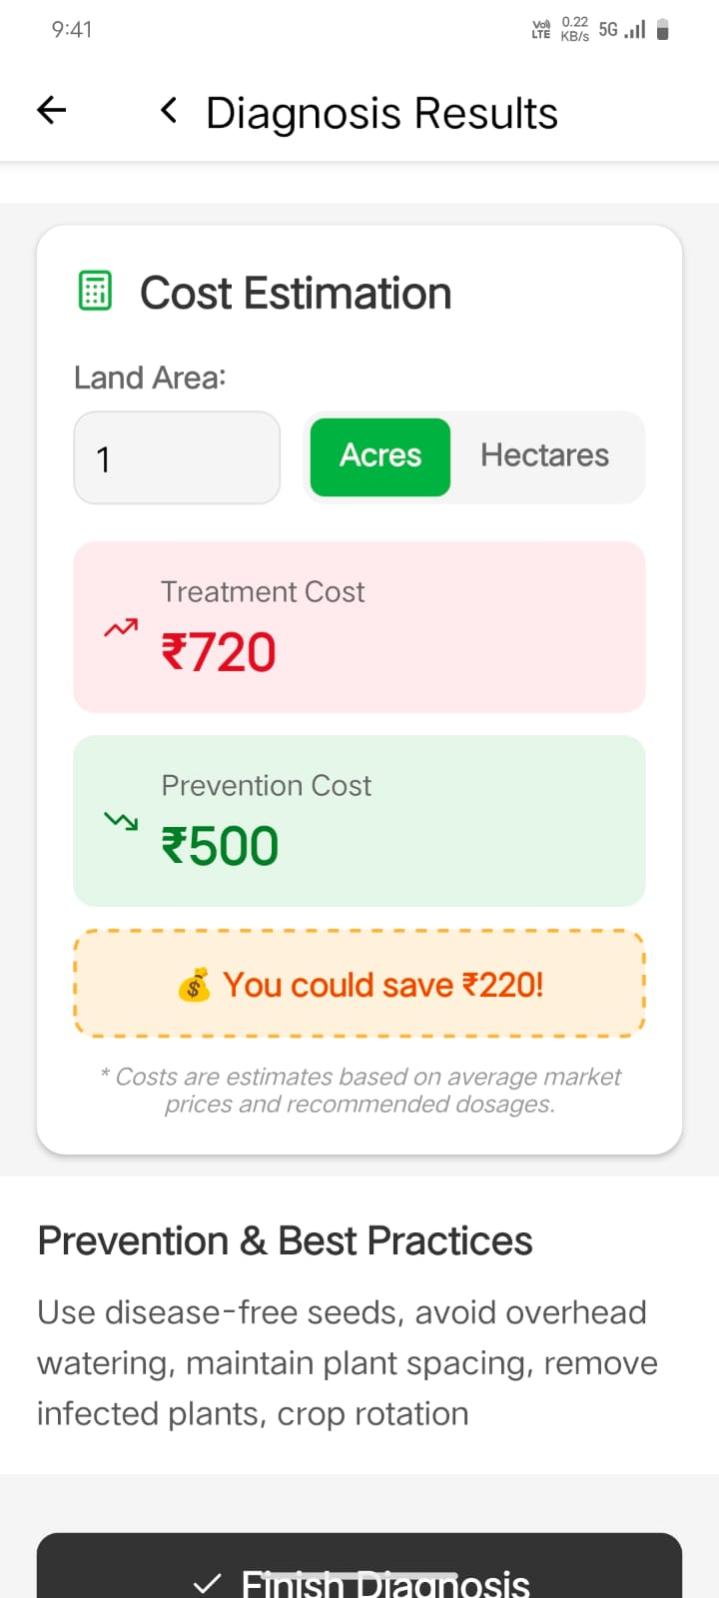

What's on this screen:
- Status Banner: A clear indicator (Green for Healthy, Orange for Disease Detected).
- Confidence Score: Our AI tells you how sure it is about the diagnosis with a visual progress bar.
- Severity Analysis: Shows the percentage of the crop affected and the stage of the disease (Early, Late, etc.).
- Voice Explanation: Tap the "Voice Explanation" button to hear the AI explain the diagnosis and next steps in your local language.
- Treatment Plan: Detailed recommendations for pesticides, including dosages, frequency, and costs.
- Prevention Tips: Best practices to avoid the disease in the future, including organic alternatives.
- Share Report: Generate and share a professional PDF report of the diagnosis.

AI Chatbot (Agri-Bot)
Your 24/7 personal agricultural assistant.

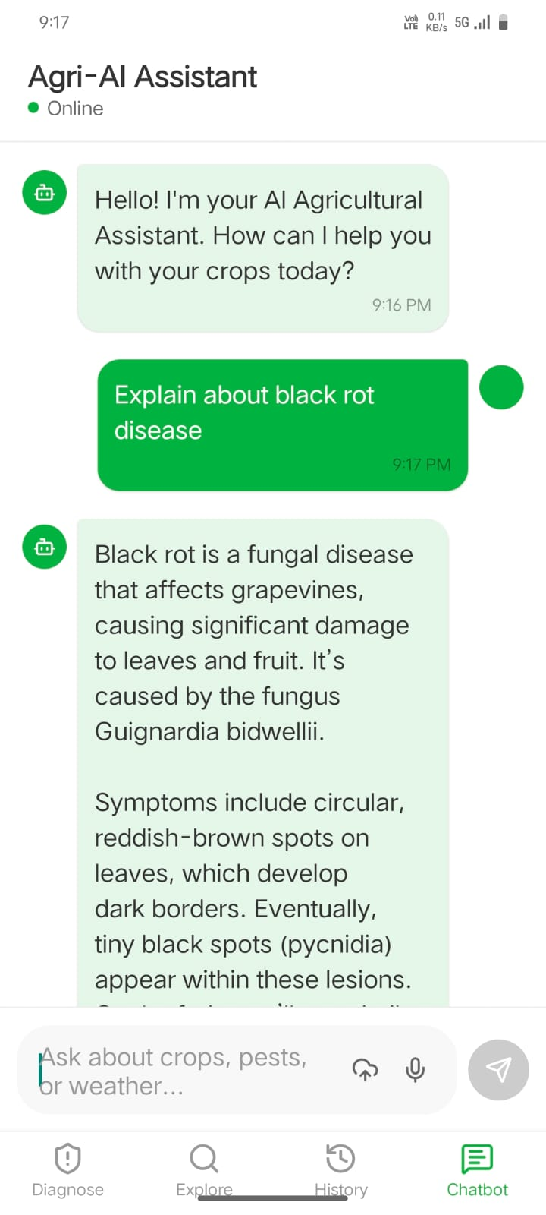

Use the Chatbot to:
- Ask Questions: Get instant answers about crop diseases, fertilizers, or general farming best practices.
- Upload Media: Send photos or videos of your crops for the AI to provide context-aware advice.
- Voice Support: Don't want to type? Use the microphone button to ask your questions using your voice.
- Multilingual Support: The bot understands and responds in several local languages.

Explore
Discover more about different crops and common diseases through the Explore screen.

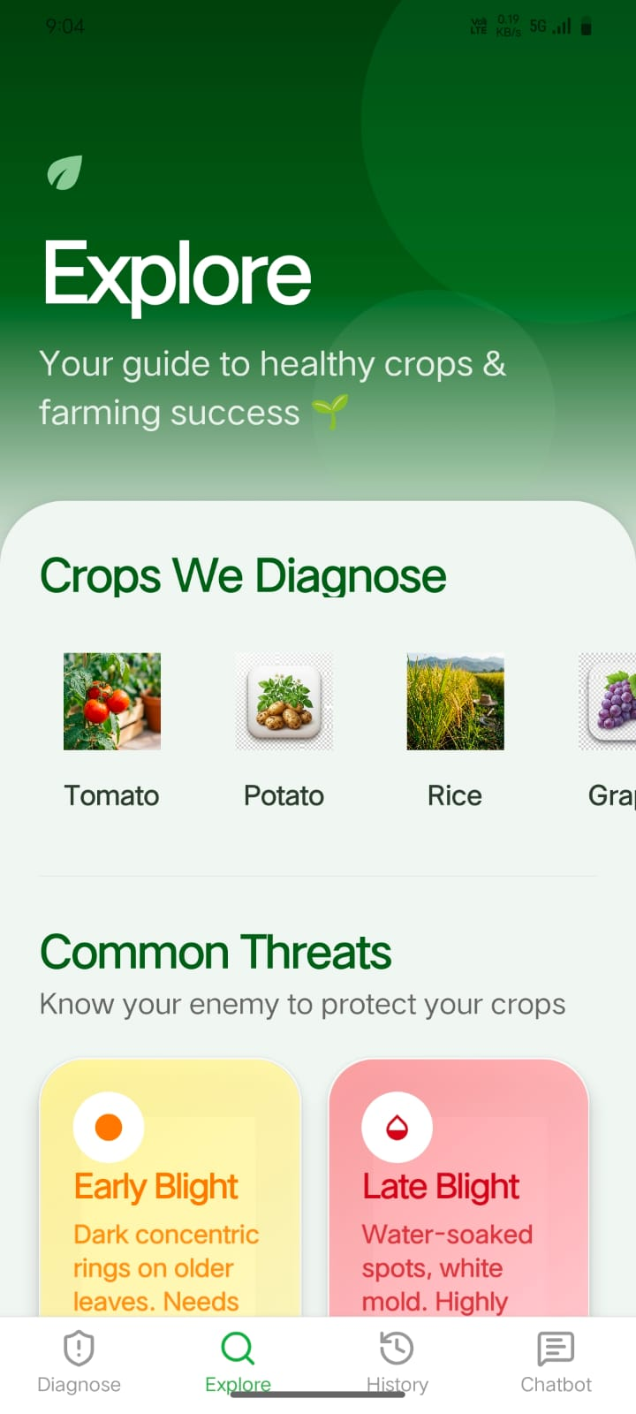

Profile & History
Manage your data and revisit past findings.
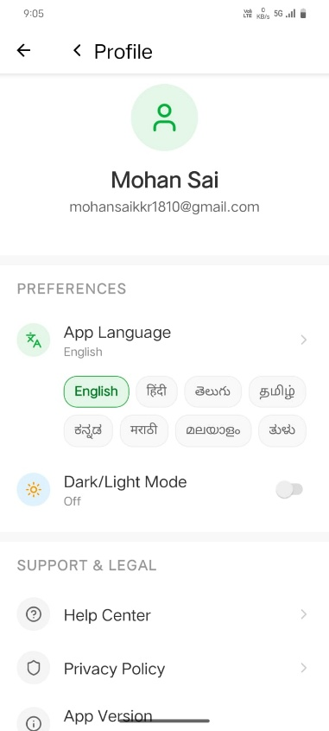

User Profile
Update your farm details, personal information, and app preferences here.

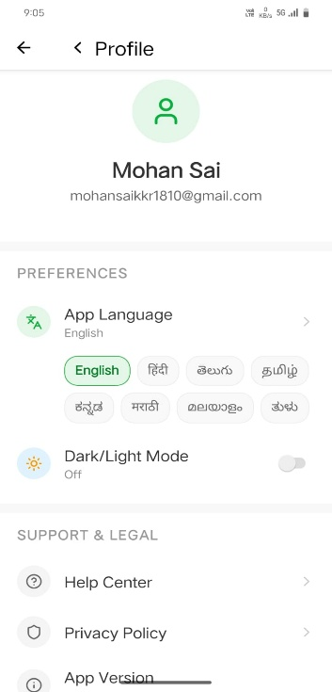

Detection History
Access all your previous diagnosis results and reports to track your crop health over time.
