Havi Assignment for list creater

Overview

- The Project name is List Creator which I made for Havi Assignment
- In this project I made one sign up page and login page for the user account.
- In this project user can create their account and login.
- When a user logs in, its shows them a page with a list creator. This page has text box into which the user can enter something and on press of enter, the items will be added to the database and populate the updated database in the list.
- There is a admin grid where the list of all users can be seen in a grid and admin also search the user via name who are in the grid.
- APIs are handle data to be processed with all the forms and make it a functional application.

productive tool

- HTML
- CSS
- BOOTSTRAP
- JQUERY/JSON
- PHP
- MYSQL

SYSTEM requirement

- Window 7 to 10.
- Any Web Browser.

OBJECTIVE

- Student can fill their feedback form.
- Admin can see all the user’s details.

FILE AND DATABASE DESIGN

Database Design of Table:-

- user register:-

S. No | Column Name | Data Type | Size | Constrains
1. | id | int |  | Primary Key
2. | fname | Varchar | 50 | Not Null
3. | lname | Varchar | 50 | Not Null
4. | email | Varchar | 50 | Not Null
5. | phone_no | bigint | 16 | Not Null
6. | addressline1 | Varchar | 50 | Not Null
7. | addressline2 | Varchar | 50 | Not Null
8. | state | Varchar | 50 | Not Null
9. | district | Varchar | 50 | Not Null
10. | pincode | int | 11 | Not Null
11. | dob | date |  | Not Null
12. | Password | Varchar | 16 | Not Null
13. | repassword | Varchar | 16 | Not Null

2. feedback:-

S. No | Column Name | Data Type | Size | Constrains
1. | feedback_id | int |  | Primary Key
2. | email | Varchar | 50 | Not Null
3. | name | Varchar | 50 | Not Null
4. | feedback | Varchar | 50 | Not Null

EXTERNAL INTERFACES
- Screen shots of project.
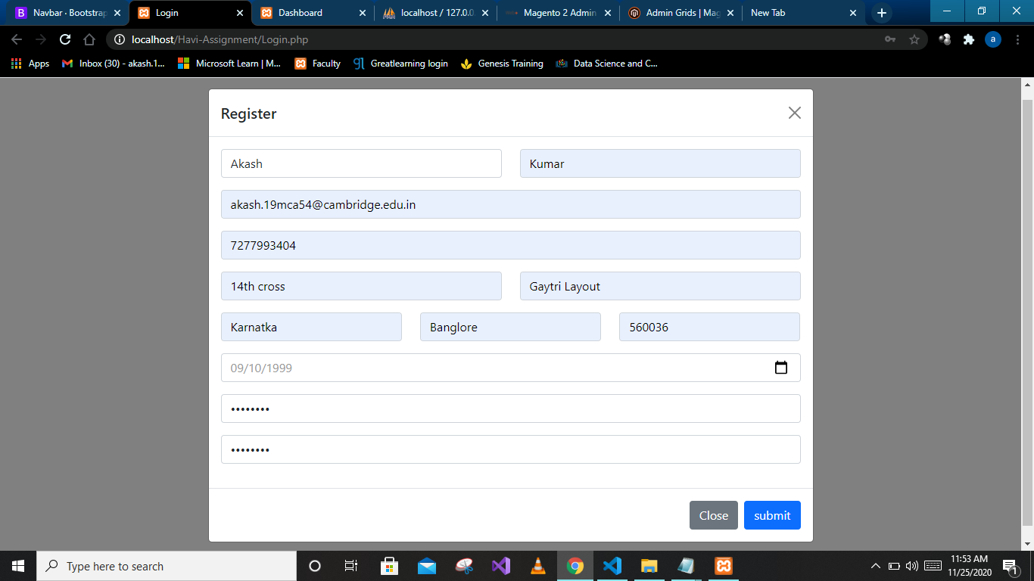

- In this form user can fill their details and register in site.

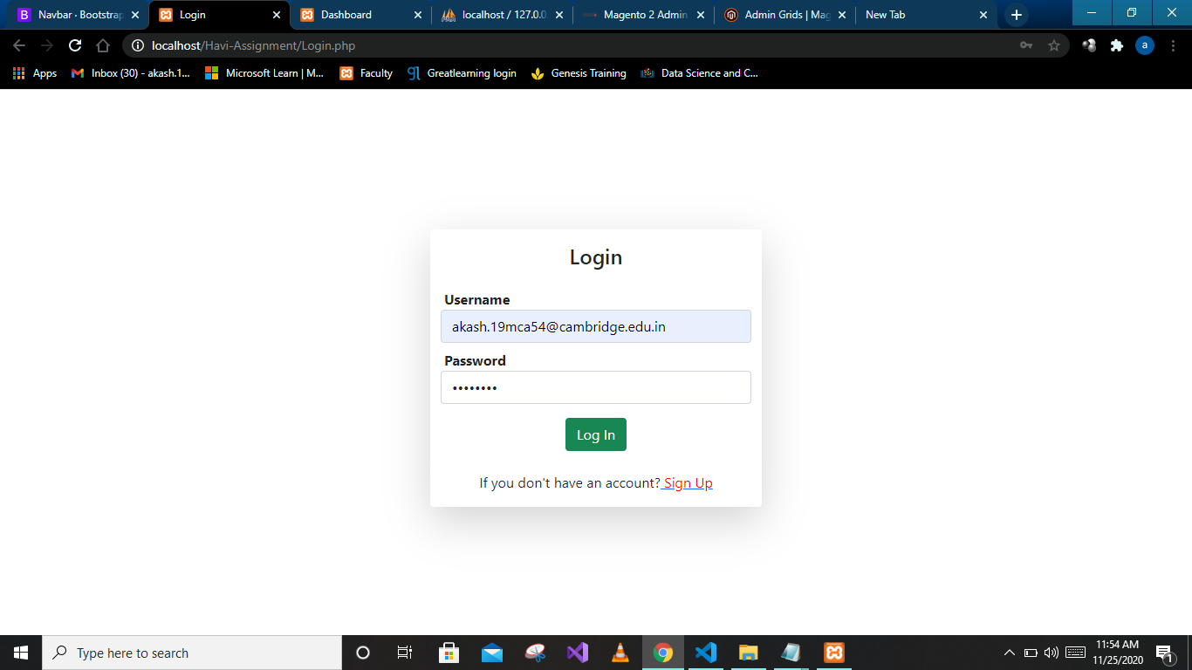
- In this form user can fill their email as username and password to login.
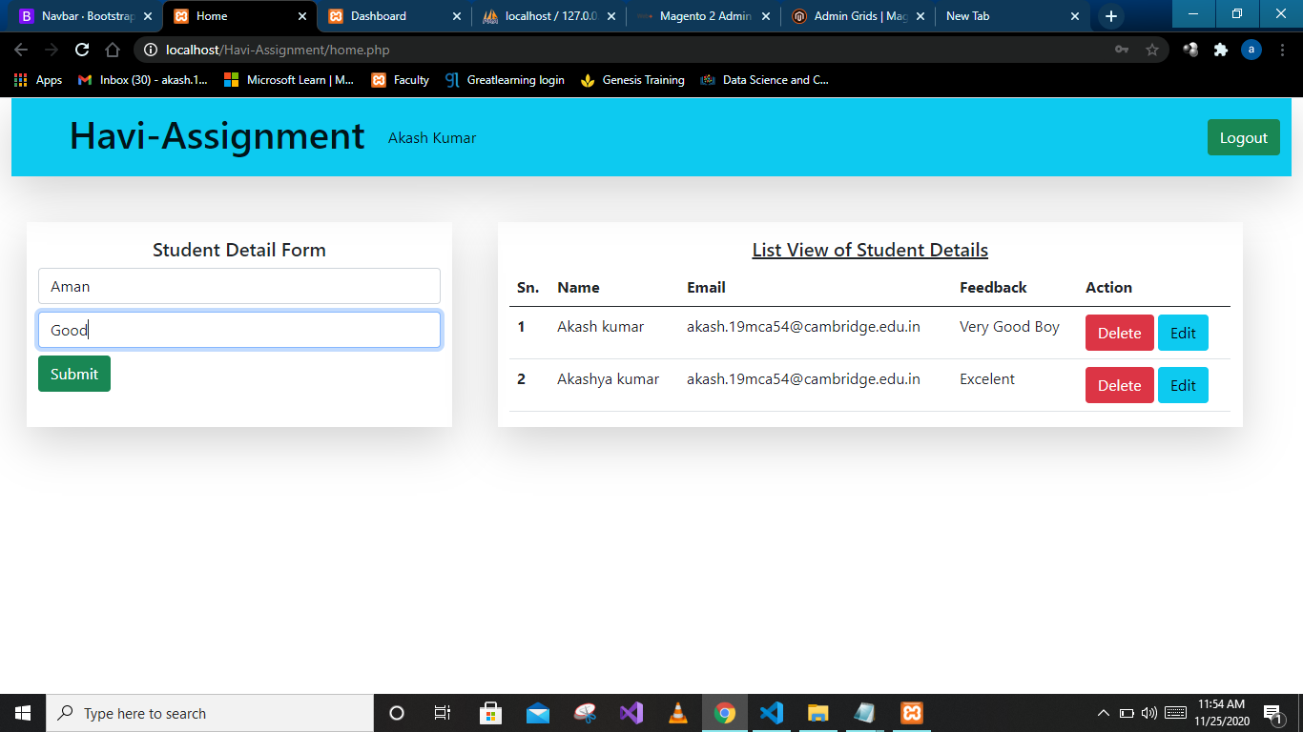
- In this form user can fill name and feedback and submit.

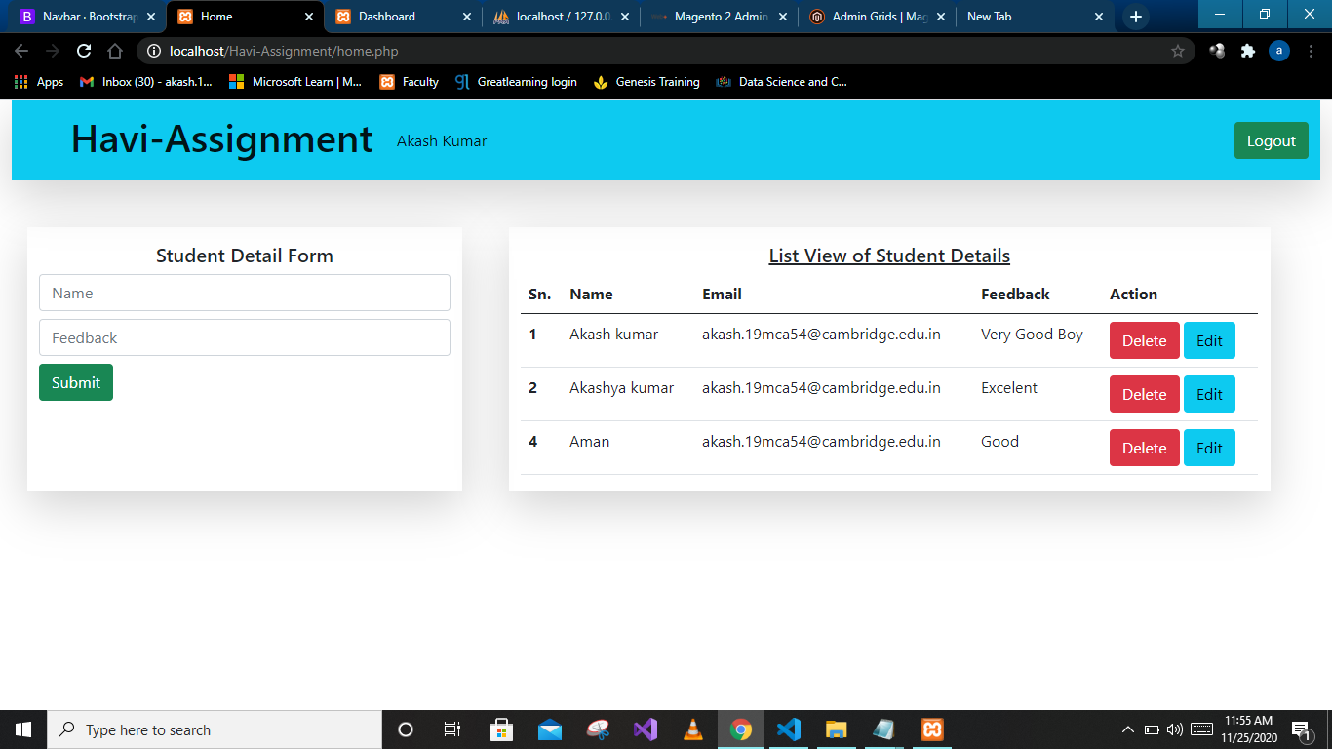
- In this form user can see their feedback.
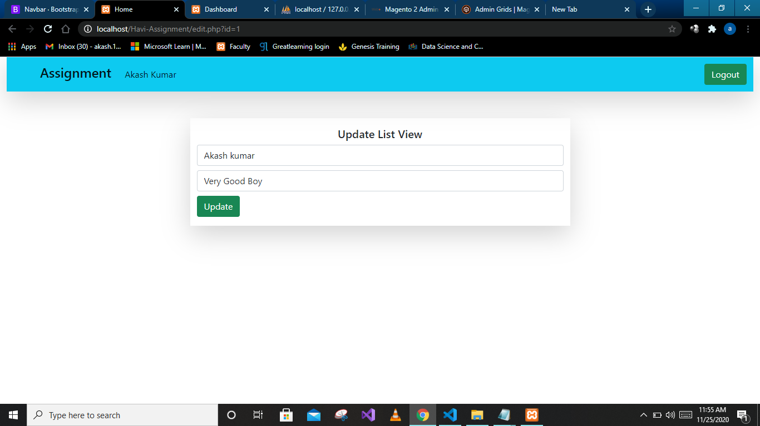
- In this form user can edit their feedback.

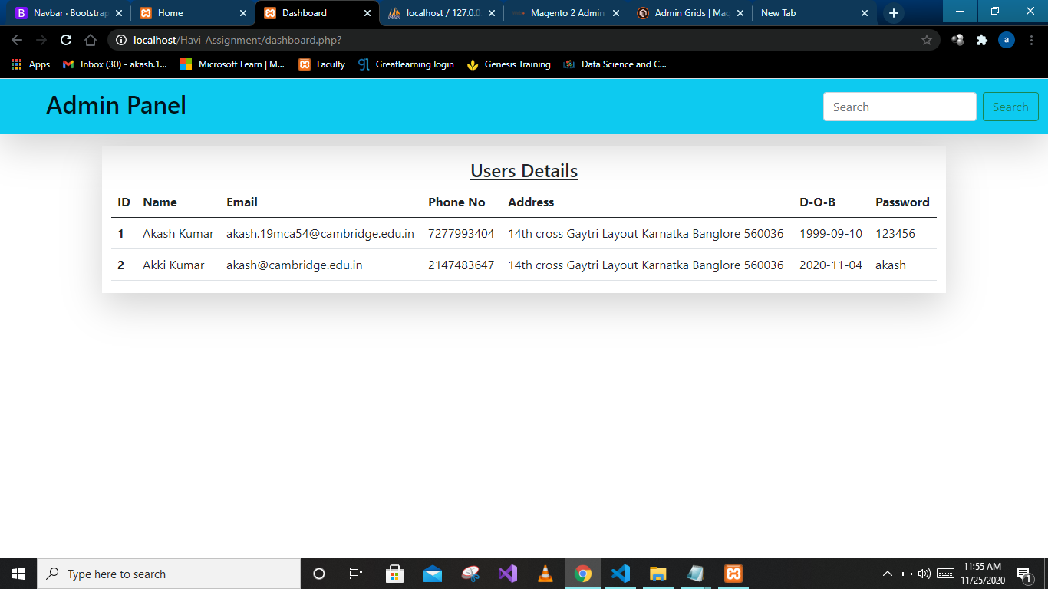
- In this page admin can see all the user’s details and also search the user’s by their name.

Api’s to handle data
Read data
https://akkiassignment.000webhostapp.com/API/api-read-feedback-table.php
https://akkiassignment.000webhostapp.com/API/api-read-single-userregister-table.php
https://akkiassignment.000webhostapp.com/API/api-read-userregister-table.php

Insert data
https://akkiassignment.000webhostapp.com/API/api-insert.php

Update data
https://akkiassignment.000webhostapp.com/API/api-update.php

Search data
https://akkiassignment.000webhostapp.com/API/api-search.php

Delete data
https://akkiassignment.000webhostapp.com/API/api-delete.php

What you have learned
- Full stack development.

Link of your project
- Users Pnnel link
https://akkiassignment.000webhostapp.com/Havi-Assignment/index.php

- Admin pannel
https://akkiassignment.000webhostapp.com/Dashboard/dashboard.php

git hub link
https://github.com/Akashdalmia/Internship-project.git

