PERSONAL BLOG ON IBM CLOUD STATIC WEB APPS

**PHASE 4 PROJECT:**

## An IBM Cloud Static Web App and deploying your travel blog website. Here are the general steps you can follow:

1. If you do not have an IBM Cloud account yet, go to <https://cloud.ibm.com/registration>to register,
2. 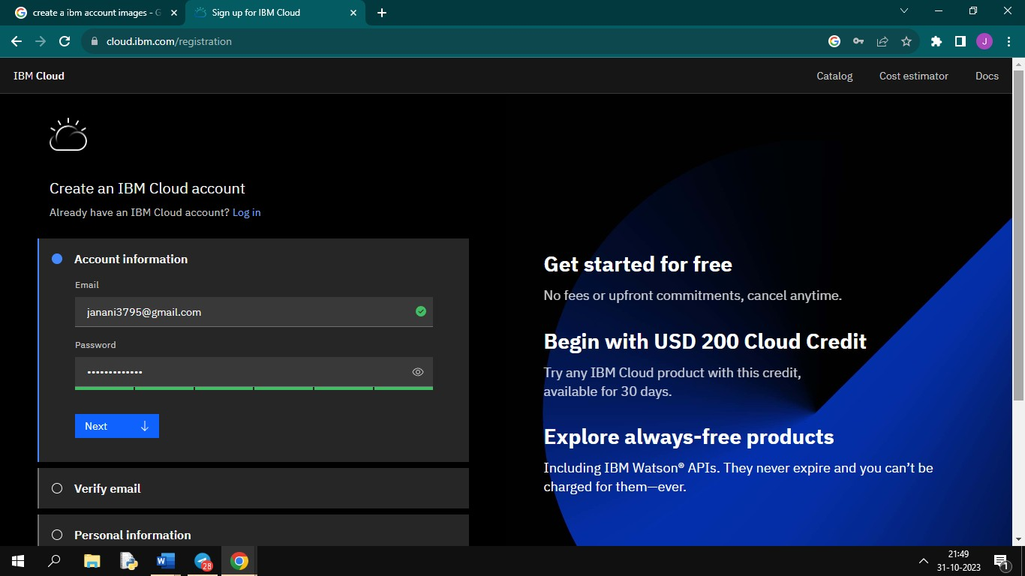In the Create an account window, enter your email and password,
3. The Verify email section will inform you that a verification code was sent to your email.

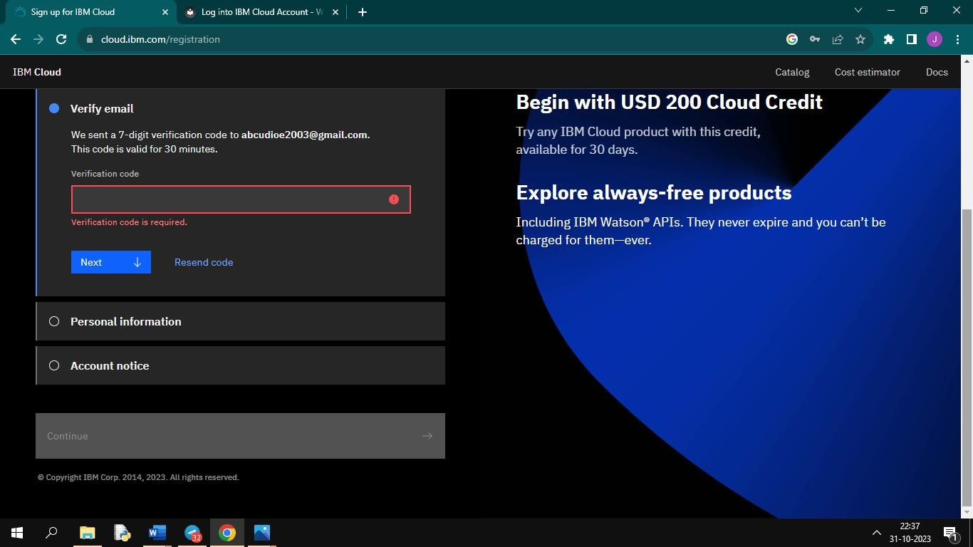

1. 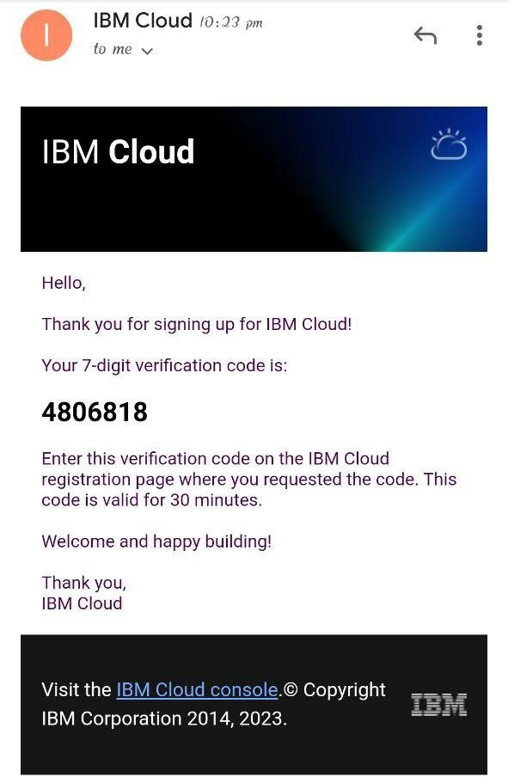Switch to your email provider to retrieve the verification code,
2. 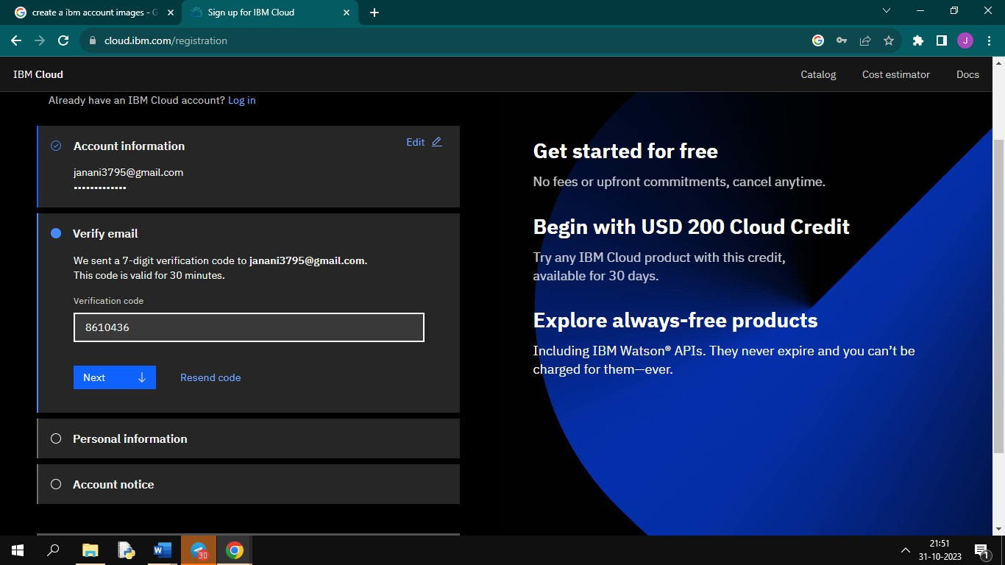Enter the verification code in the Verify email section, and click Next,
3. 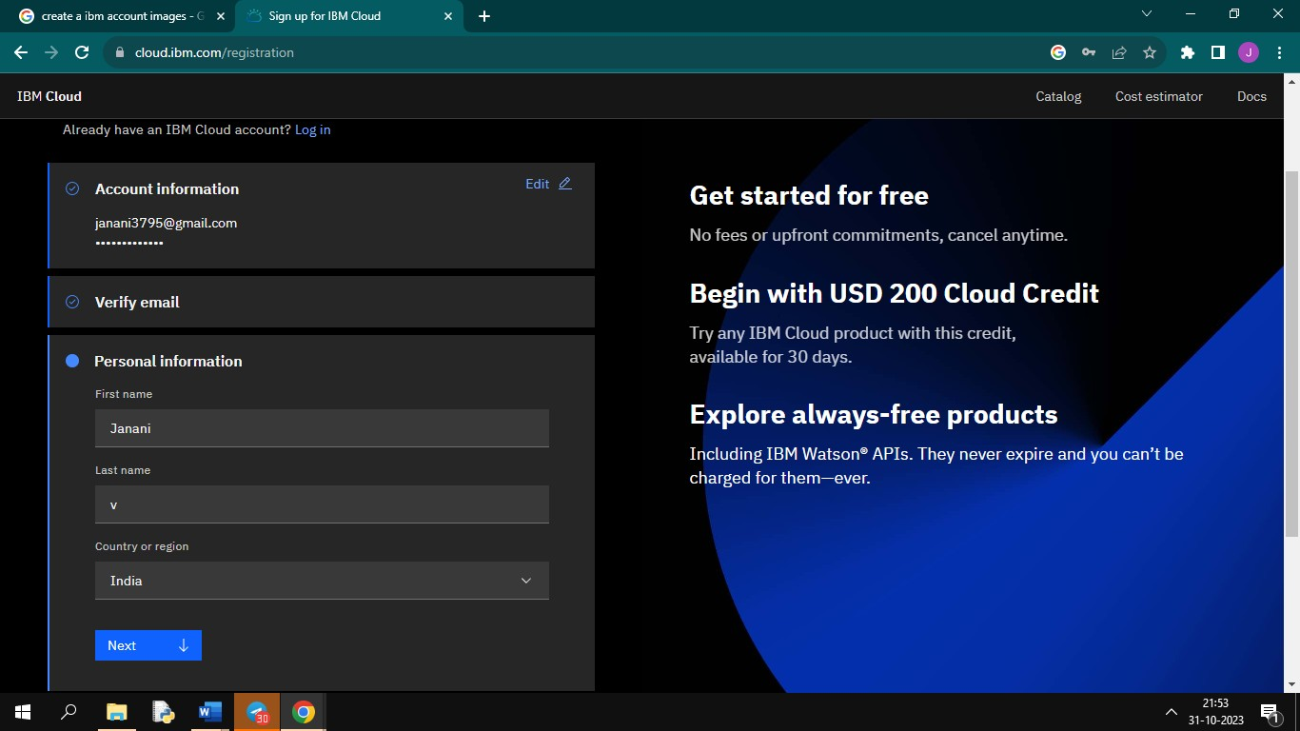Enter your first name, last name and country in the Personal information section and click Next,
4. Click Create account.
5. 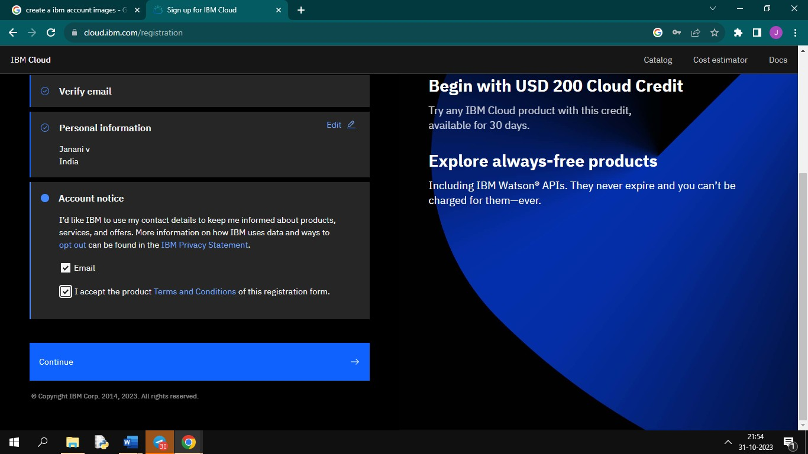Your account is being created,
6. 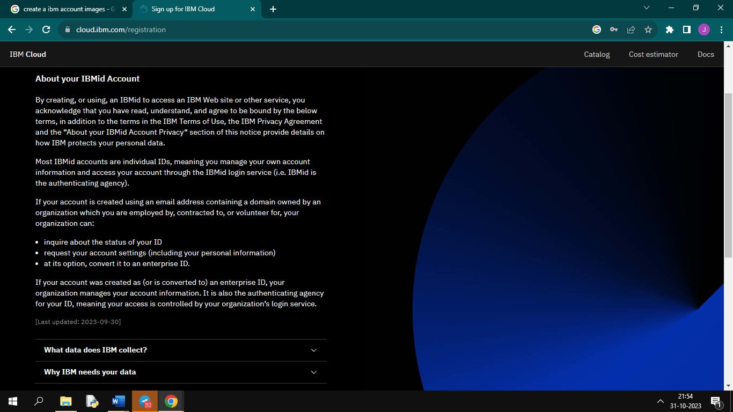Review the IBM Privacy Statement,
7. 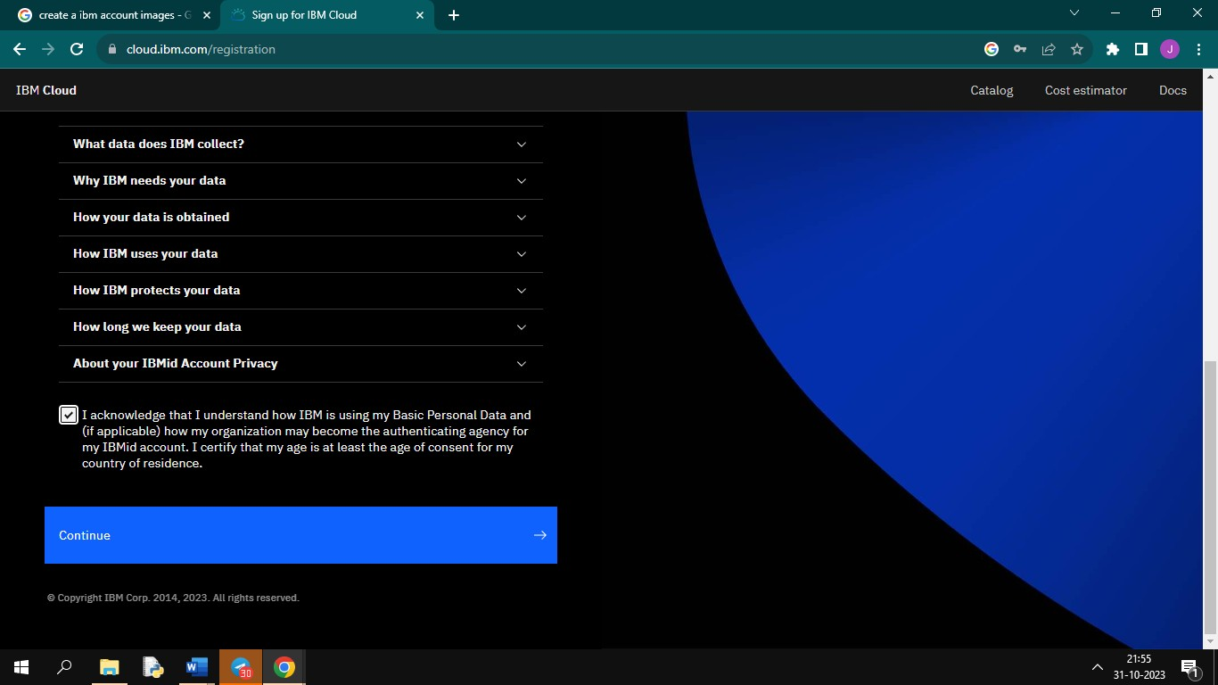Click Proceed to acknowledge the privacy statement,
8. Switch to your email provider to review the Welcome to IBM Cloud email, and click the Login link.
9. 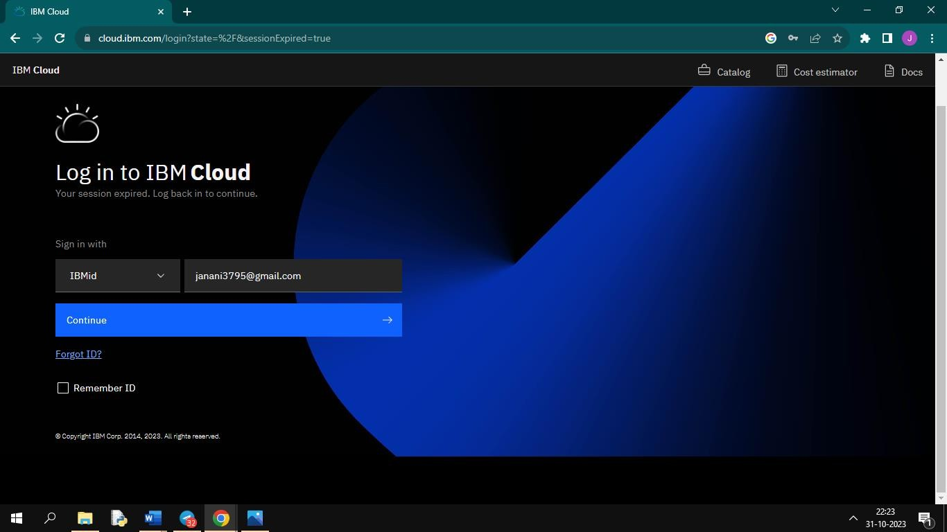Enter your IBM Id to login,
10. 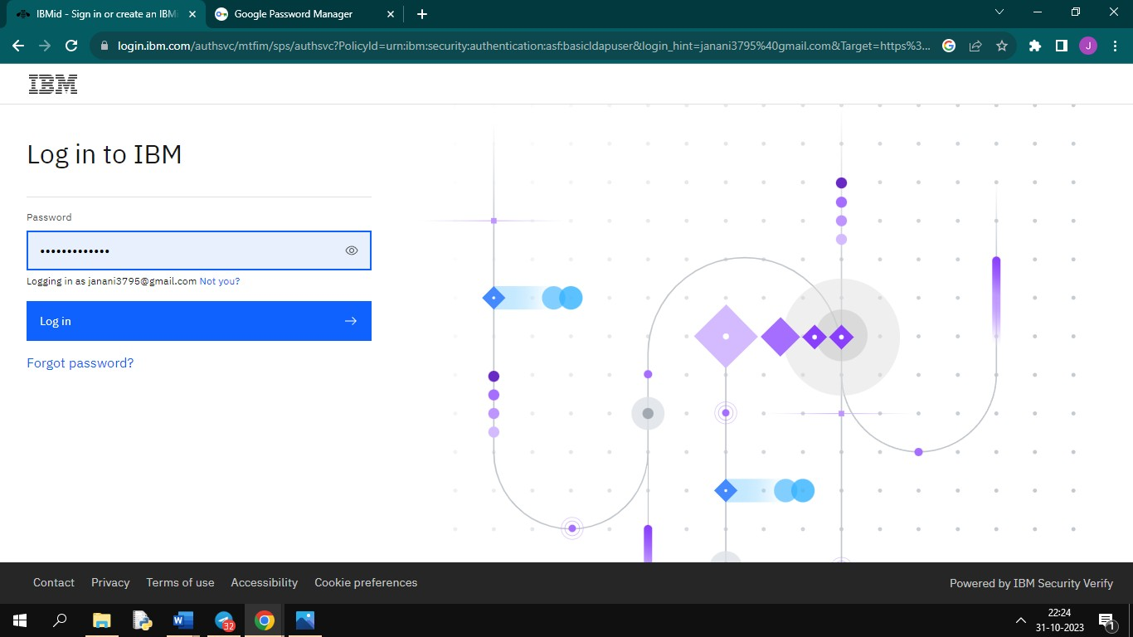Enter your password to login,
11. 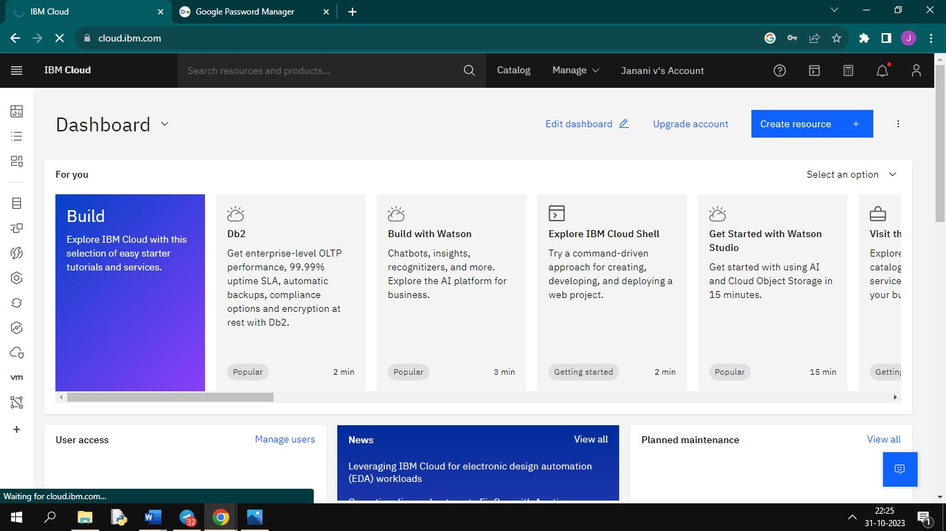The IBM Cloud dashboard page should load,
12. You have successfully registered a new IBM Cloud account.

# To sign up for an IBM Cloud account, follow these steps:

* + Visit the IBM Cloud website (https:/[/www.ibm](http://www.ibm.com/cloud)).[com/cloud).](http://www.ibm.com/cloud))
  + Click on the "Sign up" or "Get started for free" button.
  + You will be prompted to create an IBM ID if you don't already have one. Fill in your email address, create a password, and provide the necessary information.
  + Follow the on-screen instructions to complete the registration process.
  + You may need to verify your email address to activate your account.
  + Once your account is set up, you can log in and explore IBM Cloud services.

# Follow these steps to create a new Static Web App and set up the repository, build pipeline, and deployment options:

## Sign in to IBM Cloud:

If you haven't already, sign in to your IBM Cloud account.

## Access the IBM Cloud Dashboard:

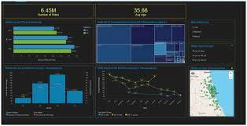

From the IBM Cloud Dashboard, click on "Create Resource" or a similar button to create a new resource.

## Search for "Static Web App":

In the IBM Cloud catalog, search for "Static Web App" and select it.

## Configure Your Static Web App:

Follow the prompts and provide the necessary information:

* + Choose a name for your app.
  + Connect to your repository:

You'll need to provide the repository URL (e.g., GitHub), and grant the necessary permissions.

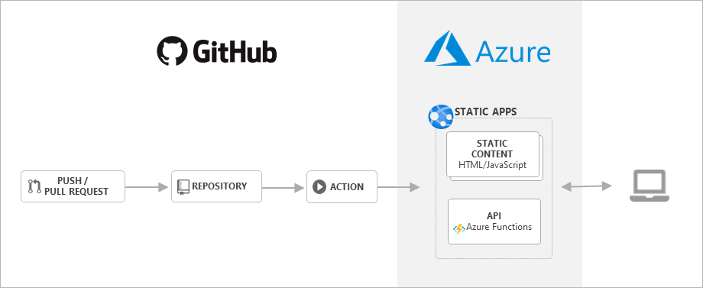

* + Configure the build settings:

Set up your build pipeline, such as specifying the build command and build environment.

* + Select deployment options:

Choose how you want to deploy your web app, which may include continuous integration and delivery options.

## Review and Confirm:

Review the settings you've configured, and once you're satisfied, confirm the creation of your Static Web App.

## Build and Deploy:

IBM Cloud will initiate the build and deployment process based on the settings you provided. You can monitor the progress through the IBM Cloud interface.

## Access Your Web App:

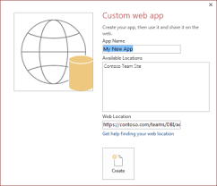

Once the deployment is complete, you will receive a URL where your Static Web App is hosted. You can access and share your website from this URL.

# Great choice! Static site generators like Jekyll or Hugo are excellent tools for creating and managing a blog. Here's a high-level overview of the process:

## Install the Static Site Generator:

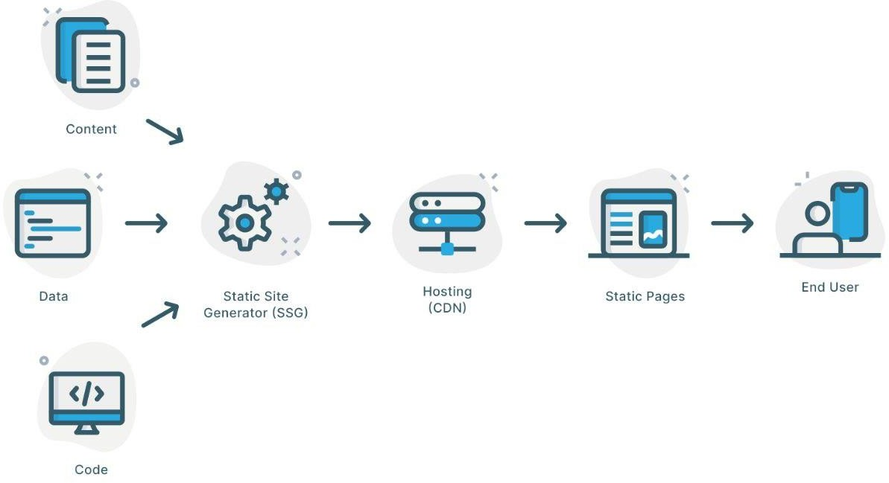

Start by installing your chosen static site generator, such as Jekyll or Hugo, on your local machine.

## Create Templates:

Design your website's layout and structure by creating template files. These templates define how your content will be displayed.

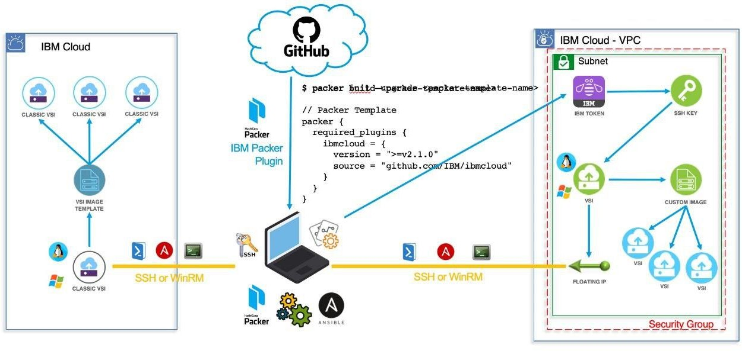

## Convert HTML Content:

Take your existing HTML content and break it down into smaller components, such as headers, footers, and posts. These components will be used within your templates.

## Front Matter:

For each blog post, create a "front matter" section at the top of the Markdown file. This section contains metadata about the post, like title, date, and tags.

## Write in Markdown:

Write your blog posts in Markdown format. Markdown is a lightweight markup language that's easy to learn and provides a simple way to format your content.

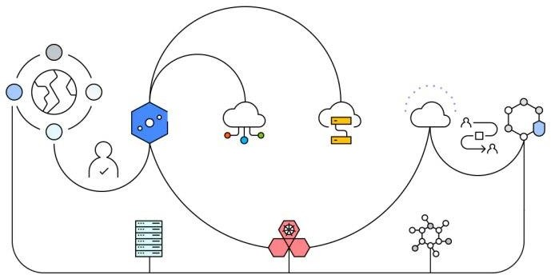

## Organize Content:

Organize your content into a directory structure. For example, you might have a directory for blog posts and another for static pages like "About" or "Contact."

## Generate the Site:

Run the static site generator to convert your templates, Markdown files, and front matter into a complete website. This will create HTML files for each page.

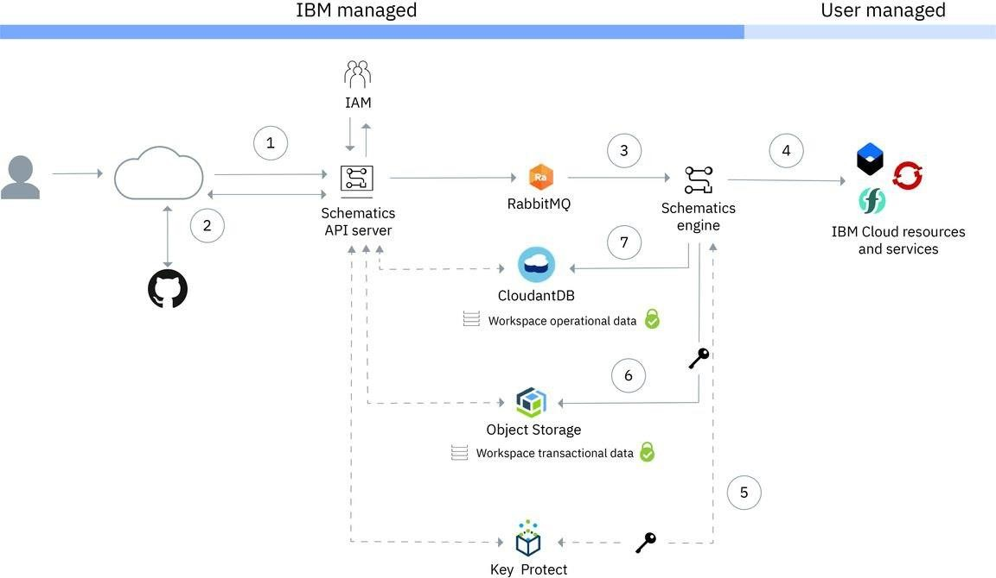

## Preview Locally:

You can preview your site locally to check how it looks and make any necessary adjustments before publishing.

## Version Control:

Consider using version control systems like Git to track changes to your content and site structure.

## Deployment:

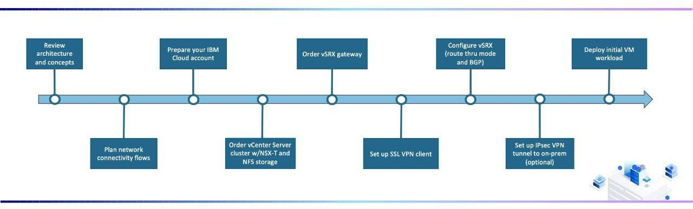

Once you're satisfied with your local preview, deploy your static site to a web server or hosting platform. Many services like Netlify, GitHub Pages, or Vercel make this process easy.

## Updating Content:

To update your blog content, simply edit the corresponding Markdown files and re- run the static site generator. Your changes will be reflected in the generated HTML.

## Automation:

You can set up automation to rebuild and deploy your site automatically when you push changes to your content repository.



**Presented by,** K.Rajeshwari V.Janani S.Anushka