# Assingment1

Q1. Install Power BI Desktop and share the final screenshot of the report view page which appears when power desktop starts.

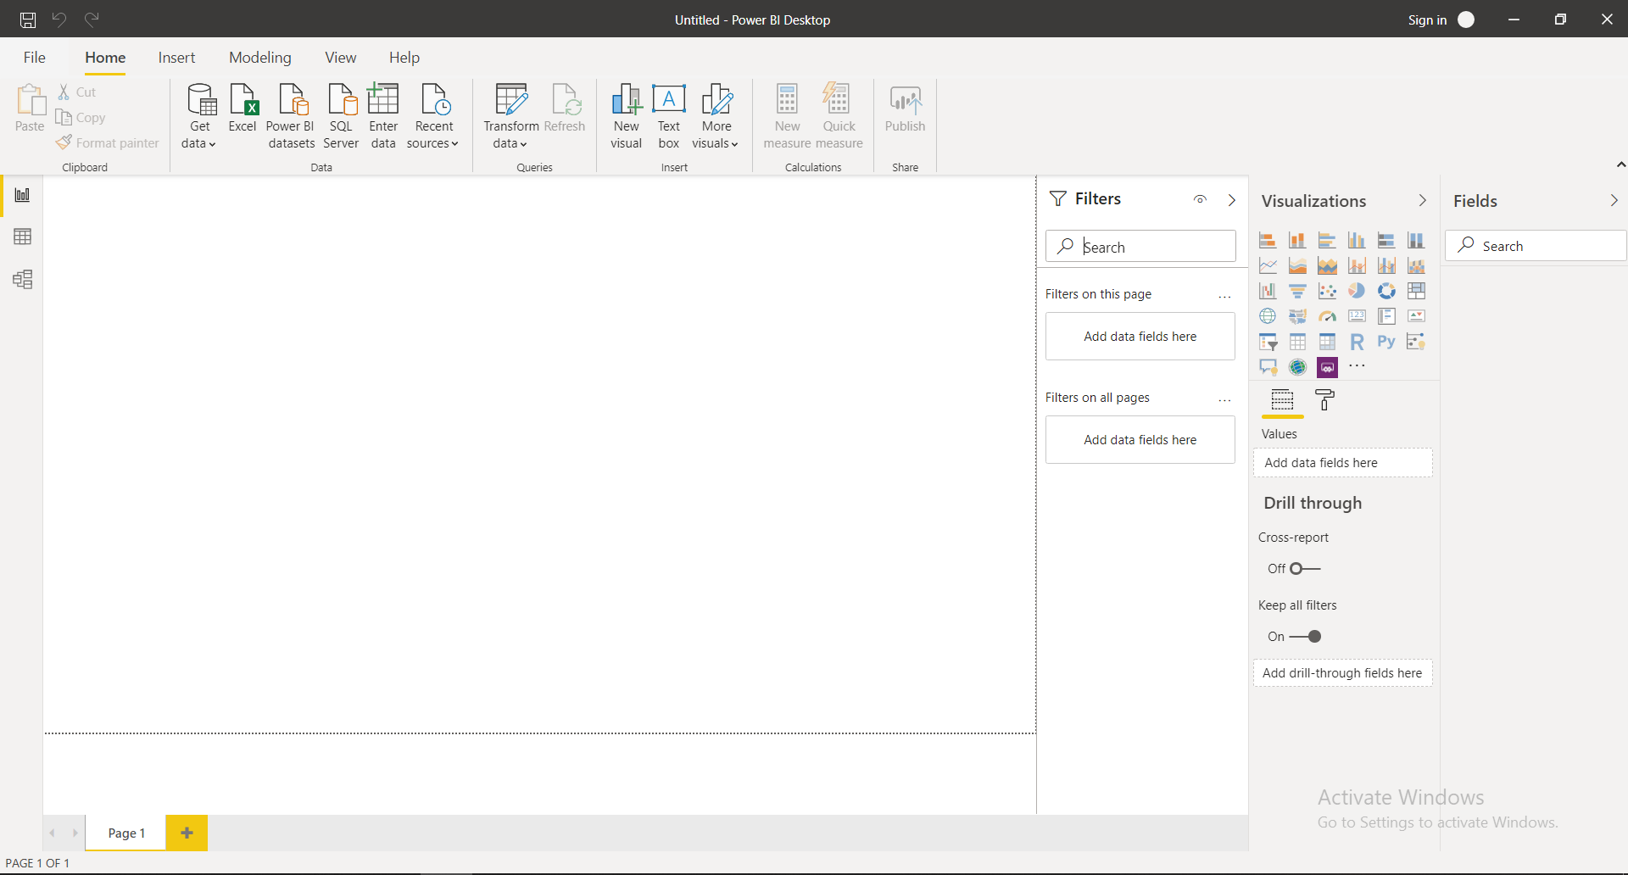

Q2. Prepare a document and with the following screenshot

− Report View

− Data View

- Model View

− Power Query Editor

− Advance Editor

− Report View

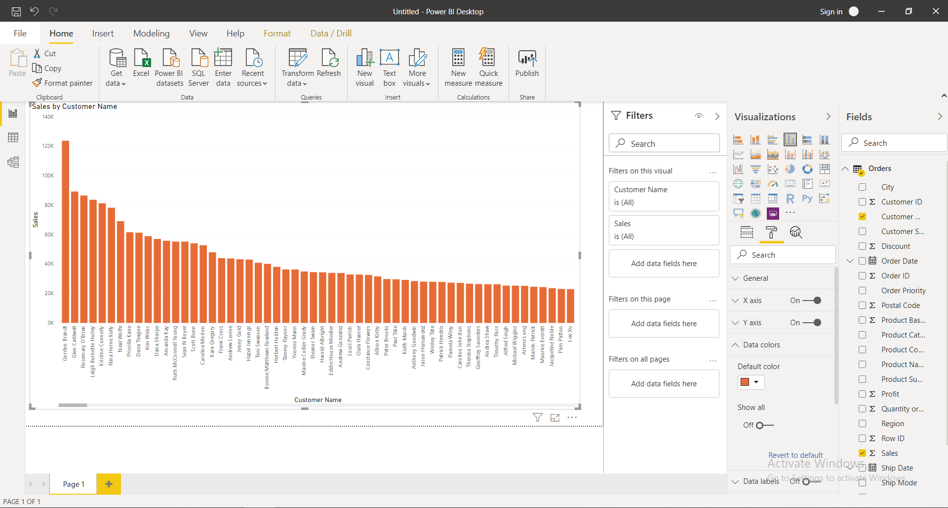

--Data View

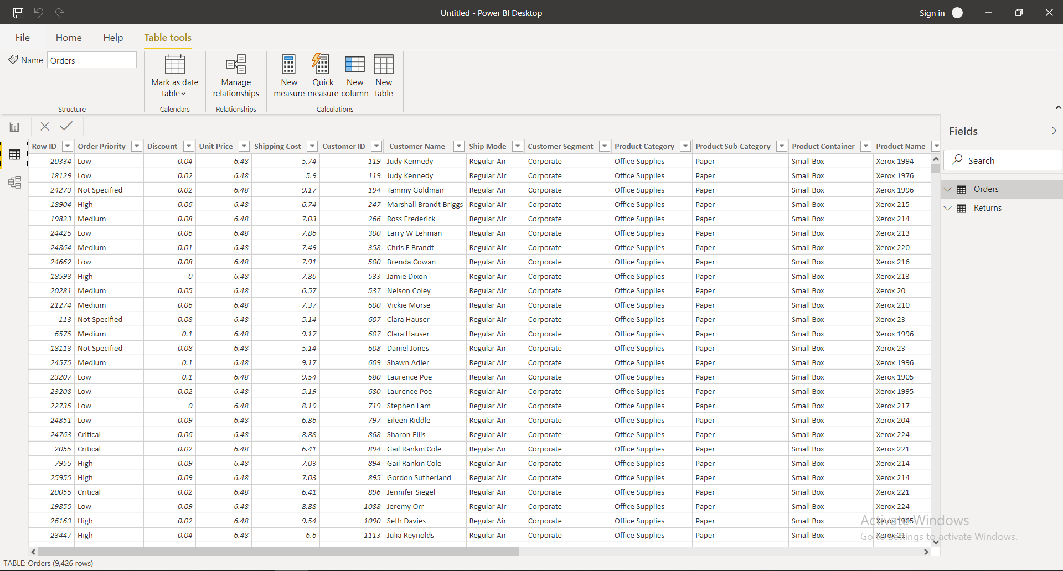

- Model View

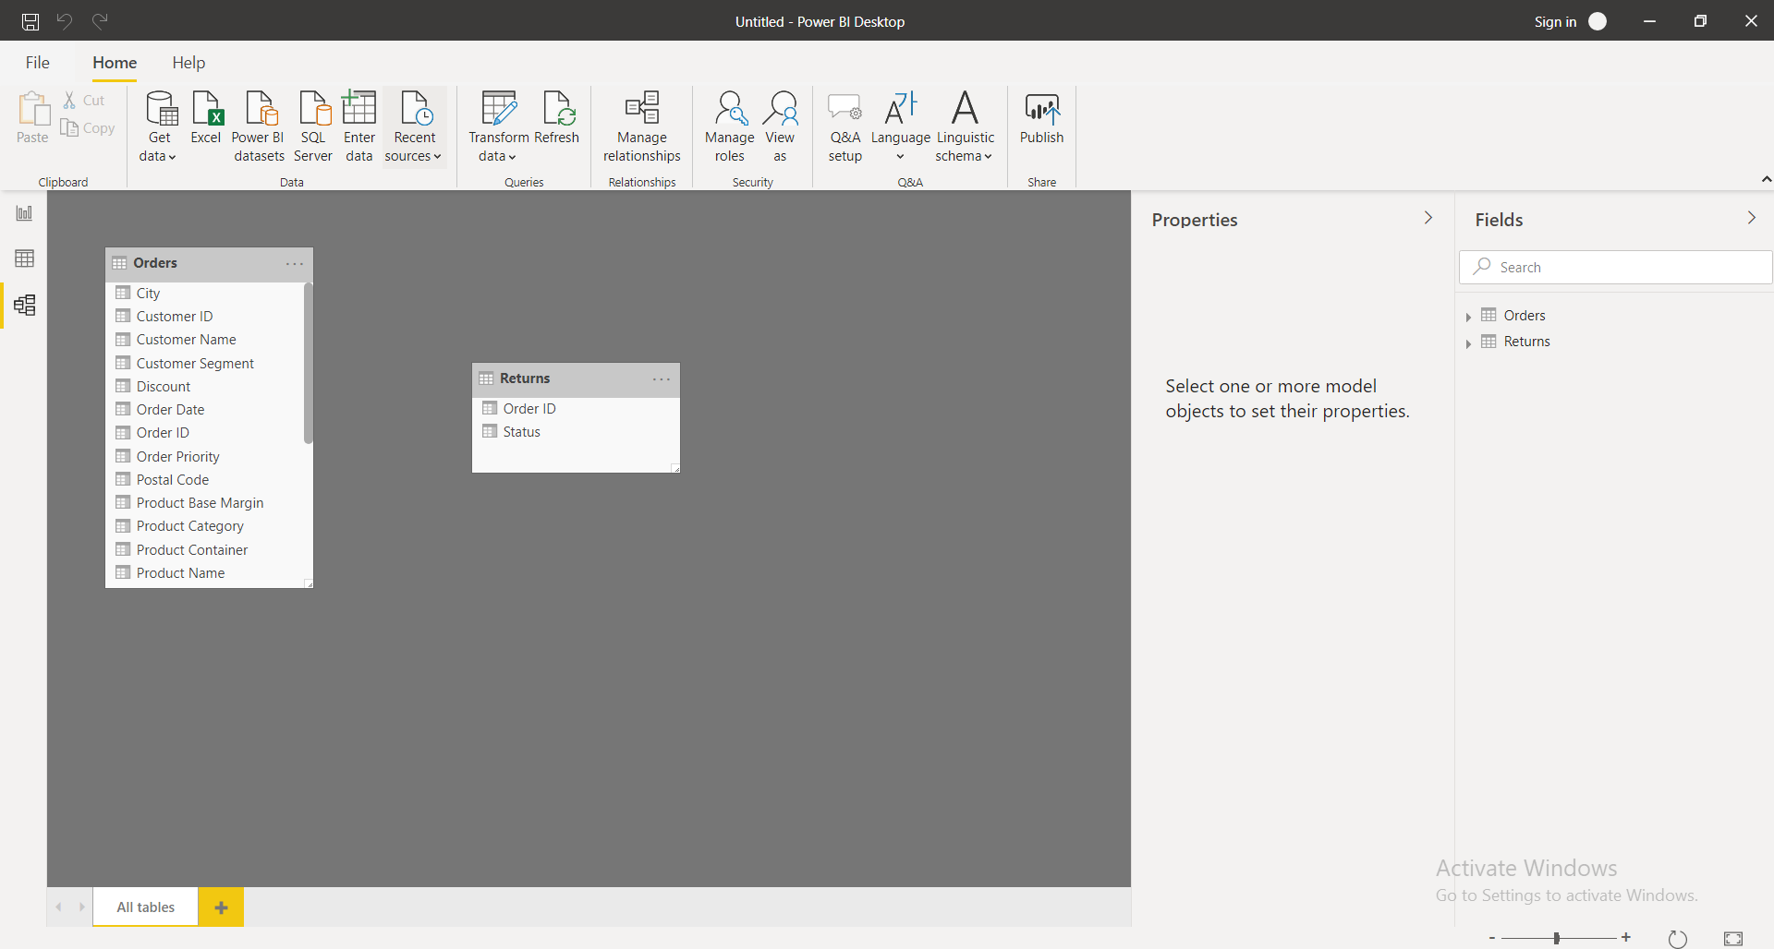

− Power Query Editor

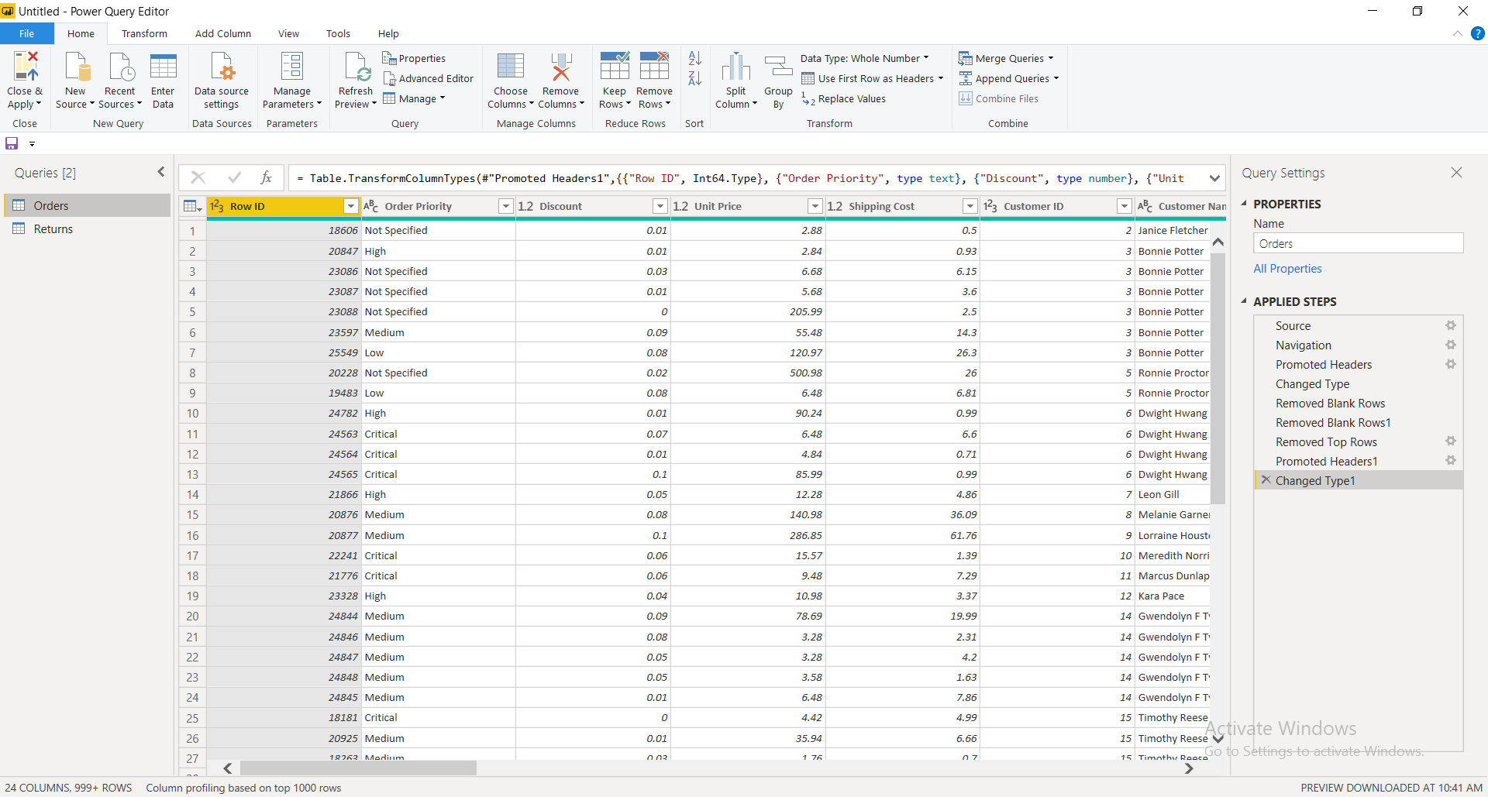

− Advance Editor

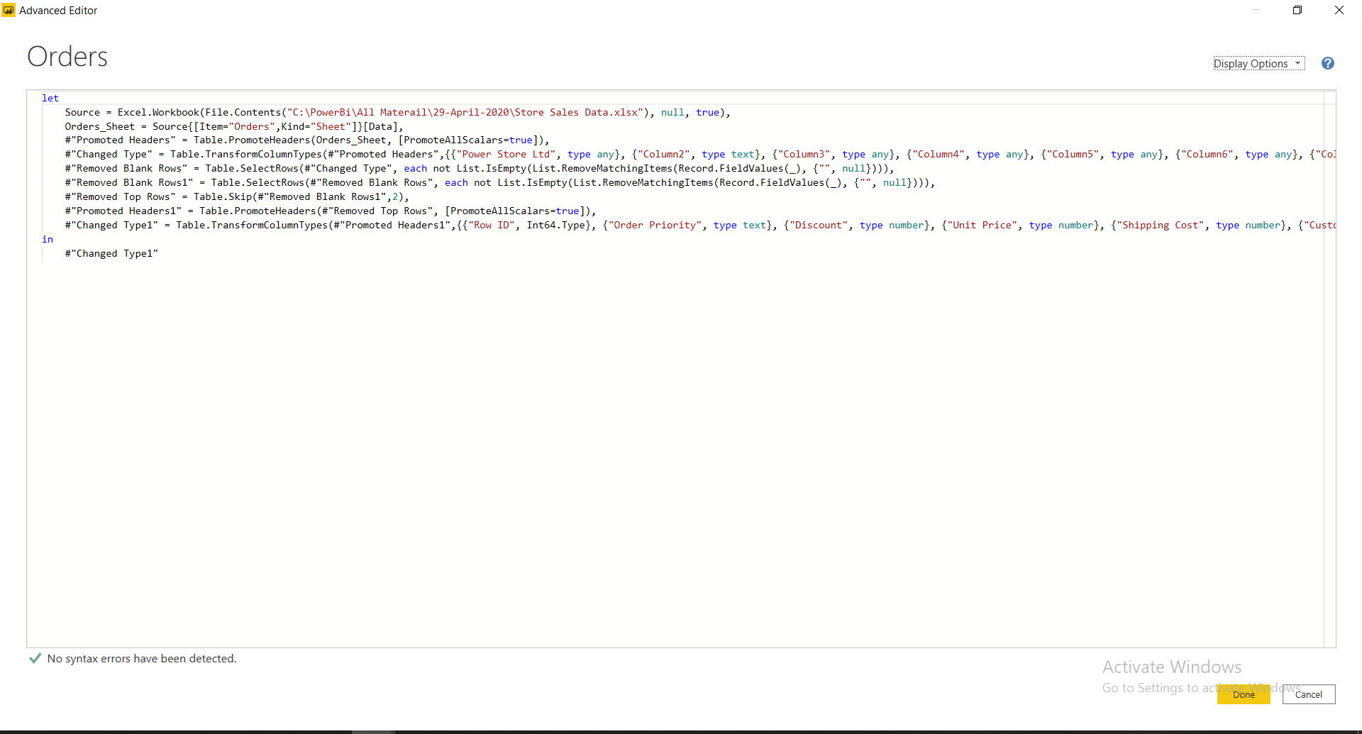

Q3.Prepare a document with details of the following along with their price.

* Power BI Desktop

Power BI is free to use.



* Power BI Pro

### Choose Power BI Pro

* Self-service and modern BI in the cloud
* Collaboration, publishing, sharing, and ad-hoc analysis
* Fully managed by Microsoft

Monthly Price for Power BI Pro

9.9$

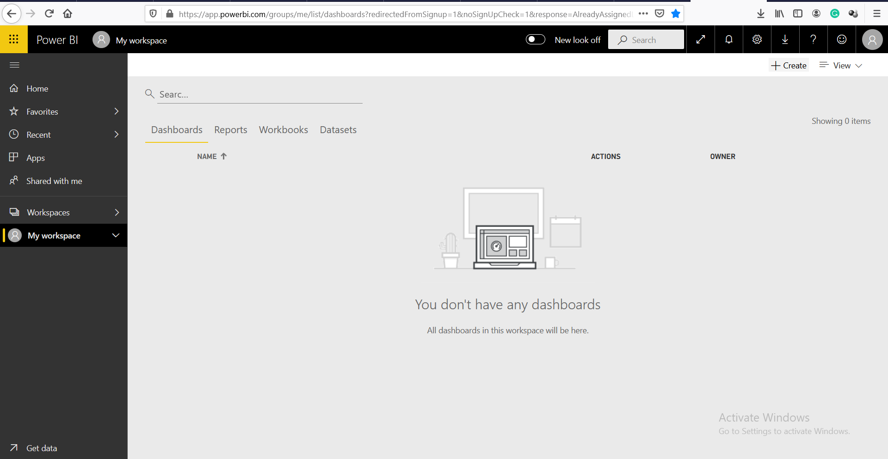

-Power BI Premium

* Enterprise BI, big data analytics, cloud and on-premises reporting
* Advanced administration and deployment controls
* Dedicated cloud compute and storage resources
* Allows any user to consume Power BI content

$4,995

Monthly price per dedicated cloud compute and storage resource with annual subscription